String s1 = "HELLO";

String s2 = "HELLO";

String s3 = new String("HELLO");

System.out.println(s1 == s2);

System.out.println(s1 == s3);

System.out.println(s1.equals(s2));

System.out.println(s1.equals(s3));

<https://www.programiz.com/java-programming/online-compiler/>

Java 8 : <https://quescol.com/interview-preparation/java-8-coding-interview-question>

<https://www.digitalocean.com/community/tutorials/java-programming-interview-questions>

https://blog.devgenius.io/java-8-coding-and-programming-interview-questions-and-answers-62512c44f062

# JDK | JRE | JVM

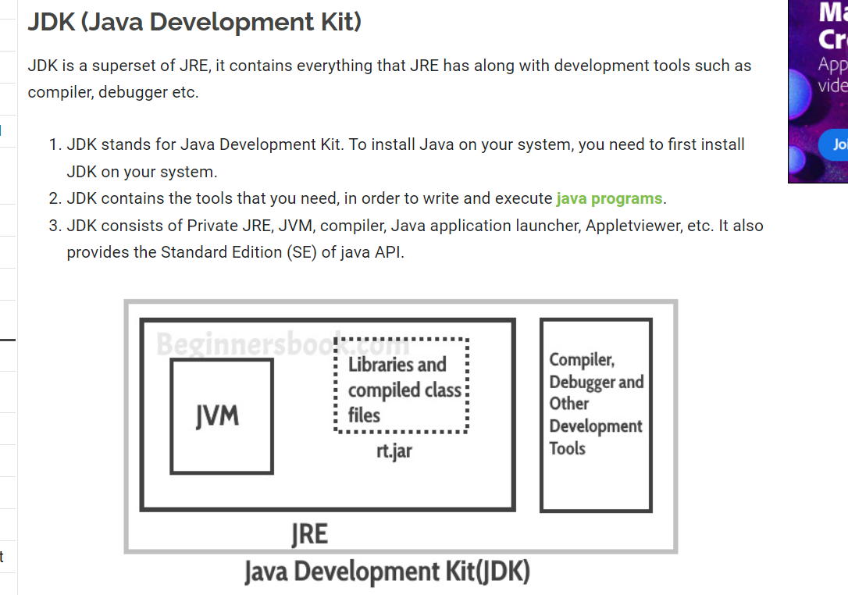

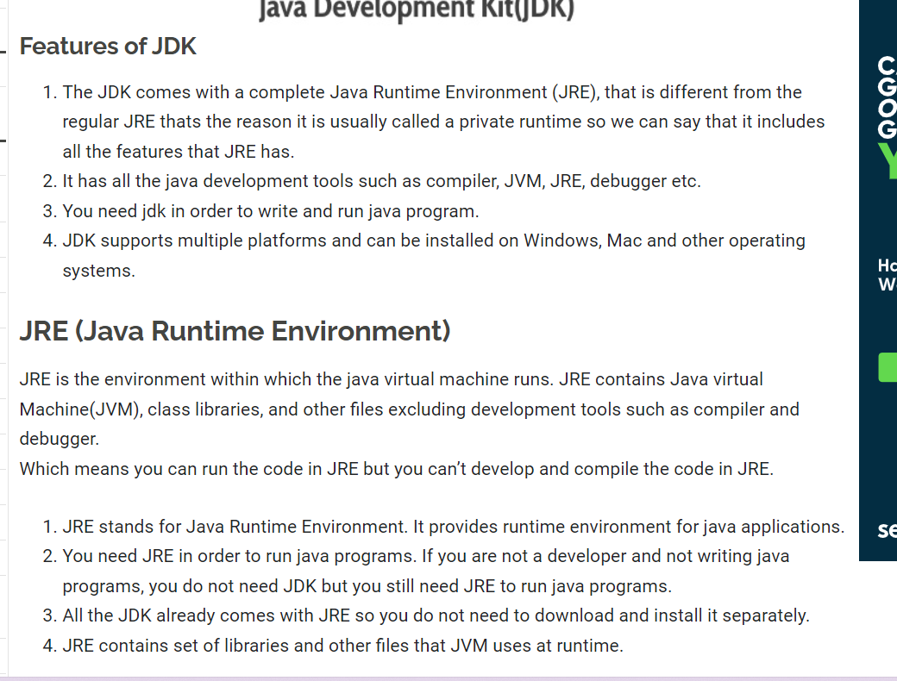

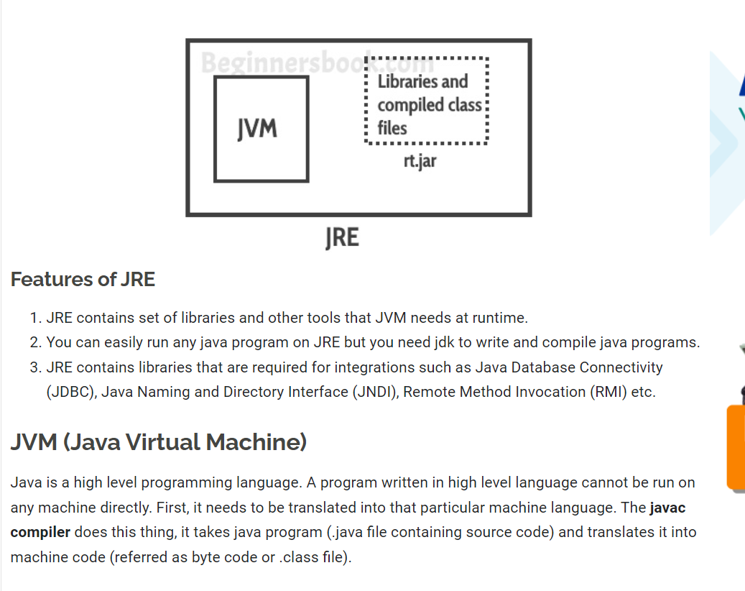

# Memory Management in Java

## **JVM Memory Structure**

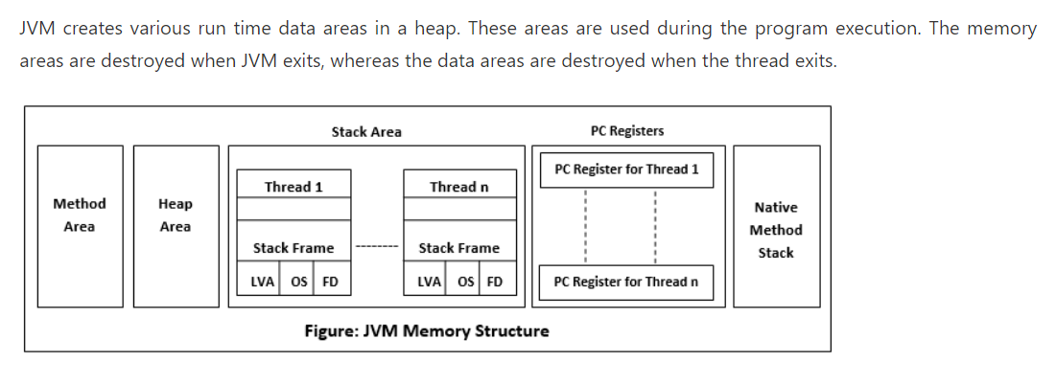

### Method Area

Method Area is a part of the heap memory which is shared among all the threads. It creates when the JVM starts up. It is used to store class structure, superclass name, interface name, and constructors. The JVM stores the following kinds of information in the method area:

* A Fully qualified name of a type (ex: String)
* The type's modifiers
* Type's direct superclass name
* A structured list of the fully qualified names of super interfaces.

Static variable stored in Method area(class area) only.

### **Heap Area**

Heap stores the actual objects. It creates when the JVM starts up. The user can control the heap if needed. It can be of fixed or dynamic size. When you use a new keyword, the JVM creates an instance for the object in a heap. While the reference of that object stores in the stack. There exists only one heap for each running JVM process. When heap becomes full, the garbage is collected. For example:

StringBuilder sb= **new** StringBuilder();

The above statement creates an object of the StringBuilder class. The object allocates to the heap, and the reference sb allocates to stack. Heap is divided into the following parts:

* Young generation
* Survivor space
* Old generation
* Permanent generation
* Code Cache

### **Stack Area**

Stack Area generates when a thread creates. It can be of either fixed or dynamic size. The stack memory is allocated per thread. It is used to store data and partial results. It contains references to heap objects. It also holds the value itself rather than a reference to an object from the heap. The variables which are stored in the stack have certain visibility, called scope.

**Stack Frame:** Stack frame is a data structure that contains the thread?s data. Thread data represents the state of the thread in the current method.

* It is used to store partial results and data. It also performs dynamic linking, values return by methods and dispatch exceptions.
* When a method invokes, a new frame creates. It destroys the frame when the invocation of the method completes.
* Each frame contains own Local Variable Array (LVA), Operand Stack (OS), and Frame Data (FD).
* The sizes of LVA, OS, and FD determined at compile time.
* Only one frame (the frame for executing method) is active at any point in a given thread of control. This frame is called the current frame, and its method is known as the current method. The class of method is called the current class.
* The frame stops the current method, if its method invokes another method or if the method completes.
* The frame created by a thread is local to that thread and cannot be referenced by any other thread.

### **Native Method Stack**

It is also known as C stack. It is a stack for native code written in a language other than Java. Java Native Interface (JNI) calls the native stack. The performance of the native stack depends on the OS.

### **PC Registers**

Each thread has a Program Counter (PC) register associated with it. PC register stores the return address or a native pointer. It also contains the address of the JVM instructions currently being executed.

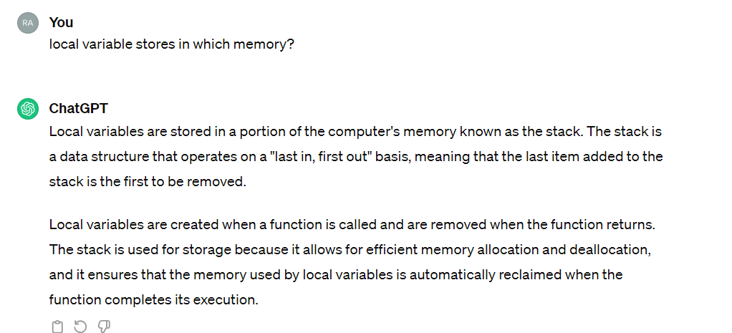

### MetaSpace

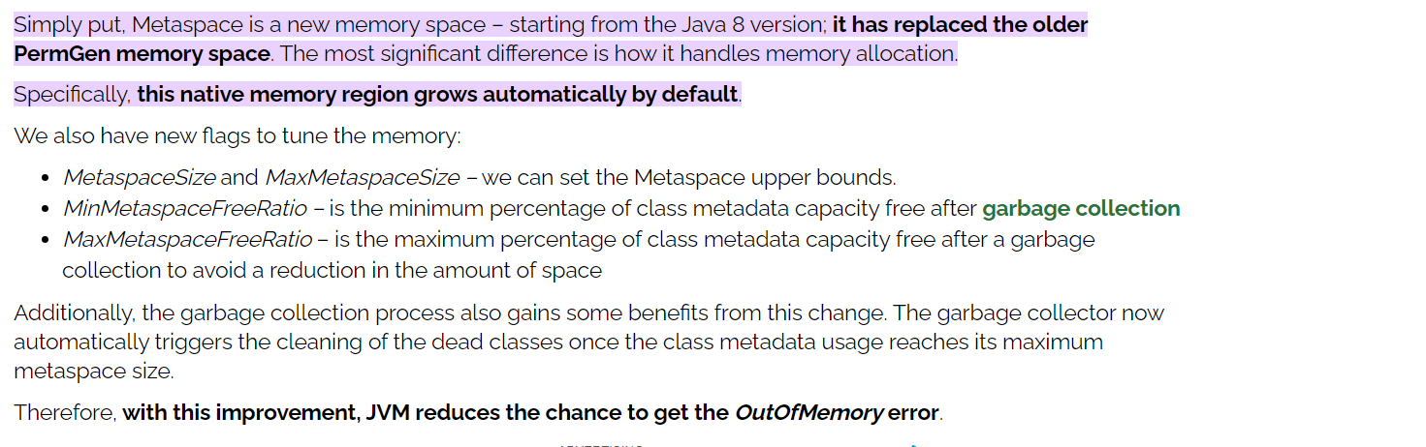

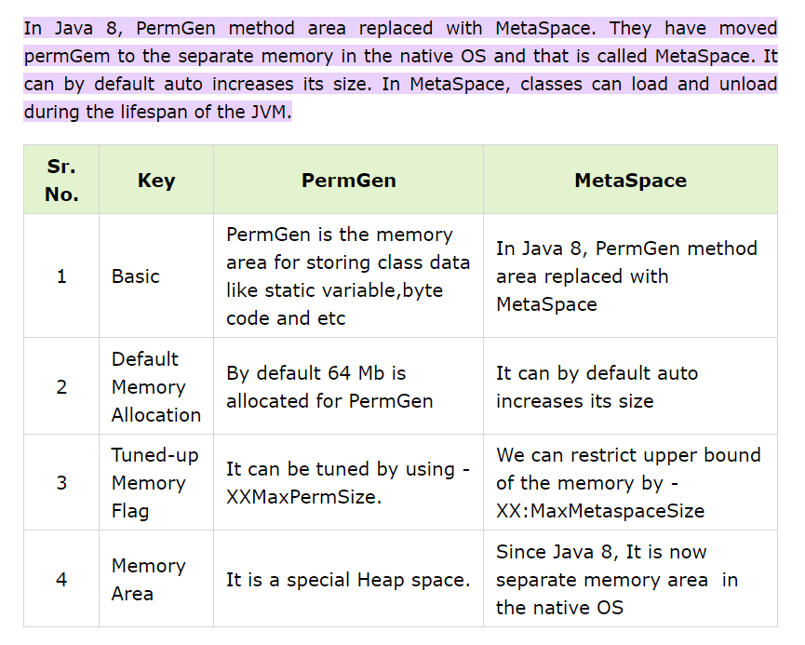

## garbage collection

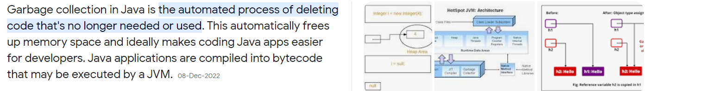

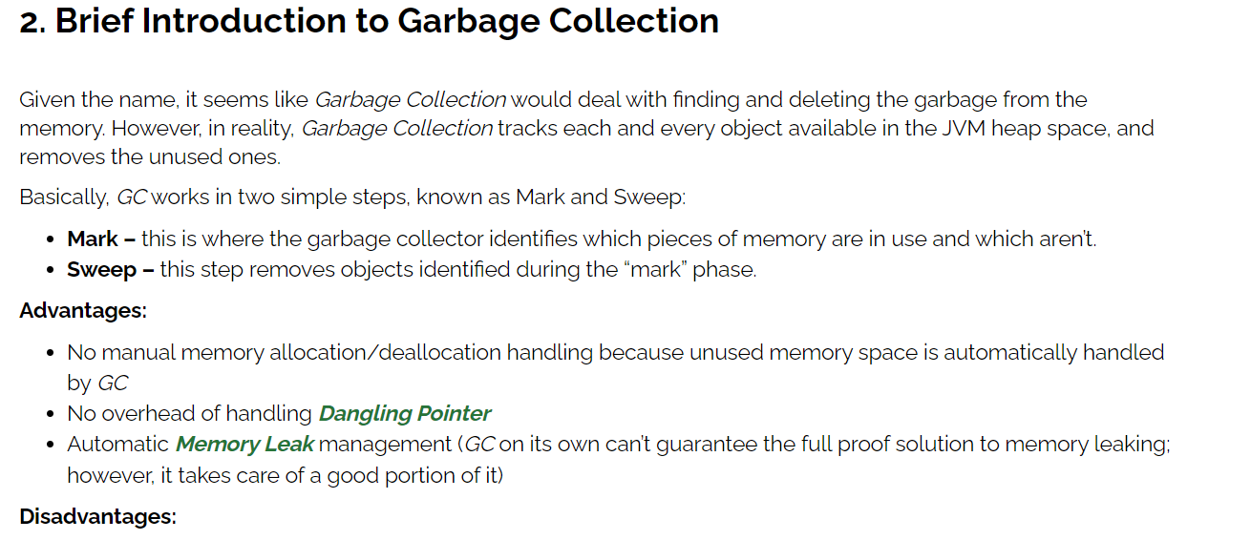

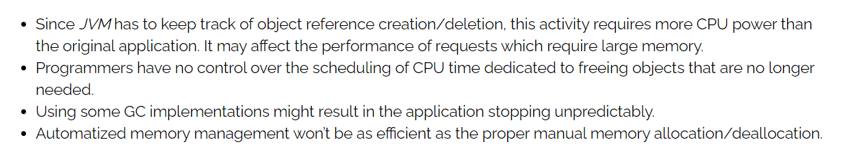

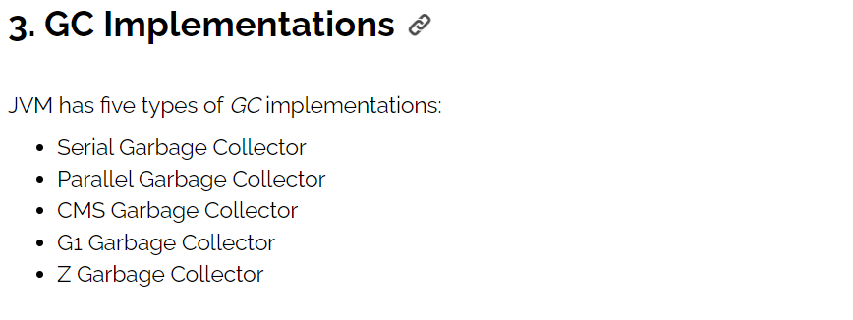

<https://www.baeldung.com/jvm-garbage-collectors>

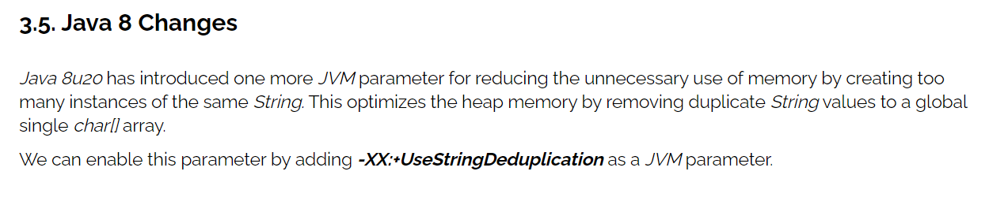

# Core Java

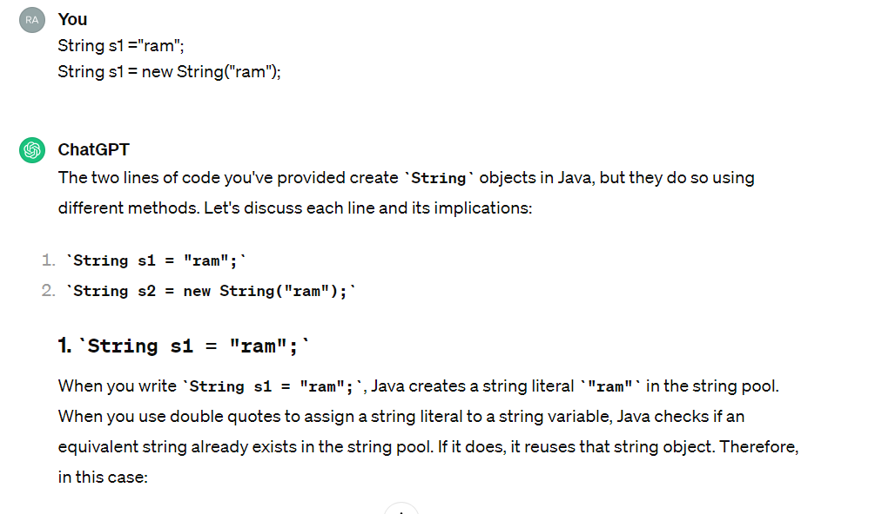

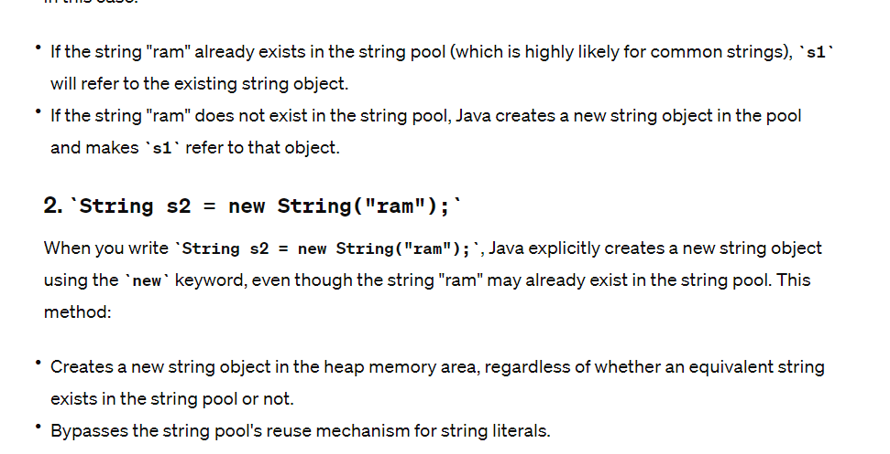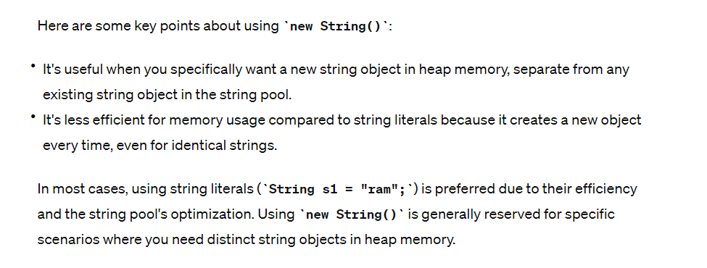

**how to create immutable object in java**

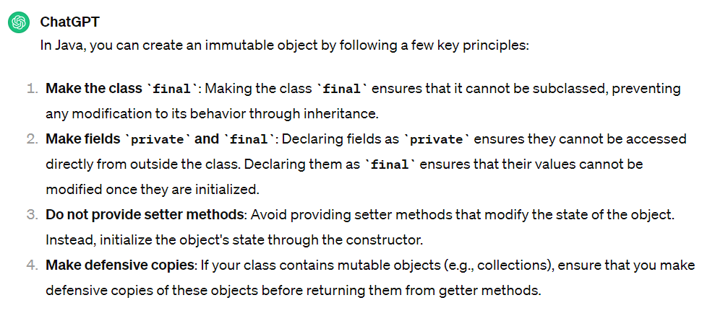

**why String is immutable?**

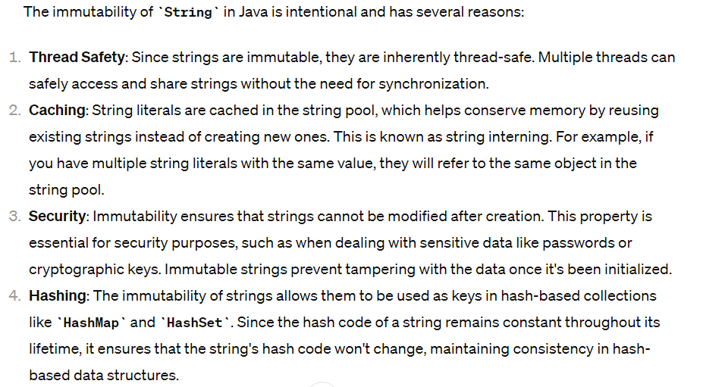

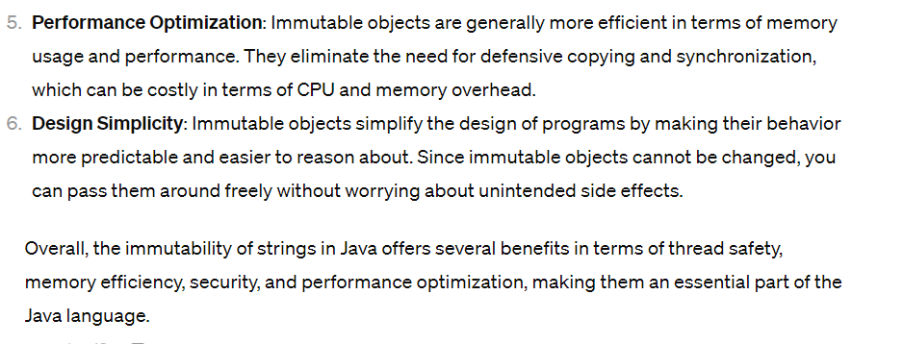

**show the structure of immutable class**

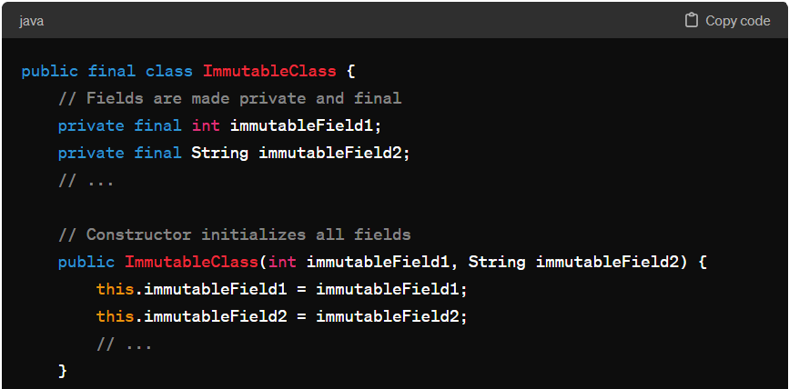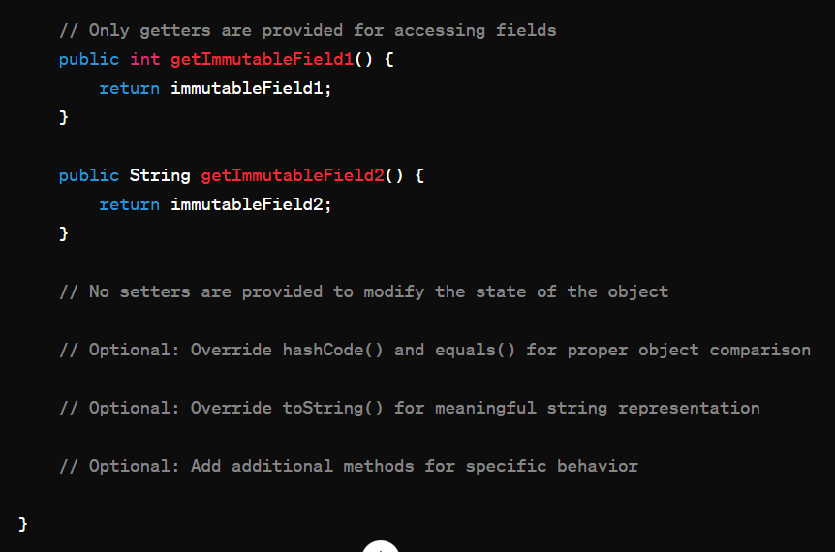

Explanation of the structure:

1. **Class Declaration**: The class is declared using the **final** keyword to prevent subclassing, ensuring that the class remains immutable and cannot be overridden.
2. **Fields**: All fields are made **private** and **final** to prevent direct access and modification. This ensures that the state of the object cannot be changed after initialization.
3. **Constructor**: The constructor initializes all fields of the class. Once the object is constructed, its state cannot be modified.
4. **Getters**: Only getter methods are provided to access the values of the fields. These methods allow clients to retrieve the values of the immutable fields but do not provide any means to modify them.
5. **No Setters**: Setters are not provided in an immutable class, as they would allow the state of the object to be changed after initialization, violating immutability.
6. **Optional Overrides**: It's common to override **hashCode()**, **equals()**, and **toString()** methods for proper object comparison and meaningful string representation. Additionally, you may provide additional methods for specific behavior.

By following this structure, you ensure that instances of the **ImmutableClass** remain immutable, thread-safe, and free from unintended side effects, making them safer to use in multi-threaded and concurrent environments.

## Wrapper class

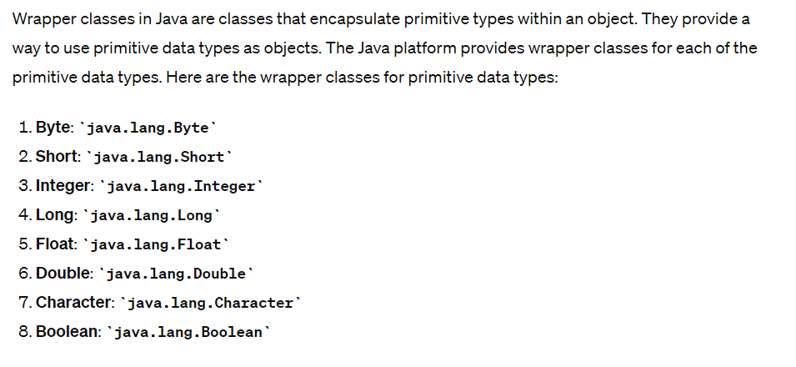

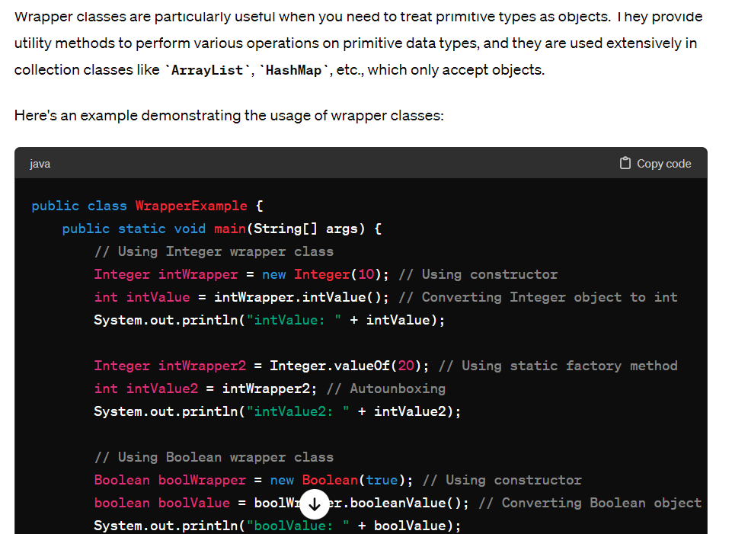

**purpose of Wrapper classes?**

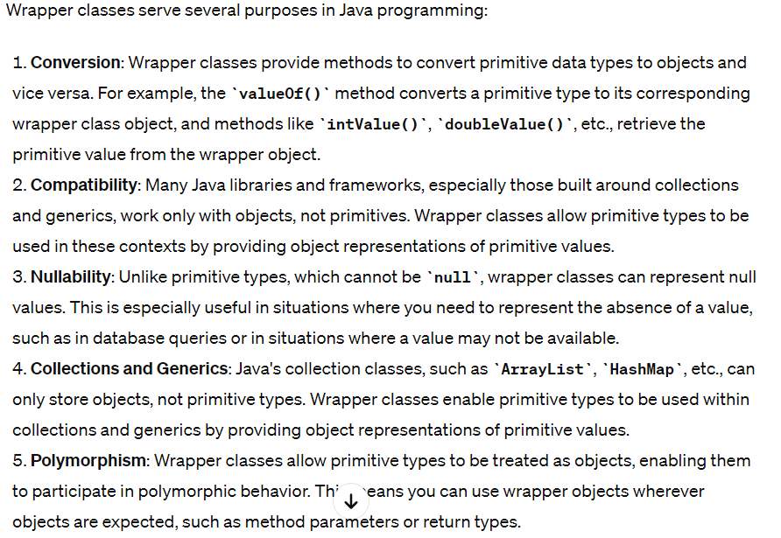

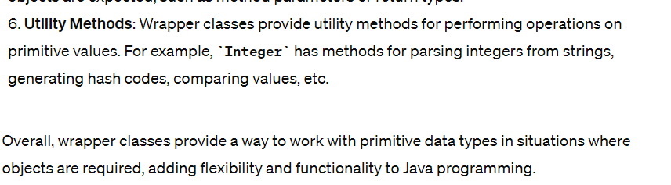

**create wrapper classes without new keyword**

Certainly! In Java, you can create wrapper classes without explicitly using the **new** keyword by utilizing static factory methods or by employing static initialization blocks. Here's an example demonstrating both approaches:

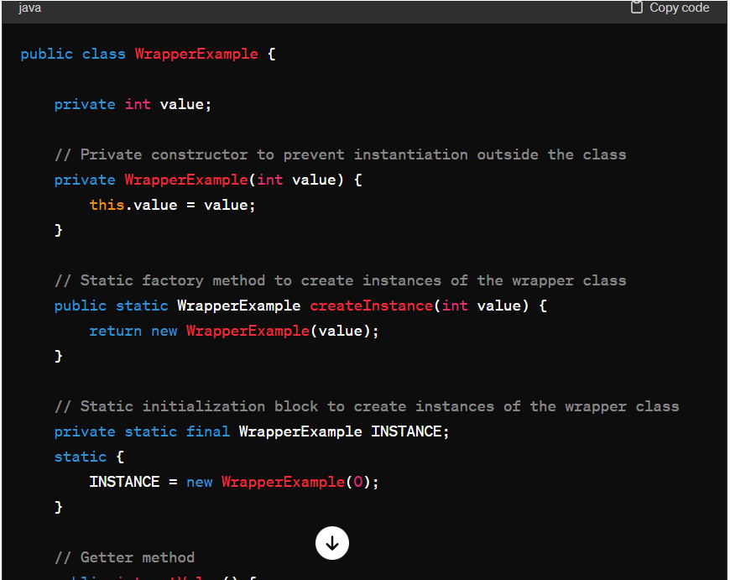

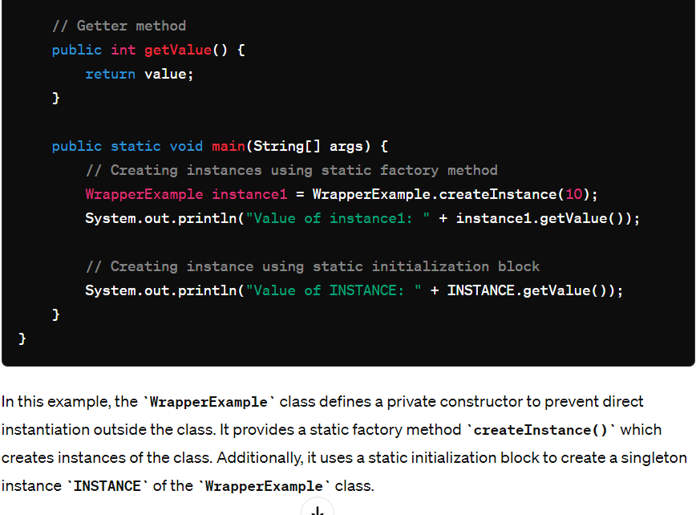

**Compatibility with Collections and Generics: why?**

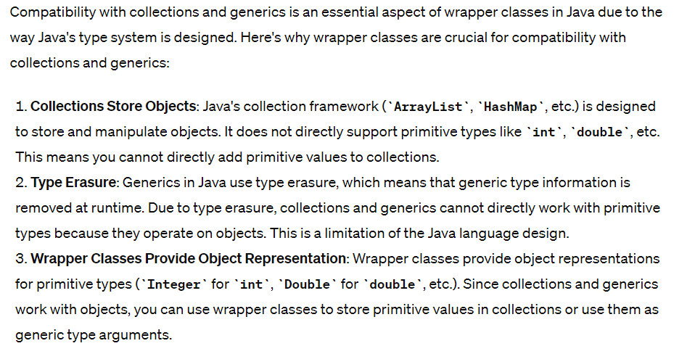

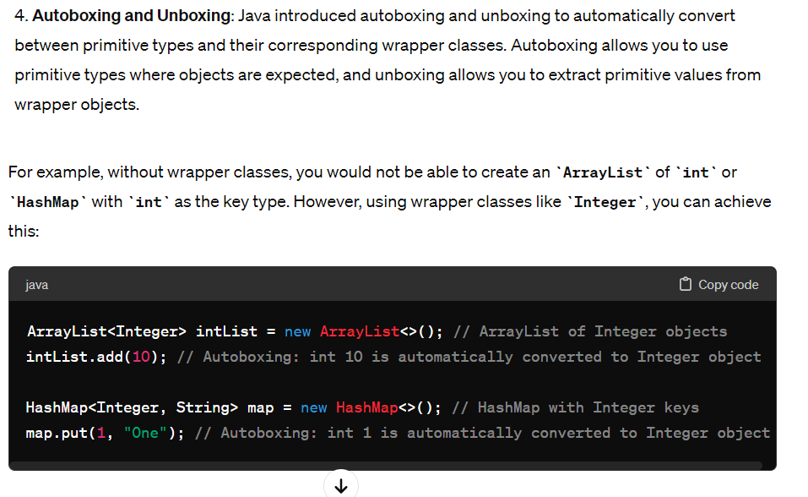

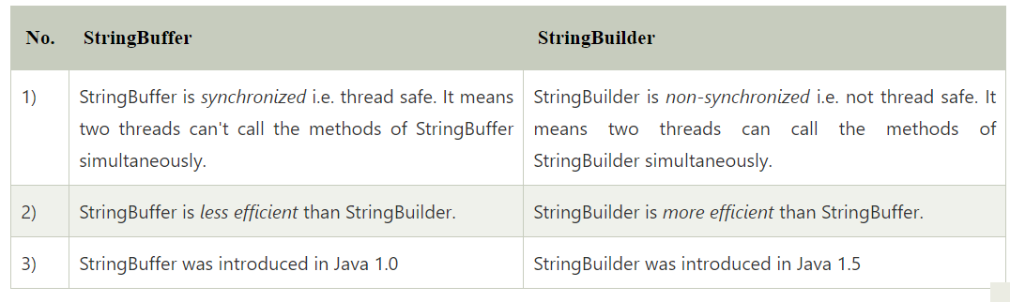

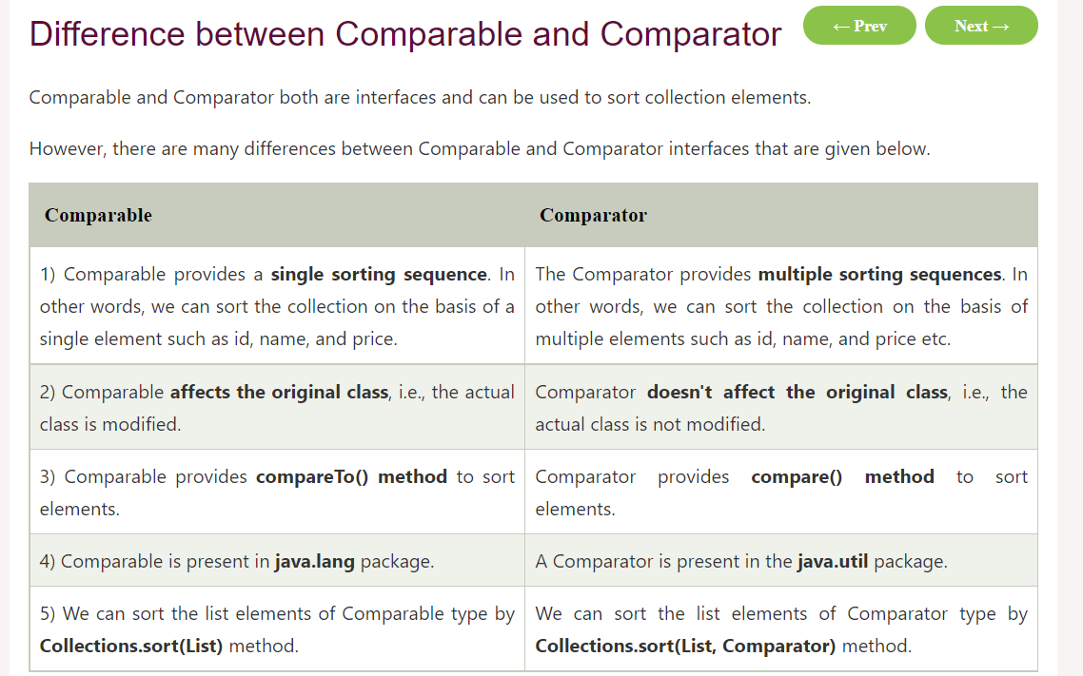

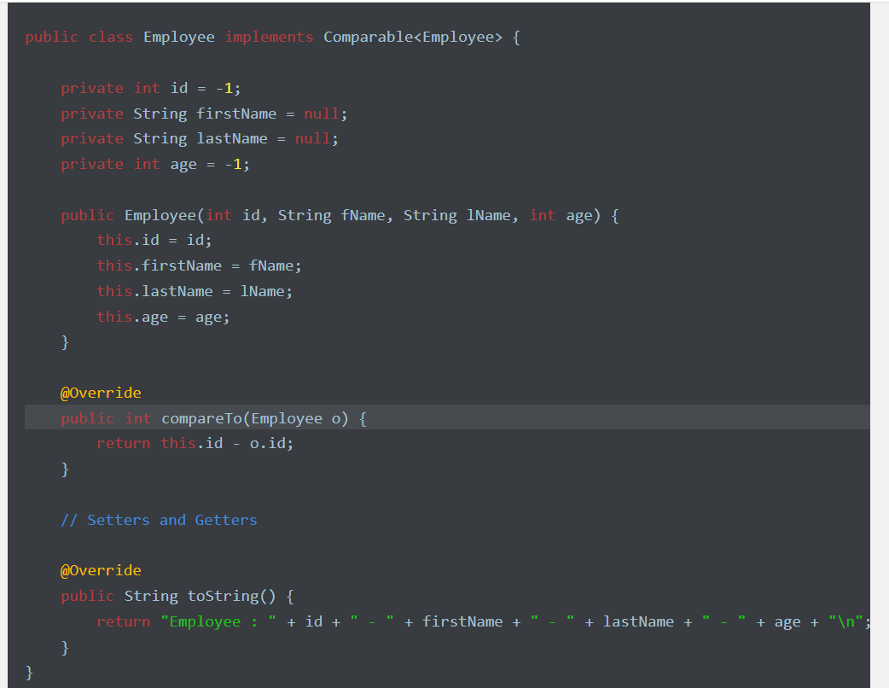

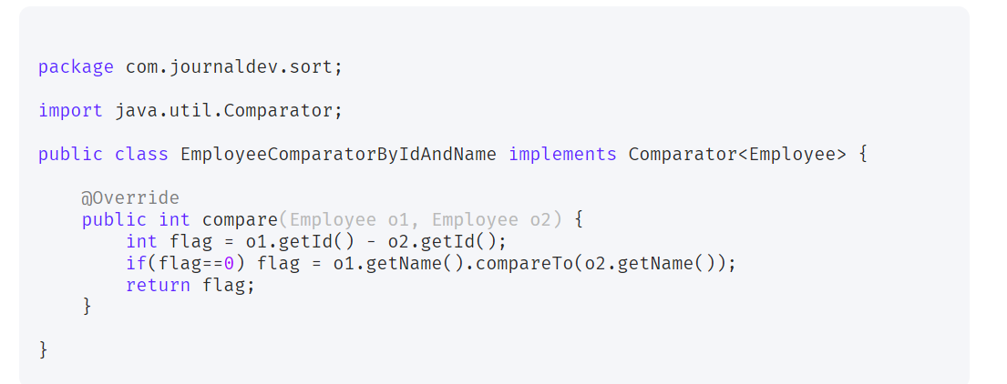

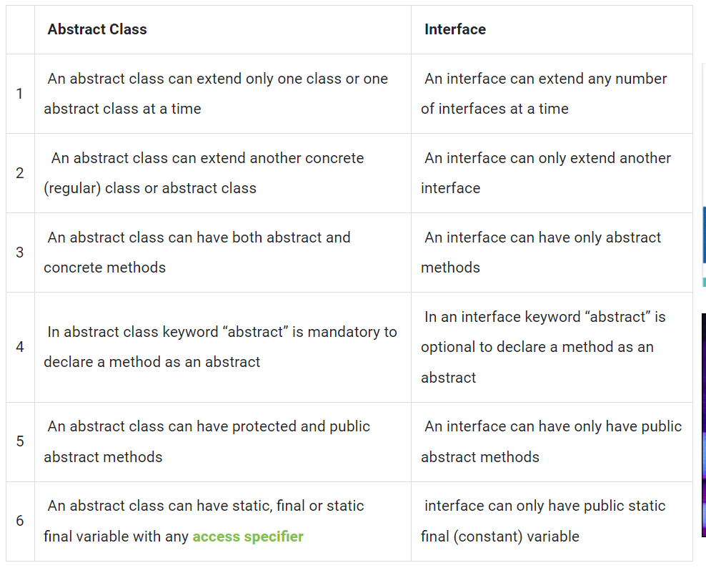

## Abstract Class:

1. **Definition**:
   * An abstract class is a class that cannot be instantiated on its own and may contain abstract methods (methods without implementation) as well as concrete methods (methods with implementation).
   * It serves as a blueprint for other classes to inherit from and can have both abstract and non-abstract methods.
2. **Usage**:
   * Use abstract classes when you want to define common behavior and characteristics among a group of related classes.
   * Abstract classes can provide partial implementation of methods, allowing subclasses to override specific behaviors while inheriting common functionalities.

**Key Points**:

* Abstract classes can have constructors, instance variables, and regular methods along with abstract methods.
* A subclass can extend only one abstract class due to Java's single inheritance limitation.

## Interface:

1. **Definition**:
   * An interface is a reference type similar to a class that contains only abstract methods, default methods (with implementation since Java 8), static methods, and constant variables (implicitly static and final).
   * It defines a contract for classes that implement it, specifying the methods they must provide.
2. **Usage**:
   * Use interfaces when you want to define a contract or set of behaviors that classes can adhere to.
   * Interfaces allow for multiple inheritance of type (a class can implement multiple interfaces), overcoming Java's single inheritance limitation for classes.
3. **Key Points**:
   * Interfaces do not have constructors, instance variables (except constants), or method implementations until Java 8 (default methods).
   * A class can implement multiple interfaces, enabling better flexibility in defining behaviors for diverse classes.

### When to Use Which:

* **Abstract Class**:
  + Use when you want to share code among related classes and provide a common base for subclasses.
  + Use when you need to declare non-public members or provide default implementations for methods.
* **Interface**:
  + Use when you want to define a contract for classes that can have different implementations.
  + Use when you need multiple inheritance of type or need to support a wide range of unrelated classes with common functionality.

In summary, abstract classes are useful for code reuse and sharing common behaviors, while interfaces define contracts for implementing classes and support multiple inheritance of type. Both concepts play crucial roles in designing flexible and modular object-oriented systems, and choosing between them depends on your specific design goals and requirements.

Top of Form

**marker interface**.

An empty interface is known as tag or marker interface. For example Serializable, EventListener, Remote(java.rmi.Remote) are tag interfaces, there are few other tag interfaces as well.

These interfaces do not have any field and methods in it. You must be thinking if they are empty why class implements them? What’s the use of it? Class implements them to claim the membership in a particular set. For example: If a class implements Serializable interface, it is claiming to be the member of Serializable classes, so if JVM (Java Virtual Machine) sees that a class is Serializable, it does some trick or special operation that helps in the serialization/de-serialization process.

Basically Tag interfaces are meaningful to the JVM (Java virtual machine). You can also create your own tag interfaces to segregate and categorize your code. It would improve the readability of your code.

This is how a tag interface looks:

package java.util;

public interface EventListener

{}

How to read the Property file from the java class

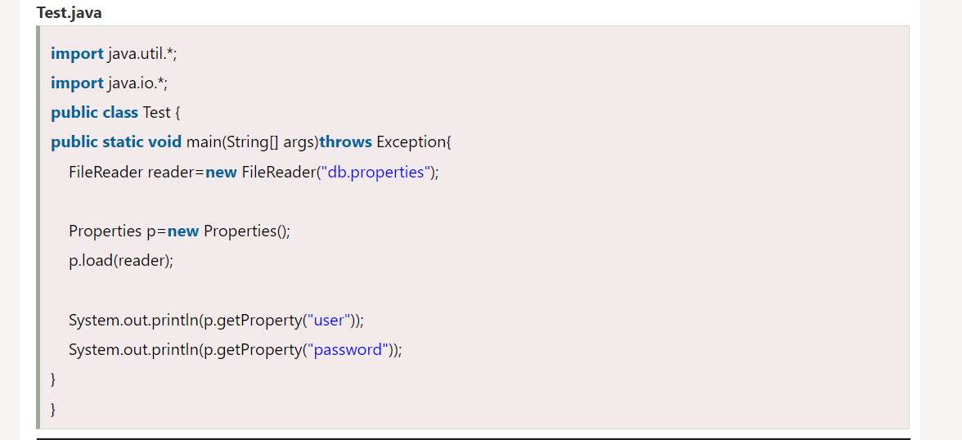

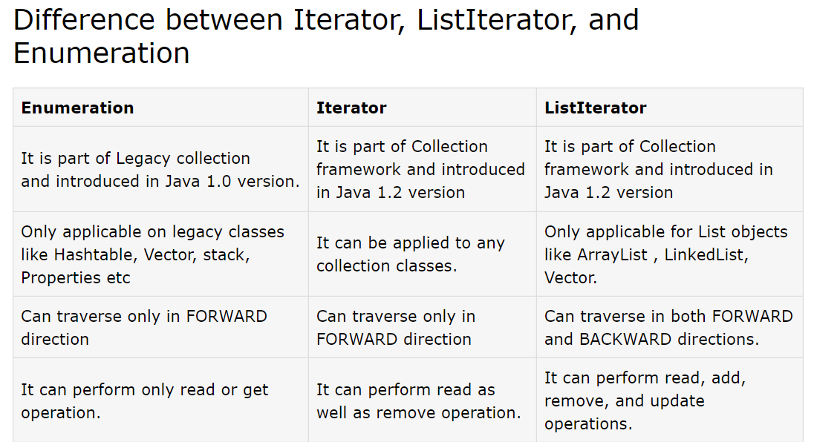

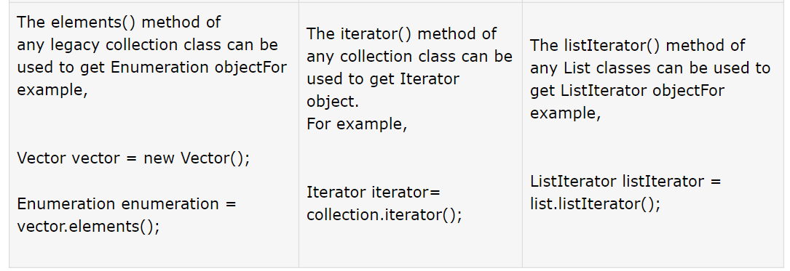

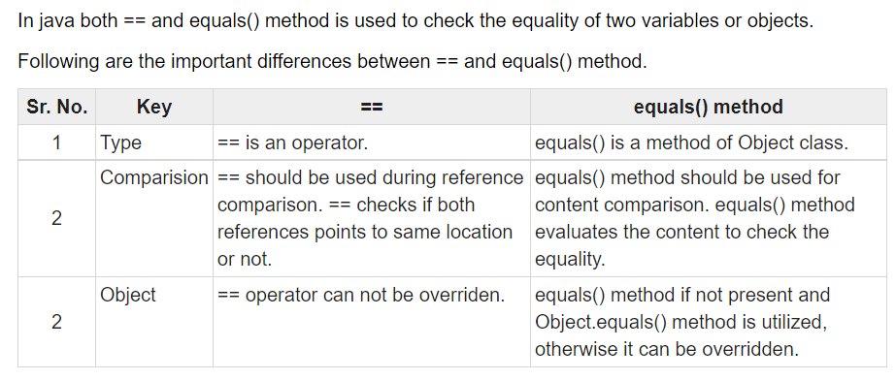

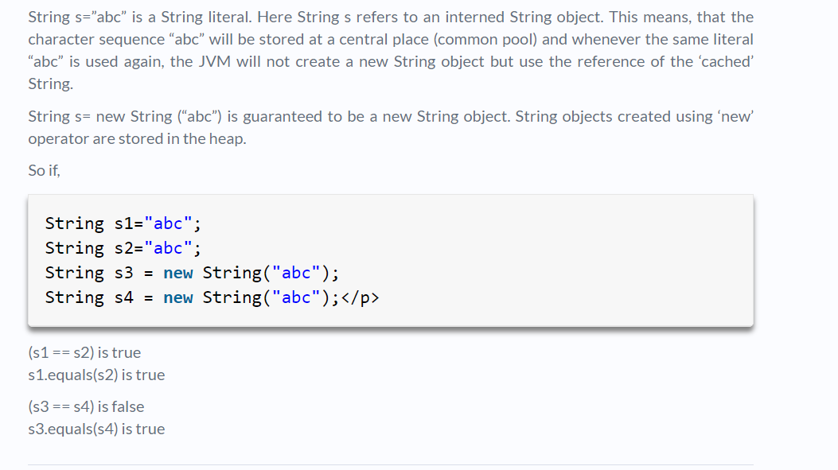

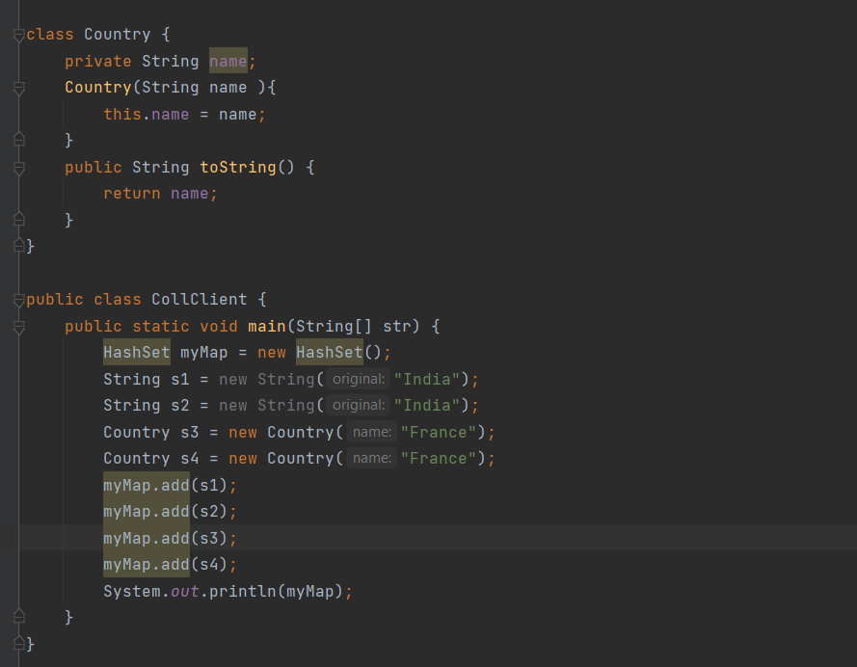

**options are :**

**A)France France India right answer**

**B)India India France France**

**C)India France**

**D)France France**

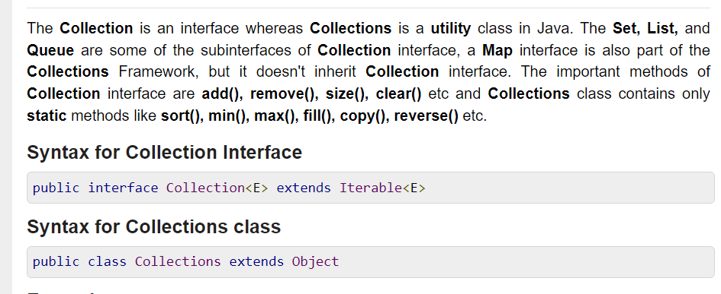

## Runnable Vs Callable

The Runnable interface is a functional interface and has a single run() method that doesn’t accept any parameters or return any values.

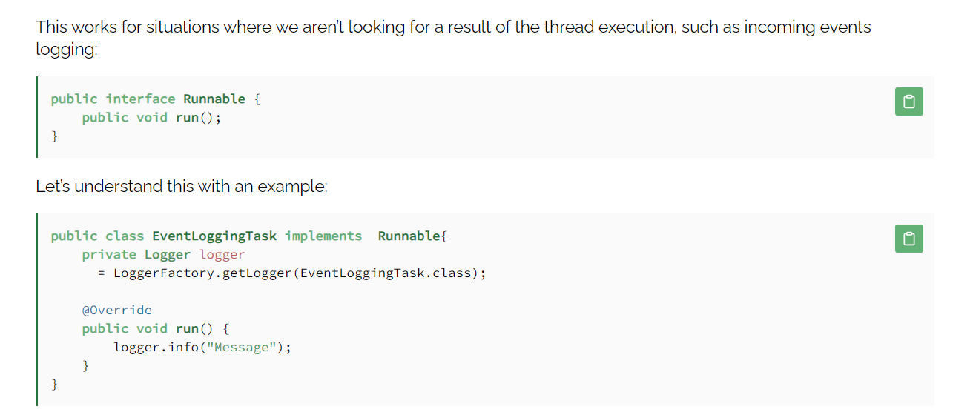

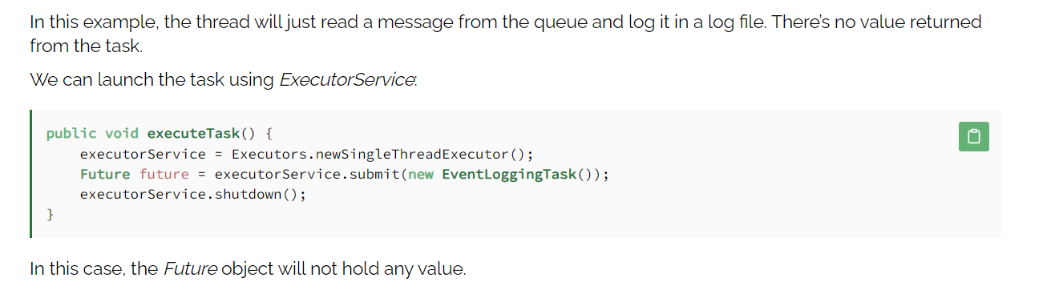

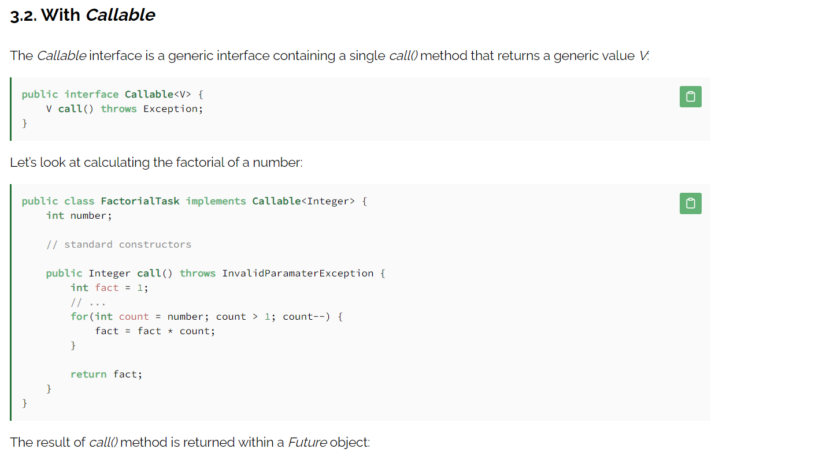

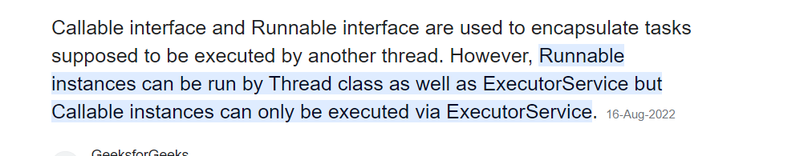

## ExecutorService

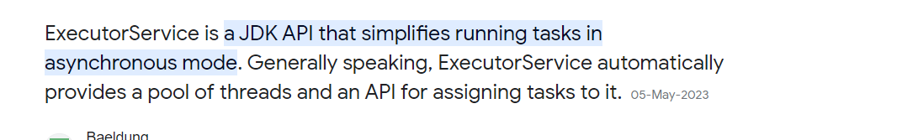

<https://www.baeldung.com/java-executor-service-tutorial#:~:text=ExecutorService%20is%20a%20JDK%20API,for%20assigning%20tasks%20to%20it>.

## HashCode() and equals()

<https://www.digitalocean.com/community/tutorials/java-equals-hashcode>

## Transient vs Volatile

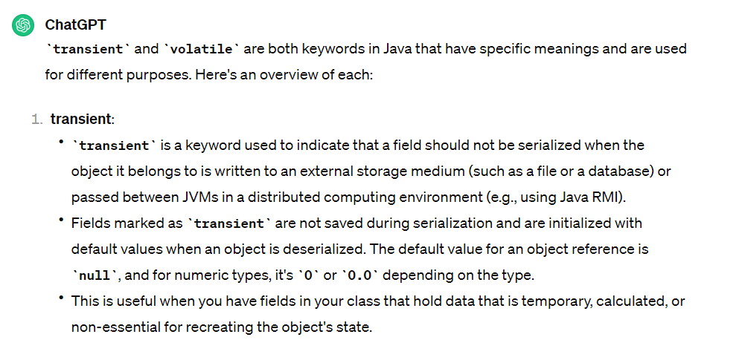

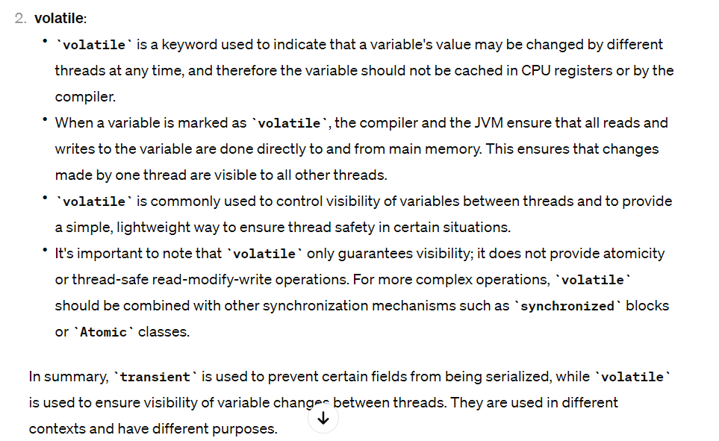

## Reflections

In Java, reflection refers to the ability of a program to inspect and manipulate its own structure, classes, methods, fields, and other elements at runtime. This capability allows Java code to analyze and modify the behavior of classes and objects dynamically, without necessarily knowing their specific details at compile time.

Reflection is primarily facilitated by the **java.lang.reflect** package, which provides classes such as **Class**, **Method**, **Field**, **Constructor**, etc., to represent various elements of a class or an object.

Here are some common tasks that can be accomplished using reflection in Java:

1. **Inspecting Class Information**: You can obtain information about a class such as its name, superclass, implemented interfaces, constructors, methods, and fields.
2. **Creating Instances Dynamically**: Reflection allows you to create new instances of classes dynamically, even if the class name is only known at runtime.
3. **Accessing and Modifying Fields**: You can read and modify fields (variables) of a class, including private fields that are not accessible through normal means.
4. **Invoking Methods Dynamically**: Reflection enables you to invoke methods on objects dynamically, including private and inaccessible methods.
5. **Working with Annotations**: Reflection can be used to inspect and process annotations at runtime, allowing for dynamic behavior based on annotated elements.

Here's a simple example demonstrating how to use reflection in Java:

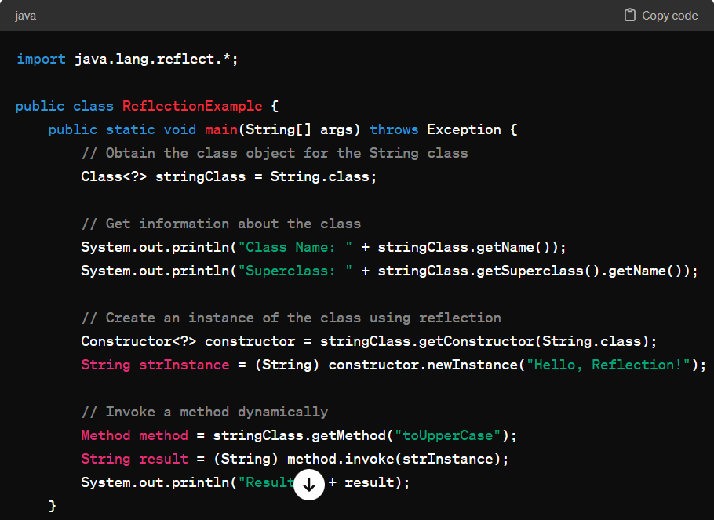

## Singleton

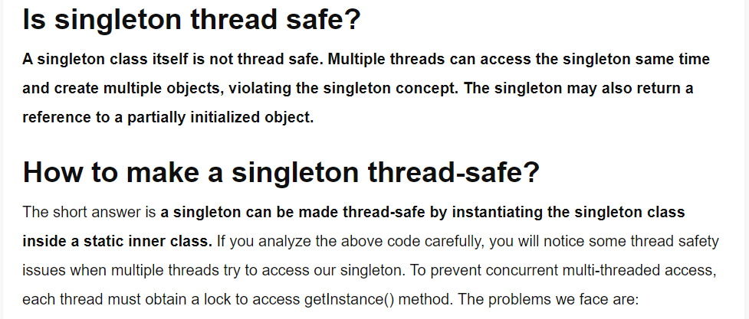

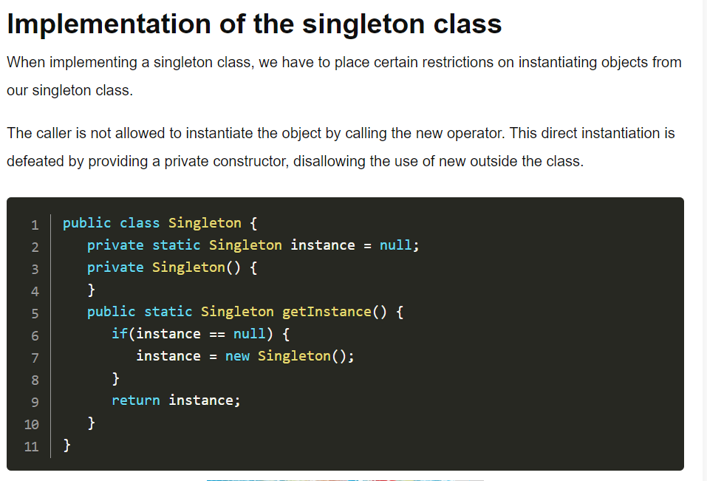

To create a singleton class in Java, you typically follow the Singleton design pattern, which ensures that a class has only one instance and provides a global point of access to that instance. Here's a basic implementation of a singleton class in Java using the Singleton pattern:

1. **Private Constructor**: The constructor of the singleton class is made private to prevent other classes from instantiating it directly.
2. **Static Instance Variable**: A private static variable (**instance**) of the class itself is used to hold the single instance of the class.
3. **getInstance() Method**: This static method provides the global point of access to the single instance of the class. It uses lazy initialization to create the instance only when **getInstance()** is called for the first time.

**Making Thread safe :**

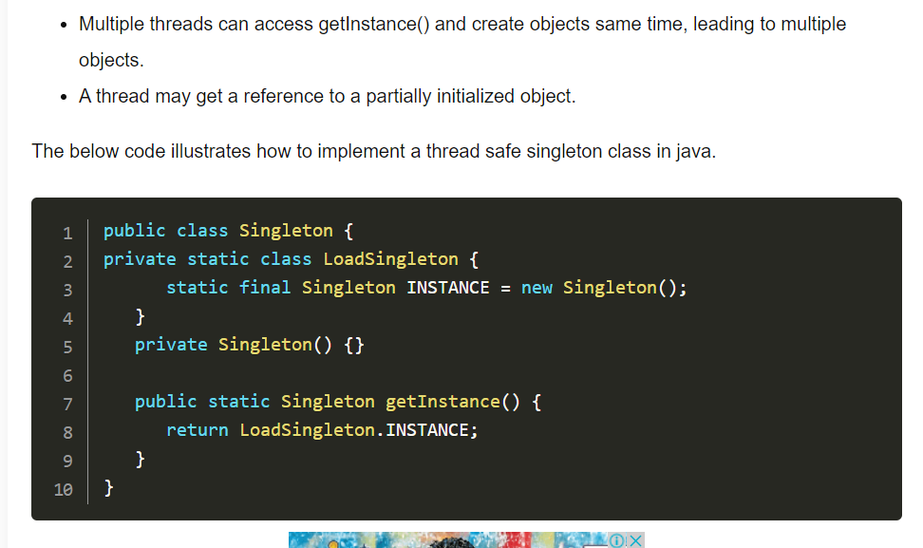

## Fail-Fast and Fail-safe

In Java, the terms "fail-fast" and "fail-safe" are often used to describe the behavior of iterators with respect to concurrent modification of the collection being iterated over.

### Fail-Fast

Fail-fast iterators operate directly on the collection and immediately throw a **ConcurrentModificationException** if they detect that the collection has been modified after the iterator was created. This is a safety mechanism to prevent unpredictable behavior due to concurrent modification.

#### Characteristics:

* **Direct Modification Detection:** Fail-fast iterators monitor changes to the collection (like add, remove, or update operations) after the iterator is created.
* **Immediate Exception:** If a modification is detected, a **ConcurrentModificationException** is thrown immediately, signaling an error in the iteration process.
* **Not Thread-Safe:** These iterators are not thread-safe and must be used with proper synchronization when used in multi-threaded environments.

### Fail-Safe

Fail-safe iterators operate on a clone (a copy) of the collection, thus they do not throw **ConcurrentModificationException** if the collection is modified during iteration. These iterators provide a snapshot of the state of the collection at the time the iterator was created.

#### Characteristics:

* **Snapshot of the Collection:** Fail-safe iterators work on a copy of the collection, allowing modifications to the original collection without affecting the iteration.
* **No Exception:** No **ConcurrentModificationException** is thrown as changes to the original collection do not affect the iterator.
* **Typically Thread-Safe:** These iterators are generally safe to use in multi-threaded environments, although the exact thread-safety depends on the implementation.

#### Example:

Classes from the **java.util.concurrent** package like **CopyOnWriteArrayList**, **CopyOnWriteArraySet**, and **ConcurrentHashMap** provide fail-safe iterators.

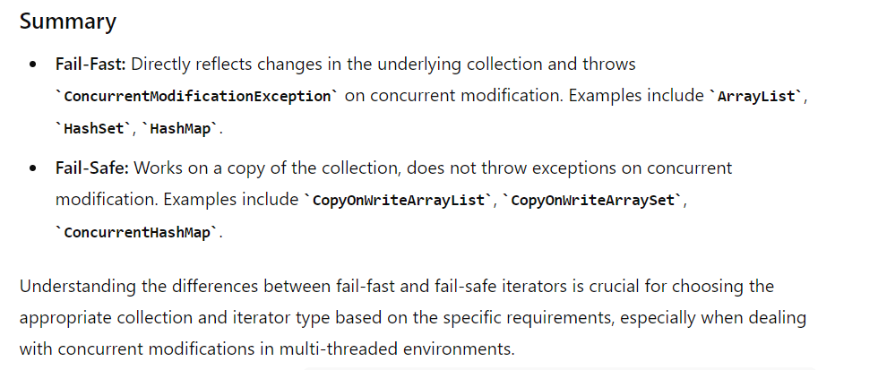

# Exceptions

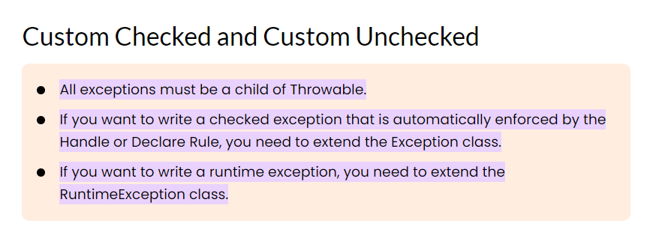

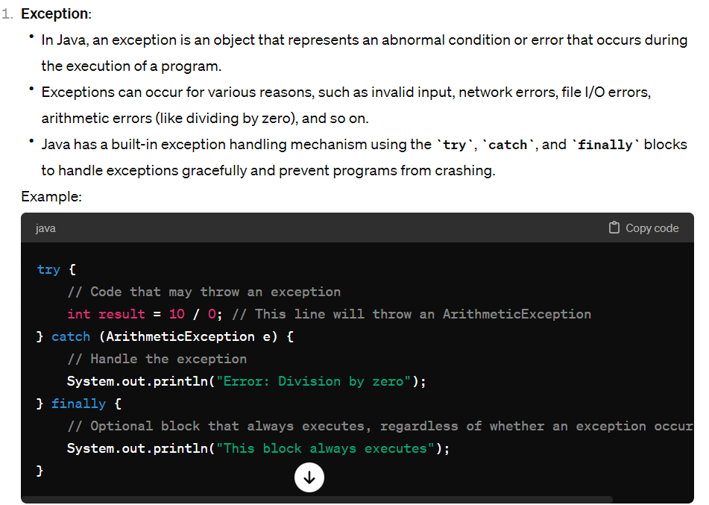

## ERROR

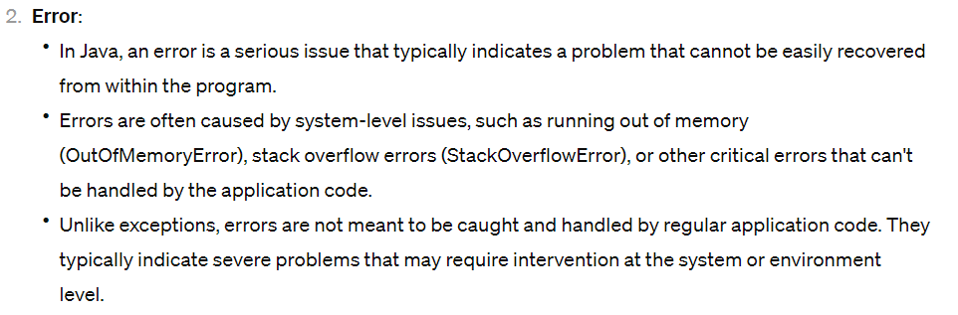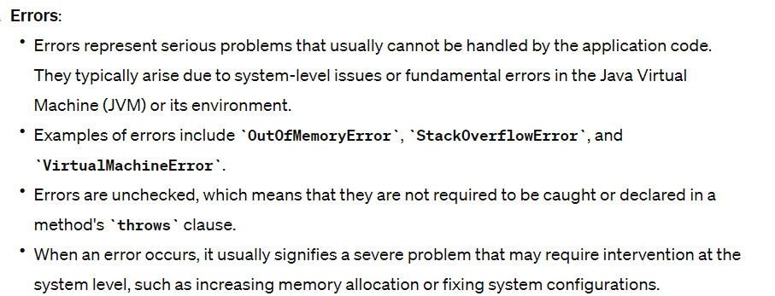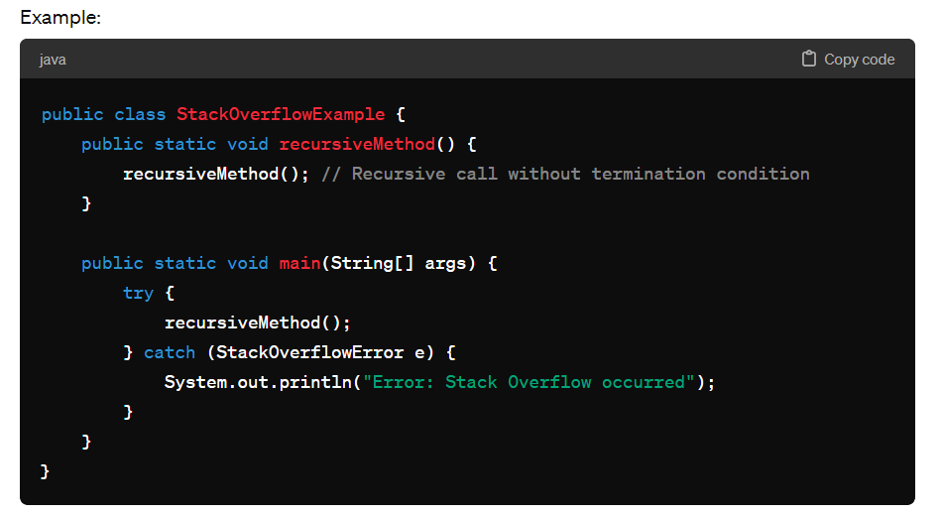

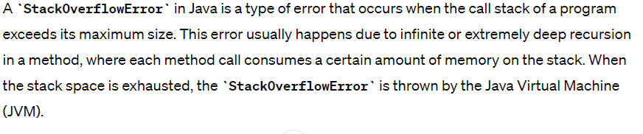

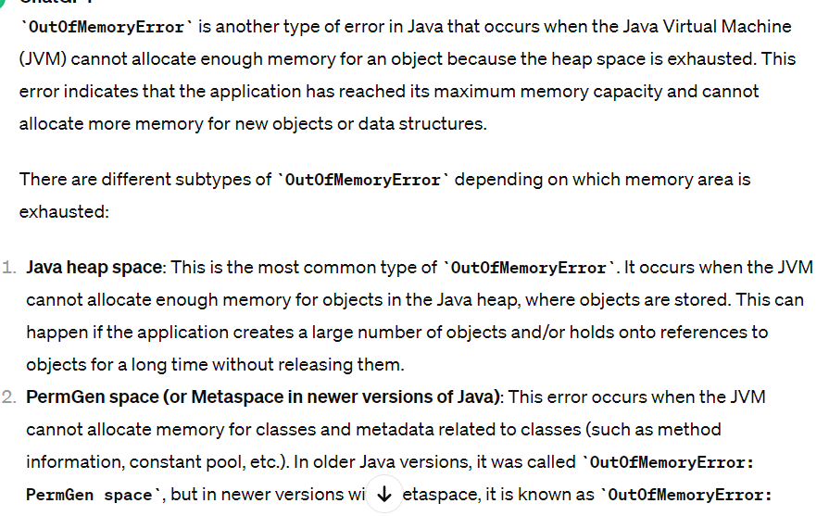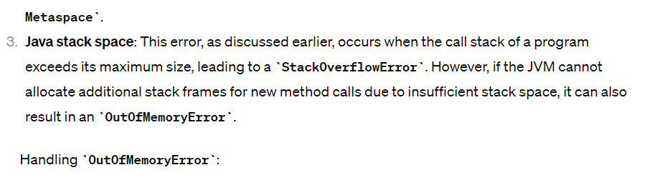

## Try-With-Resources

This statement was first introduced in Java 7 to avoid the redundant code that we had to write for exception handling. The advantages of this statement are:

1. Try with resources closes all the resources (file, database connection, network connection etc.) automatically. No need to close them explicitly. This prevents memory leaks.

2. With the help of try with resource we can reduce the unnecessary lines of code and makes the code more readable.

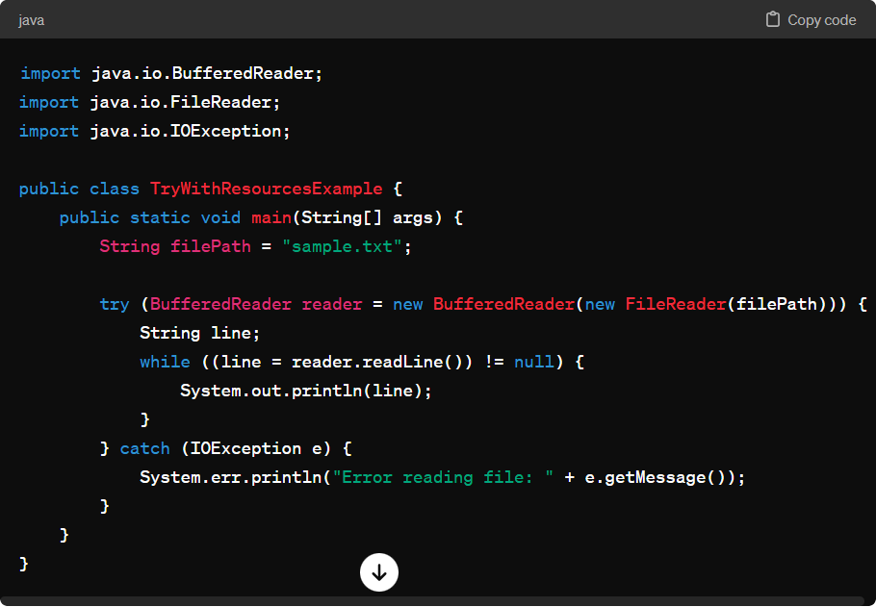

In this example, the BufferedReader is automatically closed after the try block, regardless of whether an exception occurs or not. This ensures proper resource cleanup and prevents resource leaks in Java applications.

# Java 8 Features

## Lambda Expressions

Lambda expression is a new feature which is introduced in Java 8. A lambda expression is an anonymous function. A function that doesn’t have a name and doesn’t belong to any class. The concept of lambda expression was first introduced in LISP programming language.

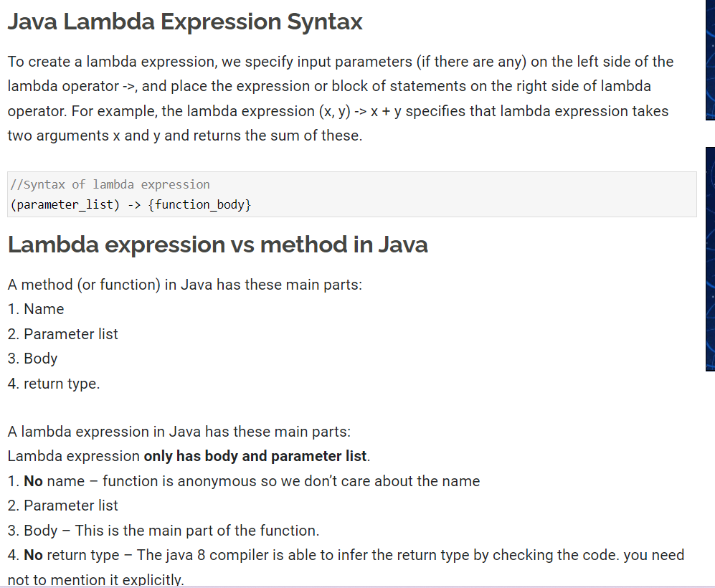

Where to use the Lambdas in Java

To use lambda expression, you need to either create your own functional interface or use the pre defined

## Functional interface

provided by Java. An interface with only single abstract method is called functional interface(or Single Abstract method interface), for example: Runnable, callable, ActionListener etc.

To use lambda expression in Java, you need to either create your own functional interface or use the pre defined functional interface provided by Java. While creating your own functional interface, mark it with @FunctionalInterface annotation, this annotation is introduced in Java 8. Although its optional, you should use it so that you get a compilation error if the interface you marked with this annotation is not following the rules of functional interfaces.

What are the rules of defining a functional interface?

The functional interface should have **Only one** abstract method. Along with the one abstract method, they can have any number of default and static methods.

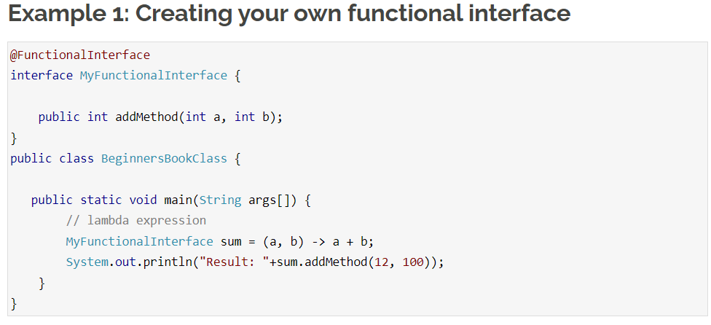

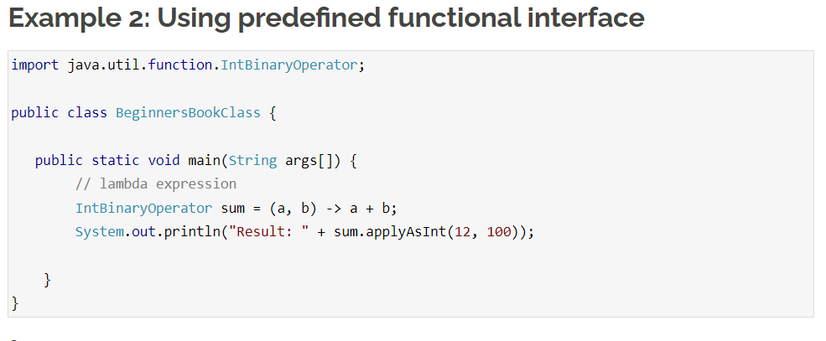

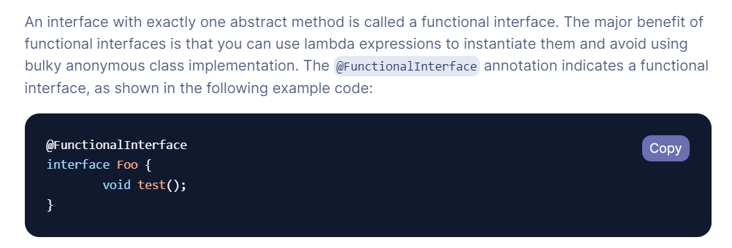

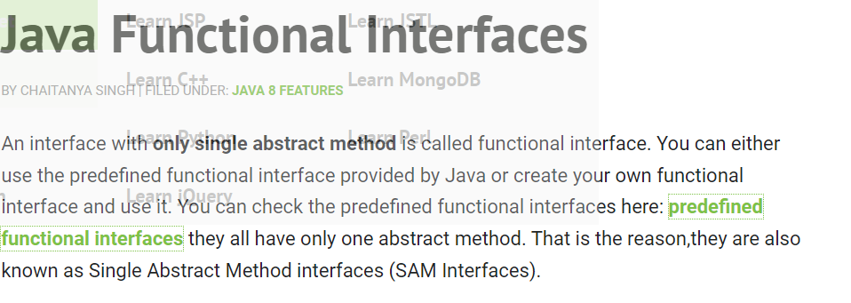

**functional interface can have default and static methods?**

Yes, a functional interface in Java can have default and static methods starting from Java 8. Before Java 8, functional interfaces were limited to containing only one abstract method, making them suitable for use with lambda expressions and method references.

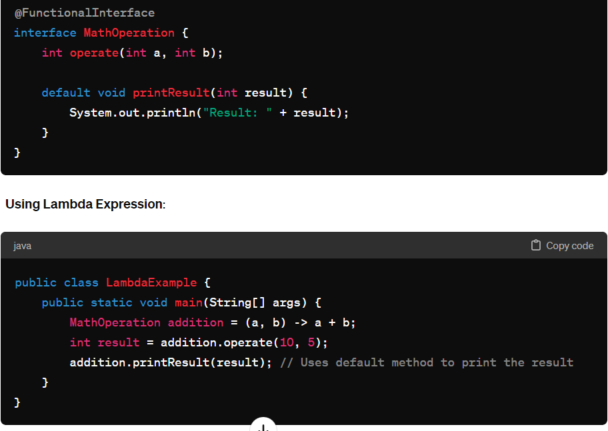

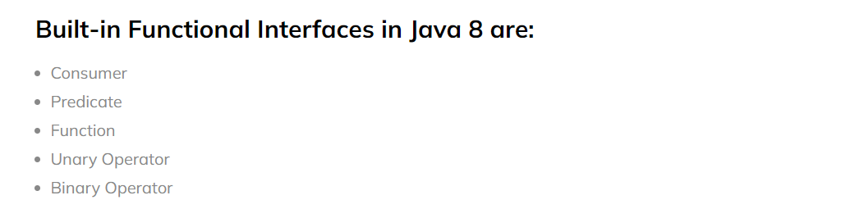

<https://blog.knoldus.com/functional-interfaces-in-java-8/>

### Consumer vs supplier

In Java, `Consumer` and `Supplier` are functional interfaces from the `java.util.function` package that are used to represent operations that consume or supply data, respectively. These interfaces are part of Java's functional programming support introduced in Java 8, which allows developers to treat functions as first-class citizens.

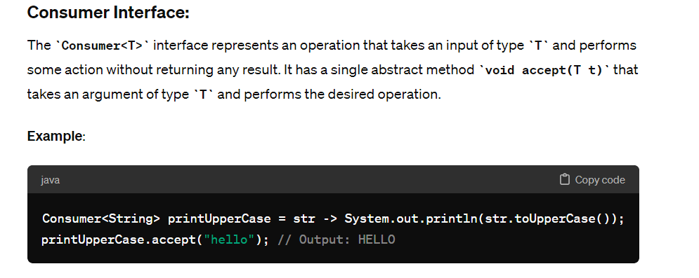

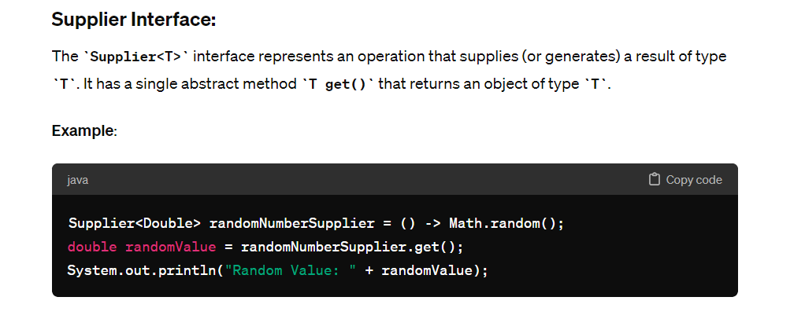

### Differences:

1. **Purpose**:

- `Consumer<T>`: Used when you need to consume/process an input (of type `T`) without returning anything.

- `Supplier<T>`: Used when you need to generate/provide a result (of type `T`).

2. **Abstract Method**:

- `Consumer<T>`: `void accept(T t)` method to consume/process the input.

- `Supplier<T>`: `T get()` method to supply/generate the result.

3. **Usage**:

- `Consumer<T>` is often used in scenarios such as forEach operations on collections, logging, or performing actions on input data.

- `Supplier<T>` is commonly used for lazy initialization, generating default values, or providing values for functional transformations.

4. **Examples**:

- `Consumer<String> printUpperCase = str -> System.out.println(str.toUpperCase());`

- `Supplier<Double> randomNumberSupplier = () -> Math.random();`

5. **Functional Composition**:

- Both `Consumer` and `Supplier` interfaces can be combined with other functional interfaces (like `Function`, `Predicate`, etc.) using functional composition methods such as `andThen` or `compose` to create more complex behaviors.

In summary, `Consumer` and `Supplier` are functional interfaces that represent different types of operations in functional programming paradigms, where `Consumer` consumes data and `Supplier` supplies data. They are widely used in Java streams, lambda expressions, and functional programming constructs to write concise and expressive code.

**Lazy loading**

Lazy loading is a concept where the computation or evaluation of a value is deferred until it is actually needed. In the context of the Java Stream API, lazy loading refers to the delayed execution of stream operations until a terminal operation is invoked. This lazy evaluation strategy helps in optimizing performance by avoiding unnecessary computations on intermediate stream elements.

When you work with streams in Java, intermediate operations (such as **filter**, **map**, **flatMap**, etc.) are lazily executed. This means they are only executed when a terminal operation (such as **forEach**, **collect**, **reduce**, etc.) is called on the stream. Lazy loading allows streams to perform optimizations such as fusion of operations and short-circuiting, which can lead to more efficient processing of data.

## Method References

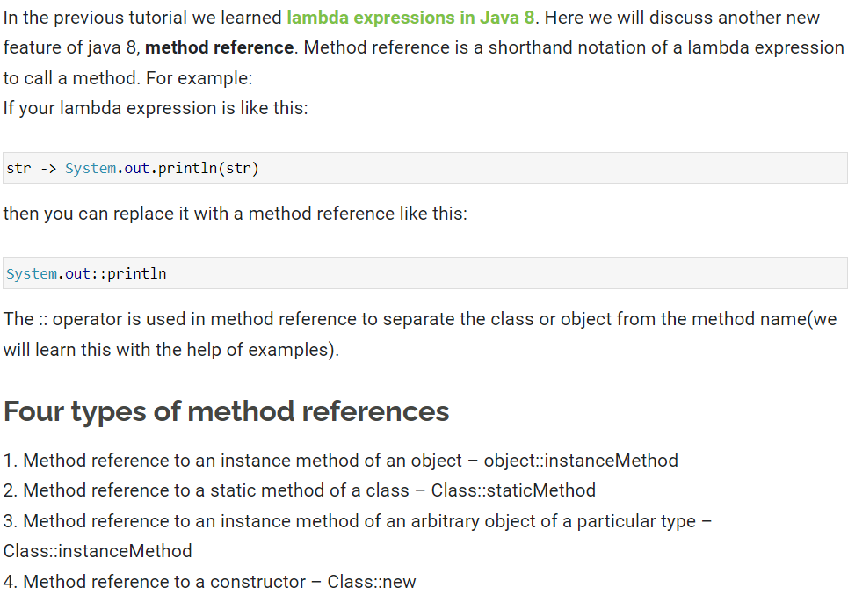

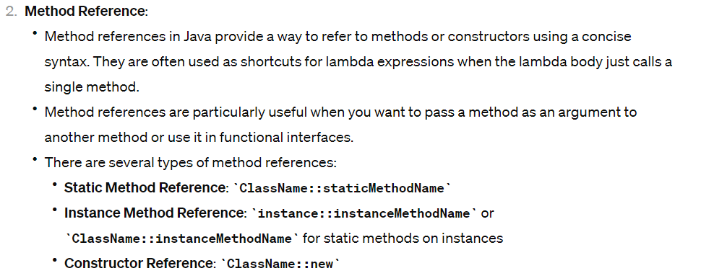

## StringJoiner

n java 8, a new class StringJoiner is introduced in the java.util package. Using this class we can join more than one strings with the specified delimiter, we can also provide prefix and suffix to the final string while joining multiple strings. In this tutorial we will see several examples of StringJoiner class and at the end of this guide, we will see the methods of StringJoiner class.

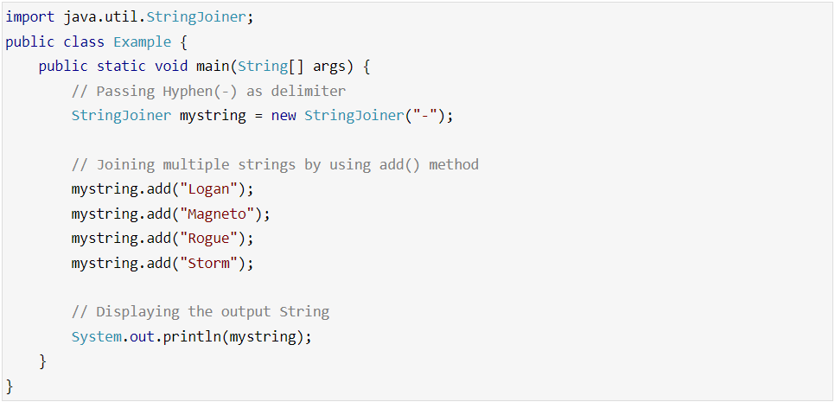

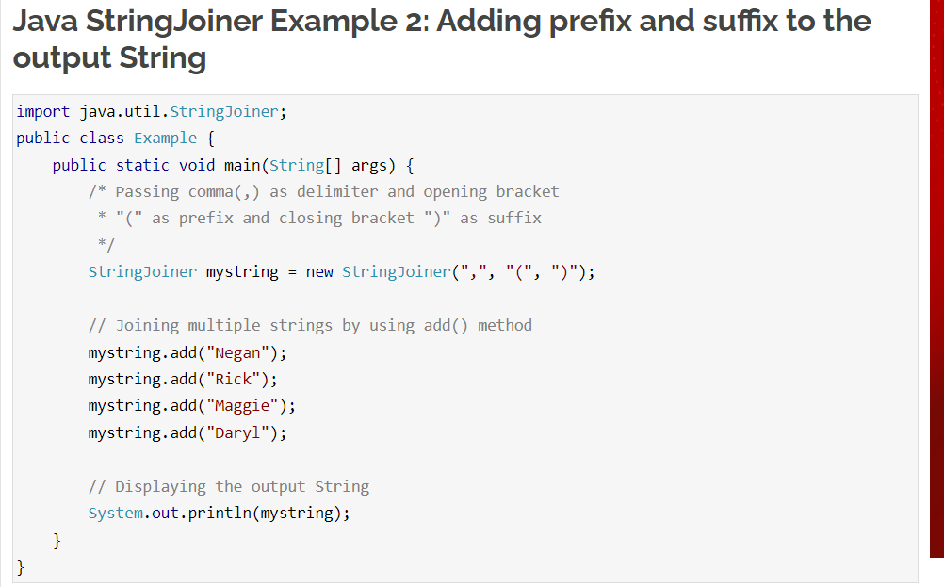

## Interface Changes – default method and static method

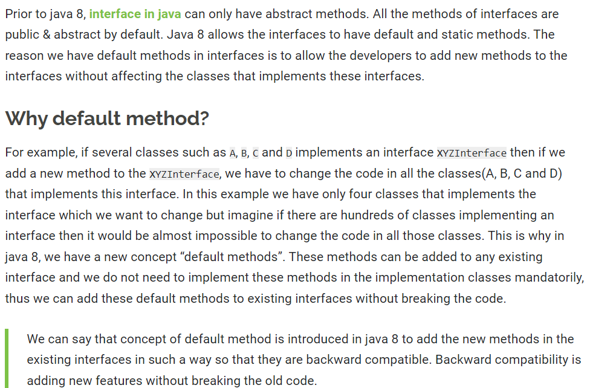

## ForEach() and filter()

In Java 8, we have a newly introduced forEach method to iterate over collections and Streams in Java. In this guide, we will learn how to use forEach() and forEachOrdered() methods to loop a particular collection and stream.

## Optional Class

In Java 8, we have a newly introduced Optional class in java.util package. This class is introduced to avoid NullPointerException that we frequently encounters if we do not perform null checks in our code. Using this class we can easily check whether a variable has null value or not and by doing this we can avoid the NullPointerException. In this guide, we will see how to work with Optional class and the usage of various methods of this class.

Before we see the example of Optional class, lets see what happens when we don’t use Optional class and do not perform null check.

1. **Creation of Optional Instances**:
   * **Optional.empty()**: Returns an empty **Optional** instance.
   * **Optional.of(value)**: Returns an **Optional** containing the specified non-null value. Throws **NullPointerException** if the provided value is null.
   * **Optional.ofNullable(value)**: Returns an **Optional** containing the specified value if non-null, otherwise returns an empty **Optional**.
2. **Checking the Presence of a Value**:
   * **boolean isPresent()**: Returns true if there is a value present, otherwise false.
   * **void ifPresent(Consumer<? super T> consumer)**: Executes the specified consumer with the value if it is present.
3. **Accessing the Value**:
   * **T get()**: Returns the value if present; otherwise, throws **NoSuchElementException**.
4. **Conditional Actions**:
   * **Optional<T> filter(Predicate<? super T> predicate)**: Returns an **Optional** containing the value if it matches the given predicate, otherwise returns an empty **Optional**.
   * **<U> Optional<U> map(Function<? super T, ? extends U> mapper)**: Applies the given function to the value if present and returns an **Optional** of the result, otherwise returns an empty **Optional**.
   * **<U> Optional<U> flatMap(Function<? super T, Optional<U>> mapper)**: Applies the given function which returns an **Optional** to the value if present and returns the result, otherwise returns an empty **Optional**.
5. **Getting Values or Defaults**:
   * **T orElse(T other)**: Returns the value if present, otherwise returns the specified default value.
   * **T orElseGet(Supplier<? extends T> supplier)**: Returns the value if present, otherwise returns the result of the specified supplier function.
   * **T orElseThrow(Supplier<? extends X> exceptionSupplier)**: Returns the value if present, otherwise throws an exception created by the provided supplier.
6. **Conversion**:
   * **Stream<T> stream()**: Returns a sequential **Stream** with the value if present, otherwise returns an empty **Stream**.
7. **Equality and Hashing**:
   * **boolean equals(Object obj)**: Indicates whether some other object is "equal to" this Optional.
   * **int hashCode()**: Returns the hash code value of the present value, if any, or 0 (zero) if no value is present.
8. **Utility Methods**:
   * **void ifPresentOrElse(Consumer<? super T> action, Runnable emptyAction)**: Executes the specified action if a value is present, otherwise executes the specified empty action.

## Arrays Parallel Sort

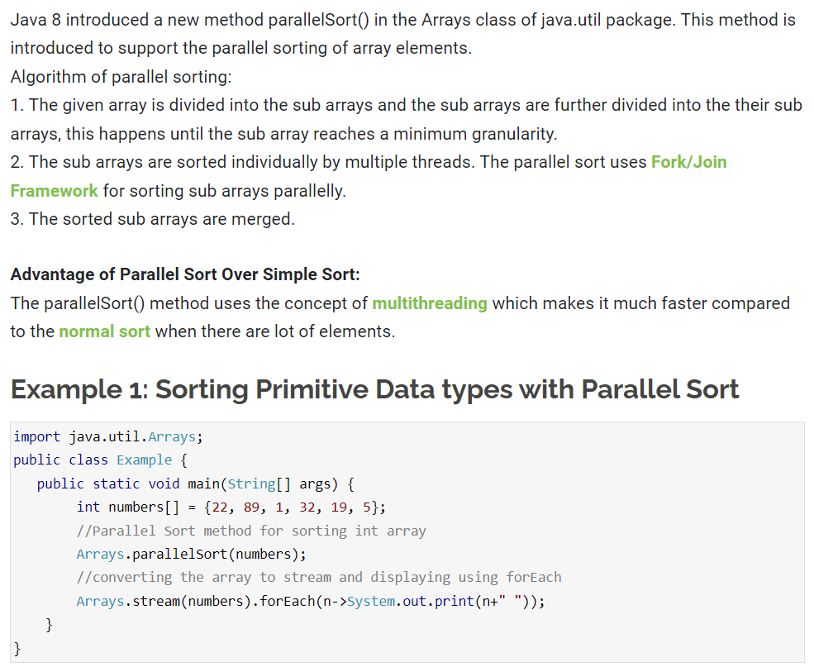

## Date Time API

Under the package java.time, Java 8 offers a new date-time API. The following are the most prominent classes among them:

Local: Simplified date-time API with no timezone management complexity.

Zoned: specialized date-time API that can handle several time zones.

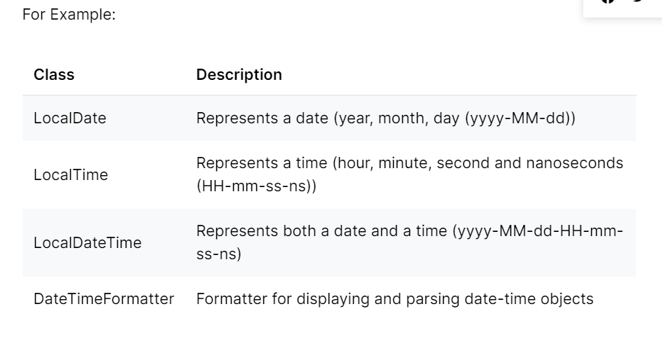

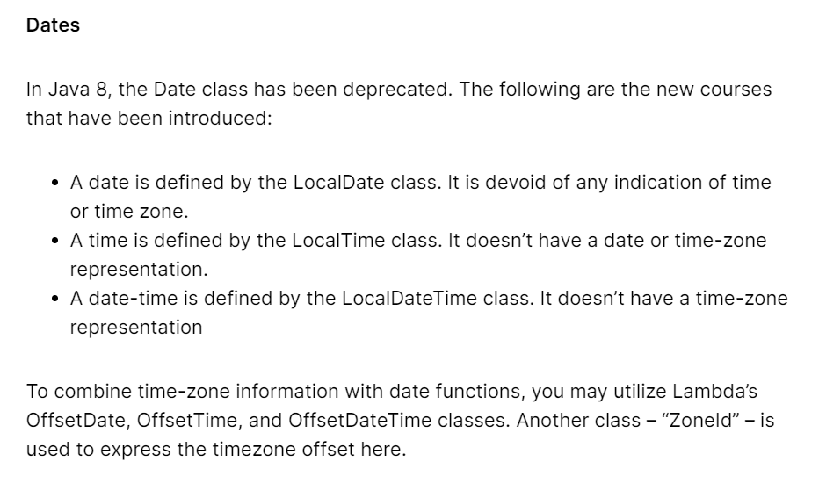

## Stream API

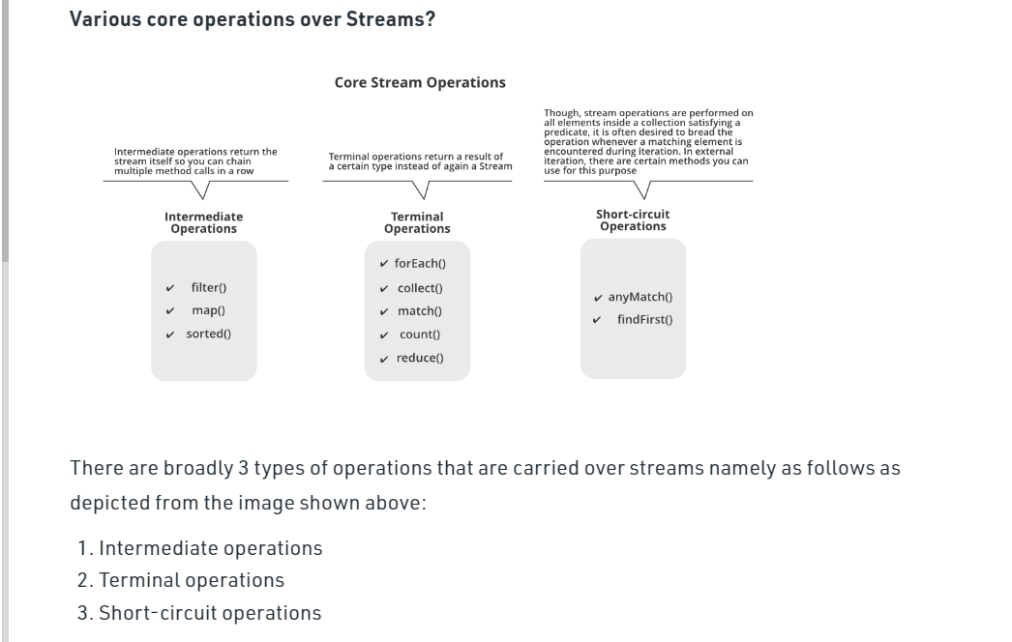

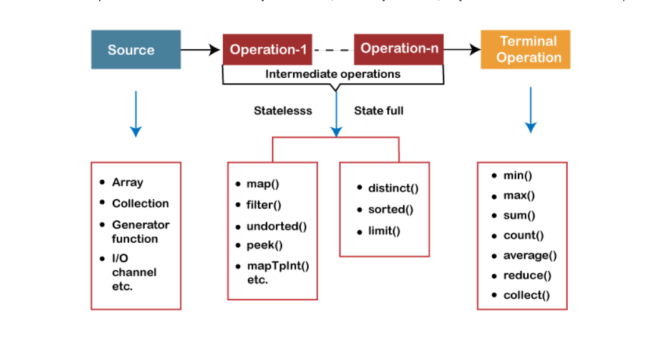

**explain reduce operation in stream api**

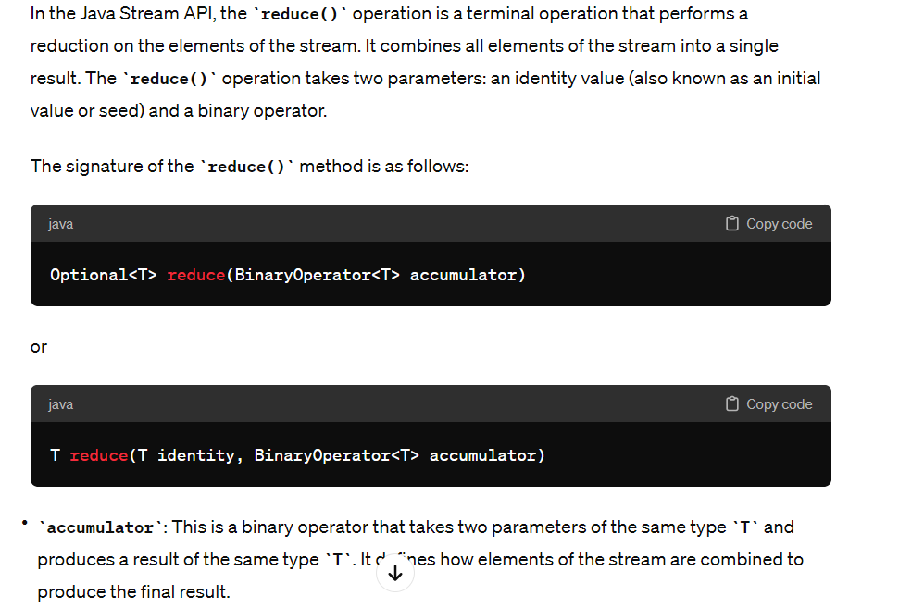

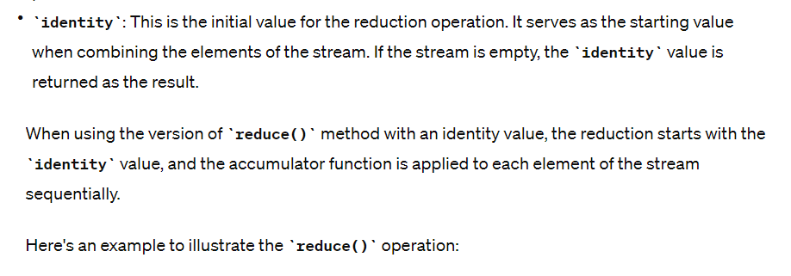

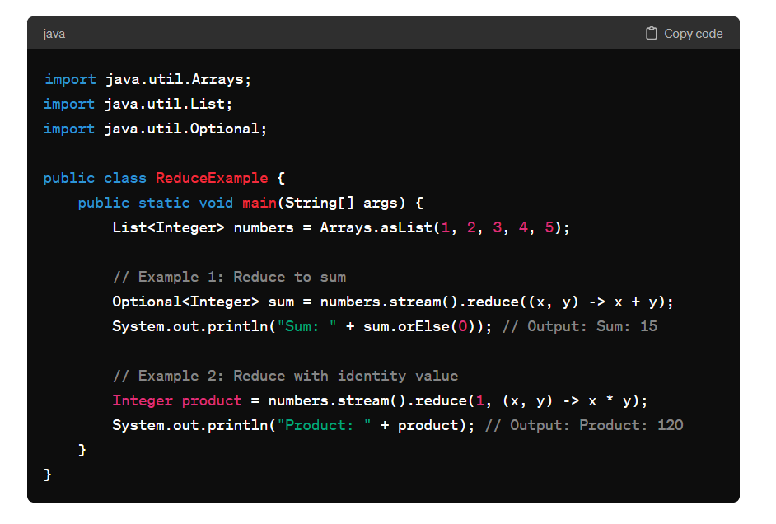

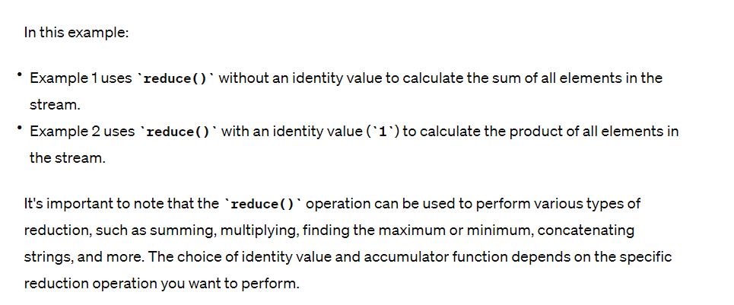

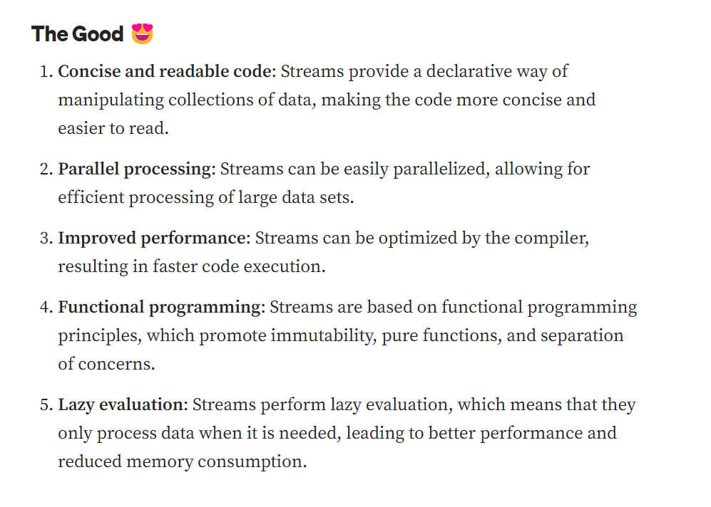

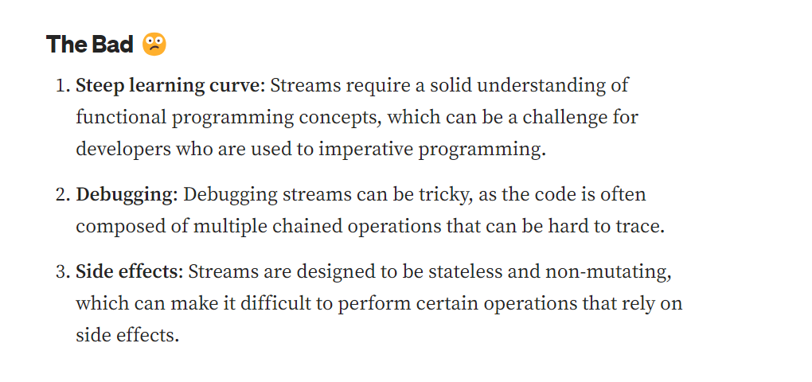

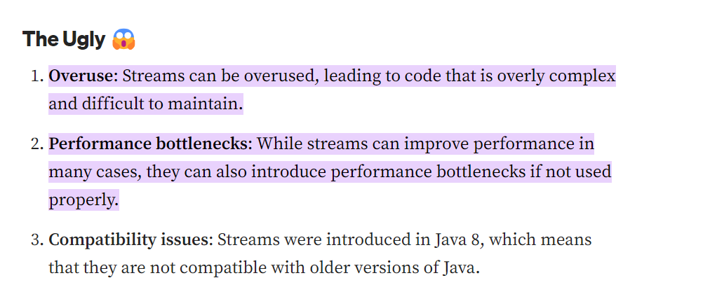

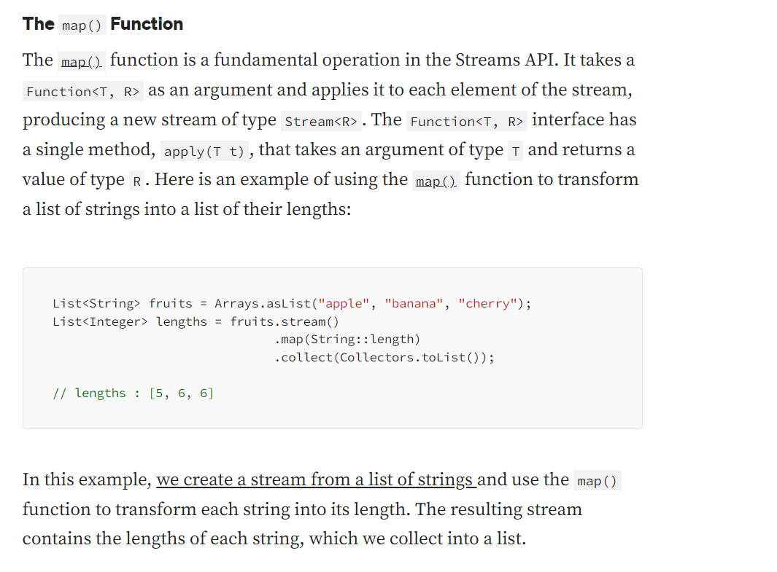

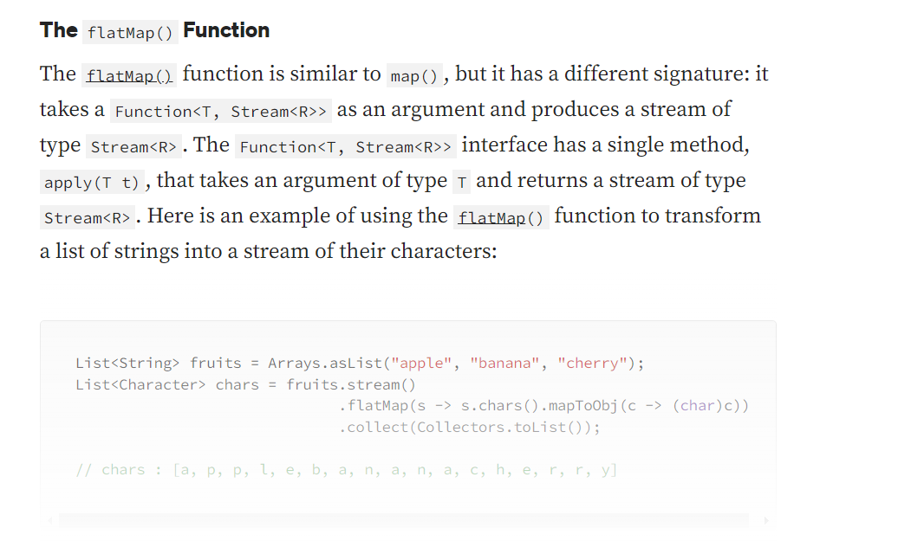

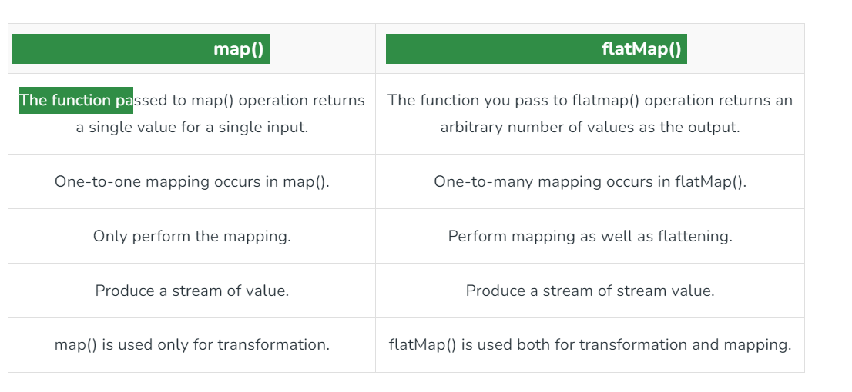

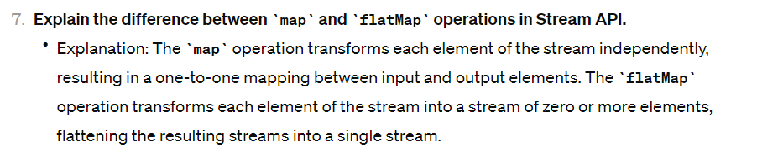

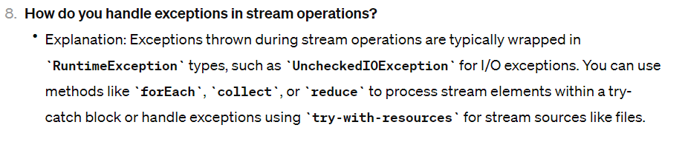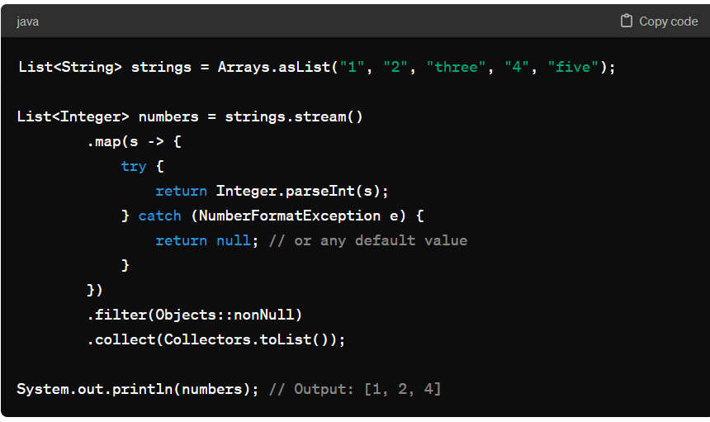

**peek()**

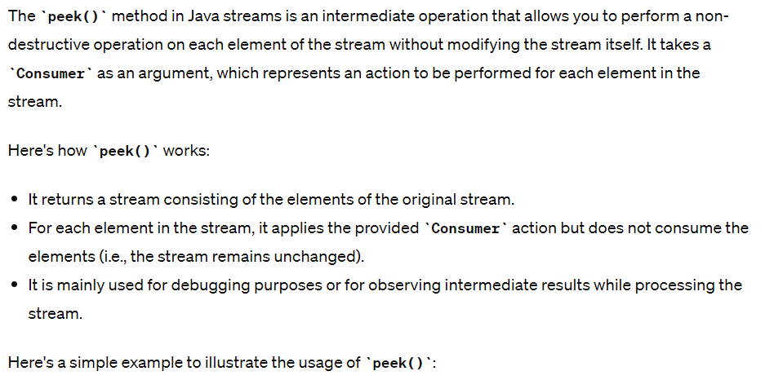

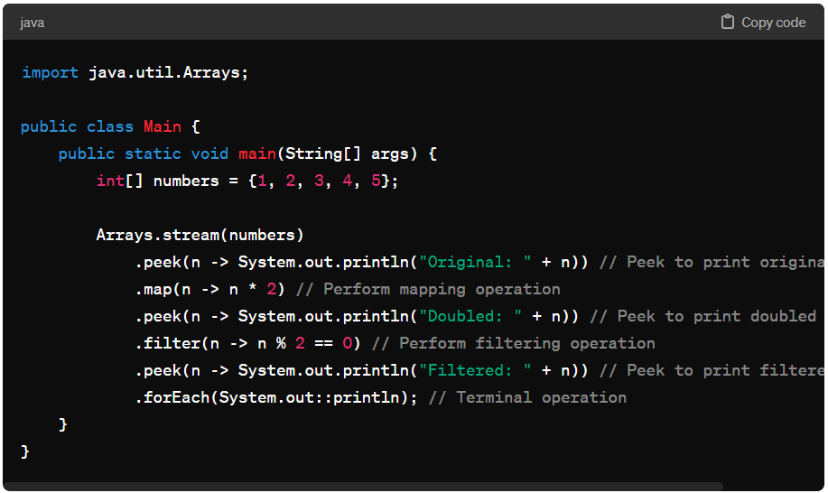

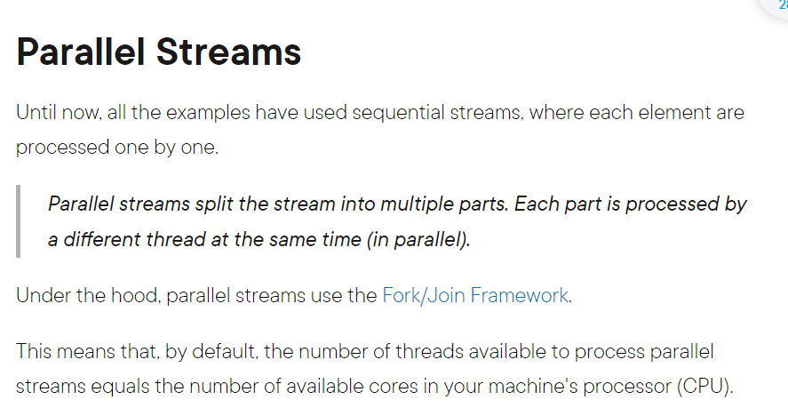

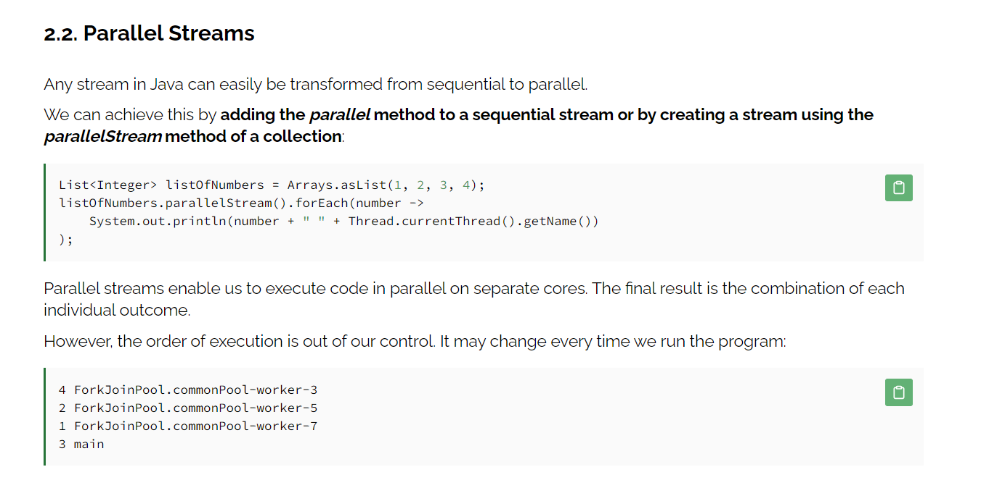

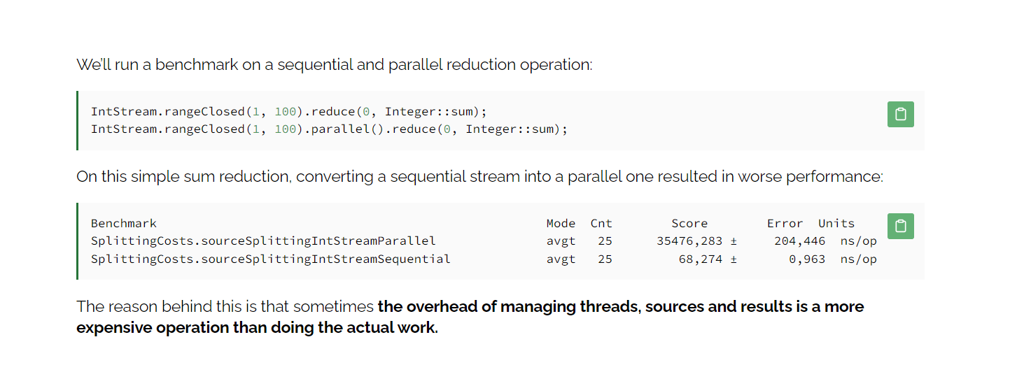

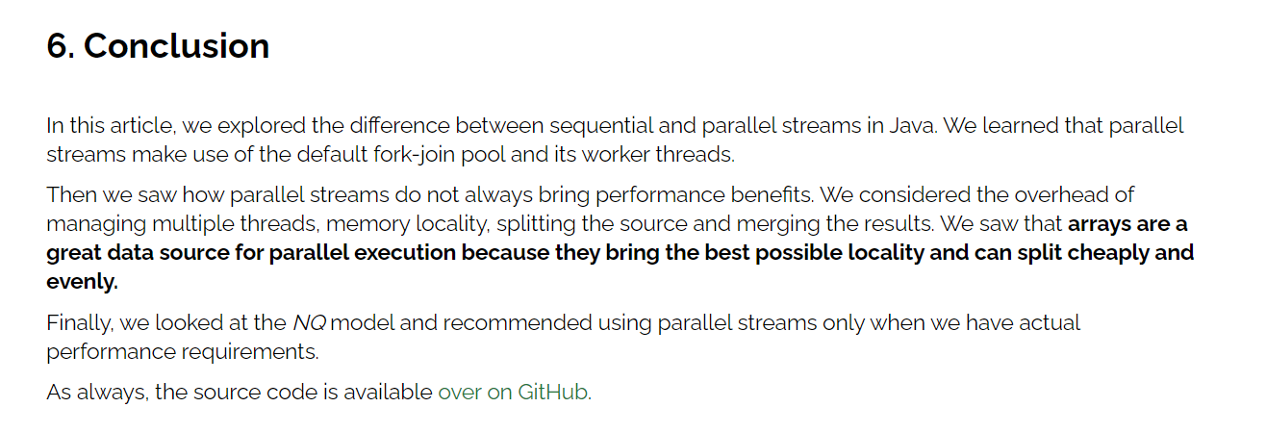

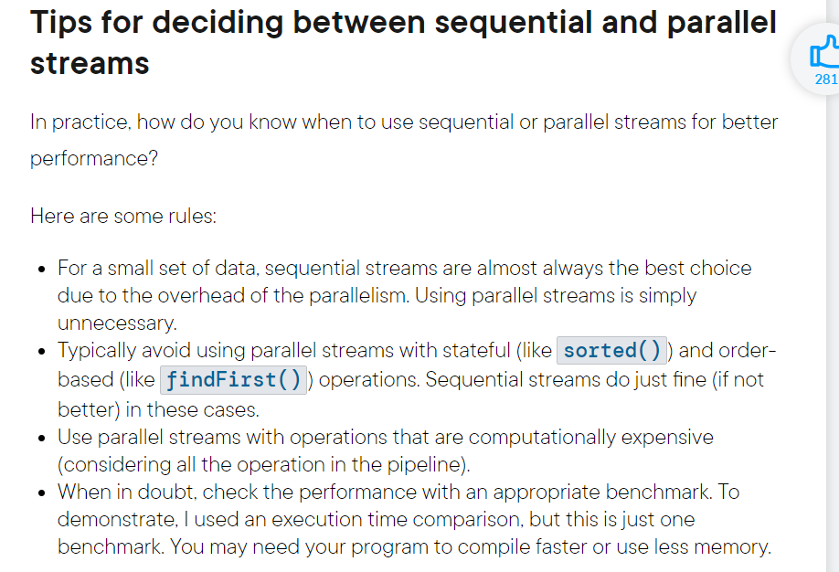

## Predicate

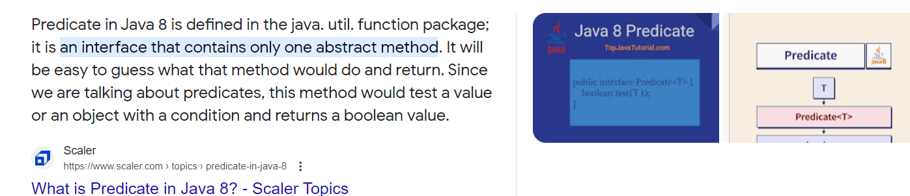

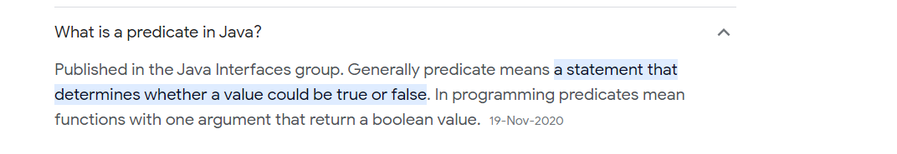

## Nashorn JavaScript

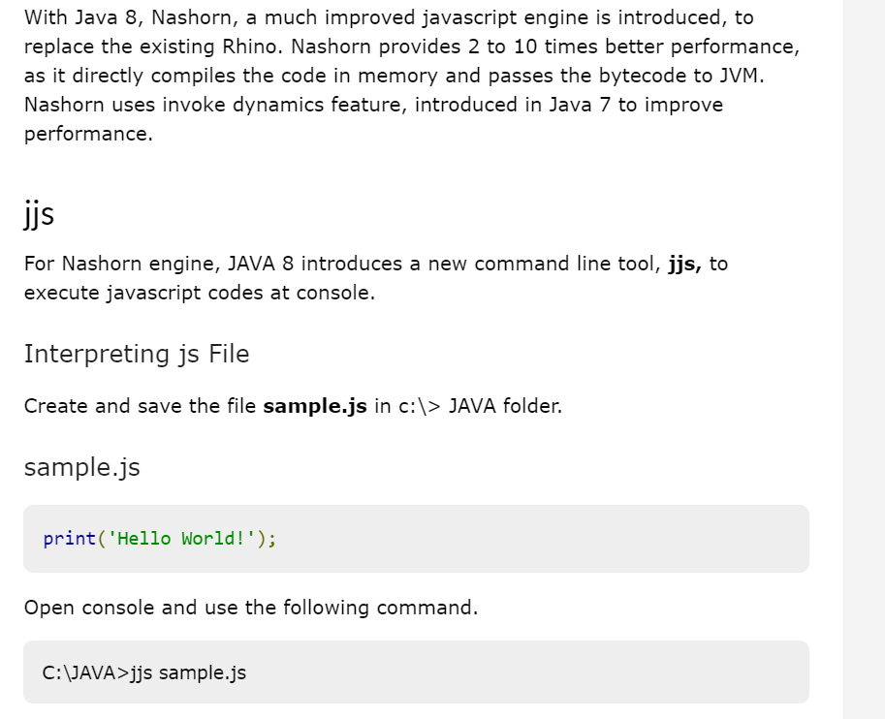

[**https://www.tutorialspoint.com/java8/java8_nashorn_java_script.htm**](https://www.tutorialspoint.com/java8/java8_nashorn_java_script.htm)

## Spliterator

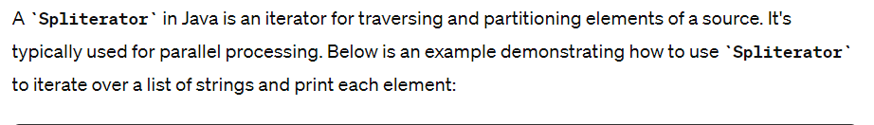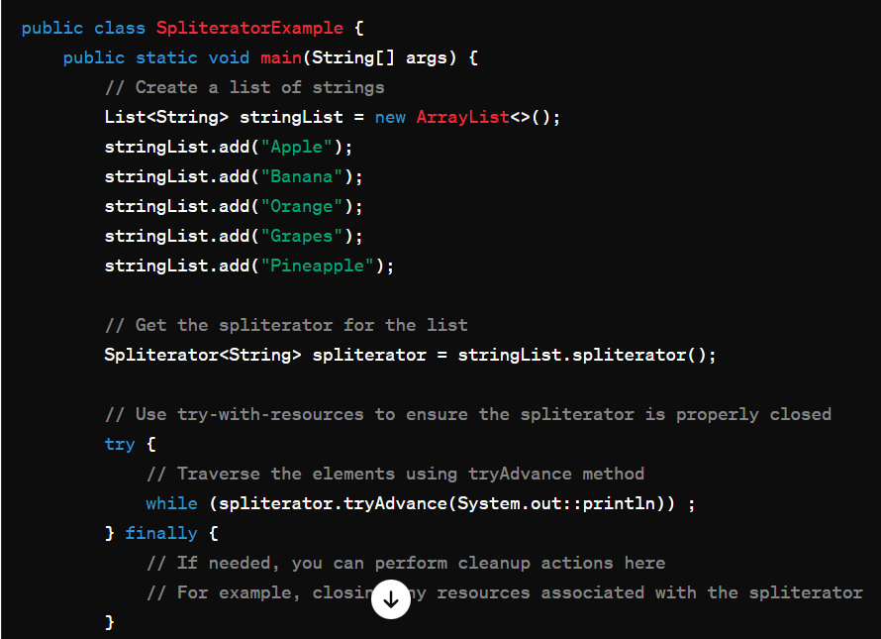

# Collections

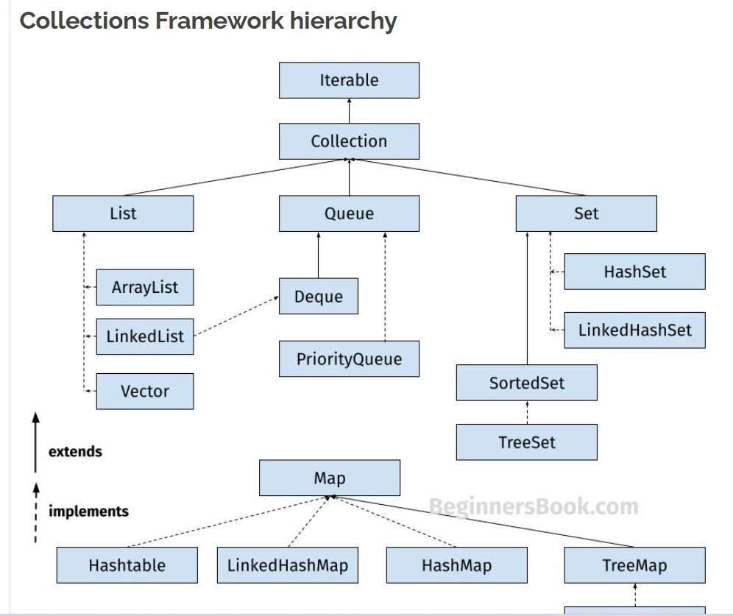

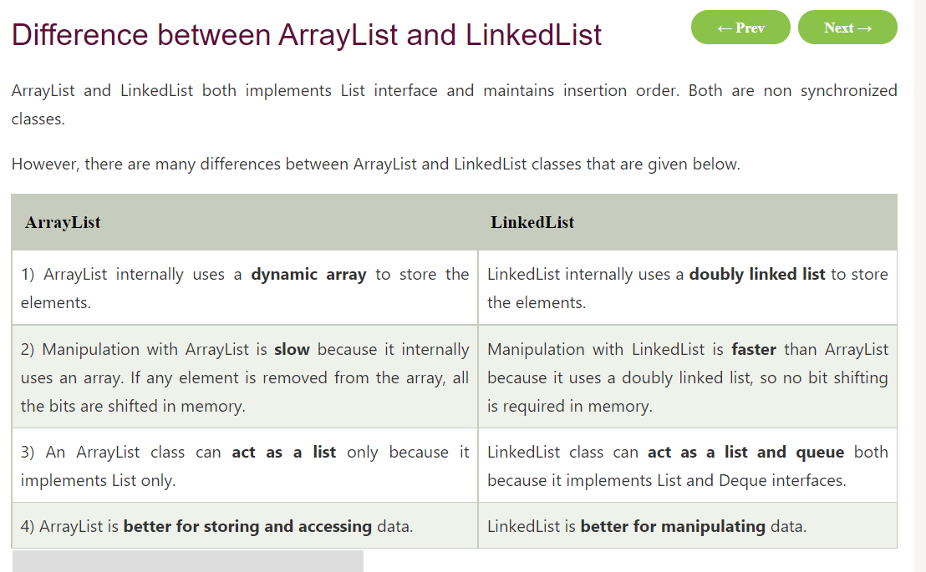

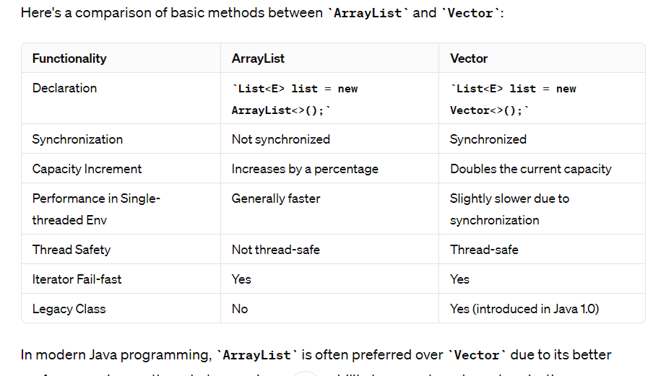

**How to make ArrayList as synchronized :**

**ArrayList**: Preferred when you need a resizable array-like structure with better performance in a single-threaded environment or when you can manage synchronization externally using other means (e.g., using **Collections.synchronizedList()** for synchronization).

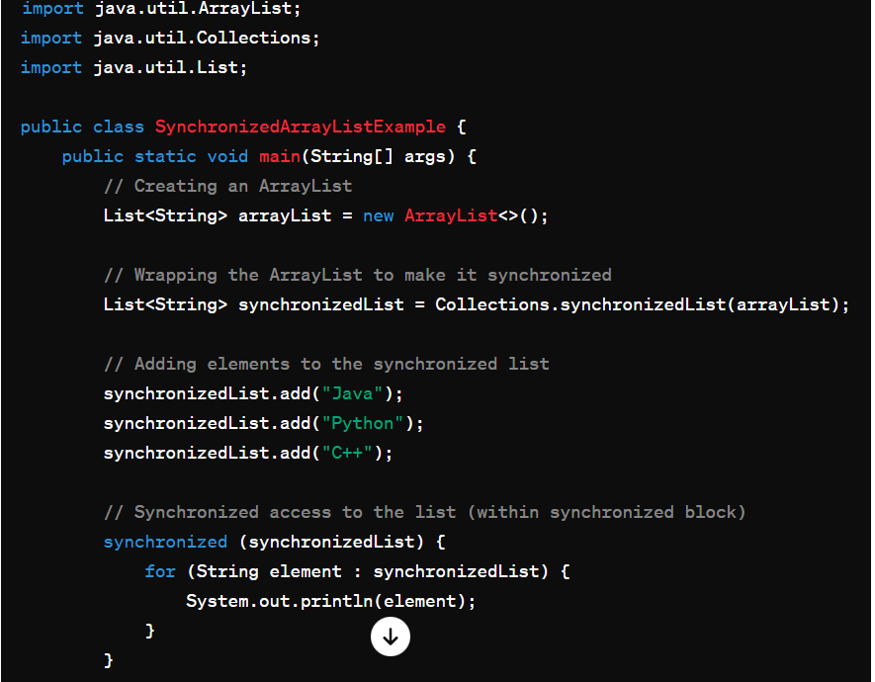

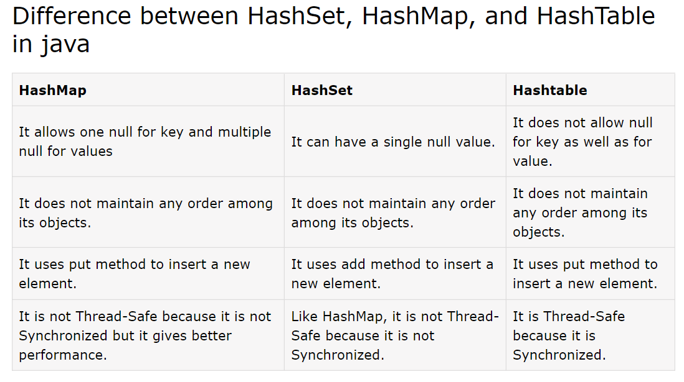

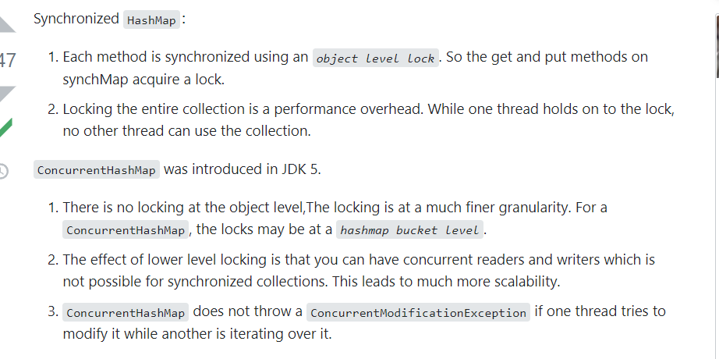

`**IdentityHashMap`** is a class in Java that implements the `Map` interface and provides a hash table-based implementation of the `Map` interface with a special focus on identity-based comparison for keys, unlike `HashMap` which uses `equals()` method for comparison. In an `IdentityHashMap`, two keys `k1` and `k2` are considered equal if and only if `(k1 == k2)` (reference equality) holds true. In contrast, in a regular `HashMap`, two keys `k1` and `k2` are considered equal if and only if `(k1 == null ? k2 == null : k1.equals(k2))` returns true.

Here are some key points about `IdentityHashMap`:

1. **Identity-Based Comparison**: `IdentityHashMap` uses reference equality (`==`) to compare keys, rather than using the `equals()` method. This means that two keys are considered equal in an `IdentityHashMap` if they refer to the same memory location.

2. **No Overriding of `equals()` and `hashCode()` Required**: Since `IdentityHashMap` relies on object identity rather than `equals()` and `hashCode()` methods, it does not require keys (or values) to override these methods for proper functioning.

3. **Performance**: `IdentityHashMap` may have better performance than a regular `HashMap` in certain cases, especially when keys are compared based on reference equality and not on their `equals()` method.

4. **Null Keys**: Unlike `HashMap`, `IdentityHashMap` allows null keys because it uses reference equality for key comparison.

5. **Not Suitable for Most Use Cases**: Because it relies on reference equality, `IdentityHashMap` is not suitable for general-purpose use cases where keys need to be compared based on their content rather than their memory location.

Here's a simple example demonstrating the usage of `IdentityHashMap`:

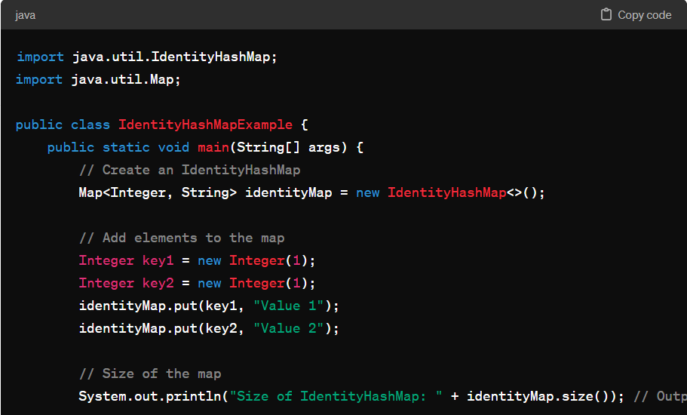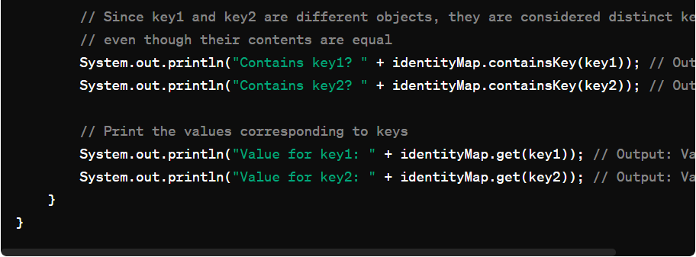

In this example, even though `key1` and `key2` have the same value (1), they are considered distinct keys in the `IdentityHashMap` because they are different object instances. This behavior is different from a regular `HashMap`, where `key1` and `key2` would be considered equal based on their content.

## Internal Implementation of HashMap

<https://www.javatpoint.com/working-of-hashmap-in-java>

User

hashmap improvements form java 7 to java 8

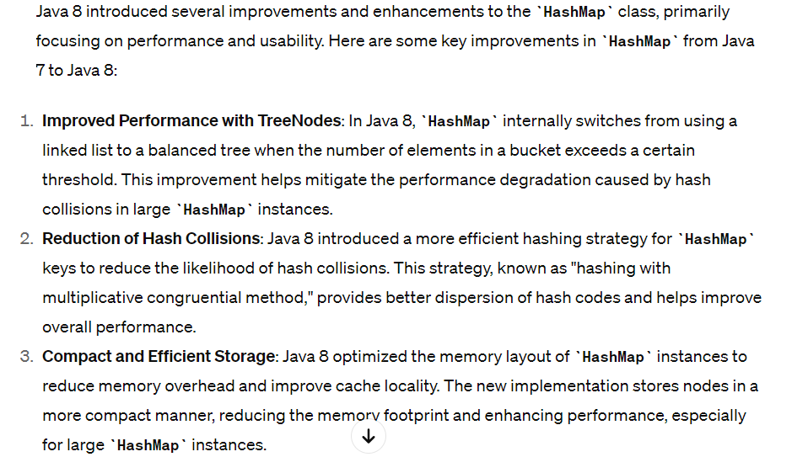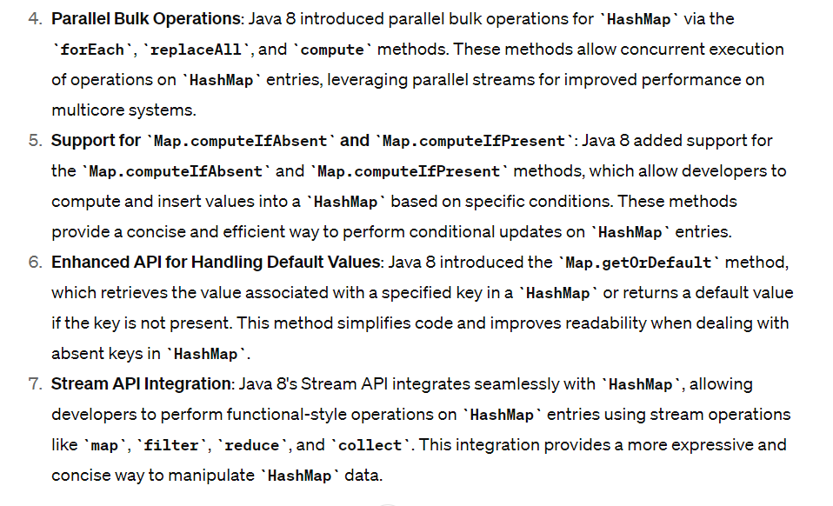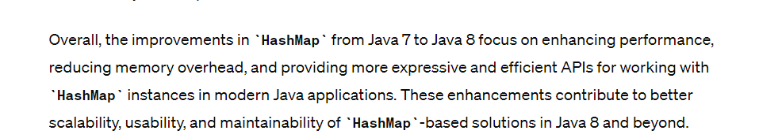

# Threads

**why wait(), notify(), notifyAll() is part of Object class?**

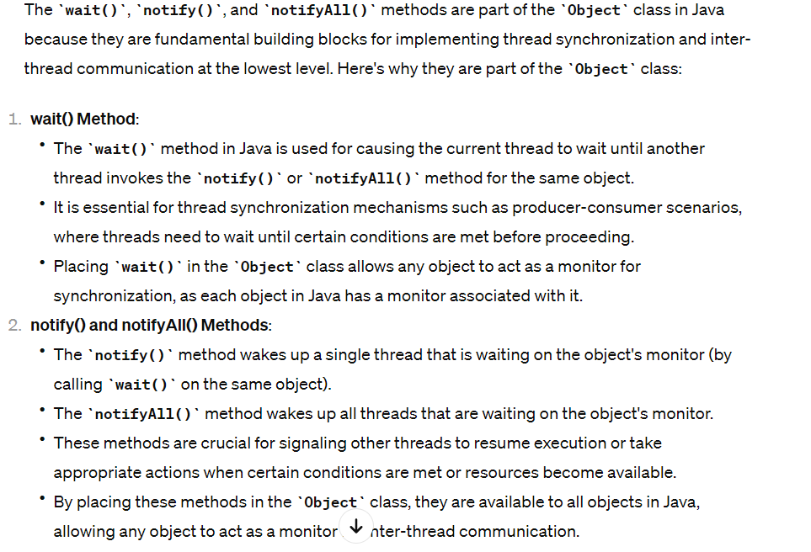

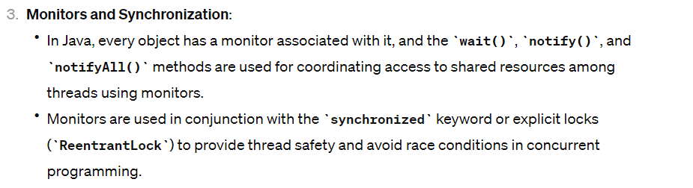

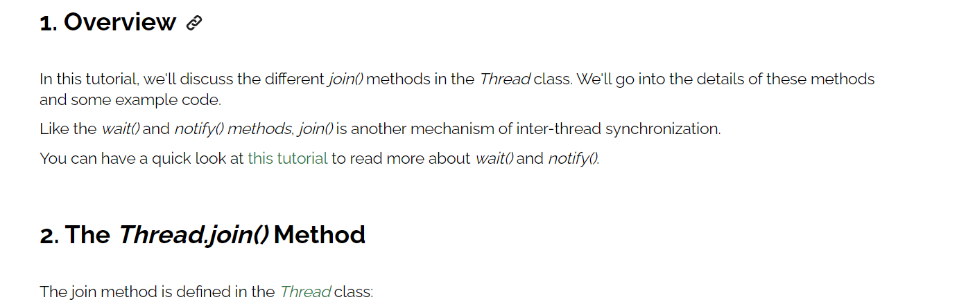

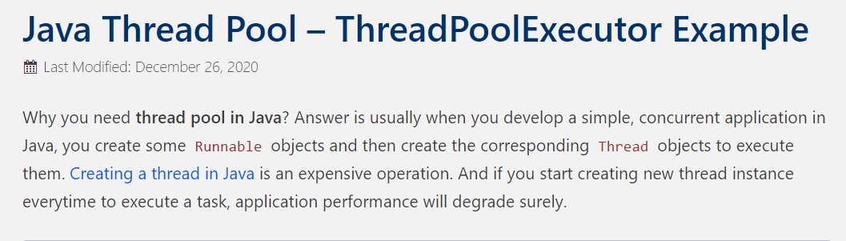

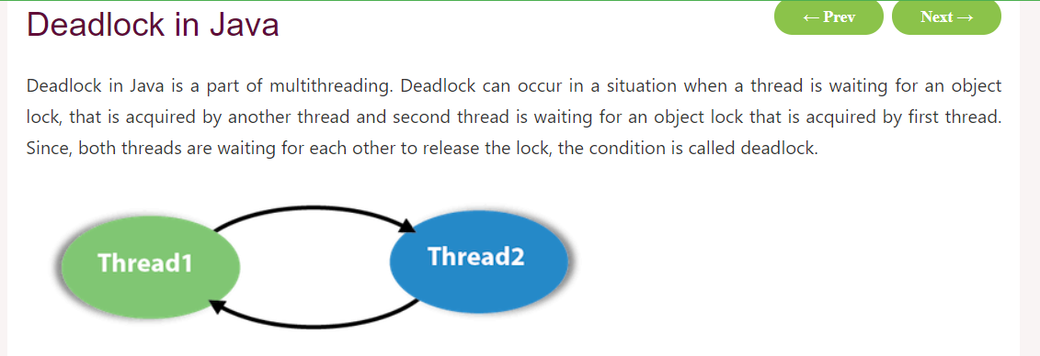

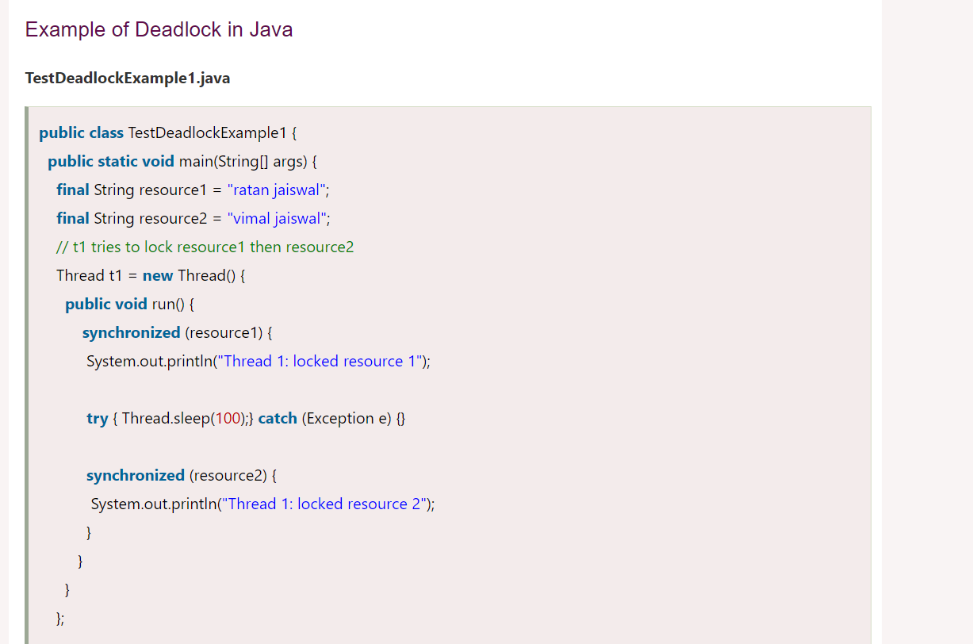

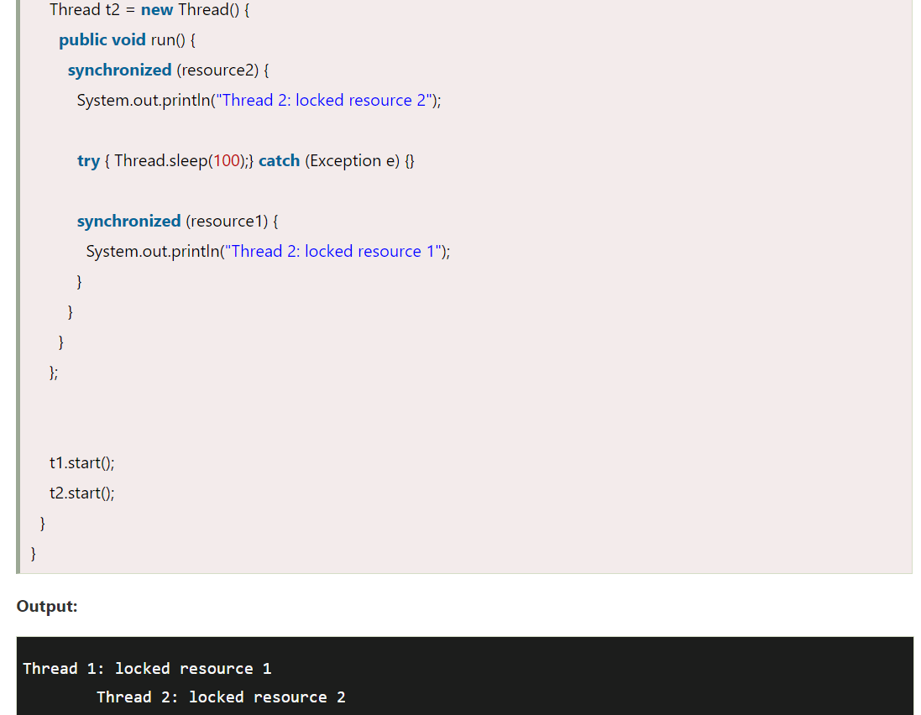

How to get current ongoing thread

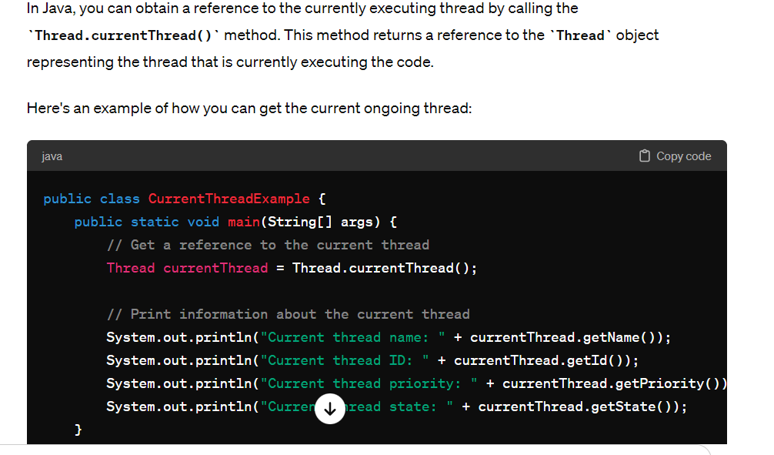

LifeCycle of threads

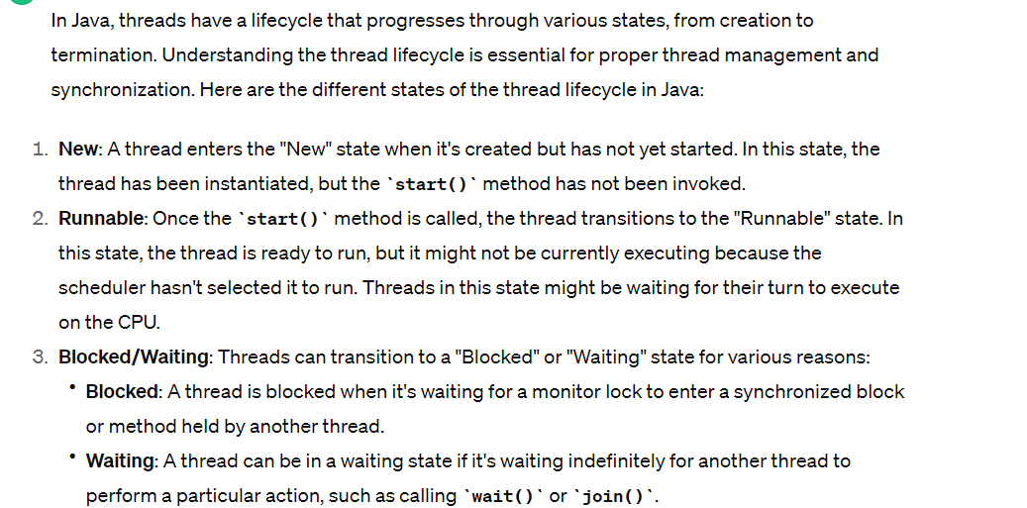

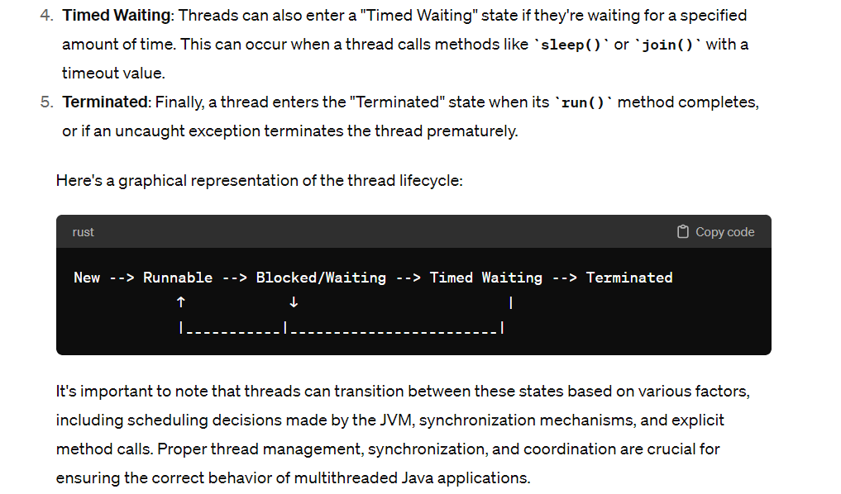

Context Switching :

Context switching is the process of switching the CPU from one process, task or thread to another. In a multitasking operating system, such as Linux, the CPU has to switch between multiple processes or threads in order to keep the system running smoothly.

<https://beginnersbook.com/2013/03/multithreading-in-java/>

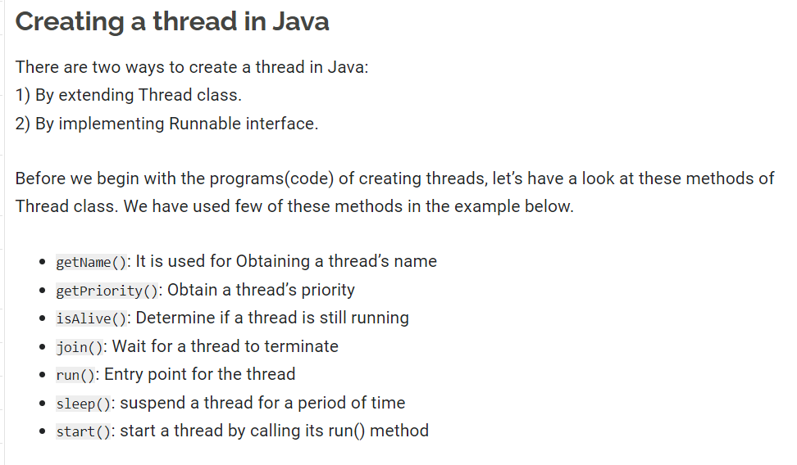

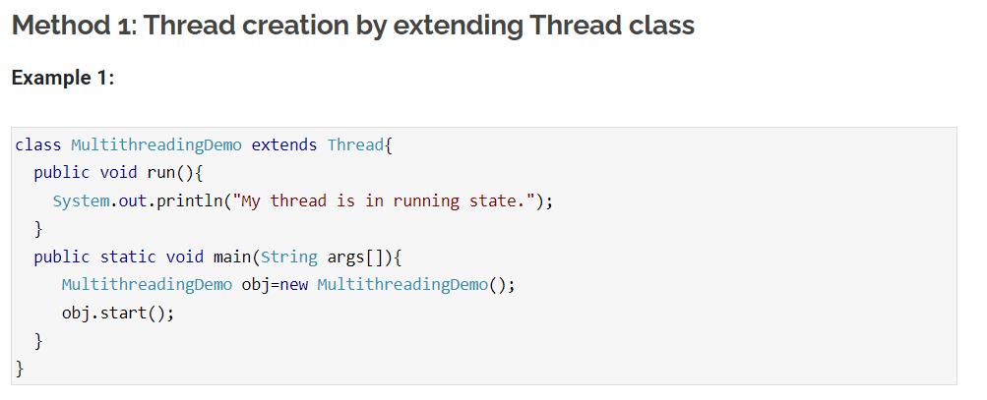

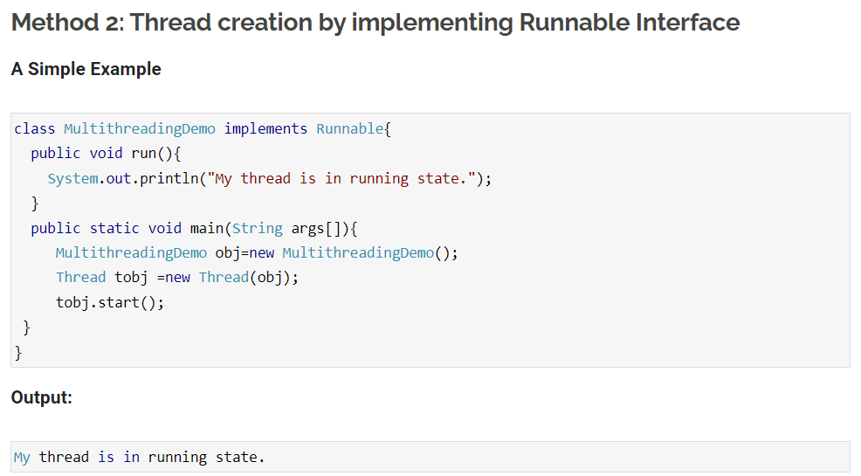

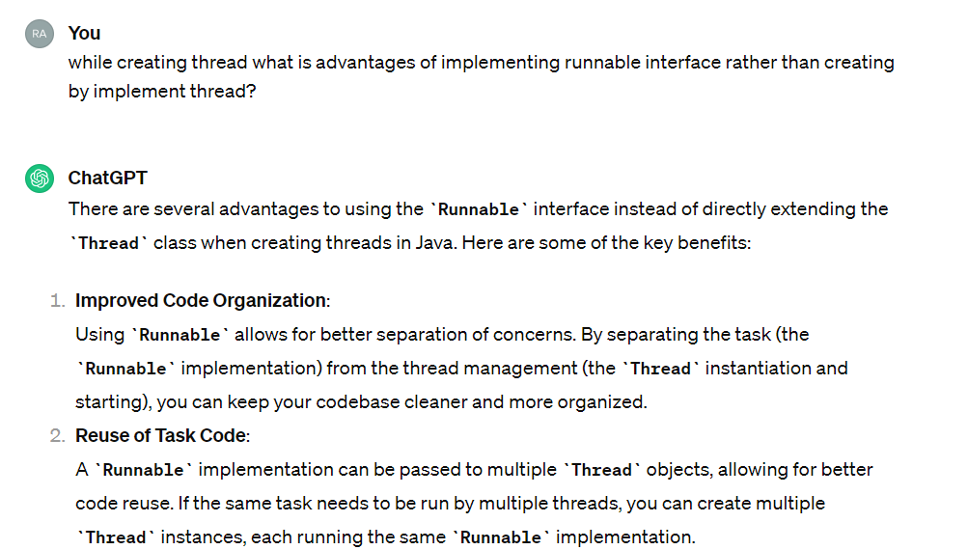

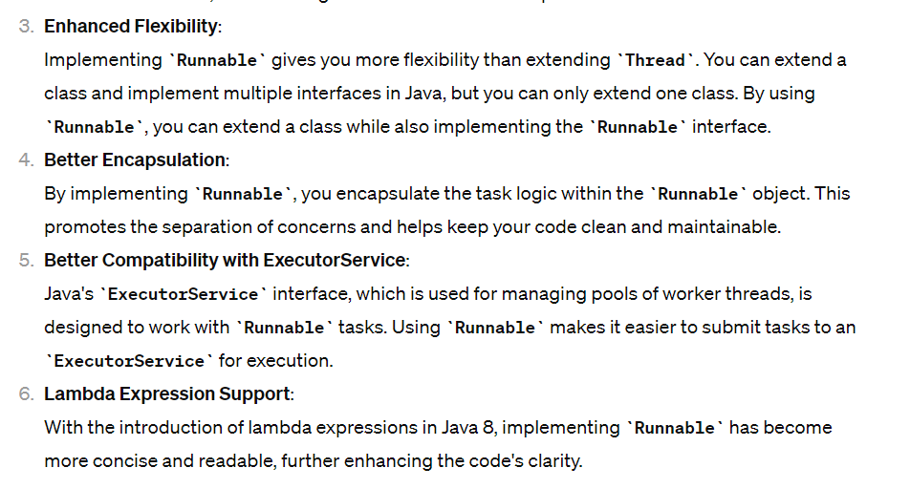

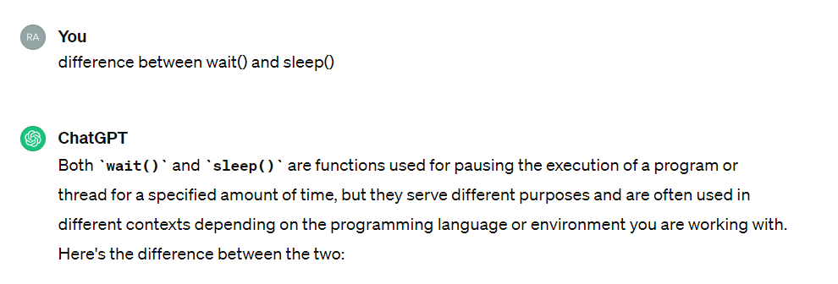

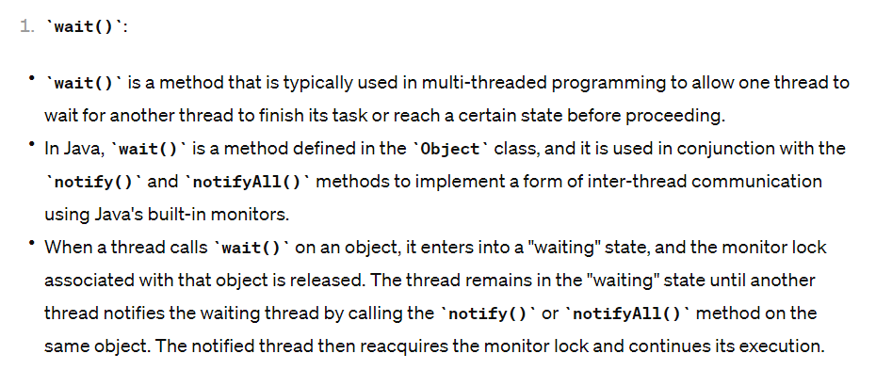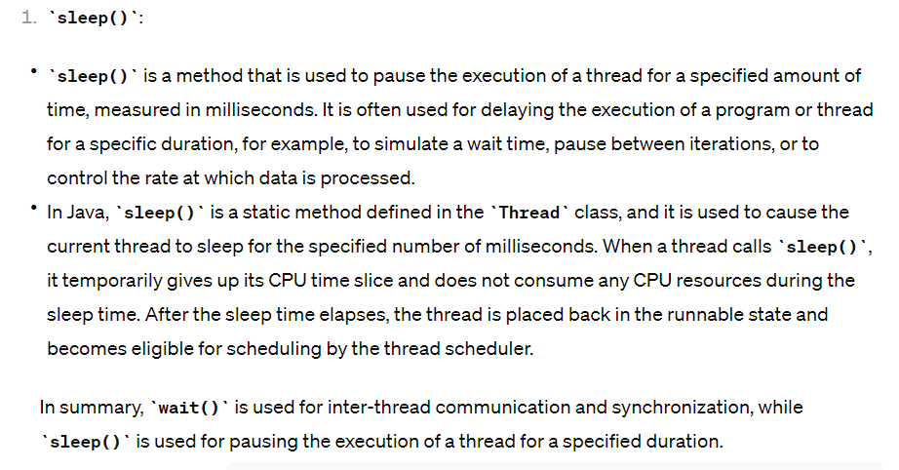

## Daemon Thread

In Java, a daemon thread is a type of thread that runs in the background and does not prevent the JVM from exiting when all non-daemon threads have finished their execution. Daemon threads are typically used for tasks such as garbage collection and other maintenance tasks.

Here's an example of how to create a daemon thread in Java:

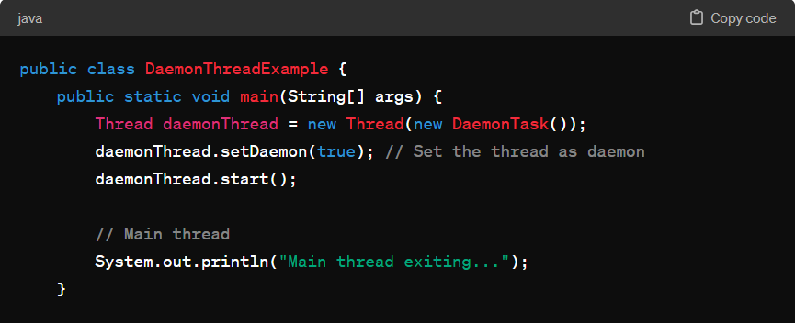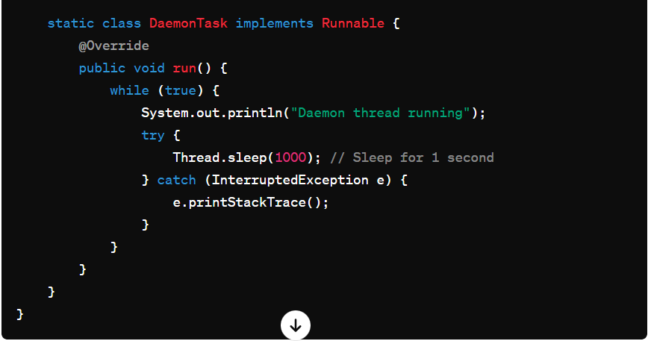

# Time Complexity:

#### **Factors affecting time complexity:**

1. **Iterations and Recursions:** The number of iterations or recursive calls an algorithm performs based on the input size.
2. **Operations:** The complexity of individual operations performed in the algorithm (e.g., arithmetic operations, comparisons, etc.).
3. **Input Size:** How the algorithm's runtime scales with the size of the input (e.g., linearly, quadratically, logarithmically, etc.).

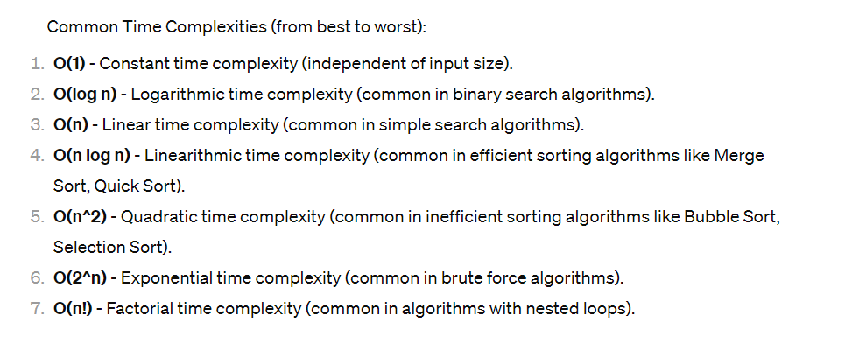

# Space Complexity

#### **Factors affecting space complexity:**

1. **Data Structures:** Memory used by variables, arrays, lists, trees, etc., in the algorithm.
2. **Function Call Stack:** Memory used by function calls and recursion.
3. **Auxiliary Space:** Additional memory space used during the algorithm's execution.

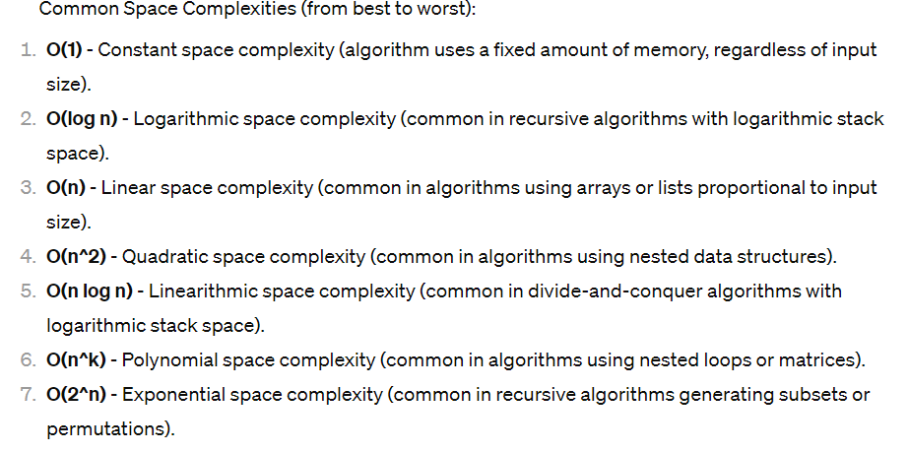

Example:

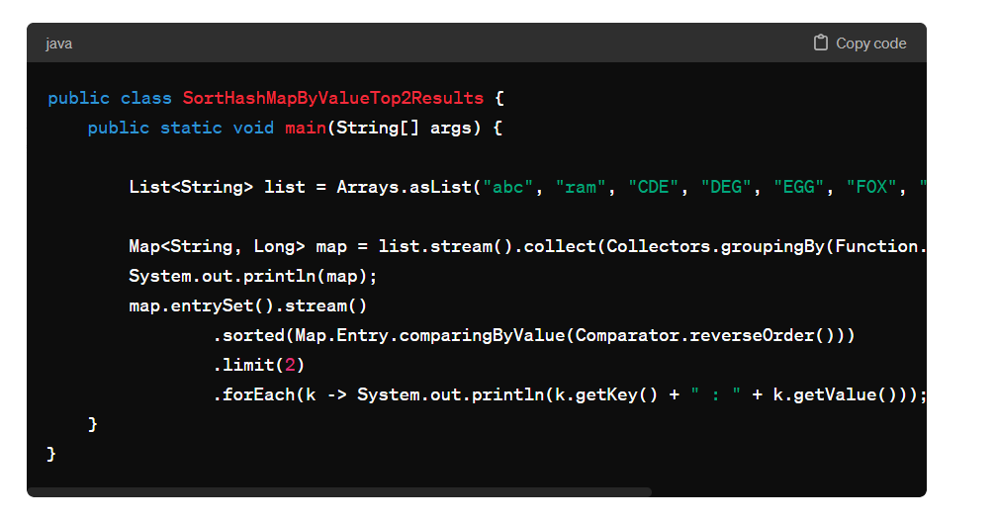

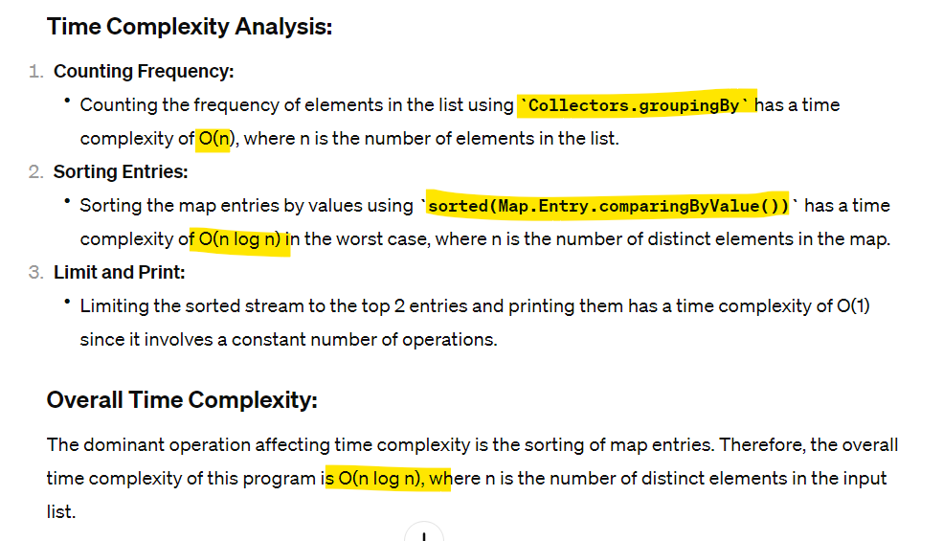

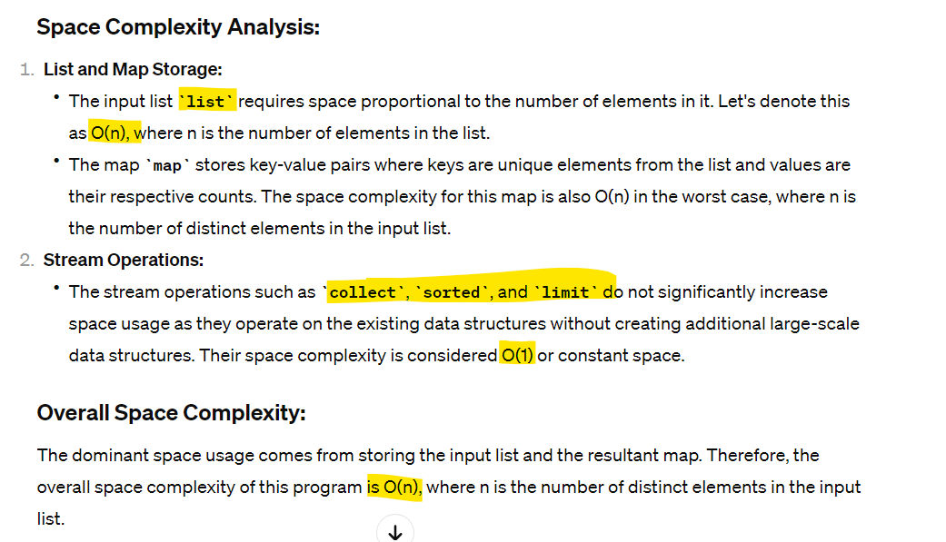

# Algorithms:

## Binary Search – O(log n)

The array elements must be sorted to implement binary search. The binary search algorithm is based on the following conditions:

* If the key is less than the middle element, then you now need to search only in the first half of the array.
* If the key is greater than the middle element, then you need to search only in the second half of the array.
* If the key is equal to the middle element in the array, then the search ends.
* Finally, if the key is not found in the whole array, then it should return -1. This indicates that the element is not present.

The following example code implements a binary search:

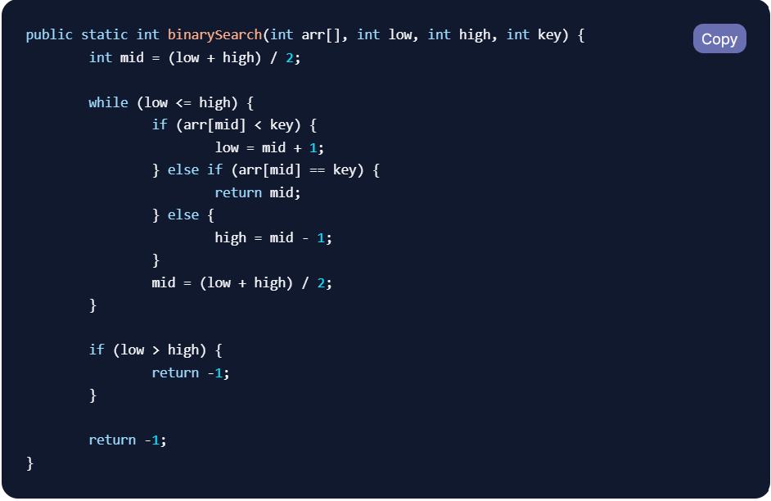

## Merge Sort – O(n log n)

Merge sort is one of the most efficient sorting algorithms. It works on the principle of “divide and conquer”. It is based on the idea of breaking down a list into several sub-lists until each sub-list consists of a single element, and then merging those sub-lists in a manner that results in a sorted list. The following example code shows one way to use merge sort:

## Quick Sort - O(n log n)

Quick Sort is a widely used sorting algorithm known for its efficiency and performance. It belongs to the divide-and-conquer category of algorithms and employs the strategy of partitioning the array into smaller sub-arrays and sorting them independently. It is based on the principle of choosing a pivot element and partitioning the array around the pivot, such that elements smaller than the pivot are placed to its left, and elements greater than the pivot are placed to its right.

Here's a high-level overview of the Quick Sort algorithm:

1. **Choose a Pivot**: Select a pivot element from the array. This can be any element, but commonly it's either the first, last, or a random element.
2. **Partitioning**: Rearrange the elements in the array such that all elements less than the pivot are moved to its left, and all elements greater than the pivot are moved to its right. The pivot itself is placed in its correct sorted position.
3. **Recursively Sort Sub-arrays**: Recursively apply the above steps to the sub-arrays on the left and right of the pivot until the entire array is sorted.
4. **Combine Sorted Sub-arrays**: The array will be sorted when all sub-arrays are sorted, and they are combined appropriately.

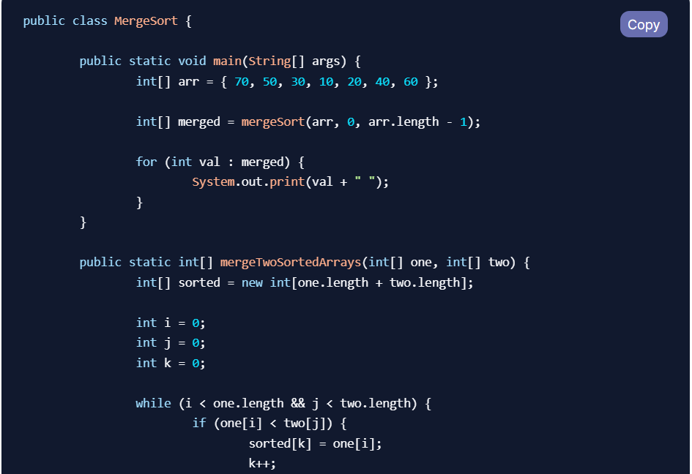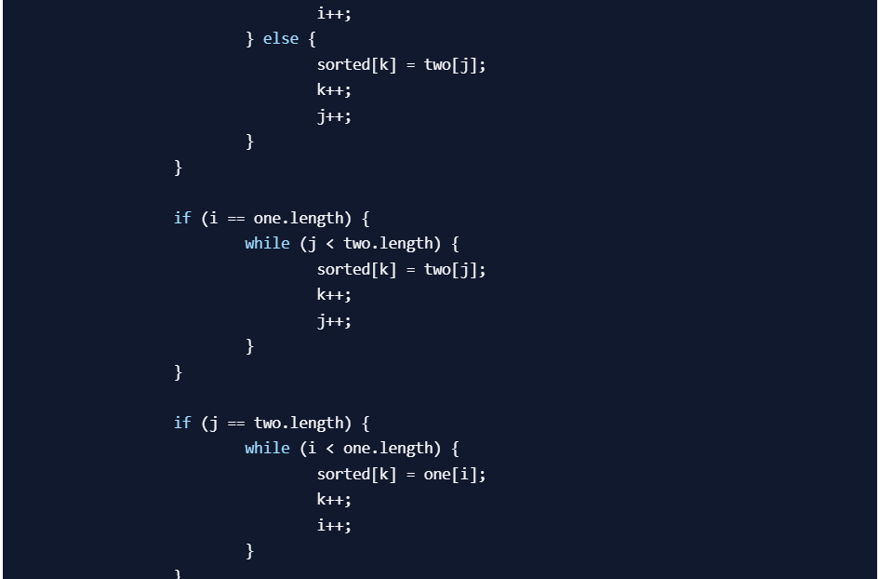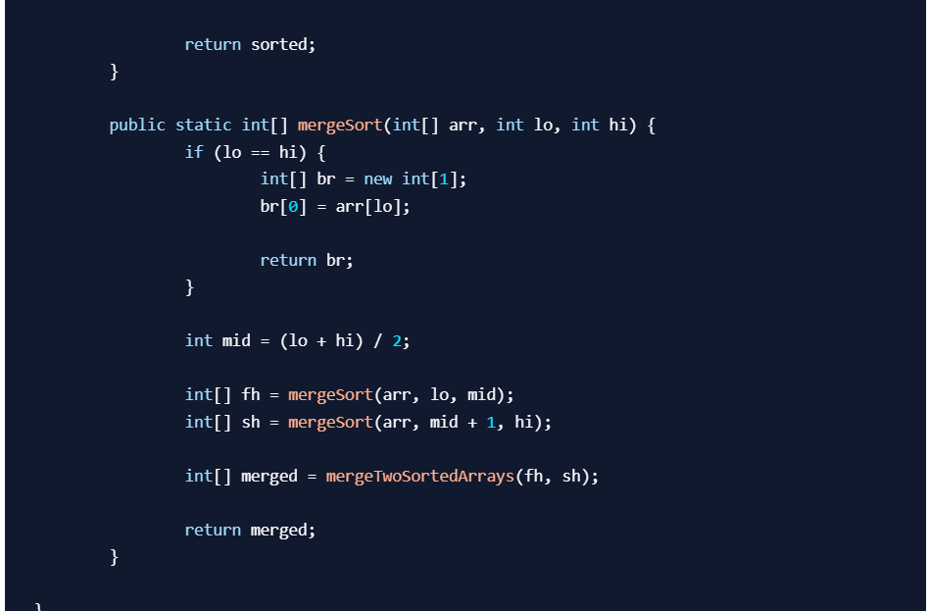

## Bubble Sort – O(n^2)

Bubble Sort is a simple sorting algorithm that repeatedly steps through the list, compares adjacent elements, and swaps them if they are in the wrong order. The pass through the list is repeated until the list is sorted. It is named as Bubble Sort because smaller elements "bubble" to the top of the list.

Here's the basic idea of the Bubble Sort algorithm:

1. Start with an unsorted list of elements.
2. Compare adjacent elements in the list.
3. If the elements are in the wrong order (e.g., if the current element is greater than the next element in ascending order), swap them.
4. Repeat this process for each pair of adjacent elements in the list until no more swaps are needed, indicating that the list is sorted.

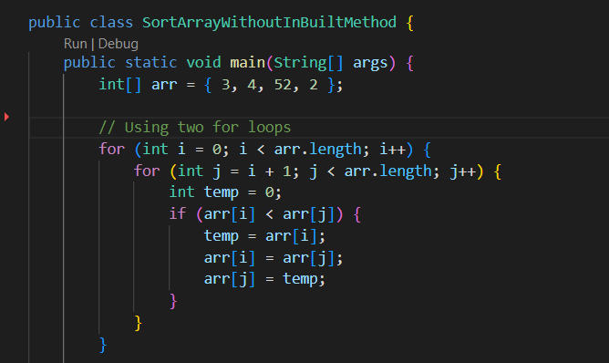

# Mock Testing JUNIT

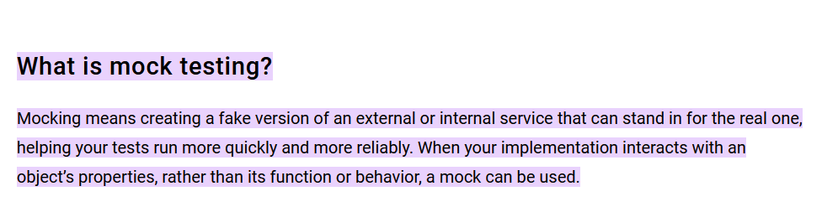

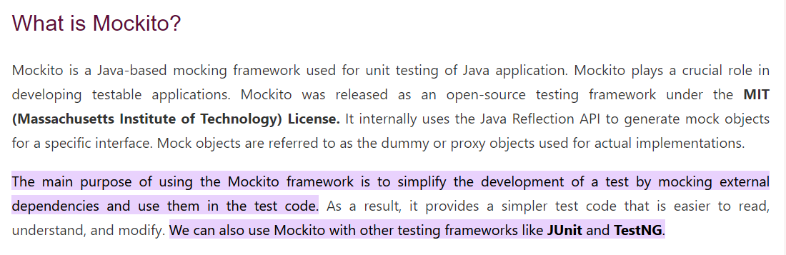

# Association mapping

In object-oriented programming, association represents a relationship between two classes or objects. There are different types of associations such as one-to-one, one-to-many, many-to-one, and many-to-many. Let's look at an example of association in Java using a one-to-many relationship.

Consider two classes: **Author** and **Book**. An **Author** can write multiple **Book** objects, establishing a one-to-many association.

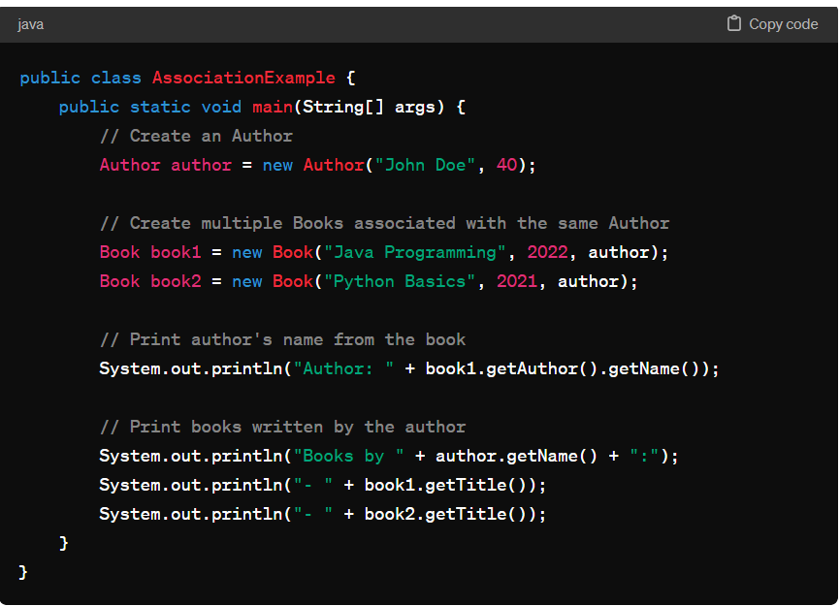

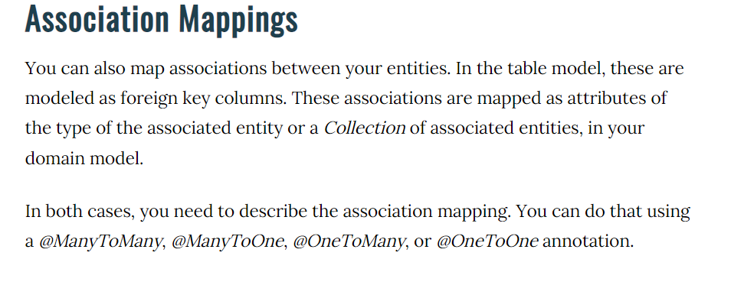

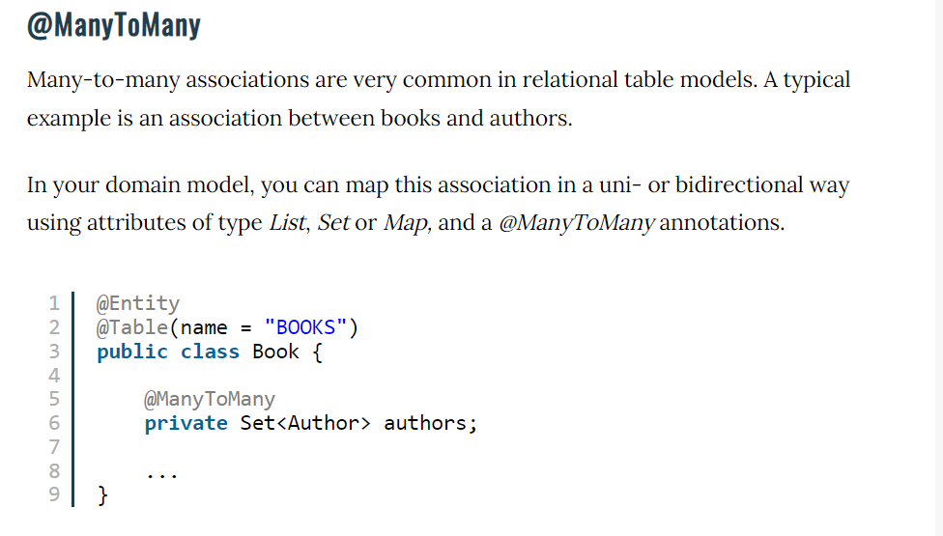

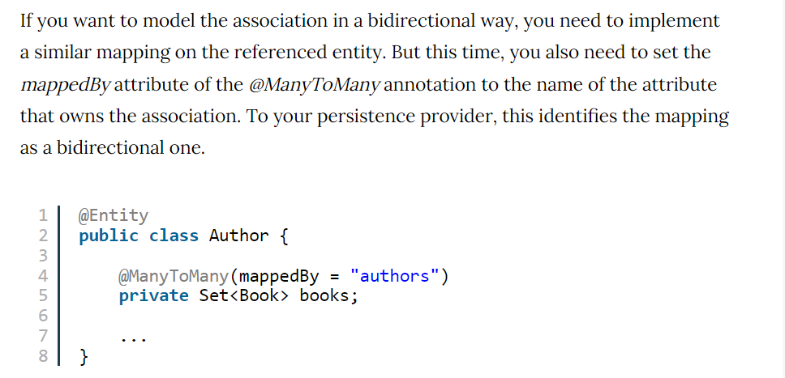

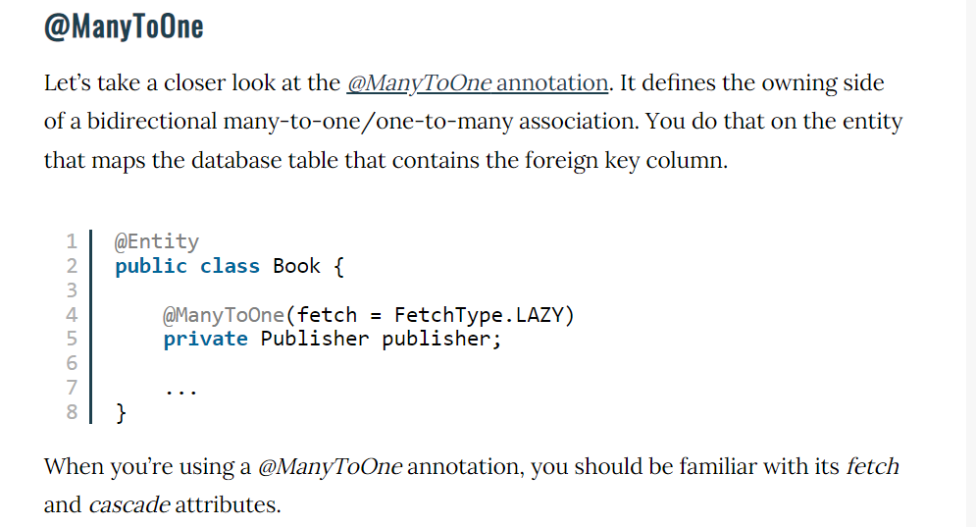

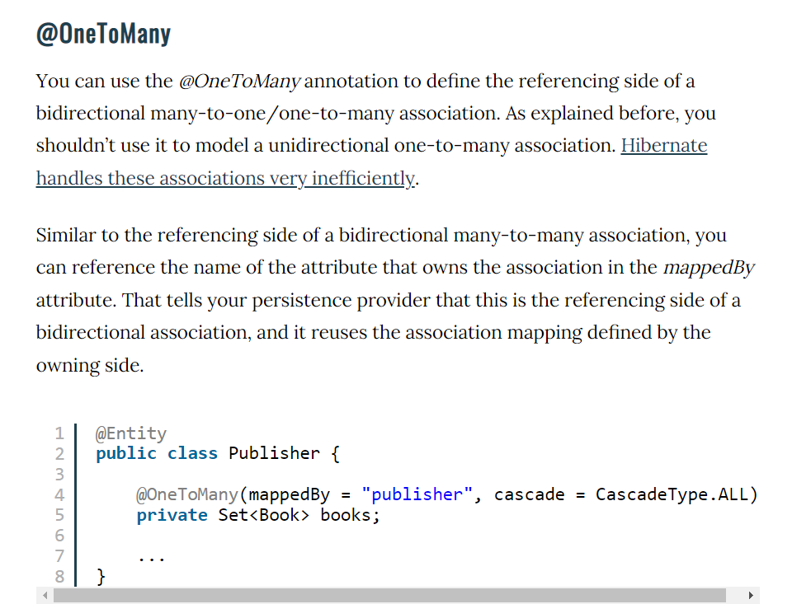

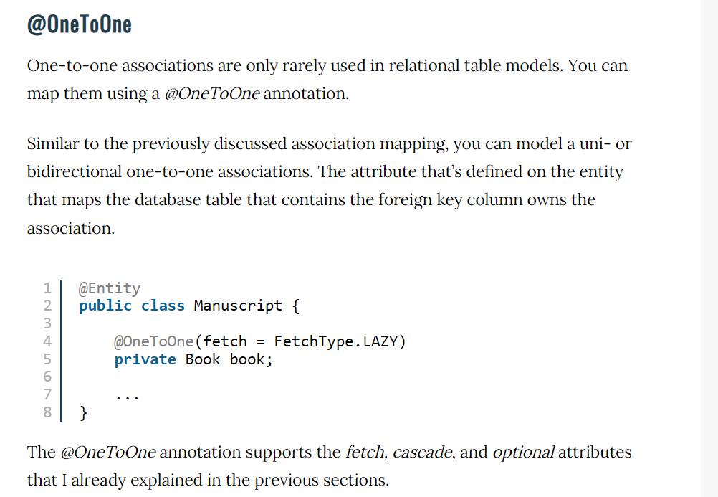

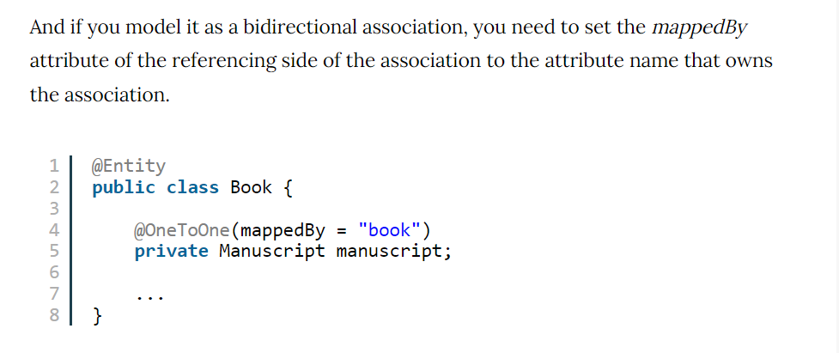

1. Association mapping annotation @JoinColumn

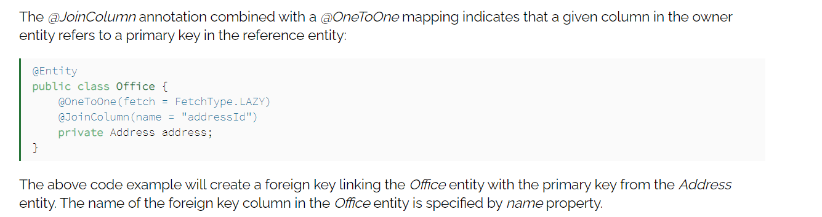

# Design Patterns

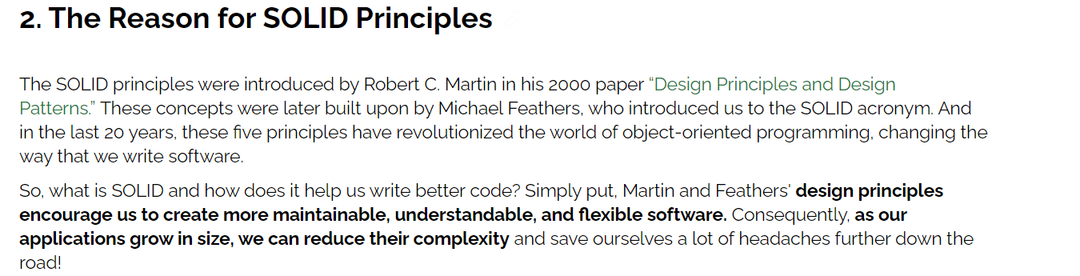

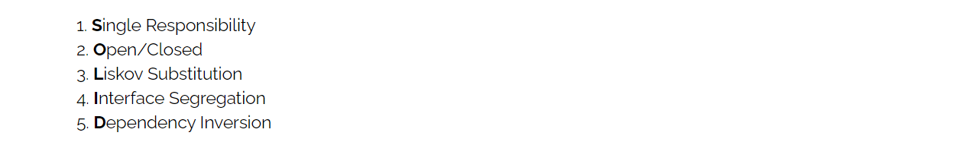

<https://www.baeldung.com/solid-principles>

**Liskov Substitution Principle (LSP)**

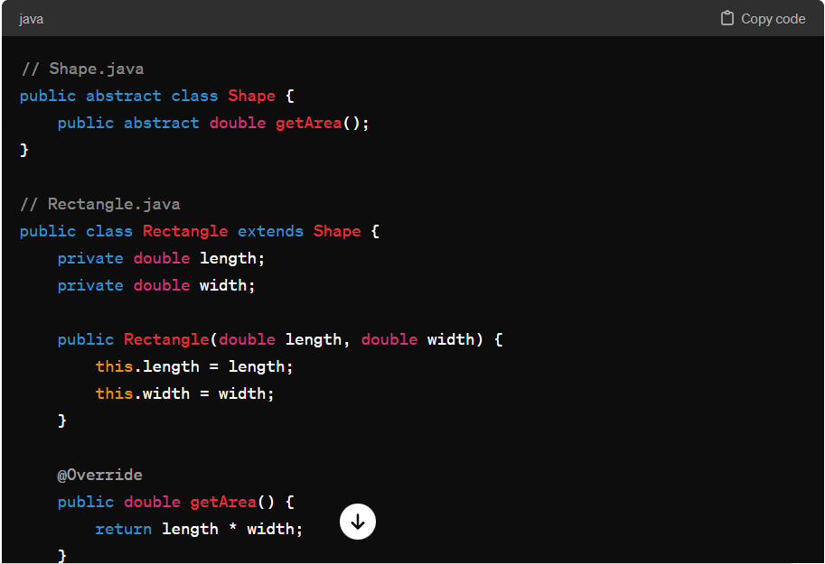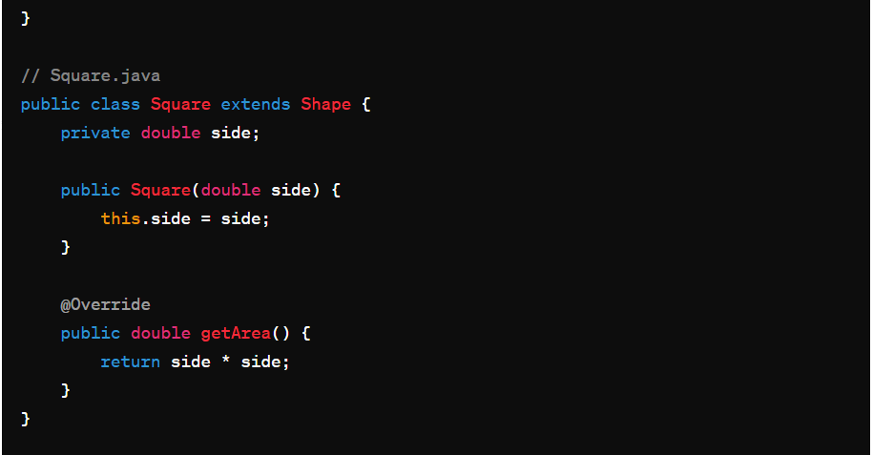

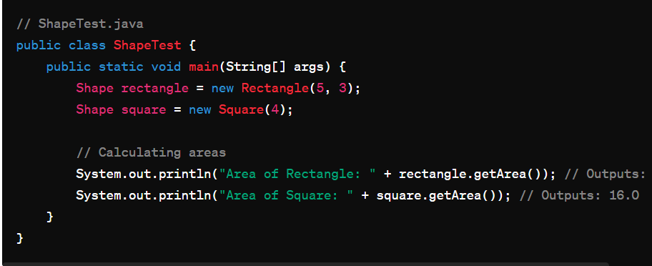

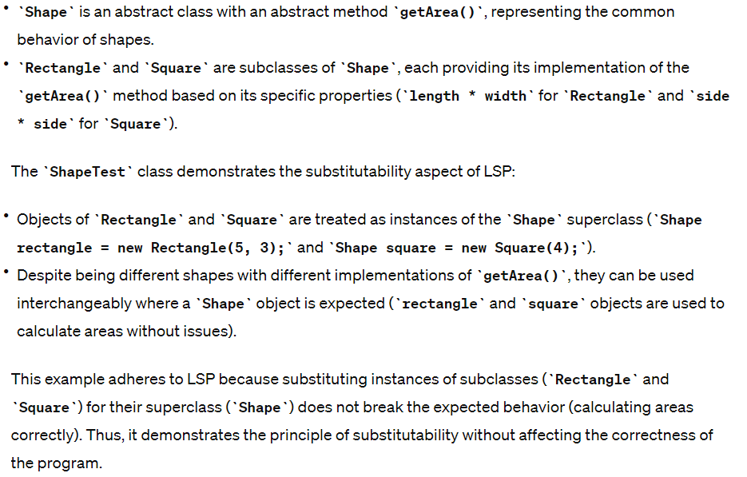

**Dependency Inversion Principle**

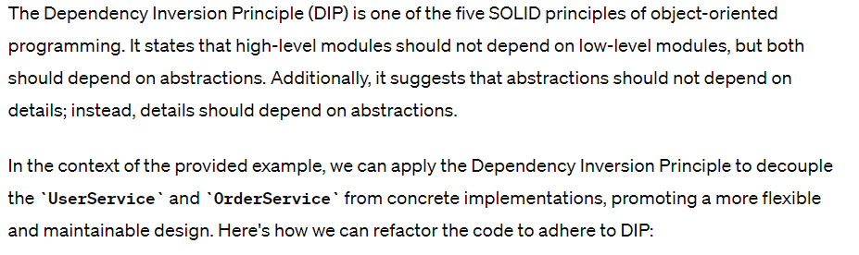

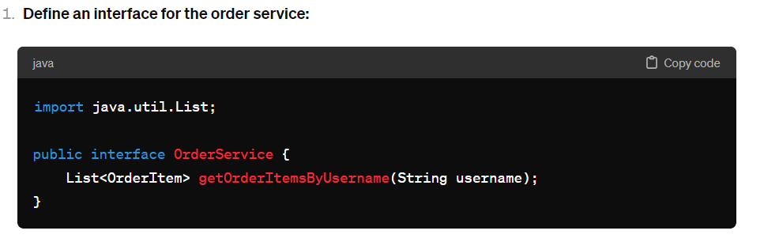

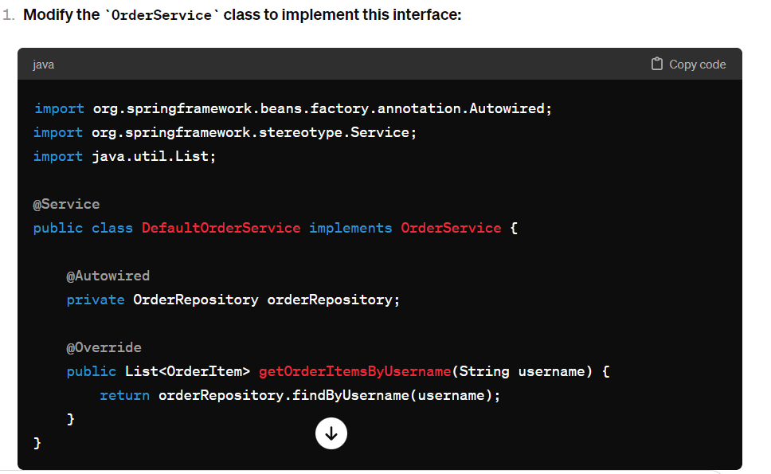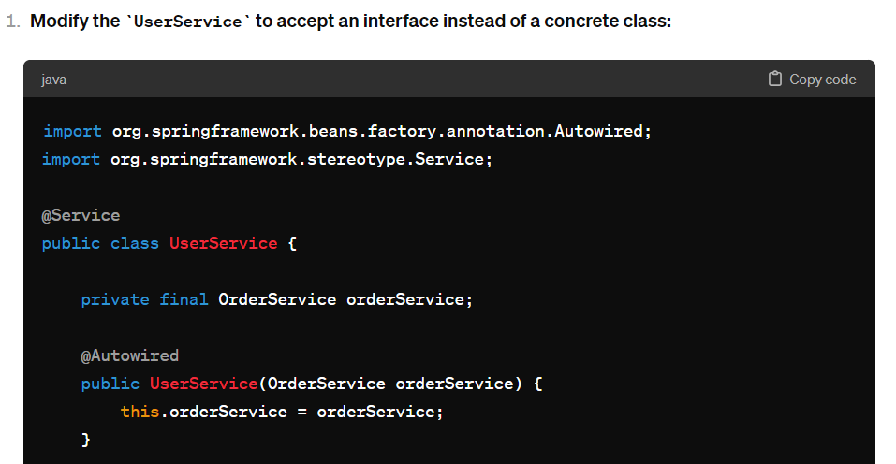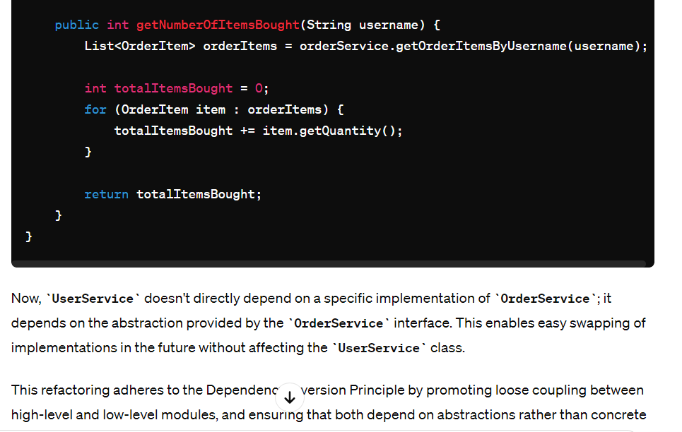

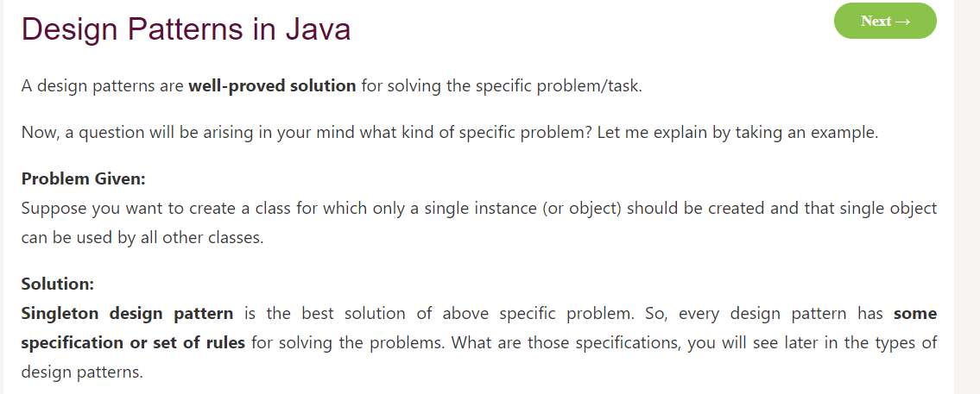

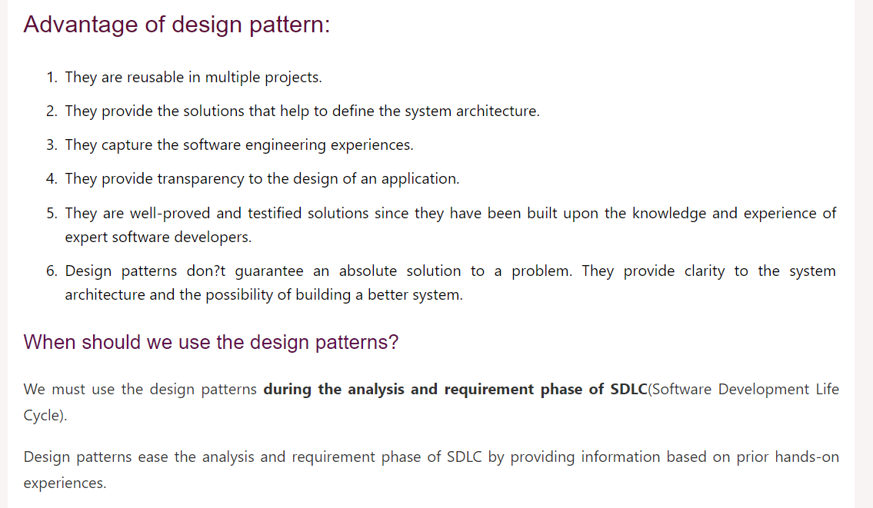

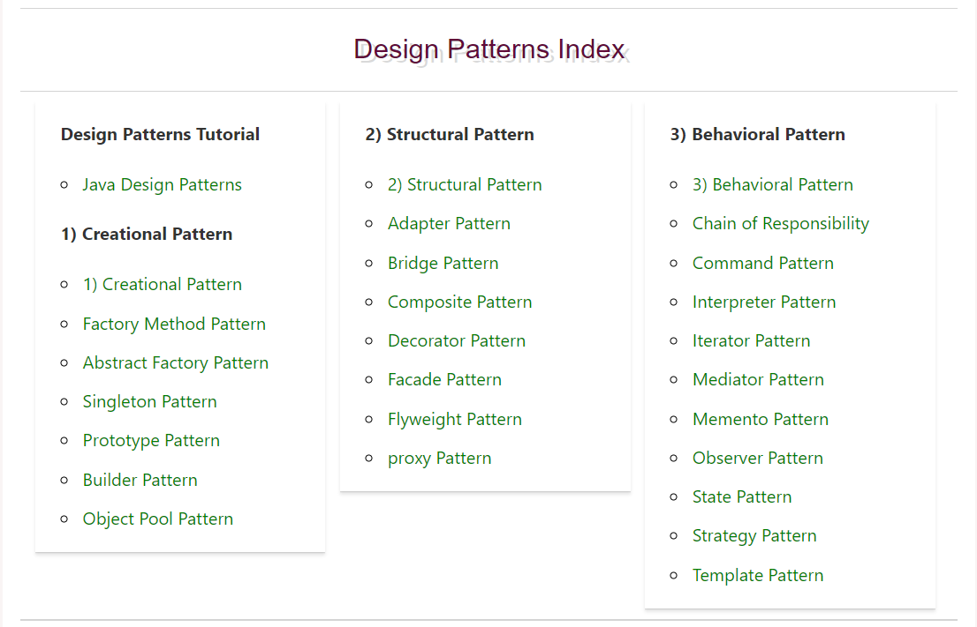

<https://www.javatpoint.com/creational-design-patterns>

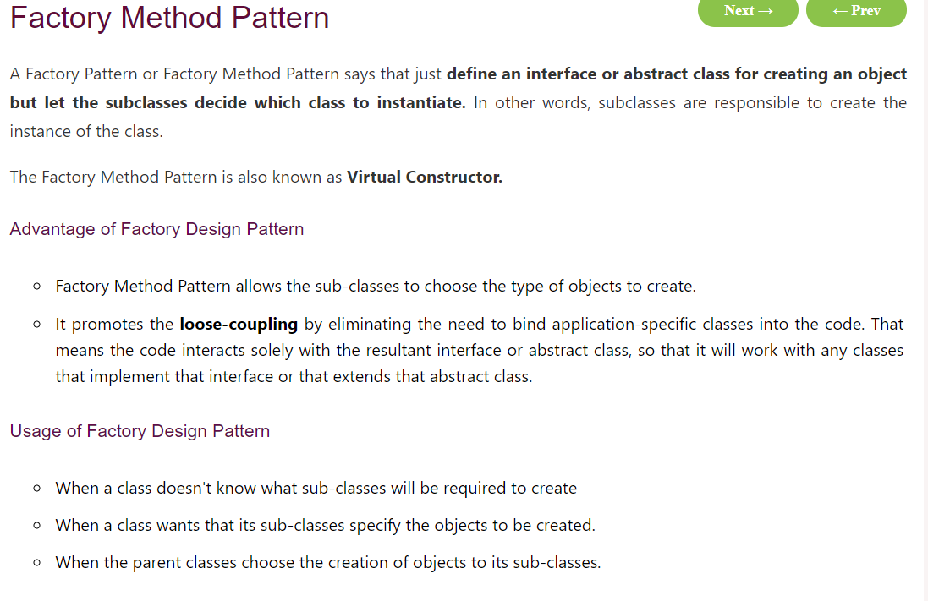

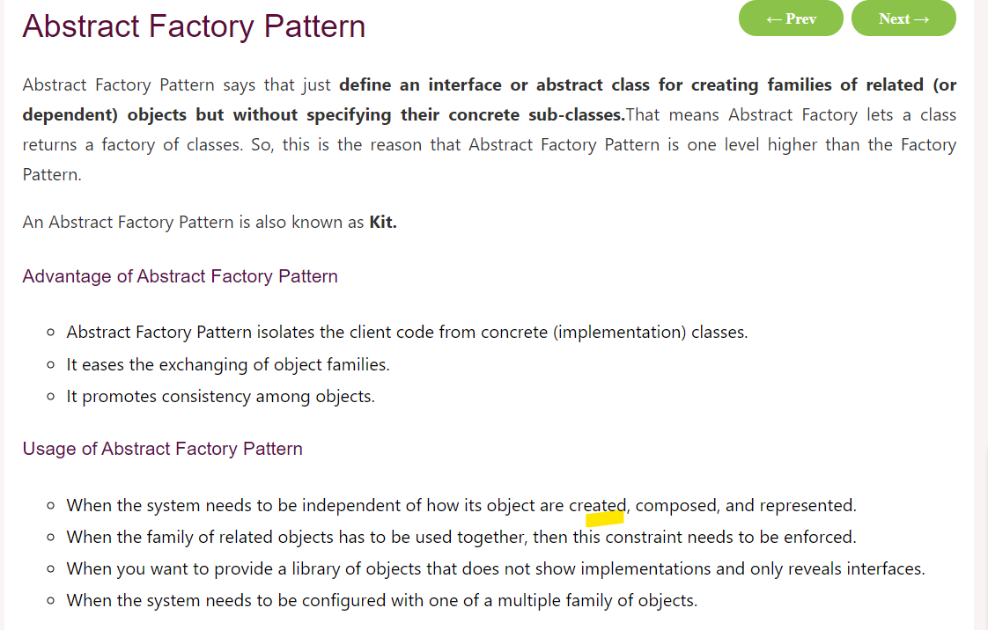

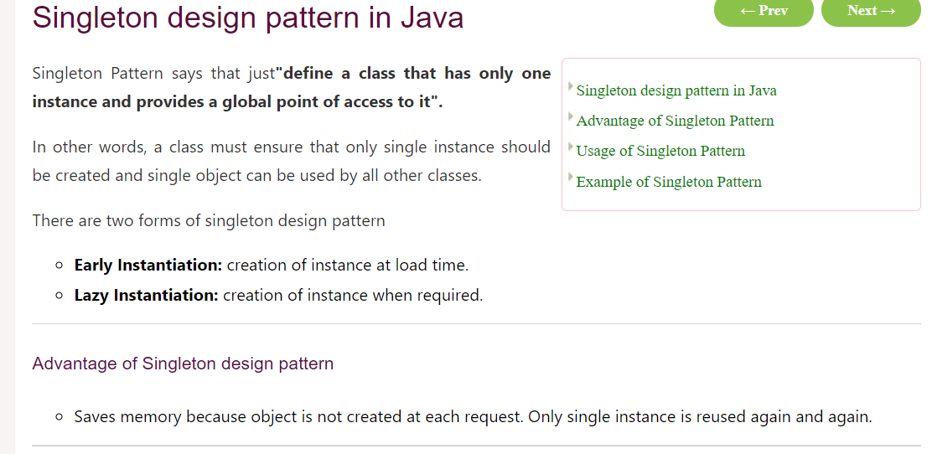

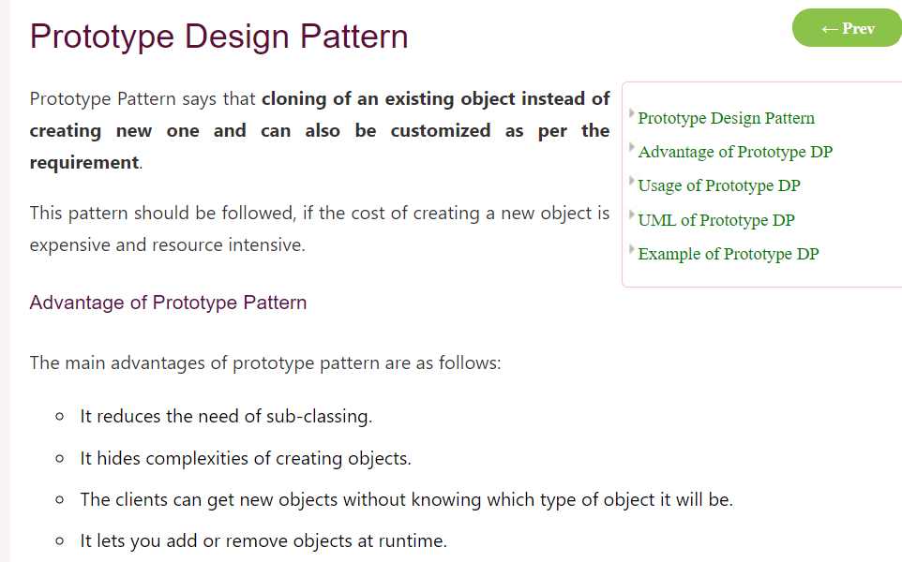

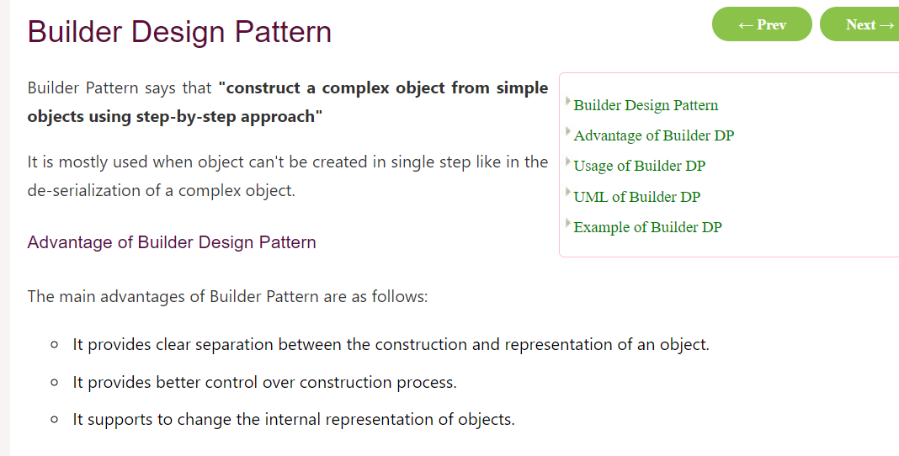

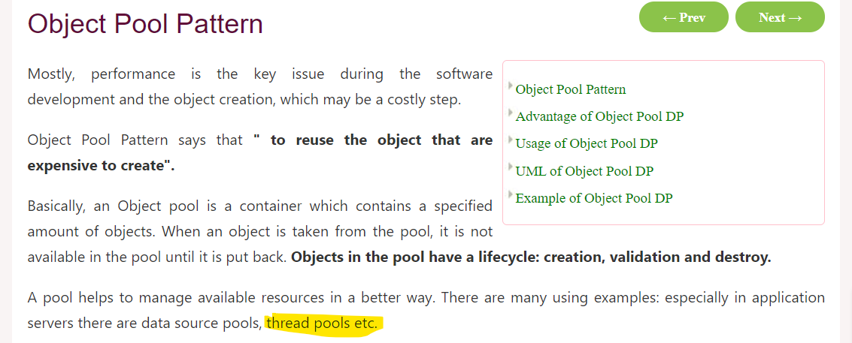

# Spring Boot

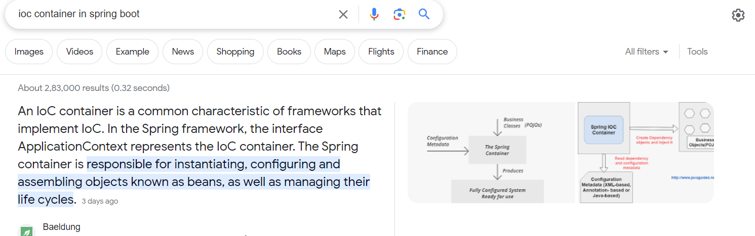

What you understand by auto-configuration by spring boot

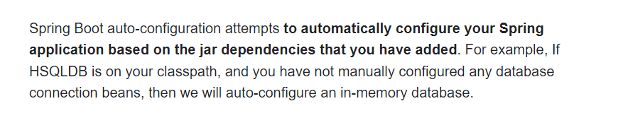

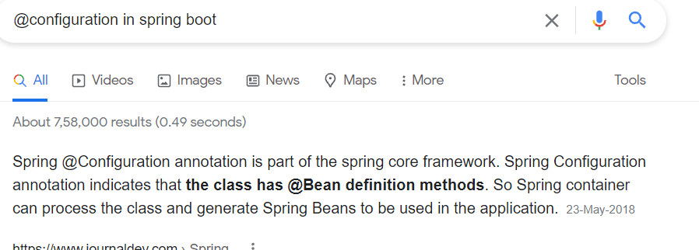

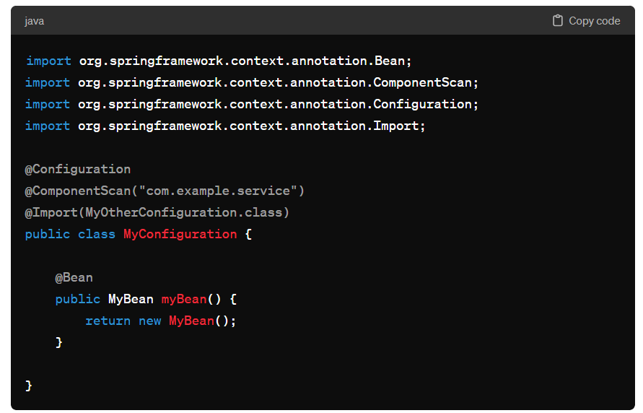

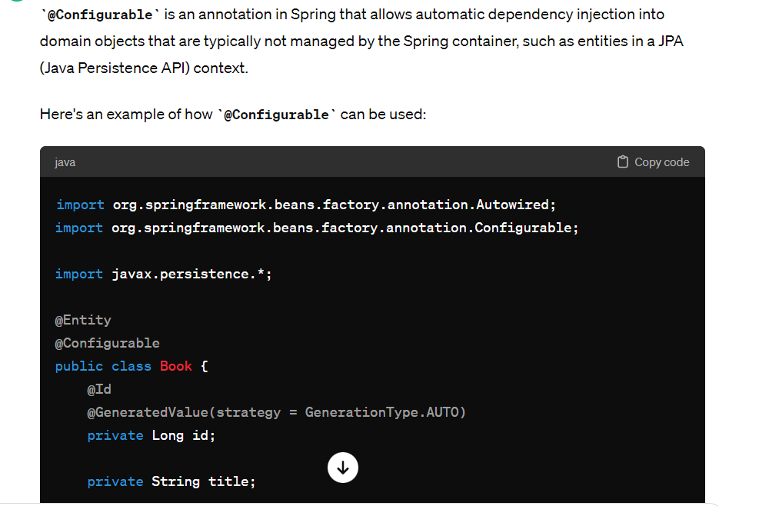

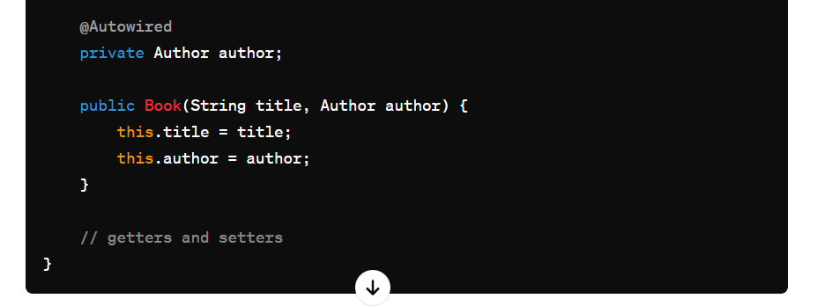

@Qualifier

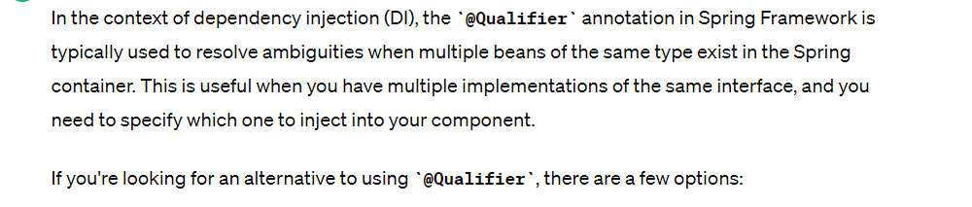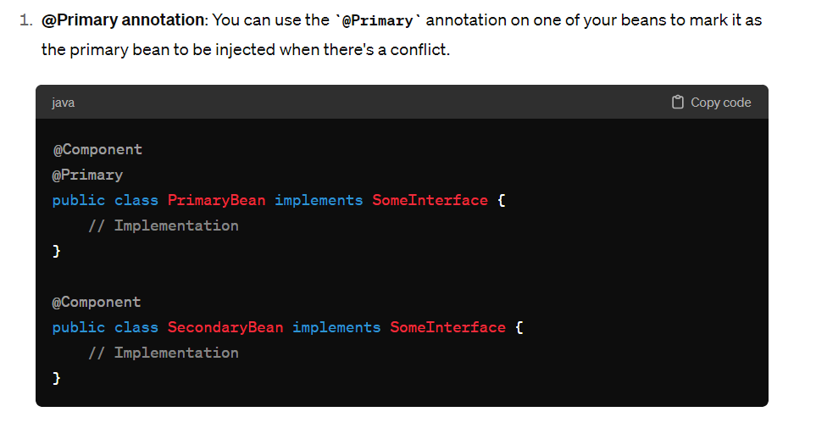

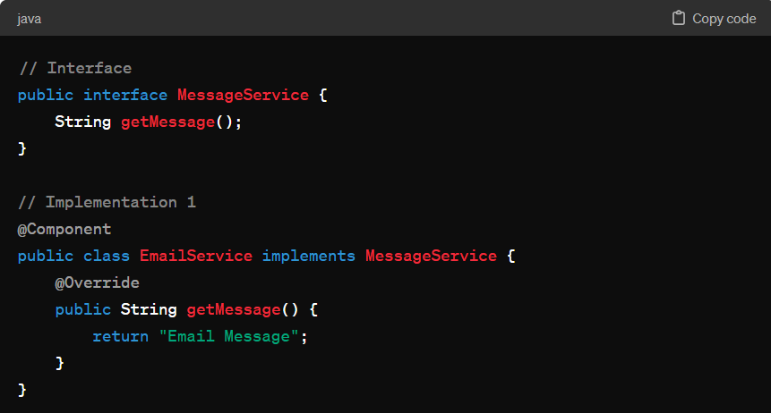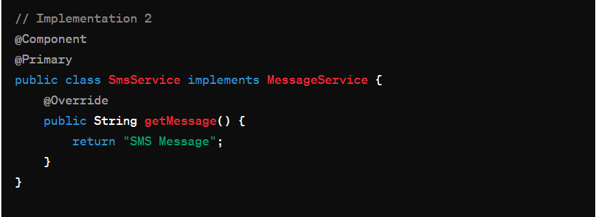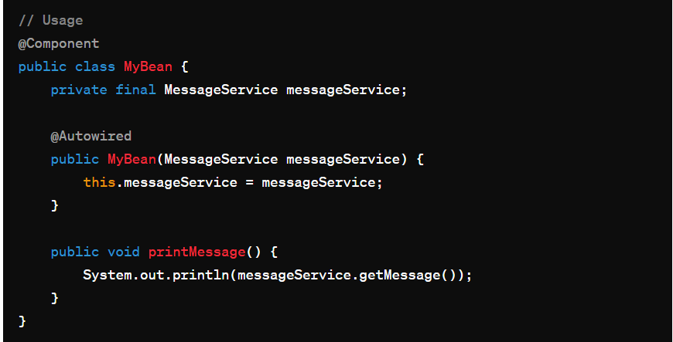

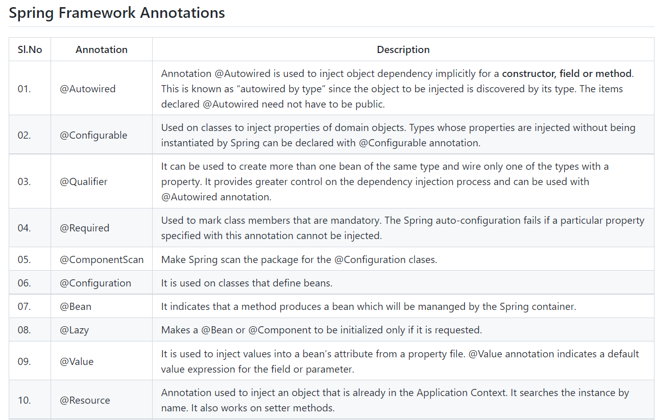

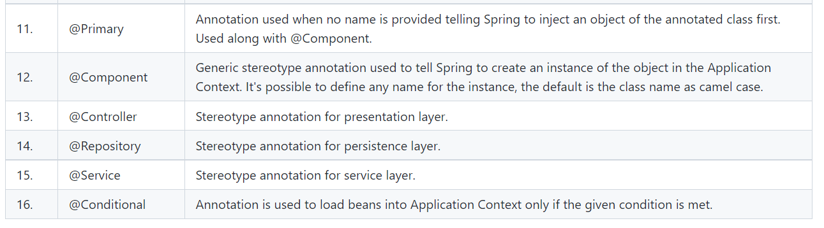

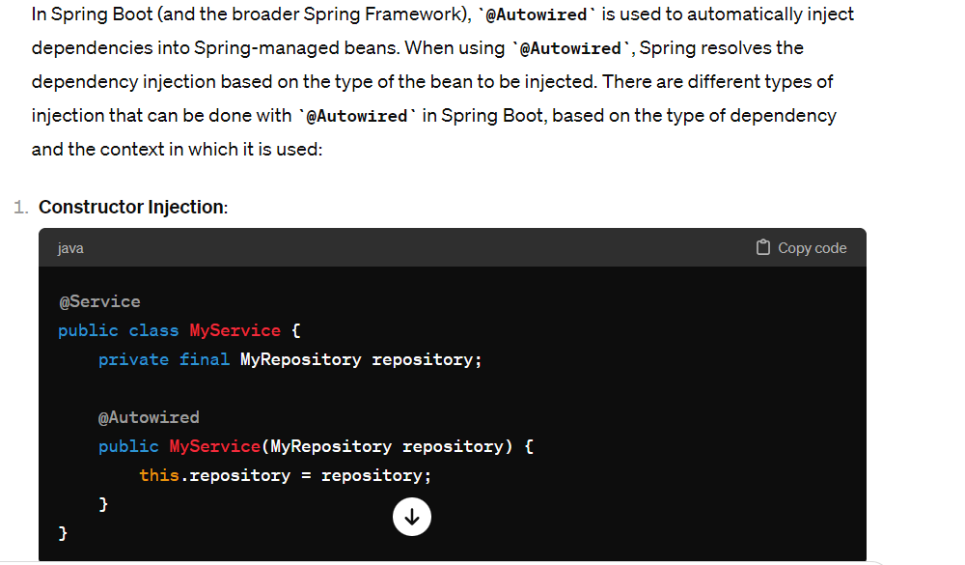

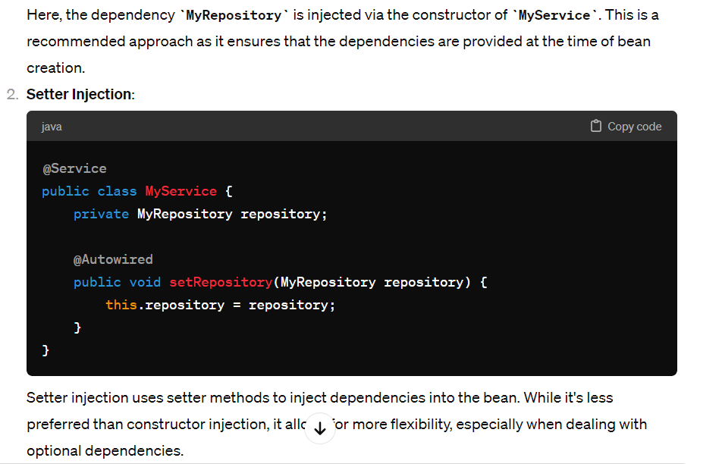

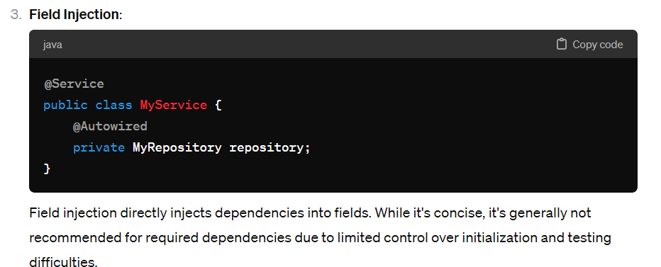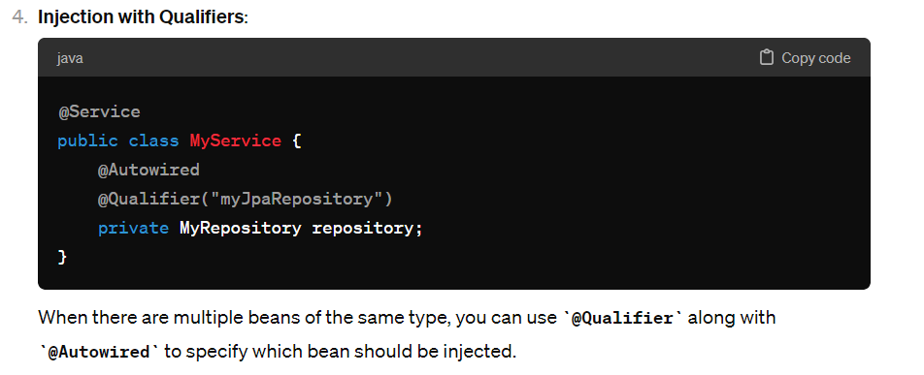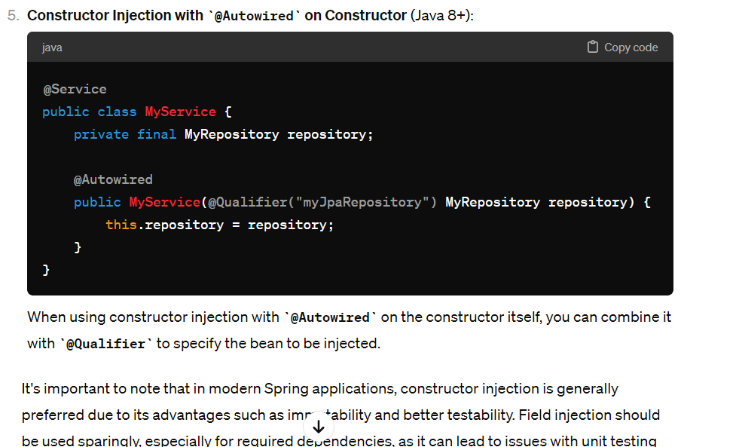

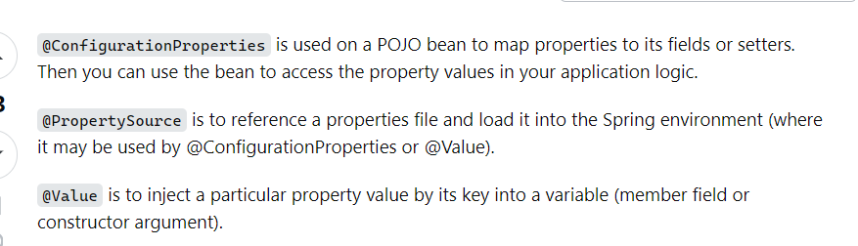

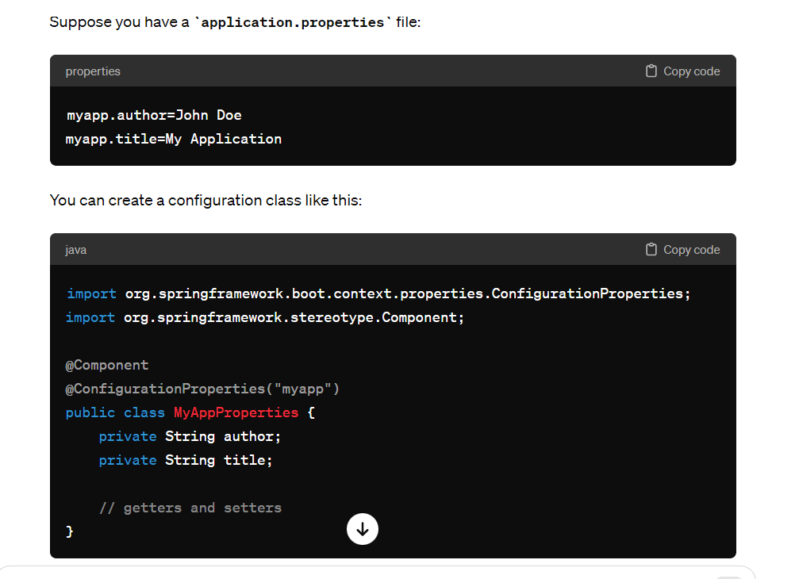

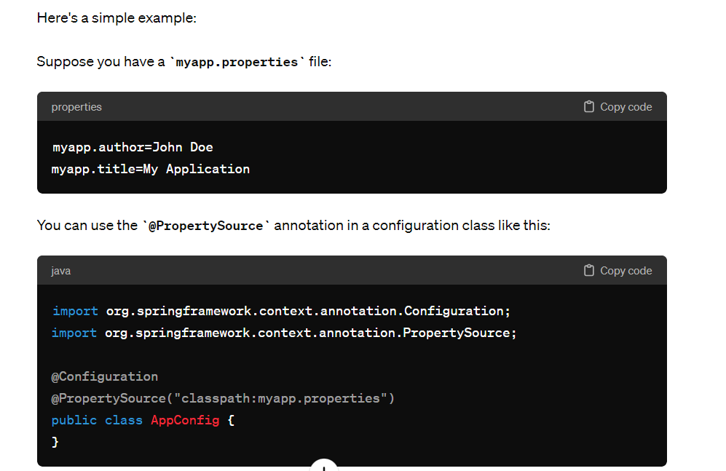

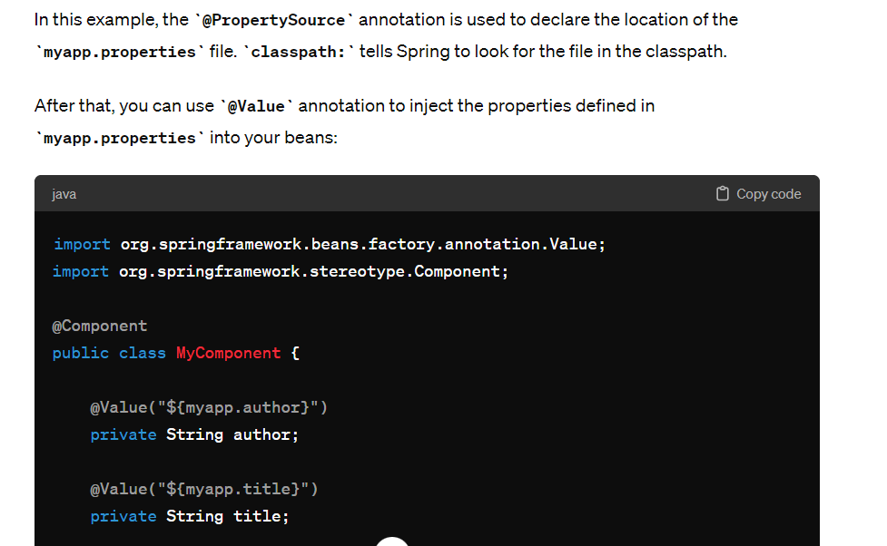

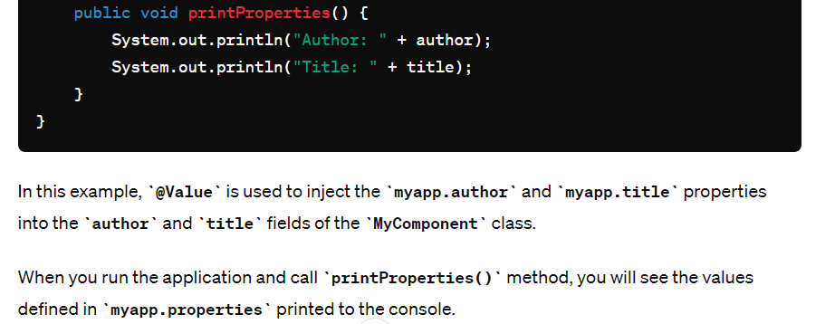

@Autowired. It allows Spring to resolve and inject collaborating beans into our bean.

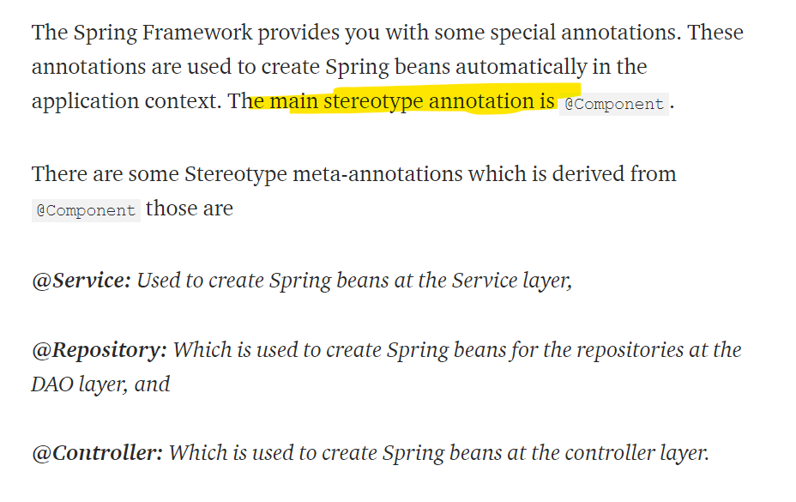

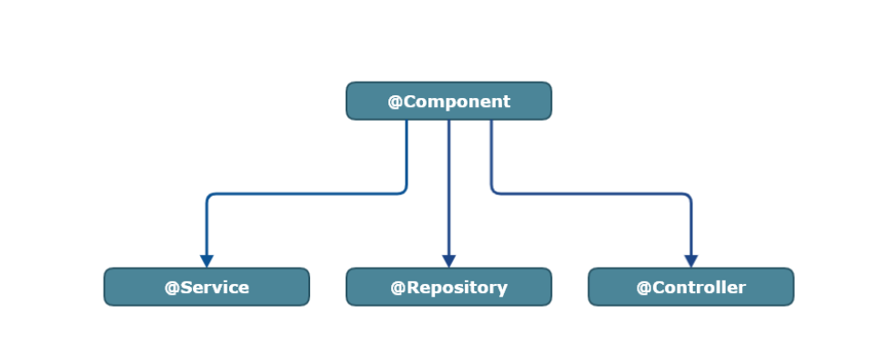

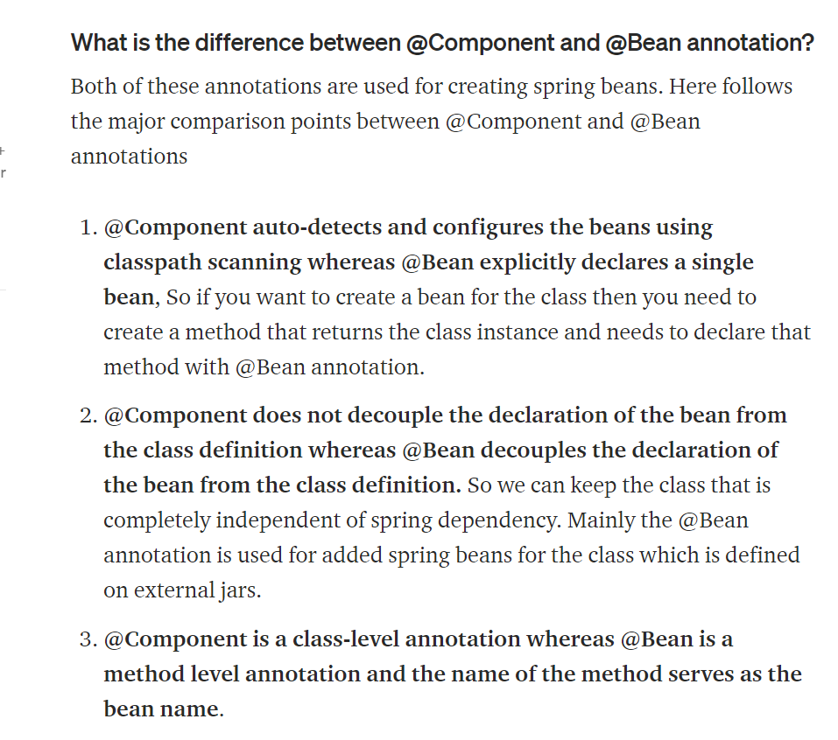

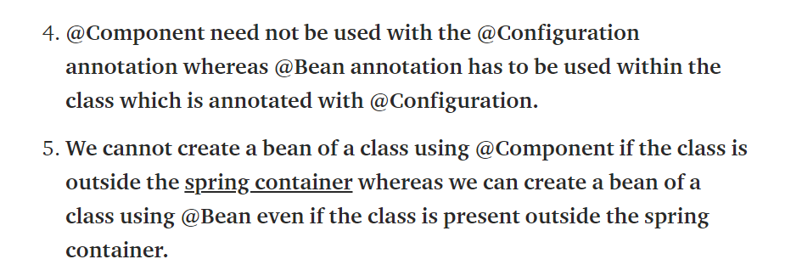

**what will happen when @service used instead of @repository and wiseverse?**

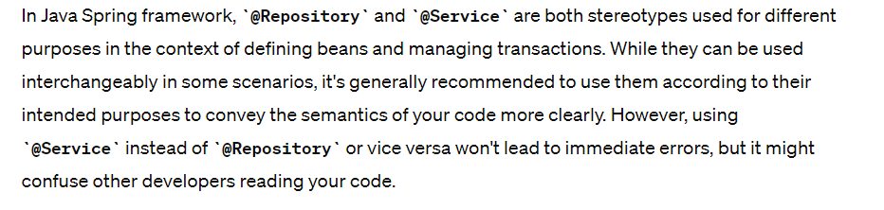

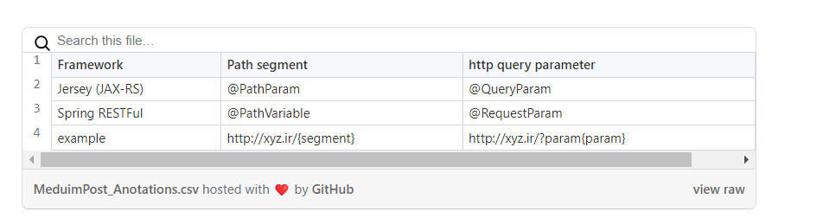

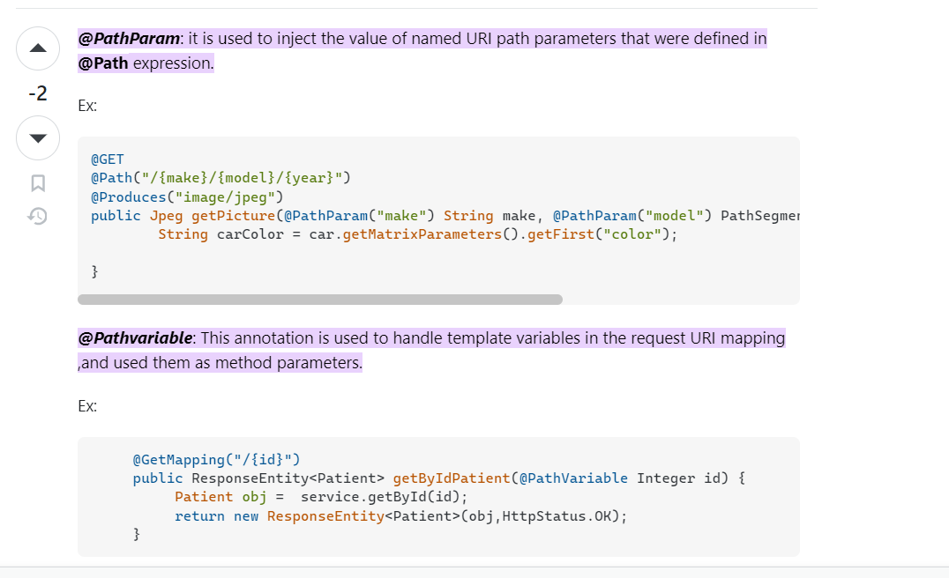

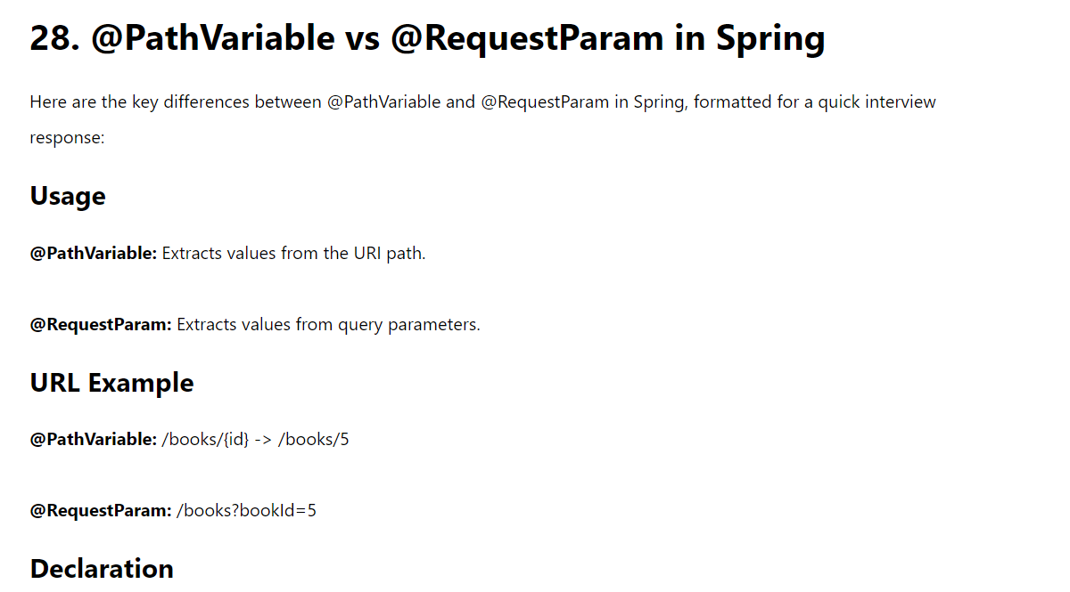

## @Bean scopes:

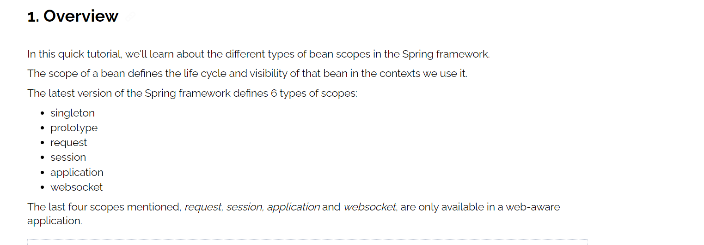

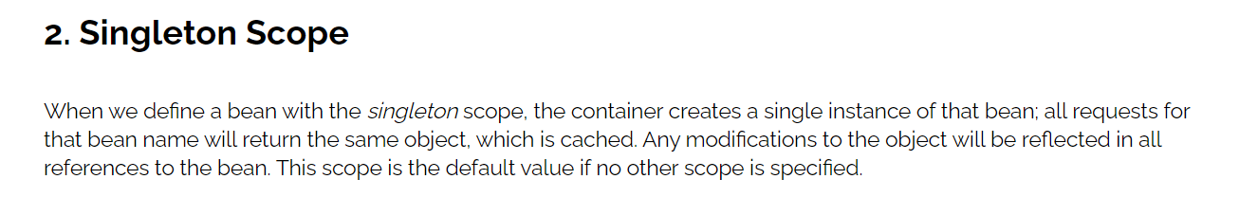

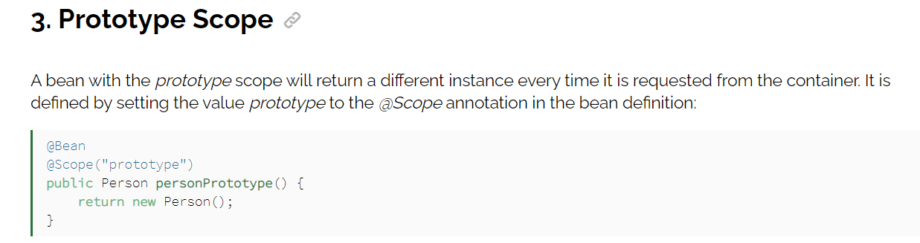

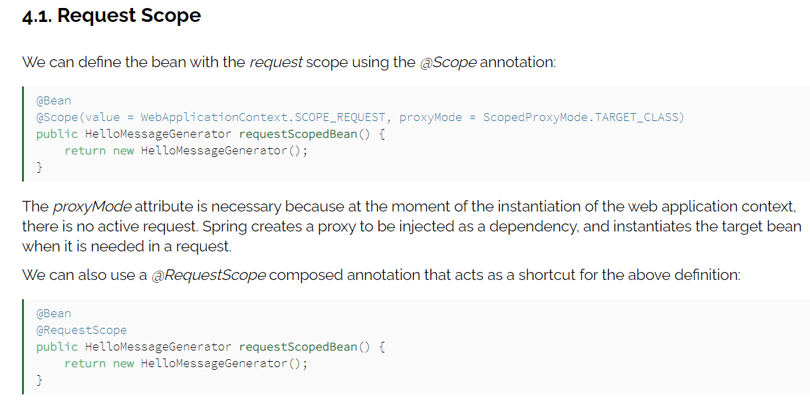

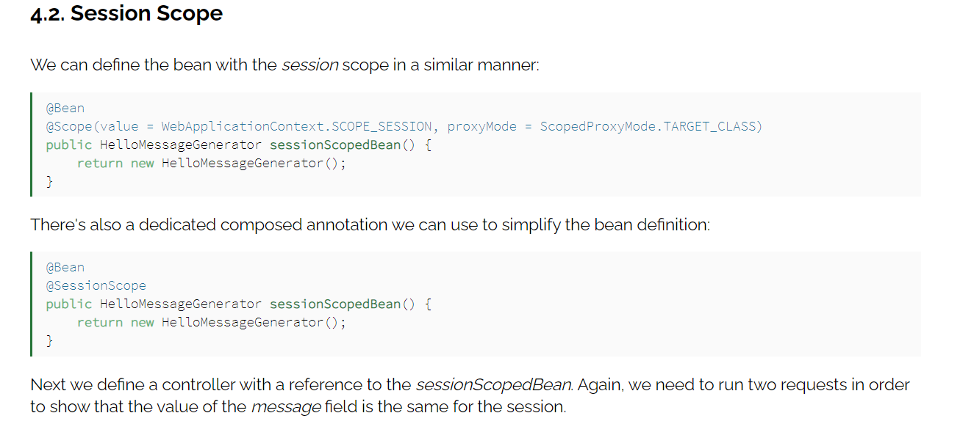

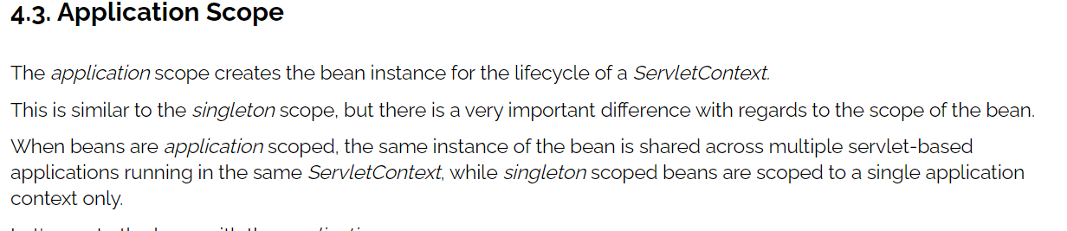

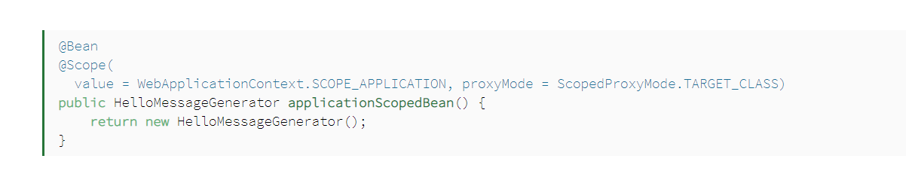

**ResponseEntity**

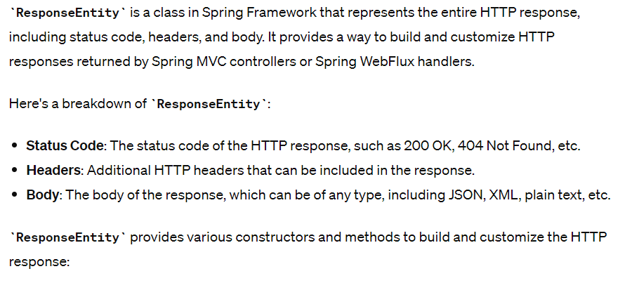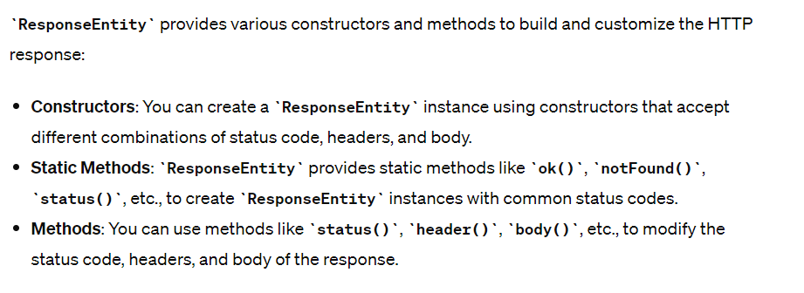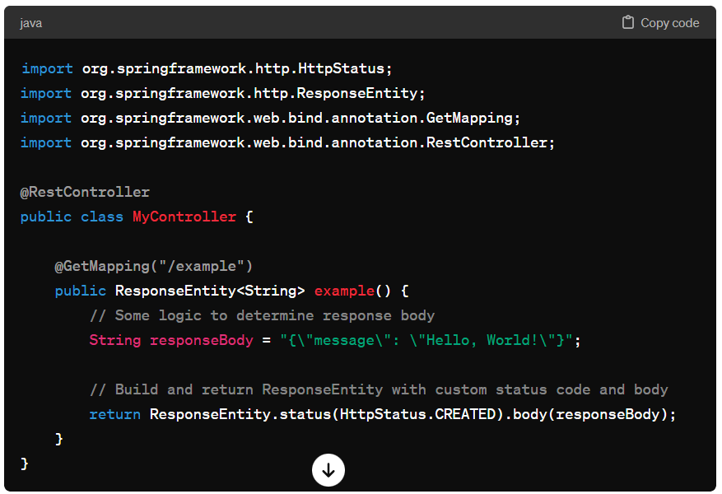

## Reflections

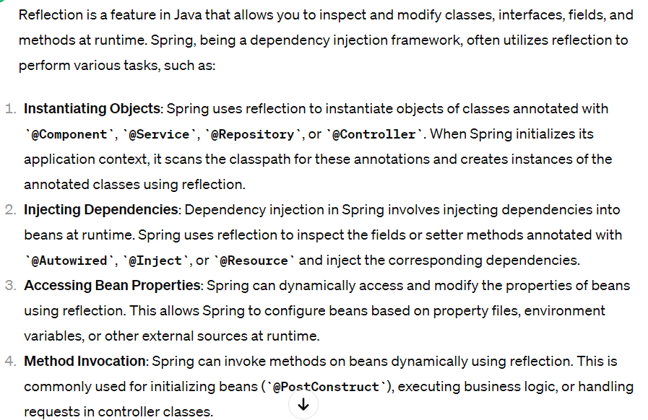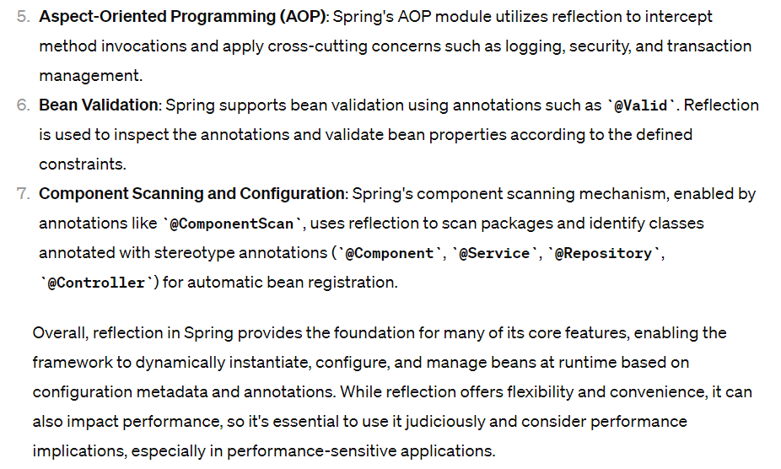

**if we define constructor as private how IOC will load?**

Inversion of Control (IoC) containers, like Spring, rely on reflection to instantiate objects and manage dependencies. If a class has a private constructor, by default, it cannot be instantiated from outside the class, including by reflection.

However, IoC containers like Spring often provide mechanisms to work around this limitation. For example:

1. **Reflection and Accessible Constructors**: Some IoC containers, including Spring, can bypass Java access control checks and invoke private constructors using reflection. Spring's **ReflectionUtils** class, for instance, provides methods to set the accessibility of constructors, methods, and fields, allowing private constructors to be invoked during object instantiation.
2. **Singleton Pattern**: If a class follows the Singleton pattern and has a private constructor, the IoC container can still access the private constructor to create the Singleton instance. This is typically done through a static method or static field within the class, which the IoC container can invoke.
3. **Factory Methods or Static Factories**: Instead of relying on constructors, classes can expose static factory methods that return instances of the class. These factory methods can have any access modifier, including private. The IoC container can then call these factory methods to create instances of the class.

Here's a basic example of how Spring can create a bean with a private constructor using reflection:

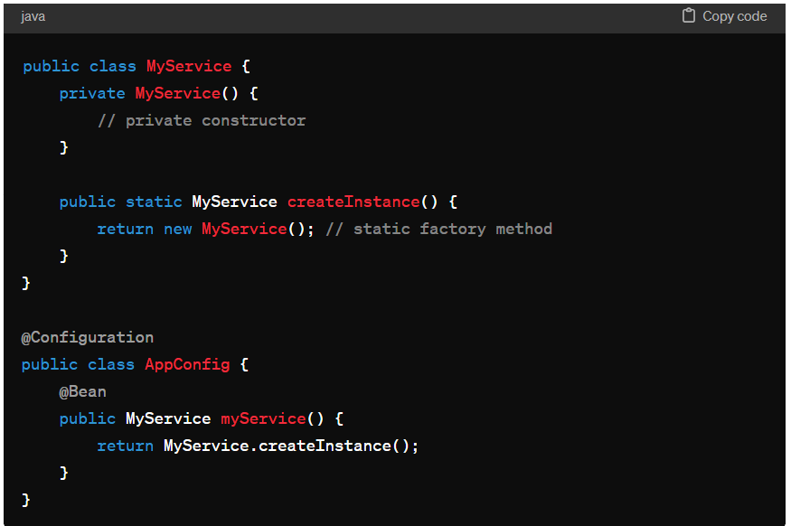In this example, **MyService** has a private constructor, but it exposes a static factory method **createInstance()** to create instances. Spring can invoke this factory method to create bean instances.

However, it's worth noting that relying heavily on private constructors may hinder testability and maintainability, as it can make it difficult to mock dependencies in unit tests or to extend classes for customization. In many cases, it's preferable to use package-private or protected constructors combined with dependency injection for better flexibility and decoupling.

## Spring boot configuration

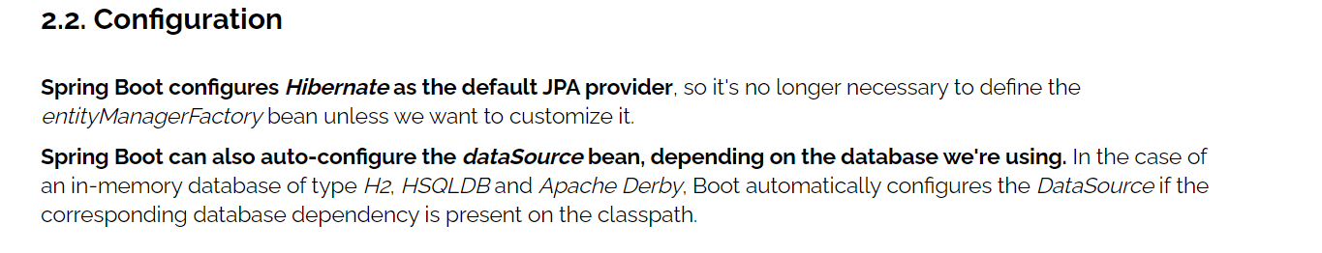 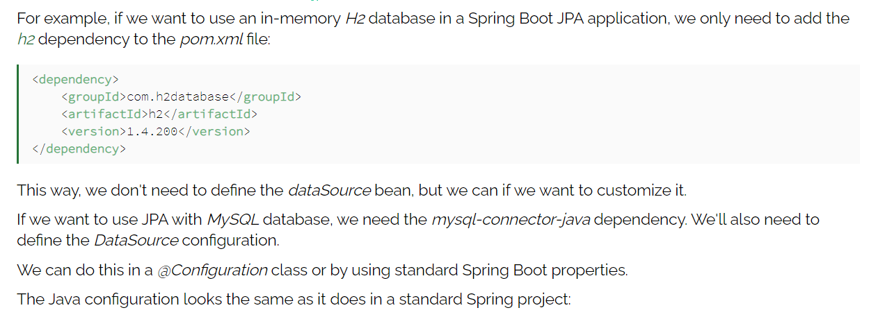

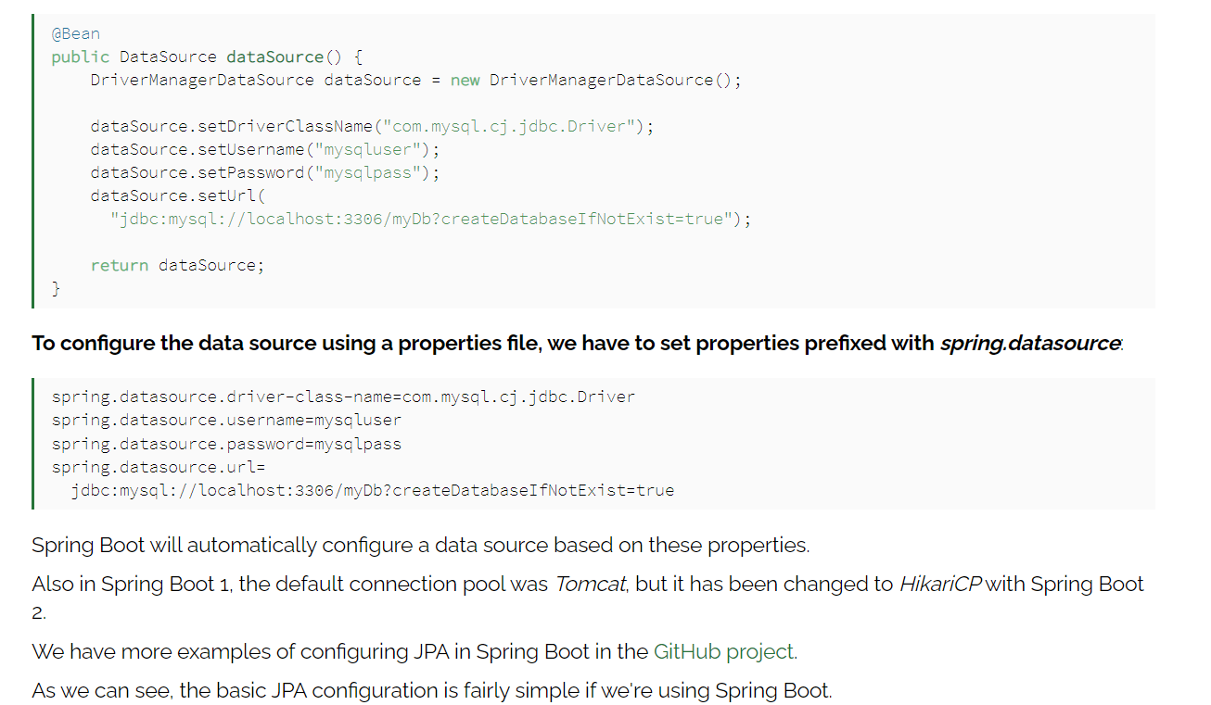

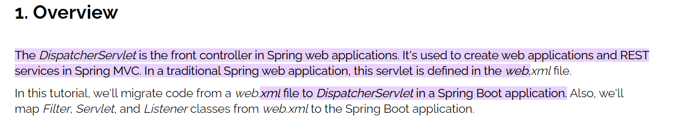

## Spring Modules:

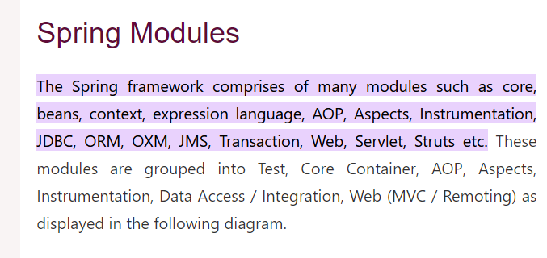

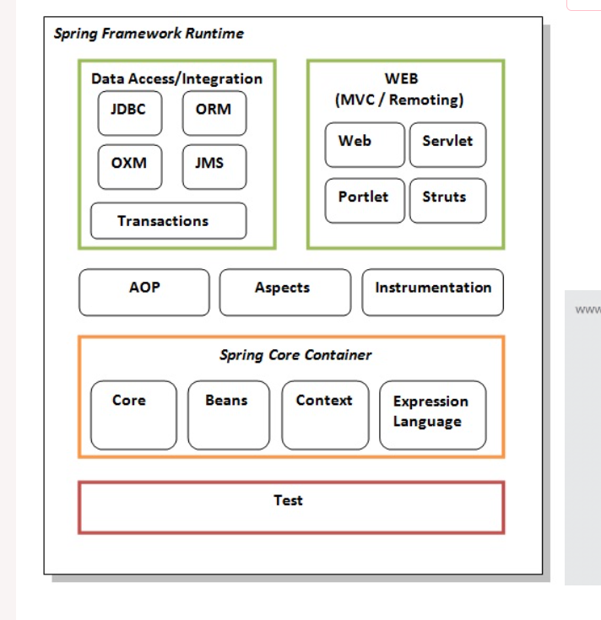

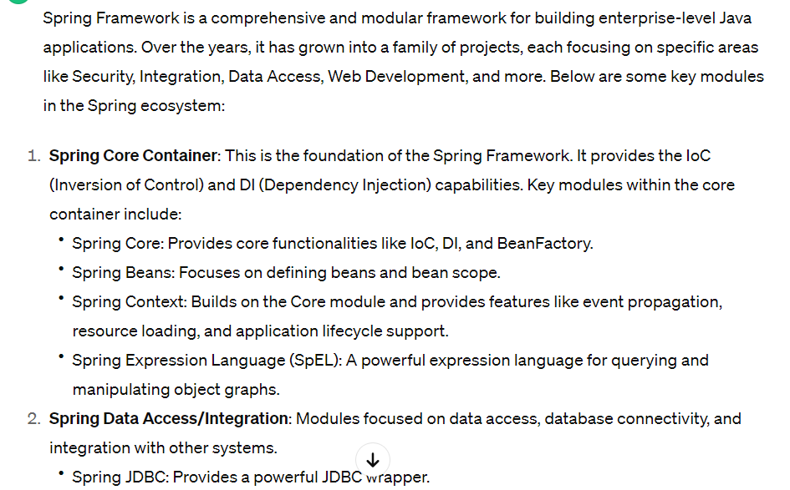

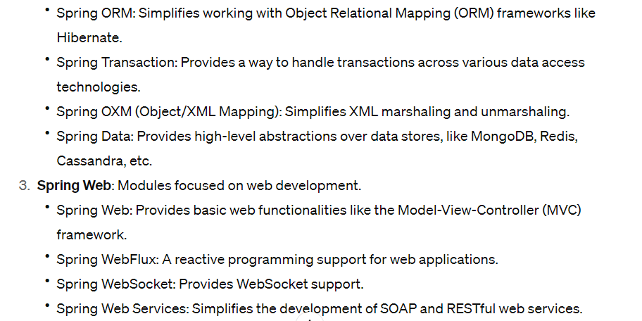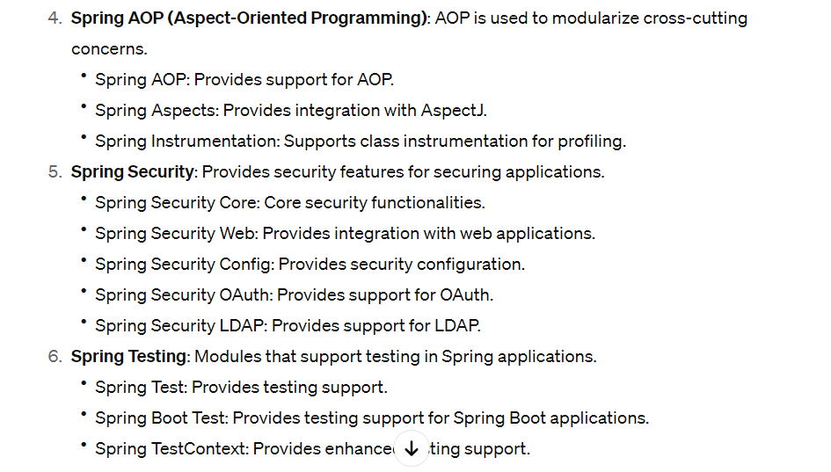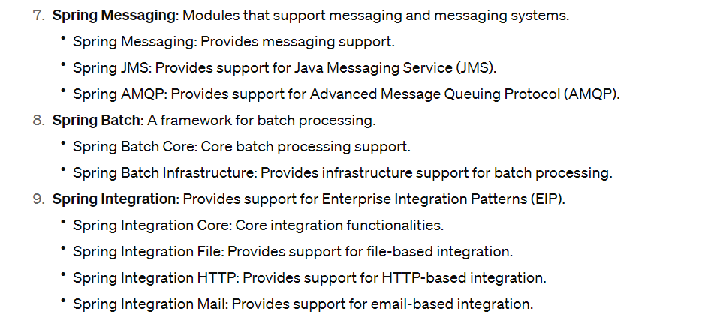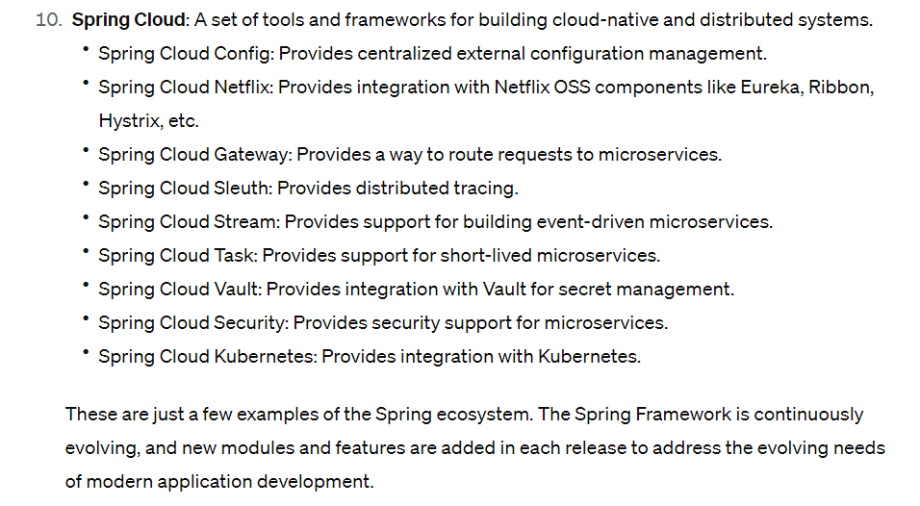

## Consumes and Produces

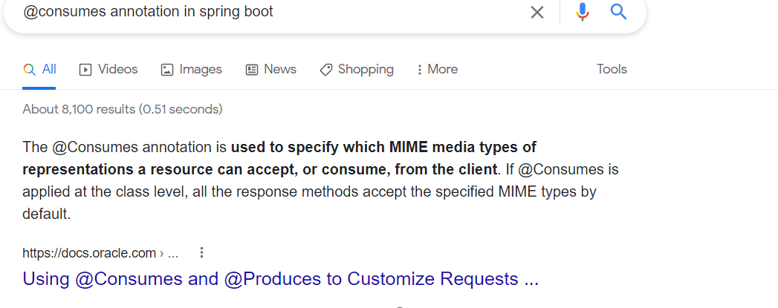

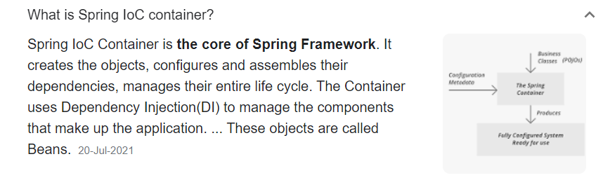

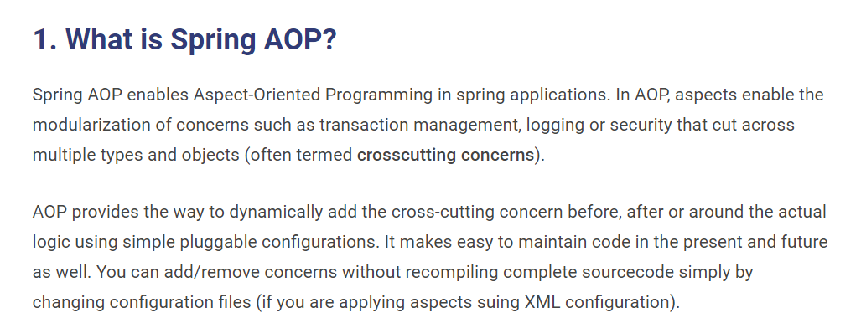

[**https://howtodoinjava.com/spring-aop-tutorial/**](https://howtodoinjava.com/spring-aop-tutorial/)

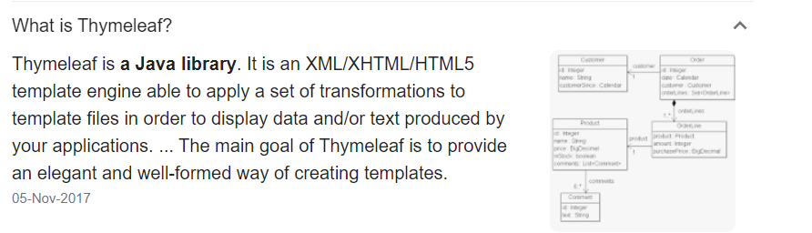

## Actuator

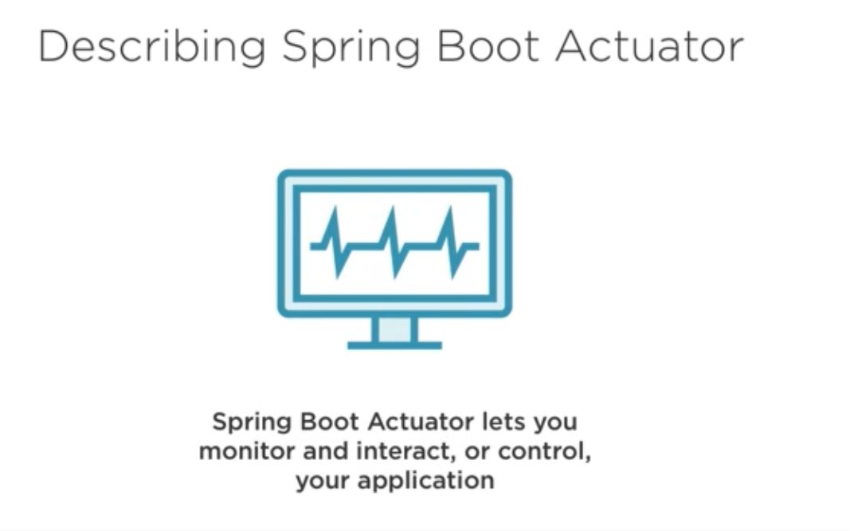

**Exposure all end points :**

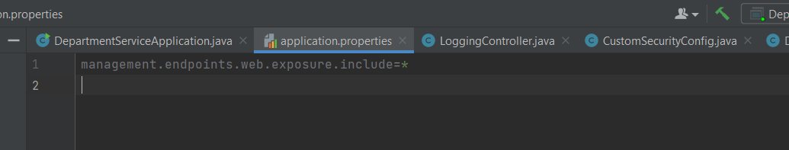

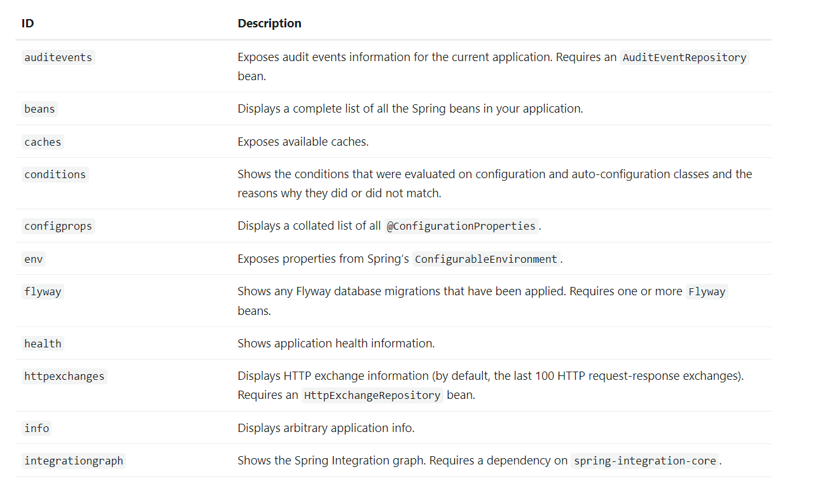

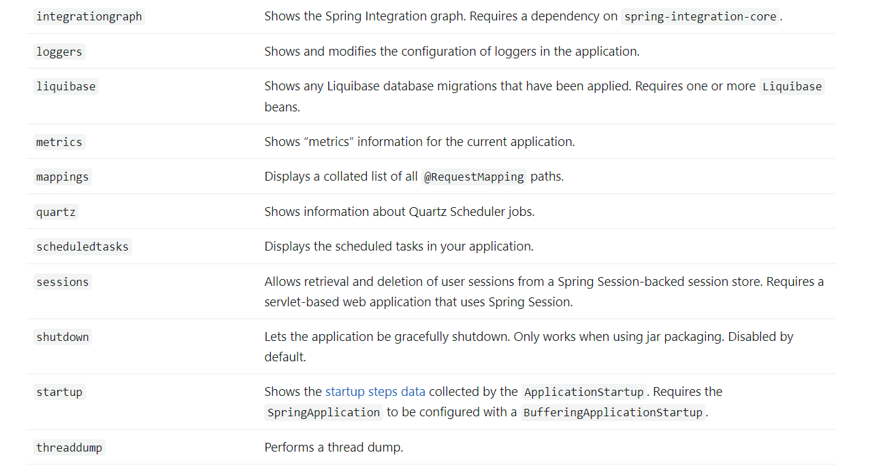

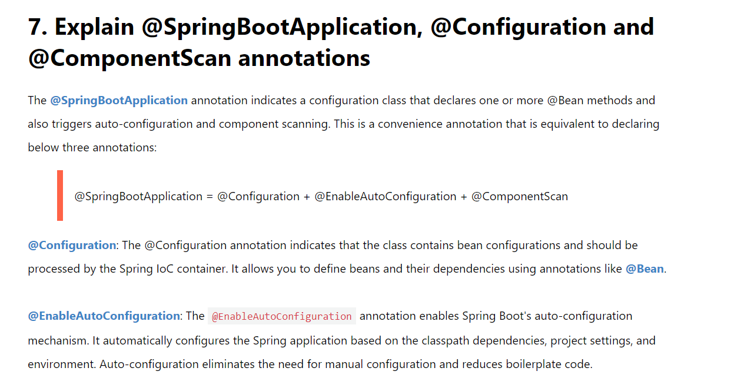

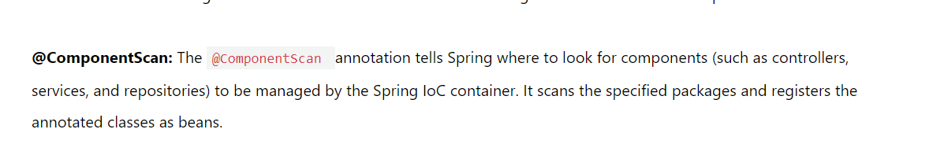

[**https://www.javaguides.net/2018/11/spring-boot-interview-questions-and-answers.html**](https://www.javaguides.net/2018/11/spring-boot-interview-questions-and-answers.html)

## Spring Boot profiles

Spring Boot profiles group parts of the application configuration and make it be available only in certain environments.

A profile is a set of configuration settings. Spring Boot allows to define profile specific property files in the form of application-{profile}.properties. It automatically loads the properties in an application.properties file for all profiles, and the ones in profile-specific property files only for the specified profile. The keys in the profile-specific property override the ones in the master property file.

Note: Spring Boot properties are loaded in a particular order. If several profiles are specified, the last-wins strategy applies.

The @Profile annotation indicates that a component is eligible for registration when the specified profile or profiles are active. The default profile is called default; all the beans that do not have a profile set belong to this profile.

There are plenty of ways of defining active profiles in Spring Boot, including command line arguments, Maven/Gradle settings, JVM system parameters, environment variables, spring.profiles.active property, and SpringApplication methods.

https://zetcode.com/springboot/profile/#:~:text=Spring%20Boot%20profiles%20group%20parts,form%20of%20application%2D%7Bprofile%7D.

## Overview of Spring Boot Dev Tools

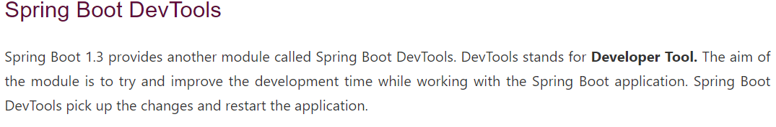

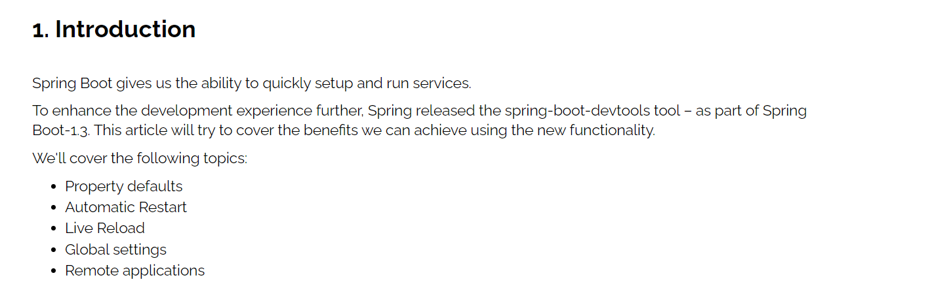

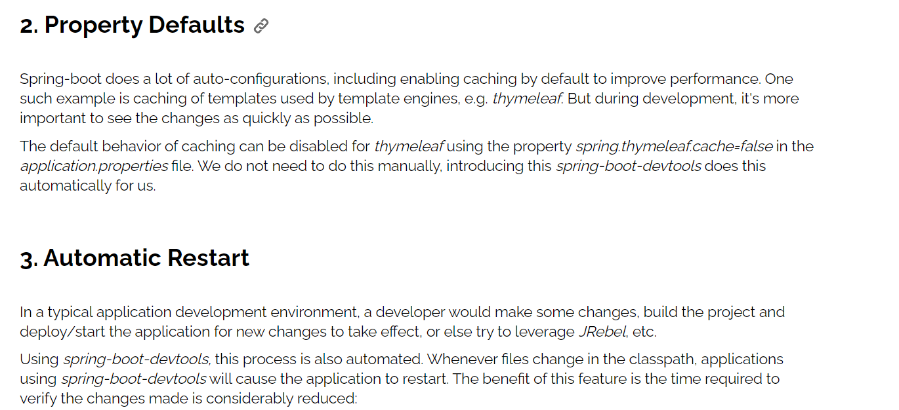

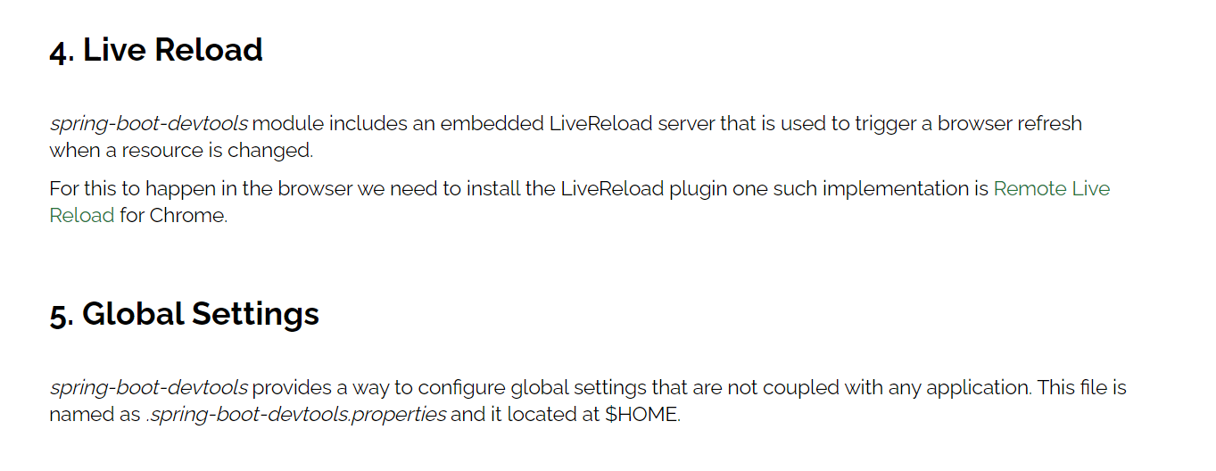

## Spring Data :

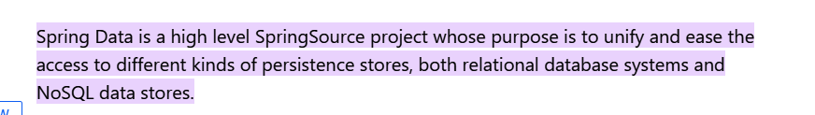

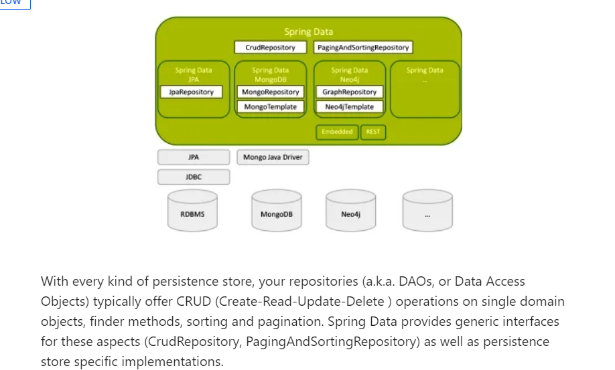

## Spring Security

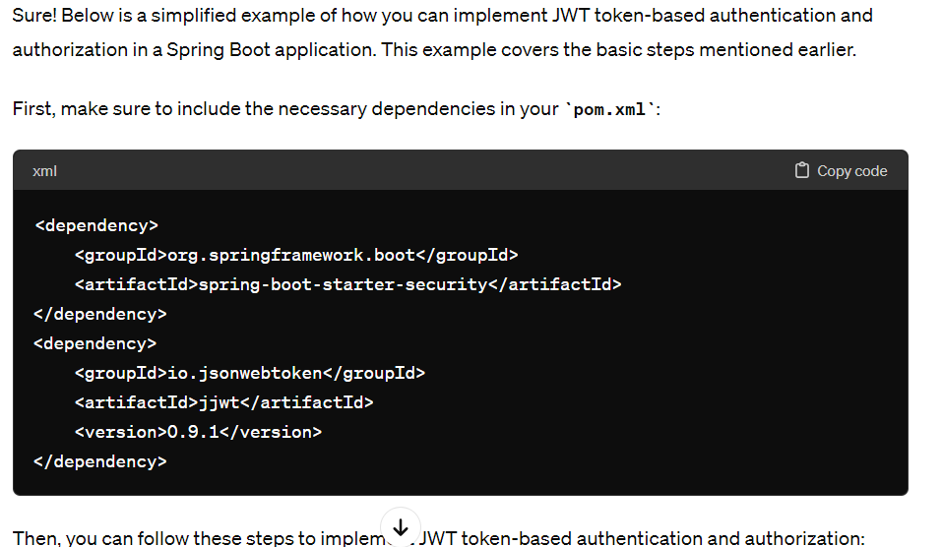

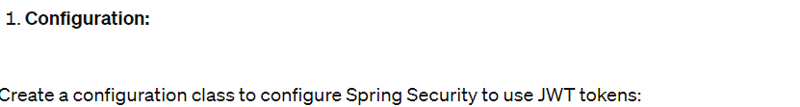

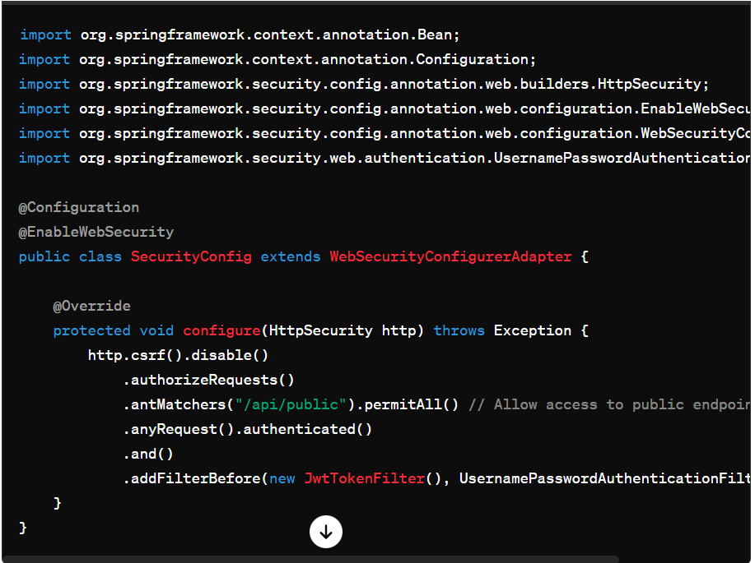

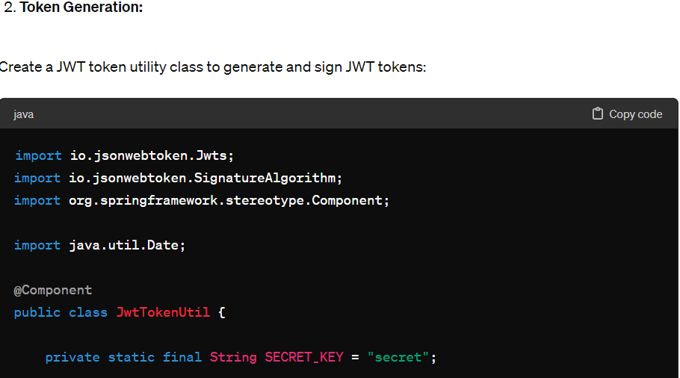

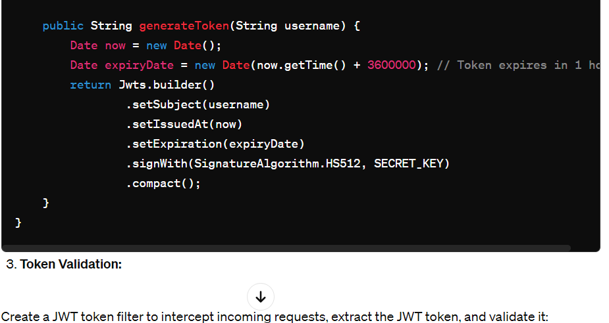

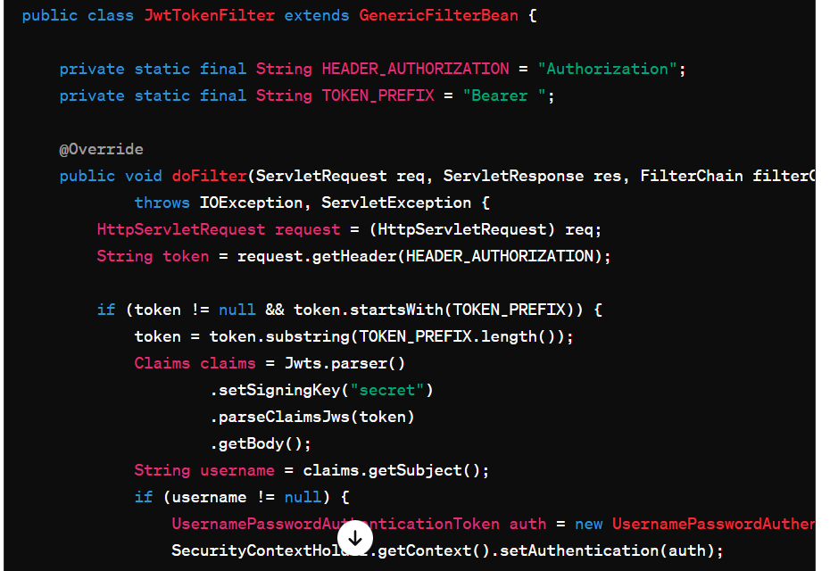

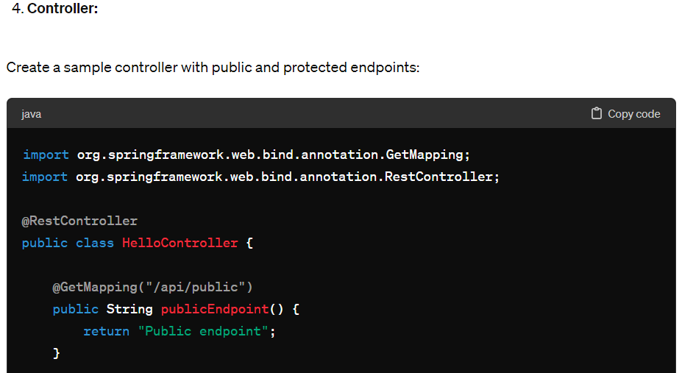

## Interview questions

**spring repository query for get employee details whose age is something and address is something**

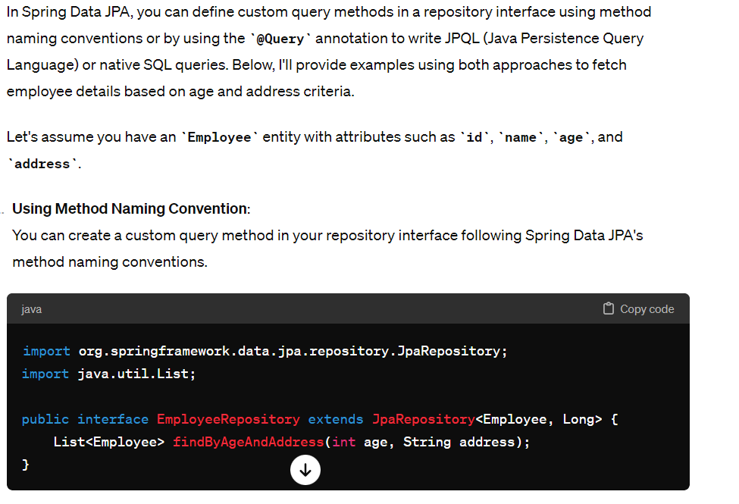

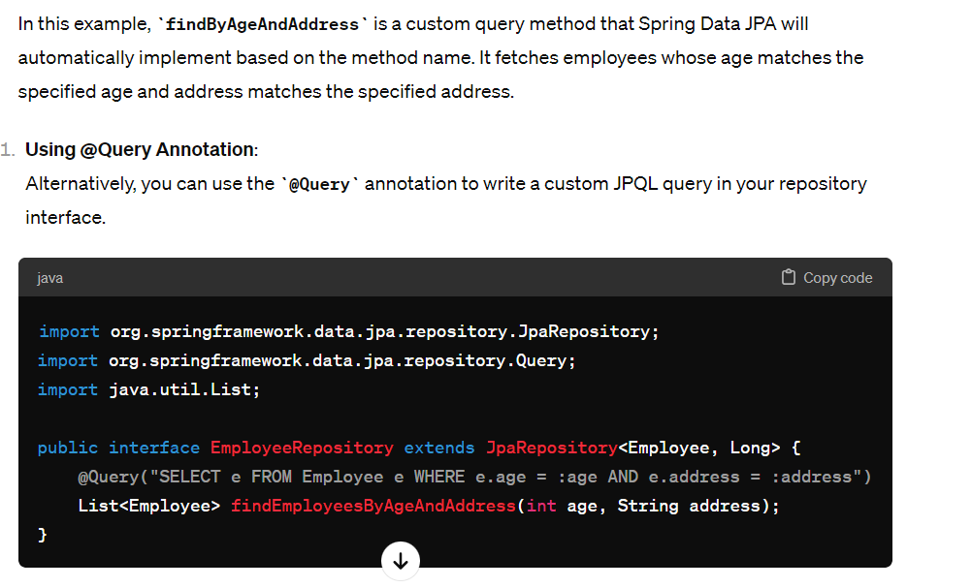

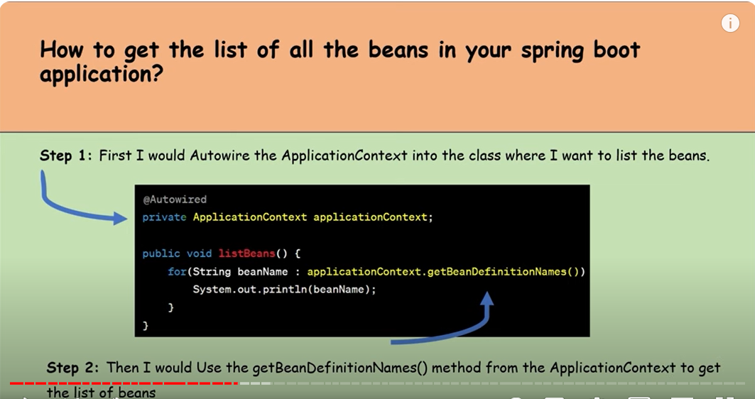

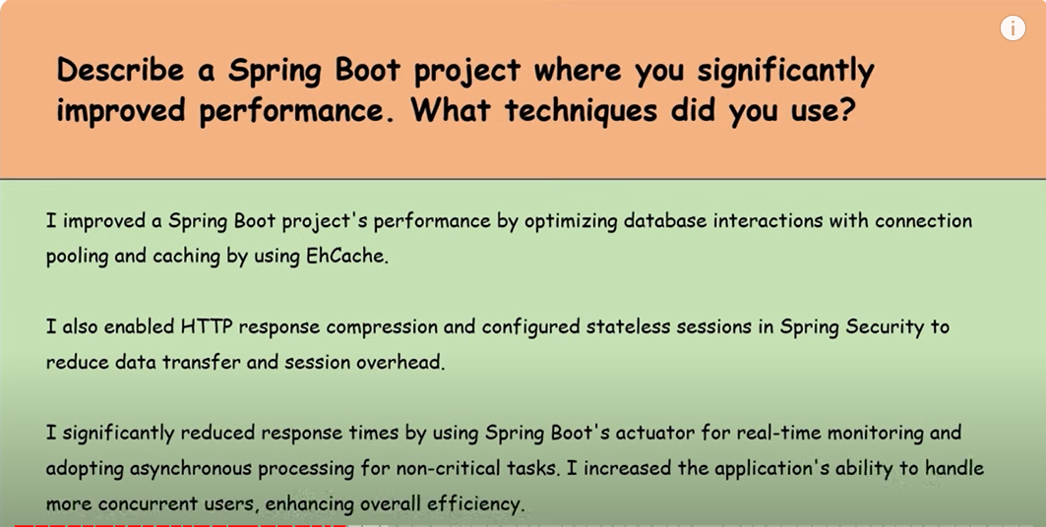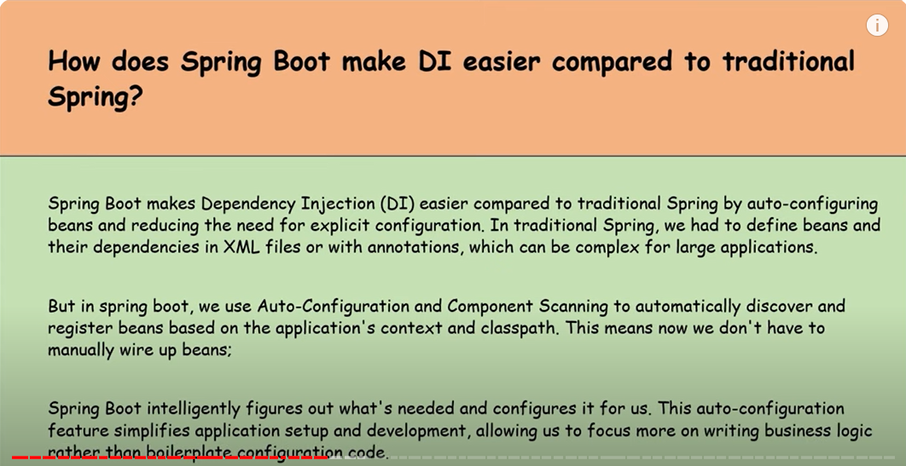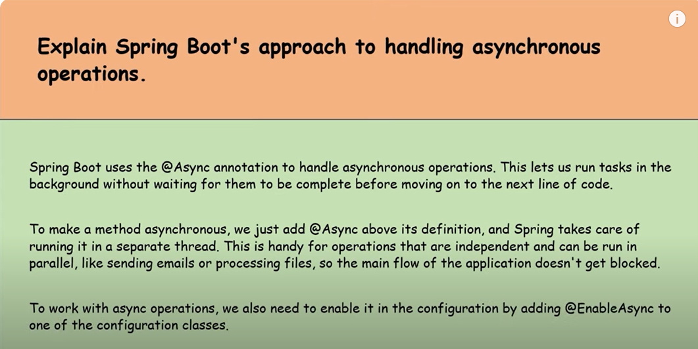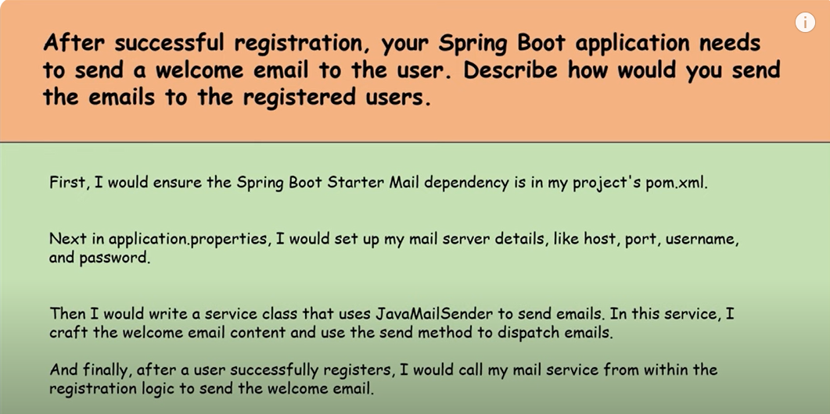

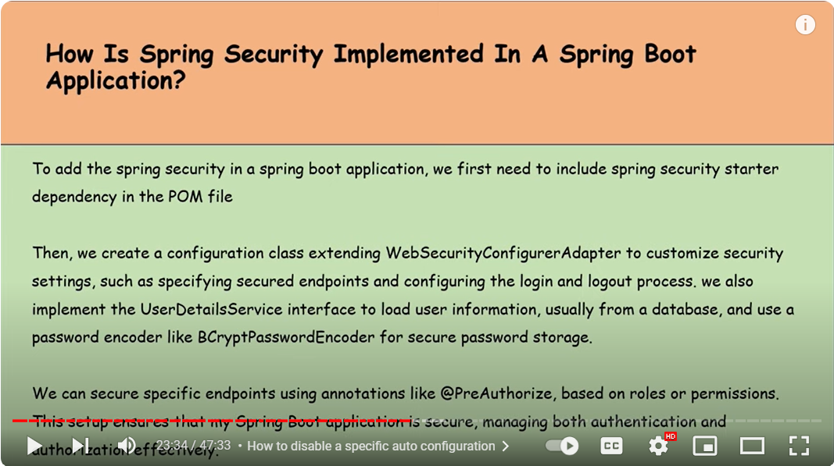

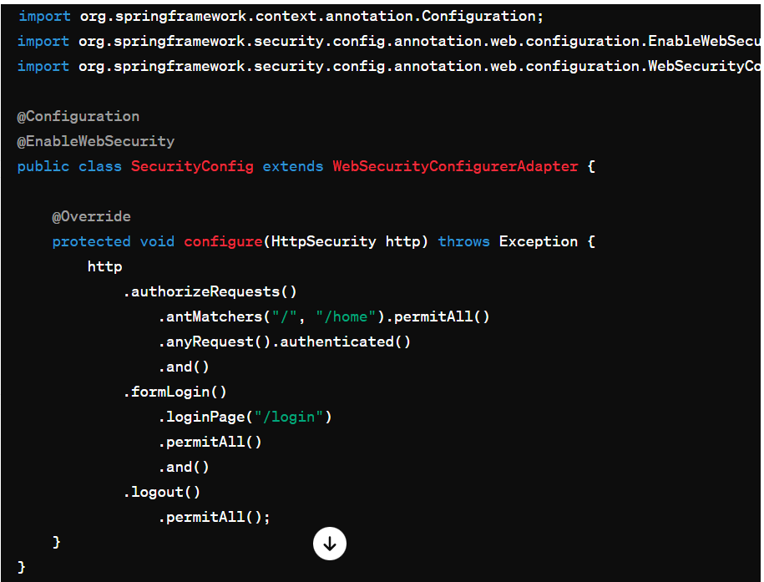

In the above example, we have configured security rules using **HttpSecurity** to permit access to certain URLs (**"/", "/home"**) without authentication, while requiring authentication for other URLs. We've also configured a custom login page (**/login**) and allowed logout for all users.

1. **User Authentication**: Spring Security supports various authentication mechanisms such as in-memory authentication, JDBC authentication, LDAP authentication, and custom authentication providers. You can configure authentication details in the security configuration class:

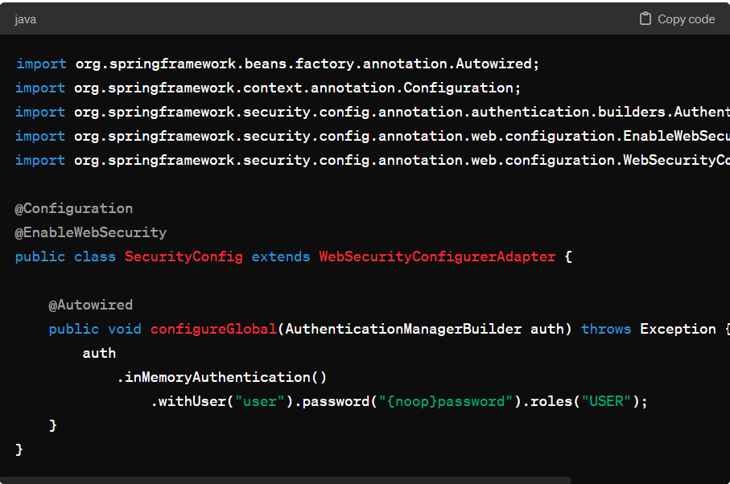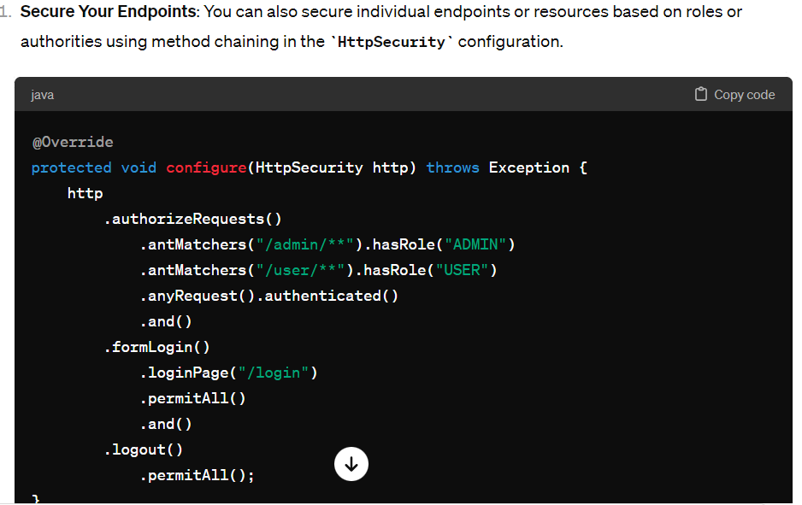

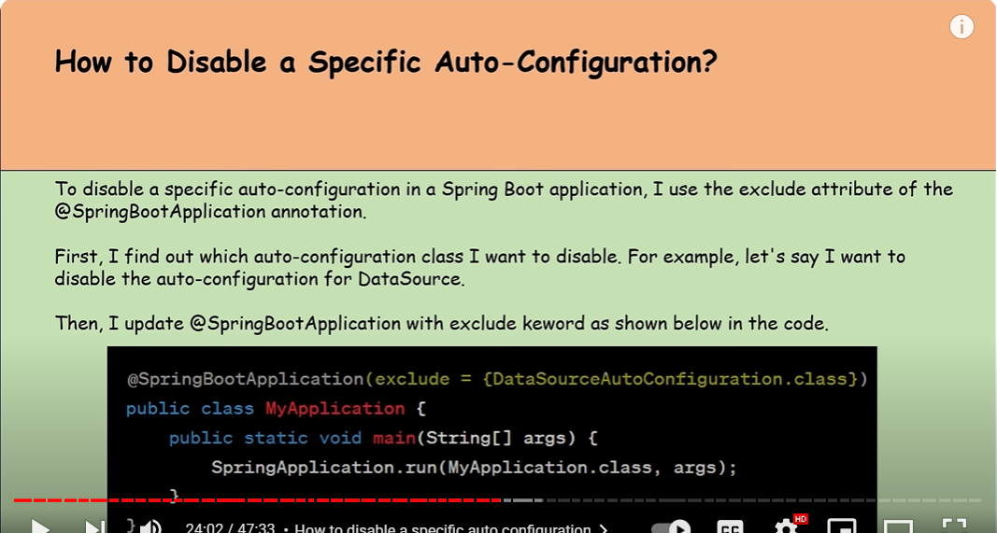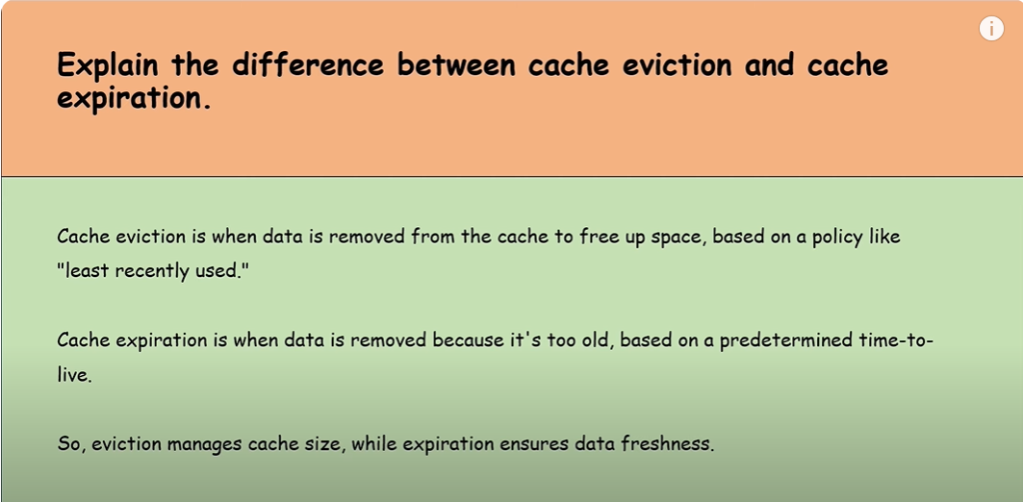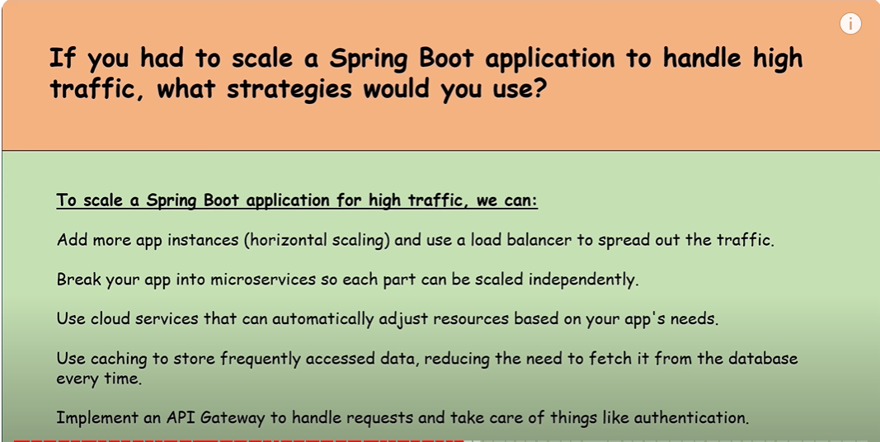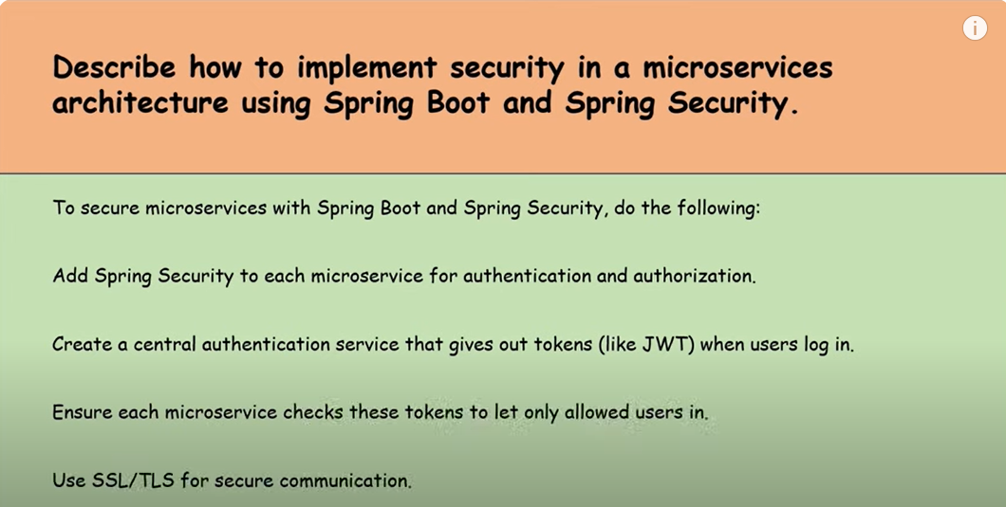

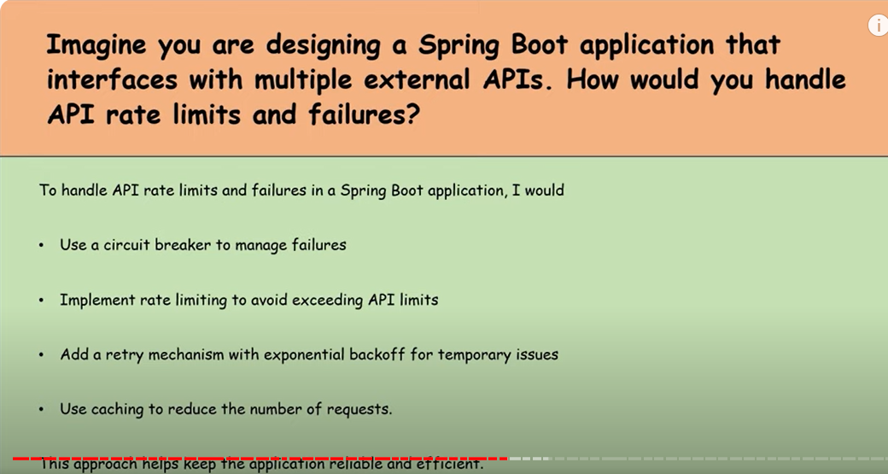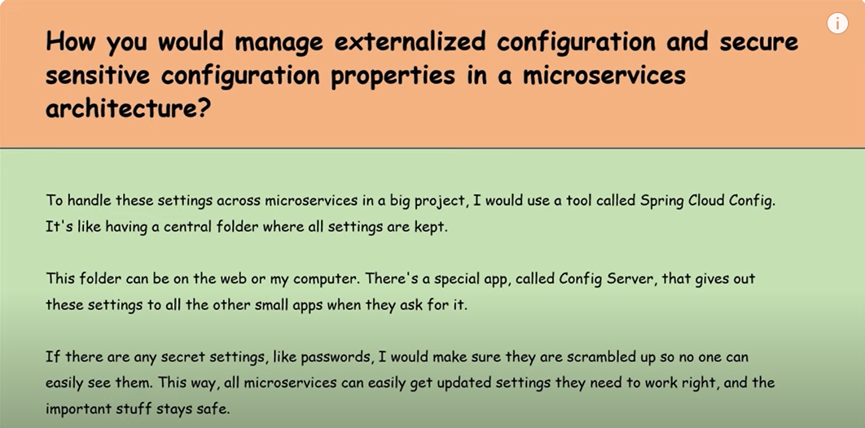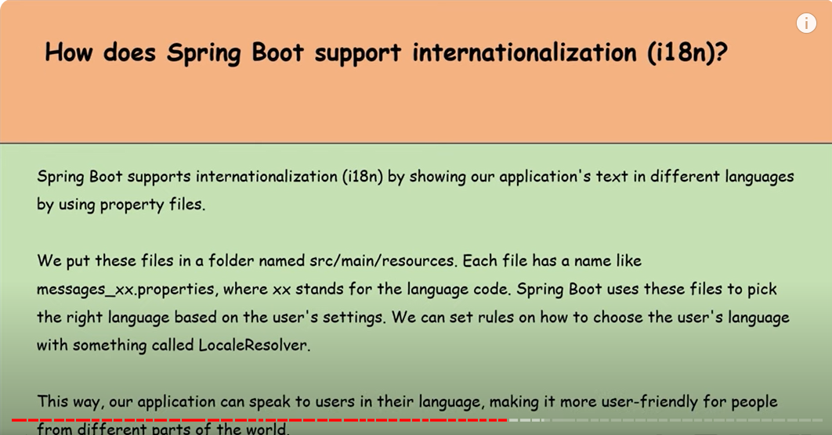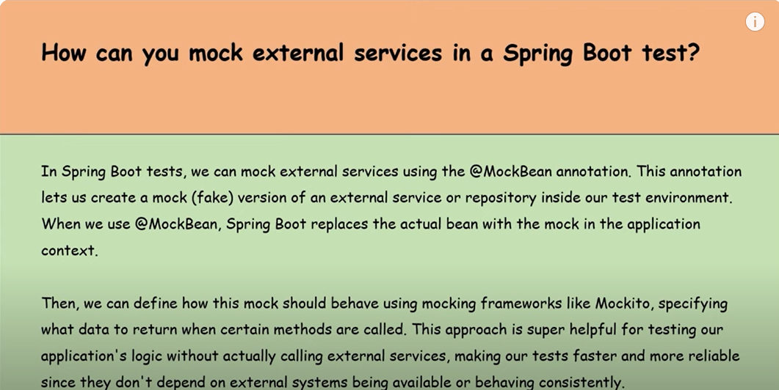

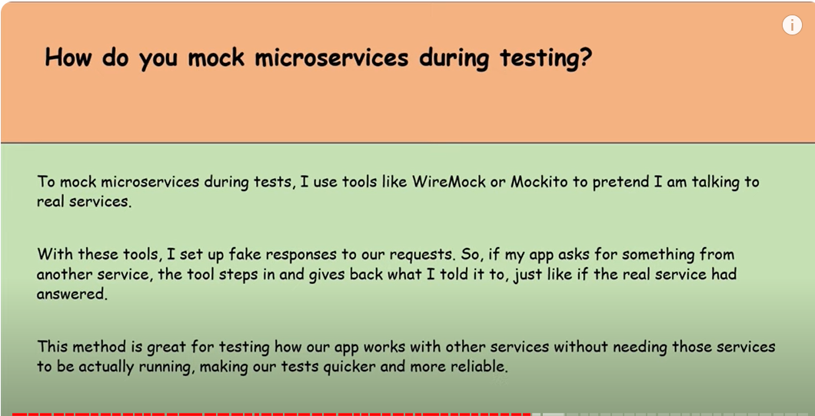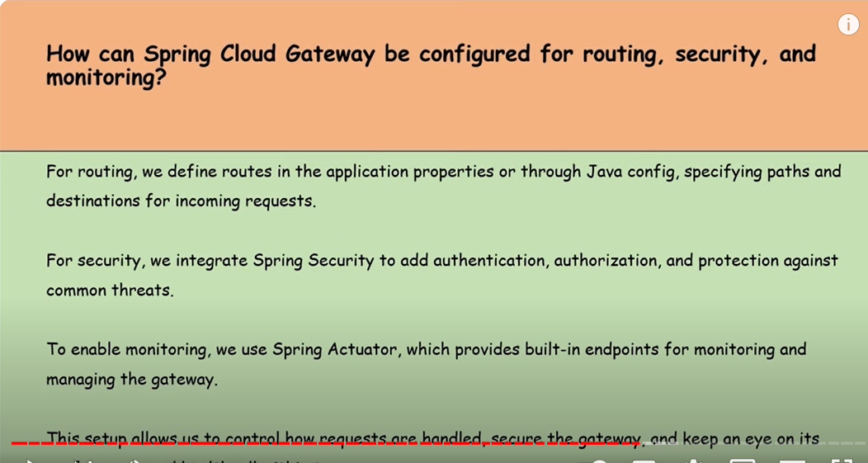

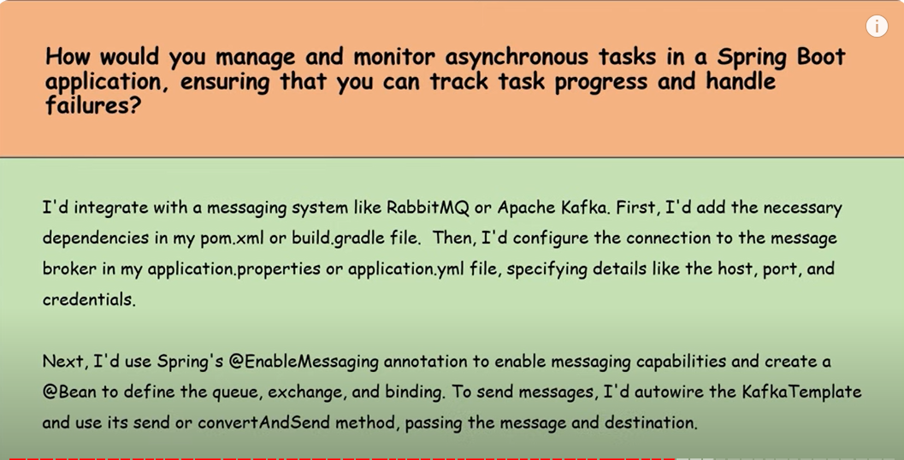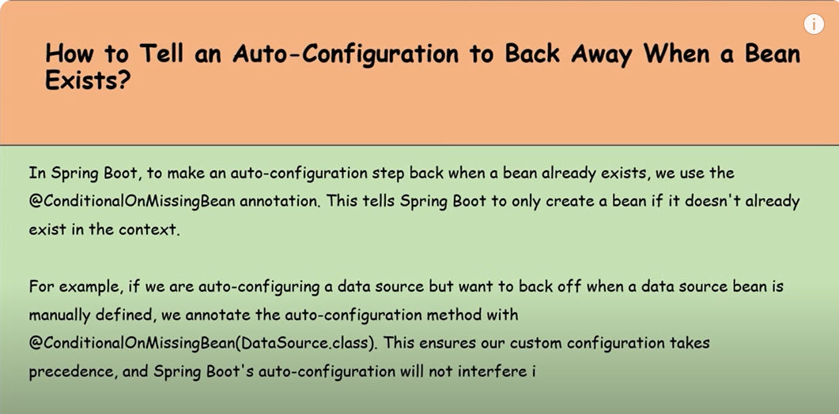

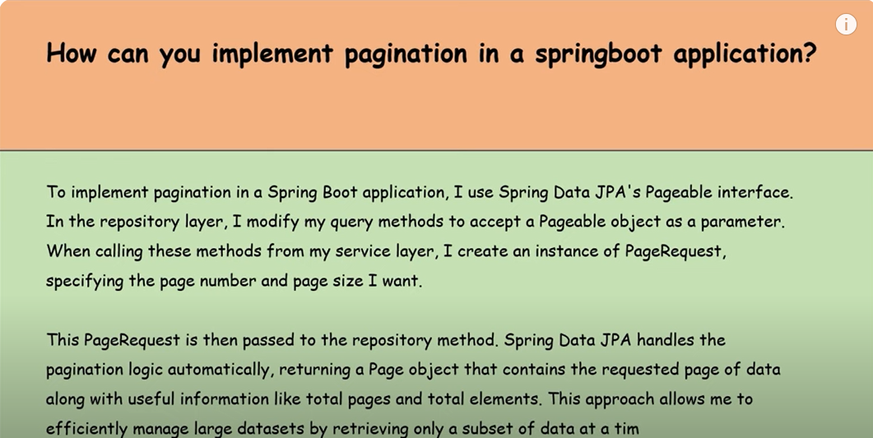

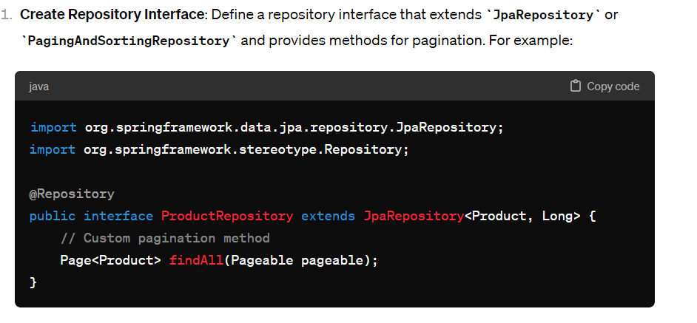

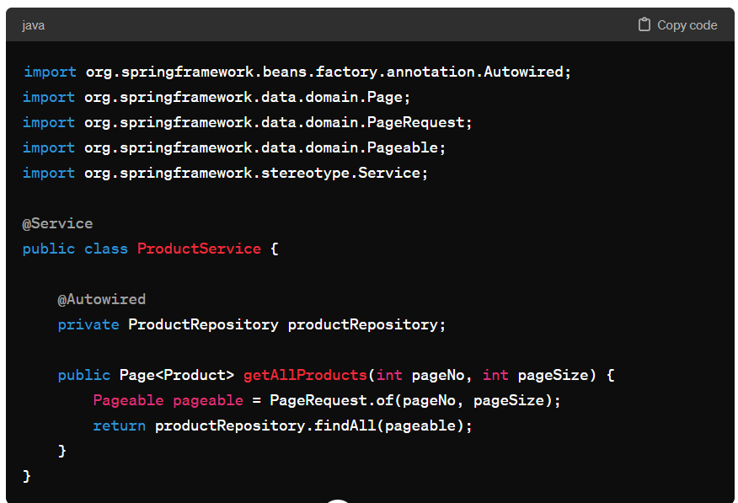

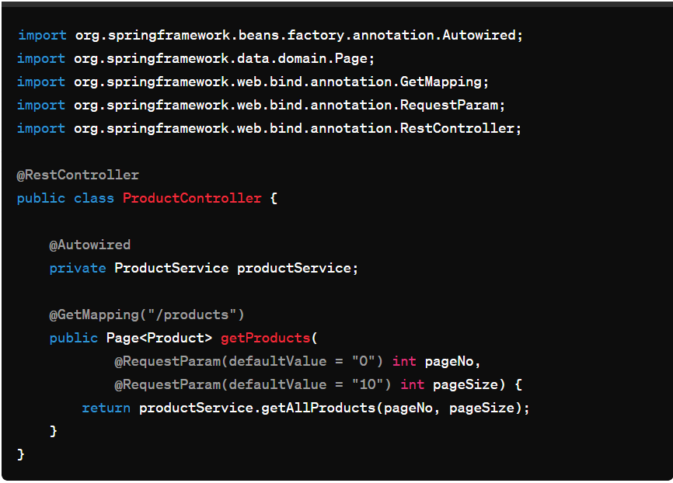

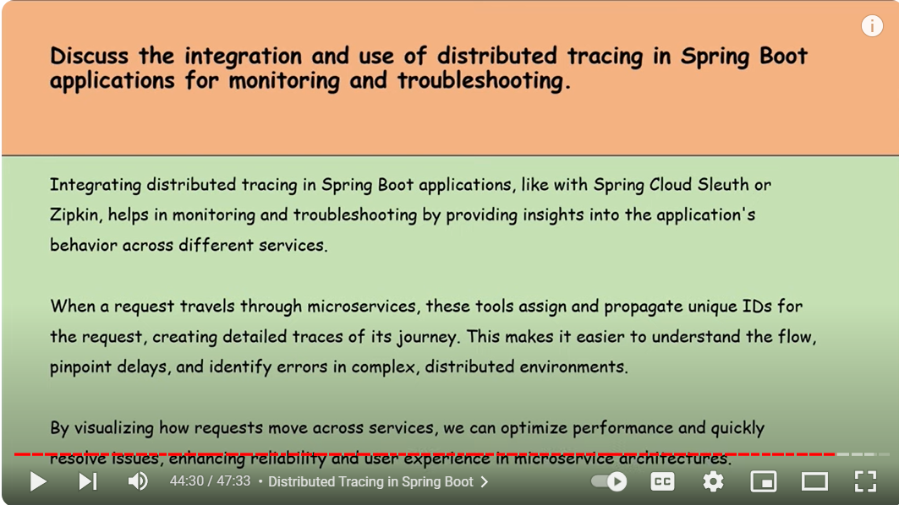

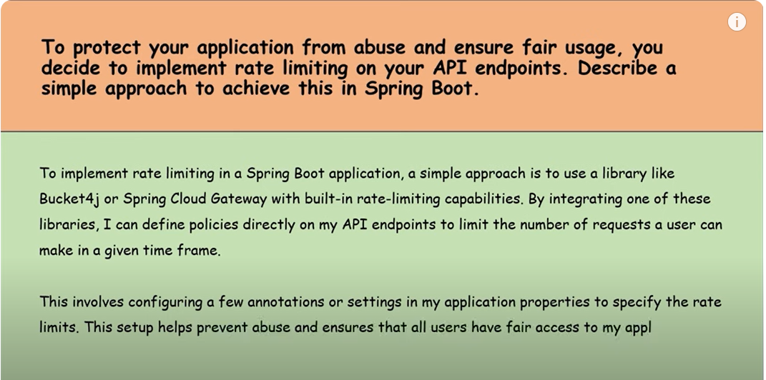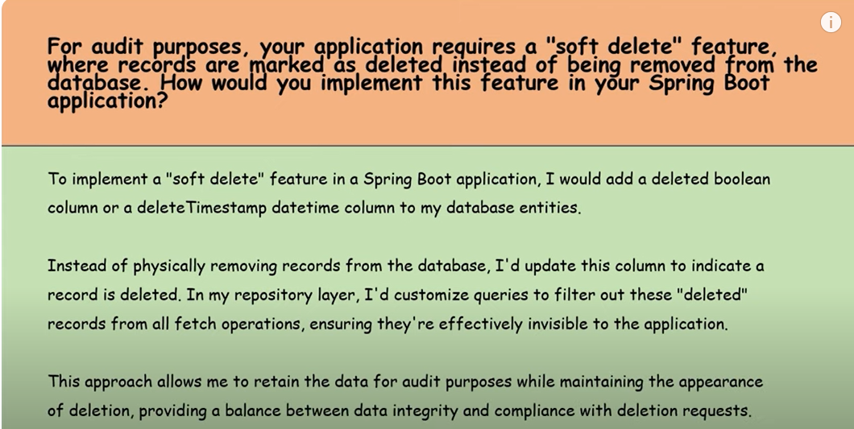

# SQL

## Query

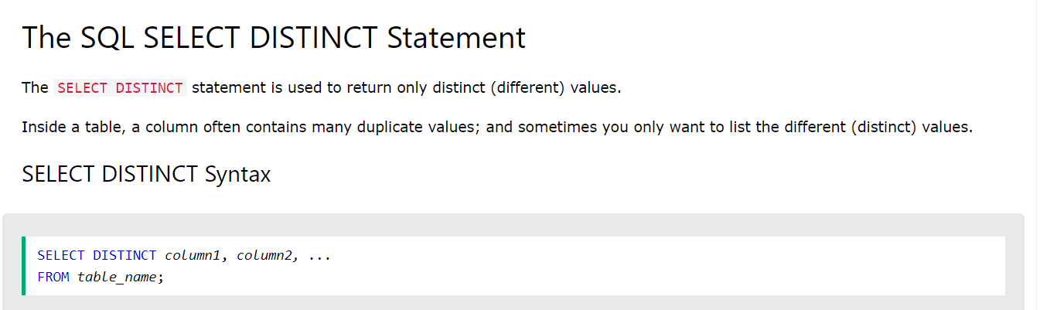

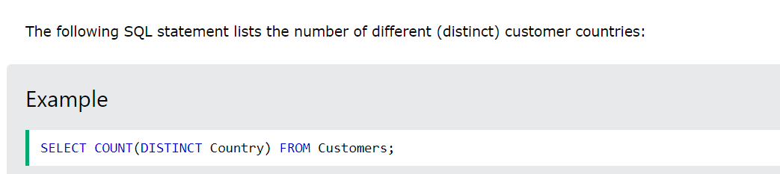

1. **maximum salary of each department from the "employees" table**

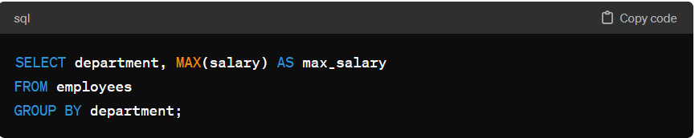

1. **second highest salary from “person” table**

SELECT *

FROM person

ORDER BY salary DESC

LIMIT 1

OFFSET 1;

1. **Calculate the total number of employees in each department:**

SELECT DepartmentName, count(*) as count

FROM person

GROUP BY DepartmentName;

1. **List departments with more than 5 employees and their average salary:**

SELECT department, COUNT(*) AS employee_count, AVG(salary) AS avg_salary

FROM employees

GROUP BY department

HAVING COUNT(*) > 5;

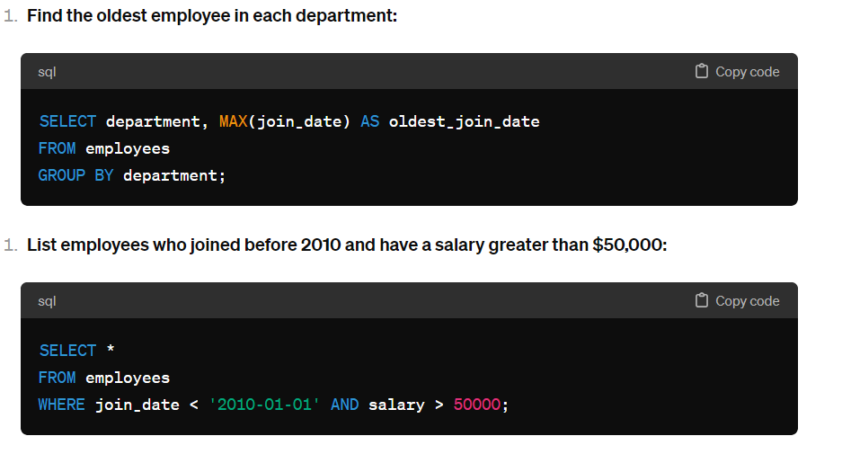

1. **Calculate the total salary expense for each department:**

SELECT department, SUM(salary) AS total_salary_expense

FROM employees

GROUP BY department;

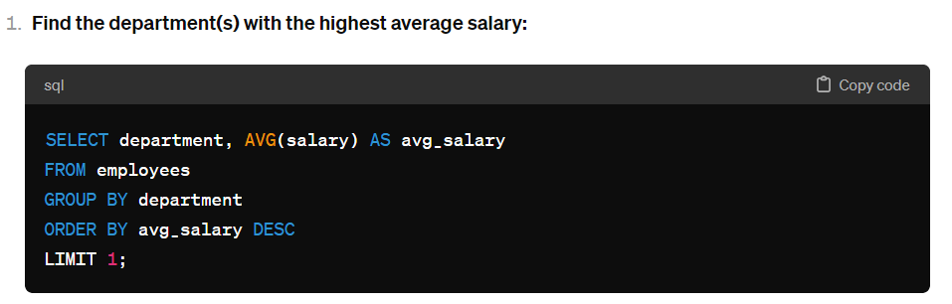

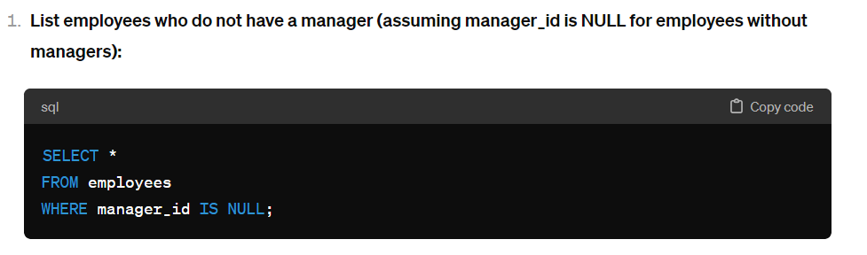

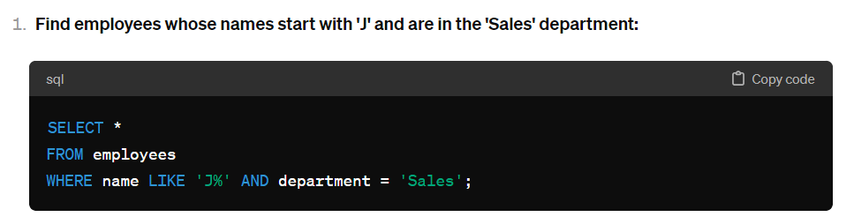

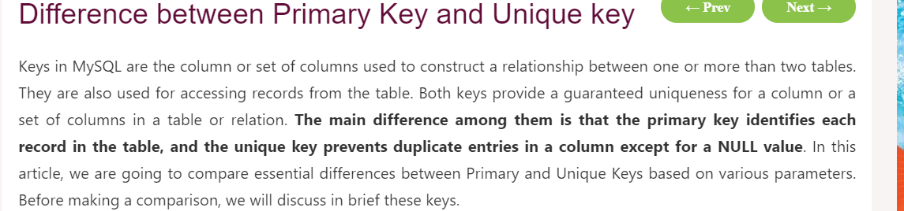

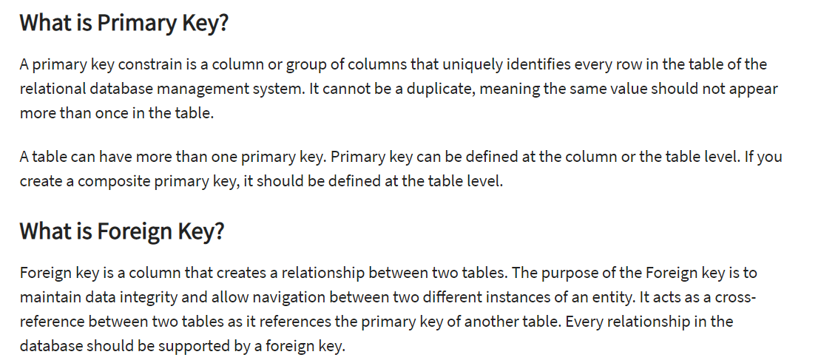

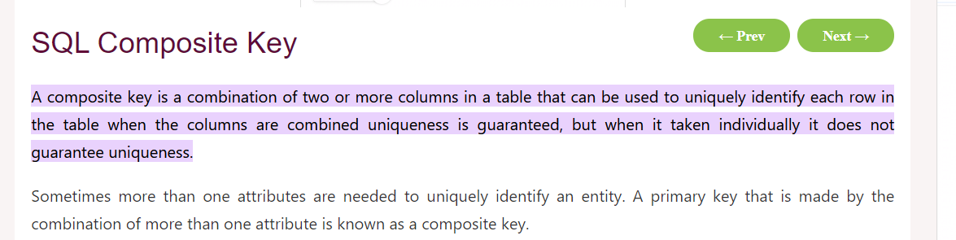

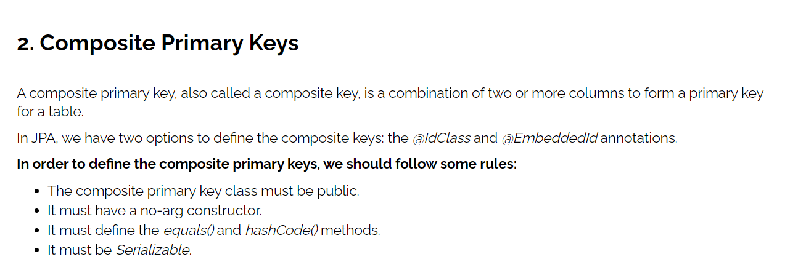

[**https://www.baeldung.com/jpa-composite-primary-keys**](https://www.baeldung.com/jpa-composite-primary-keys)

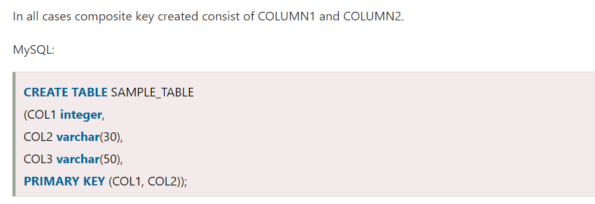

## Joins

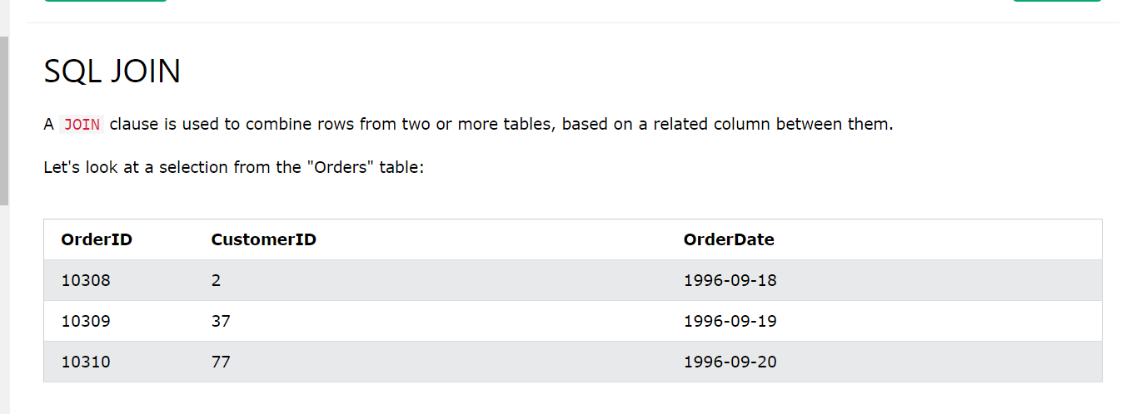

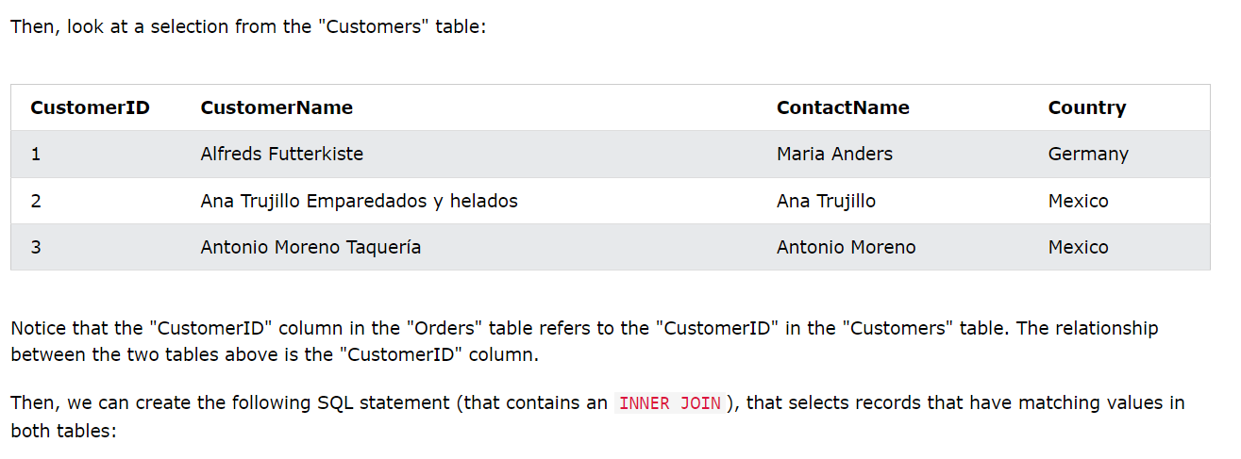

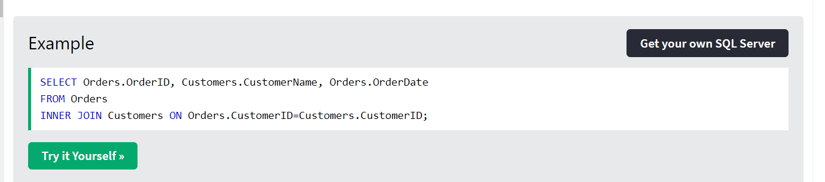

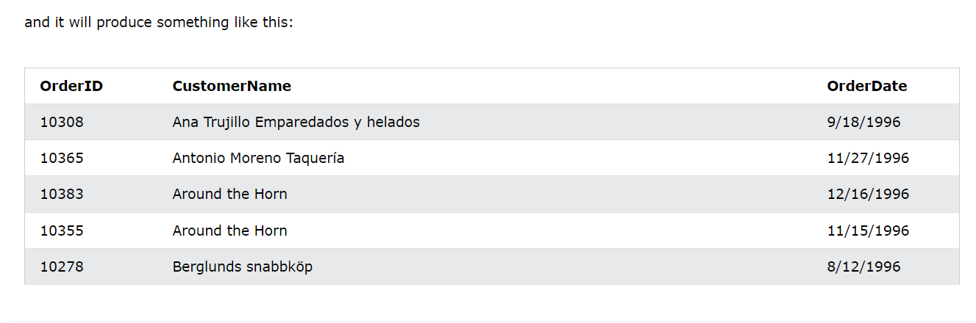

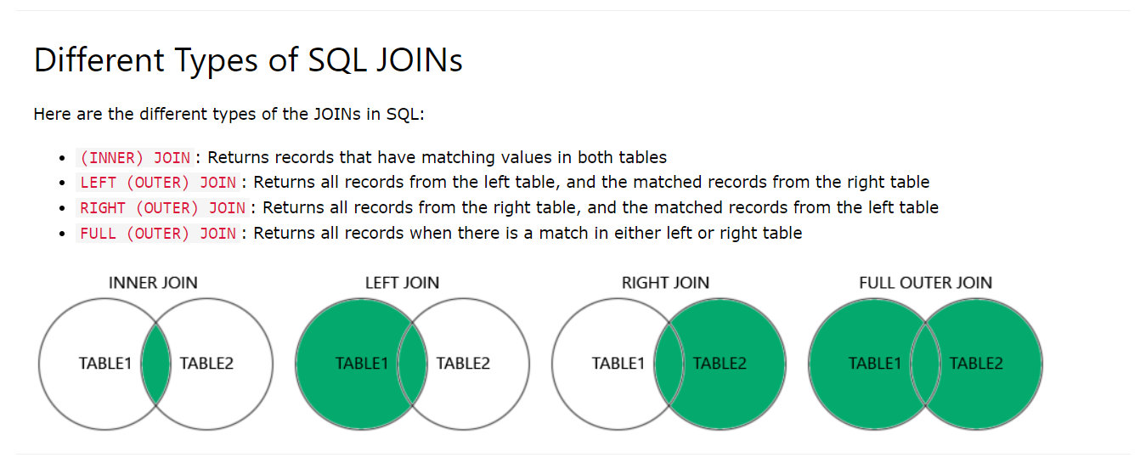

## SCHEMA

In the context of databases and data management systems, a **schema** refers to the structure or blueprint that defines the organization of data in a database. It represents the logical view of the entire database, including tables, columns, data types, relationships, constraints, and other properties.

Let's break down the concept of schema further:

1. **Database Schema**: A database schema provides a framework for how data is organized and stored in a database management system (DBMS). It includes the following components:
   * **Tables**: Represent entities or concepts in the real world (e.g., customers, products, orders). Each table consists of rows and columns where data is stored.
   * **Columns**: Define the attributes or properties of the entities. Each column has a data type (e.g., integer, varchar, date) that specifies the kind of data it can store.
   * **Primary Keys**: Columns or combination of columns that uniquely identify each row in a table. Helps in enforcing data integrity and establishing relationships between tables.
   * **Foreign Keys**: Columns that establish relationships between tables. They typically reference the primary key of another table, enforcing referential integrity.
   * **Constraints**: Rules or conditions that define the valid values or operations on data. Common constraints include NOT NULL, UNIQUE, CHECK, and FOREIGN KEY constraints.
   * **Indexes**: Data structures that improve the retrieval performance of queries by providing quick access paths to data in tables.
   * **Views**: Virtual tables derived from one or more underlying tables. Views can present a subset of data or transform data in a specific way without altering the underlying tables.
   * **Stored Procedures, Functions, and Triggers**: Programmatic constructs that enable executing code logic within the database server for tasks such as data manipulation, validation, and automation.
2. **Types of Schemas**: In a DBMS, there are typically two main types of schemas:
   * **Physical Schema**: Describes the physical storage structure of the database on disk, including file organization, indexing, and data storage mechanisms. It deals with aspects such as how data is stored, partitioned, and accessed at the physical level.
   * **Logical Schema**: Describes the logical structure of the database, including tables, views, relationships, constraints, and permissions. It focuses on how data is organized and related conceptually, irrespective of the physical storage details.
3. **Schema Evolution**: Over time, databases may undergo schema changes to accommodate new requirements, modify existing structures, or improve performance. Schema evolution involves tasks such as adding or dropping tables/columns, modifying data types, creating new relationships, and migrating data during upgrades or optimizations.
4. **Database Management and Design**: Proper schema design is crucial for efficient data management, data integrity, performance optimization, and scalability of database systems. It requires understanding the data model, business requirements, relationships between entities, and querying patterns to design an effective schema.

In summary, a schema in a database defines the logical and physical structure of data storage, including tables, columns, keys, constraints, and other database objects. It serves as a foundation for organizing and managing data effectively within a database management system.

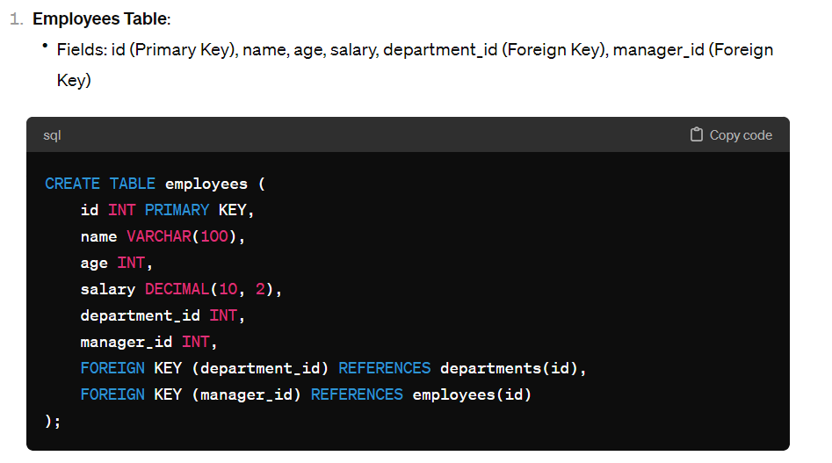 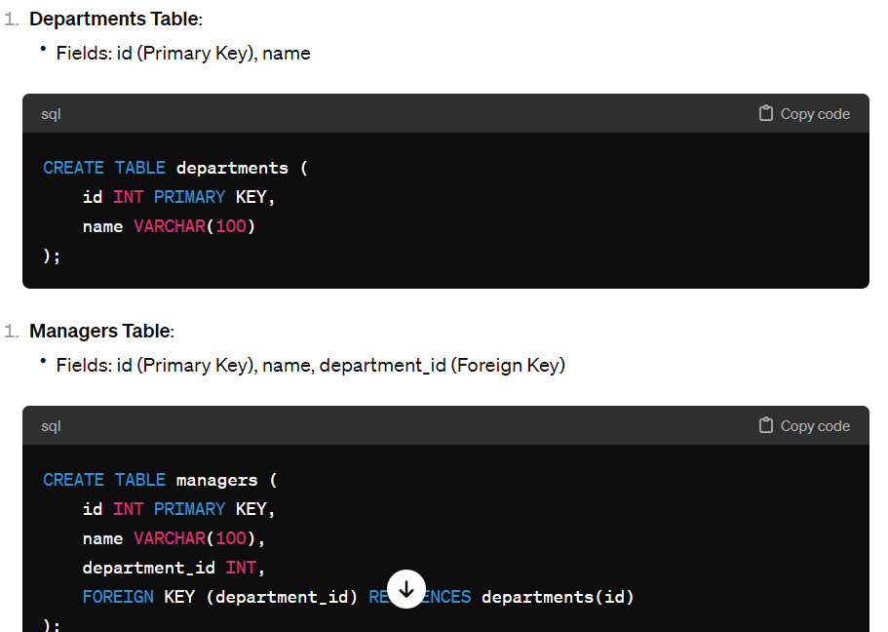 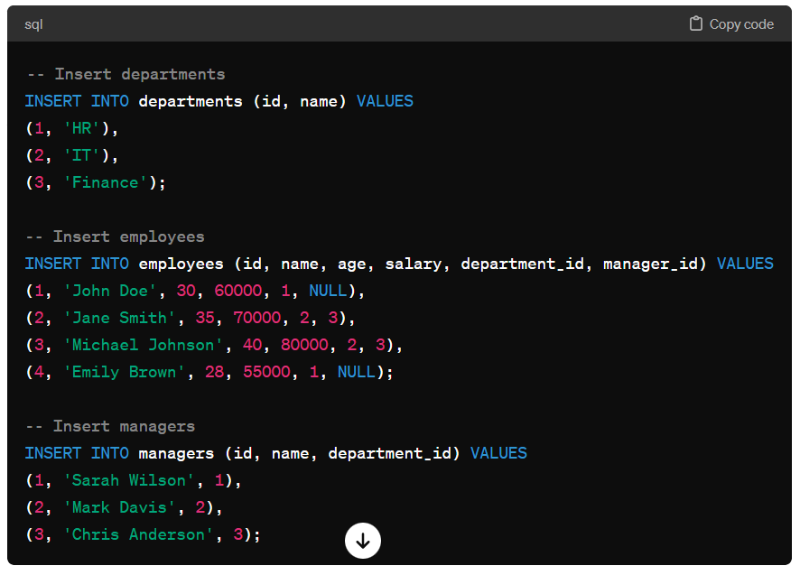

## INDEXS

Indexes in databases are data structures that improve the speed of data retrieval operations on tables. They are critical for optimizing query performance, especially in large databases with substantial amounts of data. Let's dive deeper into the concept of indexes in databases:

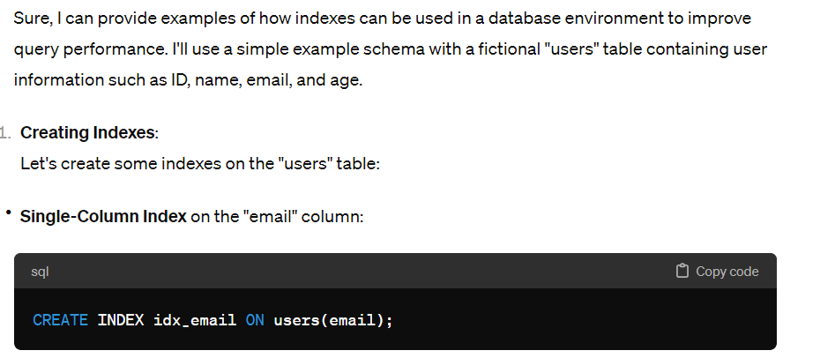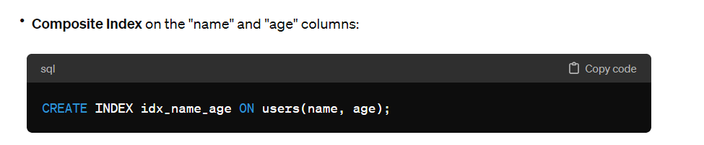

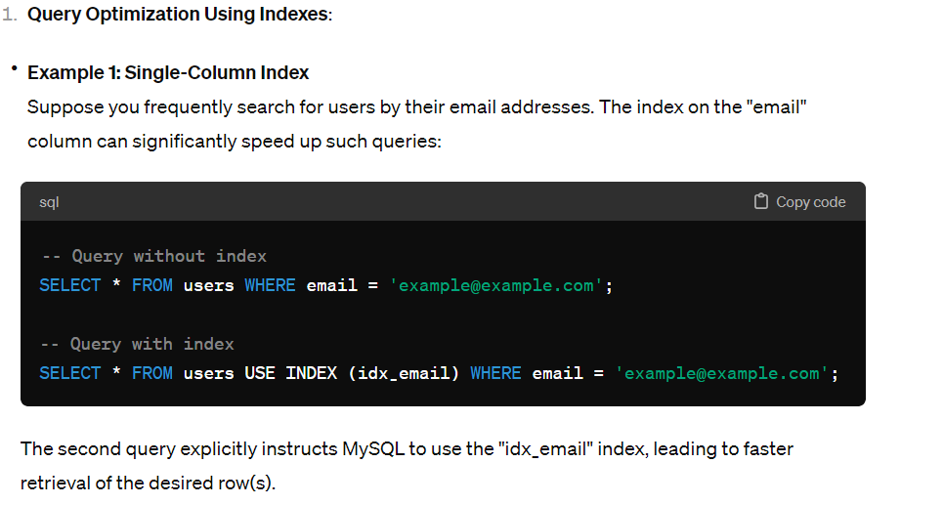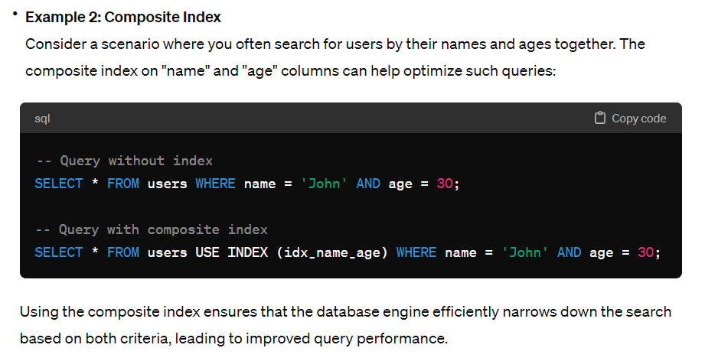

## VIEWS

Virtual tables derived from one or more underlying tables. Views can present a subset of data or transform data in a specific way without altering the underlying tables.

In MySQL, a view is a virtual table that represents the result of a stored query. Unlike physical tables, which store data directly, views do not store data themselves but provide a way to present data from one or more underlying tables in a structured format. Views are especially useful for simplifying complex queries, providing a logical layer of abstraction, and enhancing data security by controlling access to specific columns or rows. 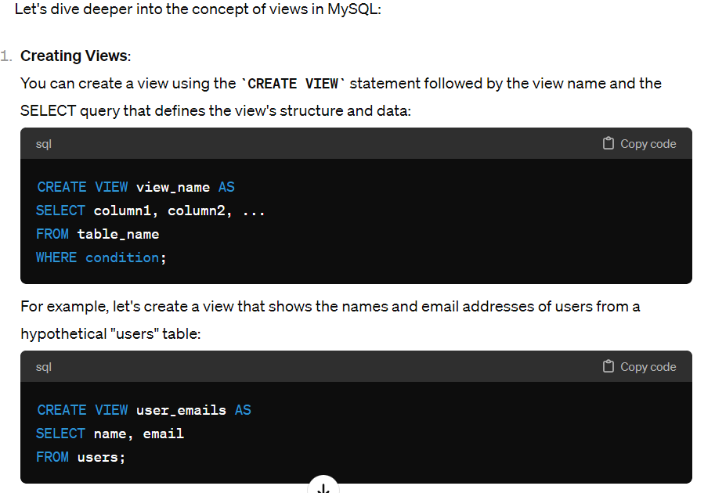 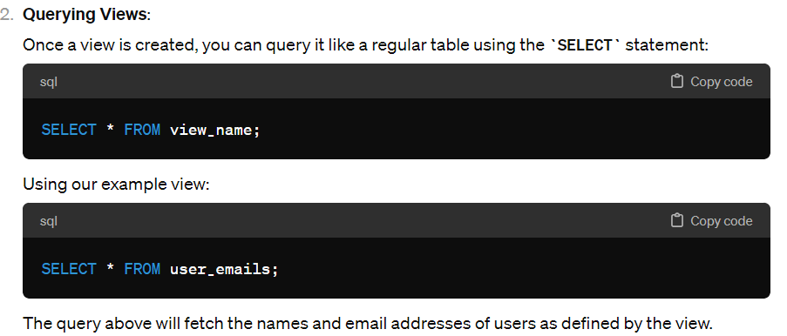

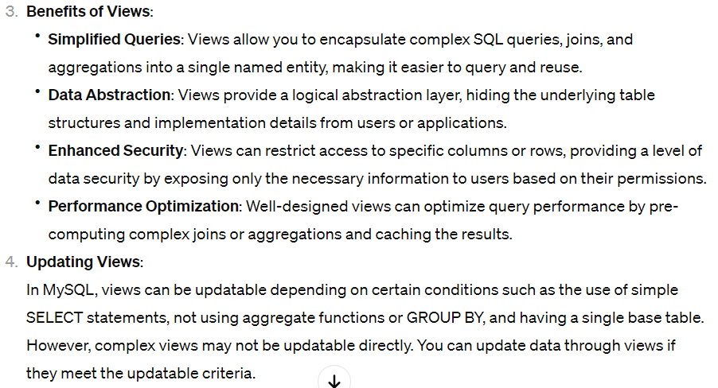

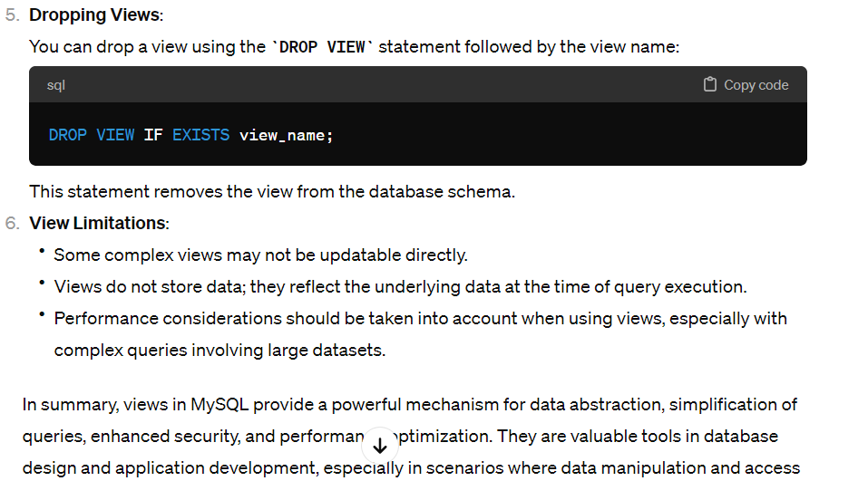

## PROCEDURES

In the context of databases, a procedure is a named collection of SQL statements that are stored in the database and can be executed as a single unit. Procedures encapsulate a set of actions or operations that can be reused and called from various parts of an application or within other SQL statements. They help improve code modularity, reduce code duplication, and enhance security by controlling access to database operations.

Here are key points about procedures in database management systems:

1. **Types of Procedures**:
   * **Stored Procedures**: These are procedures that are stored in the database and can be called from client applications or other SQL statements. They can accept parameters, execute SQL statements, perform calculations, and return results.
   * **Stored Functions**: Similar to stored procedures, stored functions also encapsulate a set of SQL statements but return a value. They are often used in SQL expressions to perform calculations or transformations.
2. **Benefits of Procedures**:
   * **Code Reusability**: Procedures allow you to write complex logic once and reuse it multiple times from different parts of your application or other procedures.
   * **Modularity**: By organizing code into procedures, you can modularize your database logic, making it easier to maintain and troubleshoot.
   * **Improved Performance**: Stored procedures can enhance performance by reducing network traffic (in client-server applications) and optimizing query execution plans.

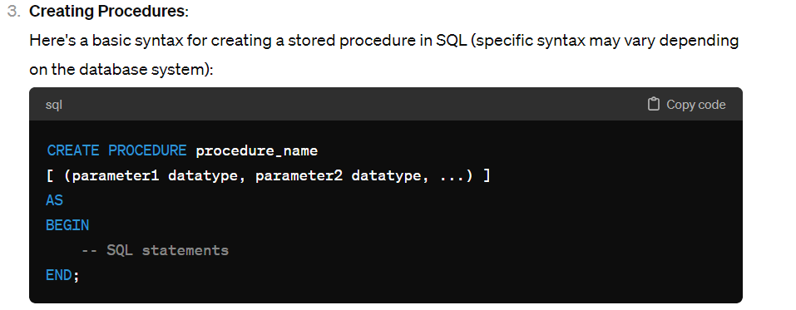 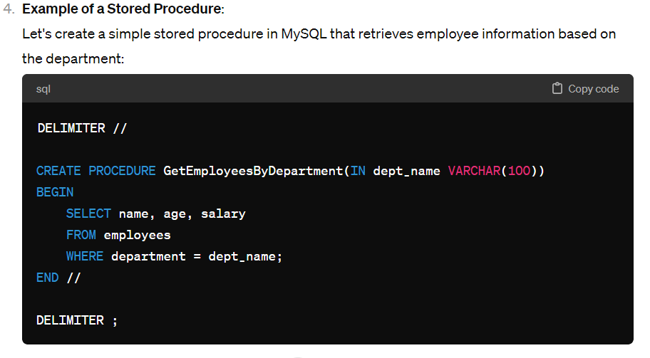 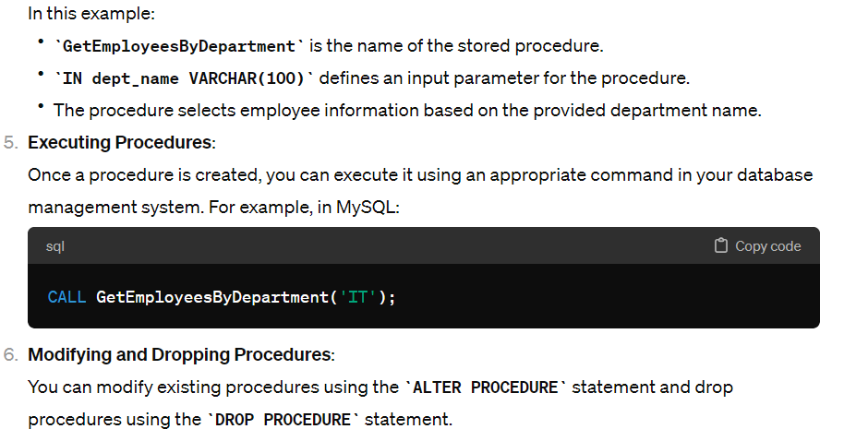

## FUNCTIONS

In the context of databases, a function is a named, reusable set of SQL statements that performs a specific task and returns a value. Functions are similar to procedures in that they encapsulate logic, but they are primarily used to compute and return a single value rather than executing a series of statements like procedures. Functions can be called from SQL statements, queries, or other functions, making them useful for calculations, transformations, and data processing tasks within a database.

Here are key points about functions in database management systems:

1. **Types of Functions**:
   * **Scalar Functions**: These functions return a single value based on input parameters. They are commonly used for calculations, string manipulations, date operations, and more.
   * **Table-Valued Functions**: These functions return a result set (table) based on input parameters. They can be used in queries as if they were tables, allowing for complex data manipulations and filtering.
2. **Benefits of Functions**:
   * **Code Reusability**: Functions allow you to encapsulate and reuse logic across multiple SQL statements, queries, or other functions.
   * **Modularity**: By organizing code into functions, you can modularize your database logic, making it easier to maintain, troubleshoot, and understand.
   * **Performance Optimization**: Functions can help optimize queries by encapsulating complex calculations or data manipulations directly in the database engine.

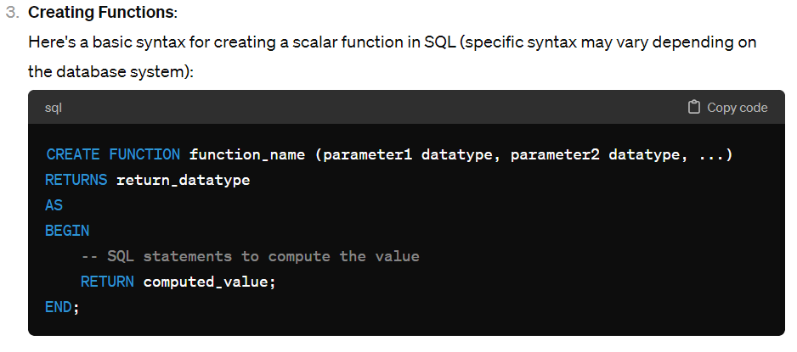 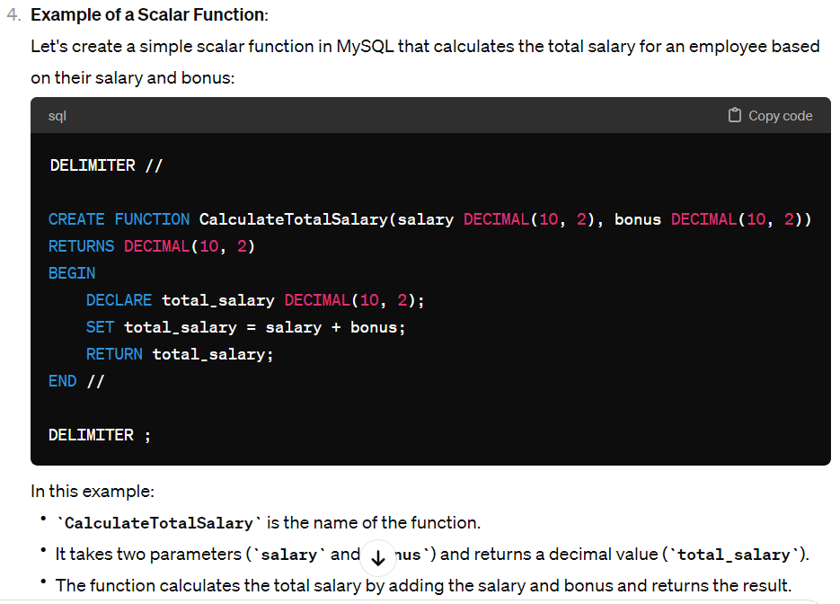

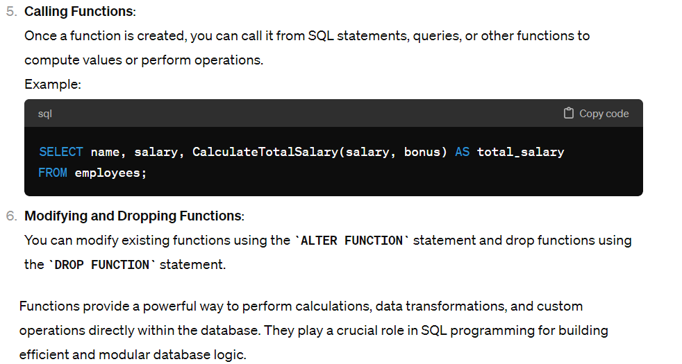

## TRIGGERS

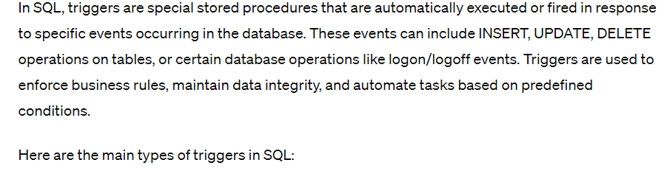

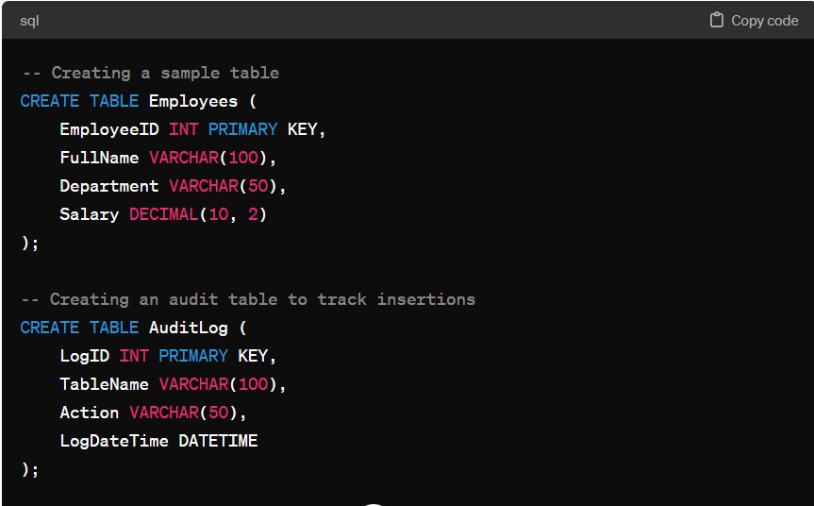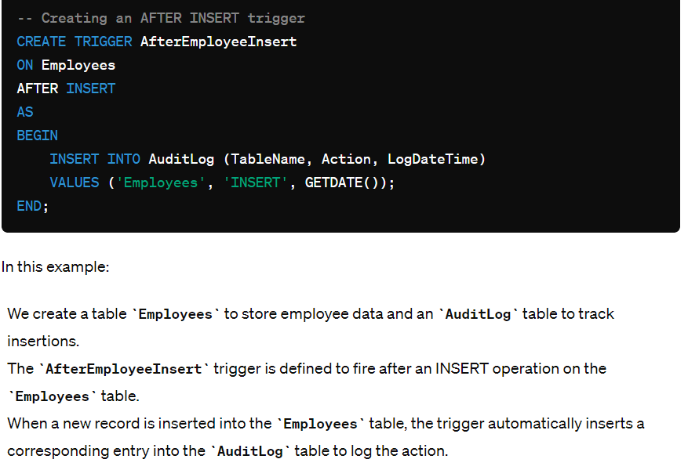

## DBMS

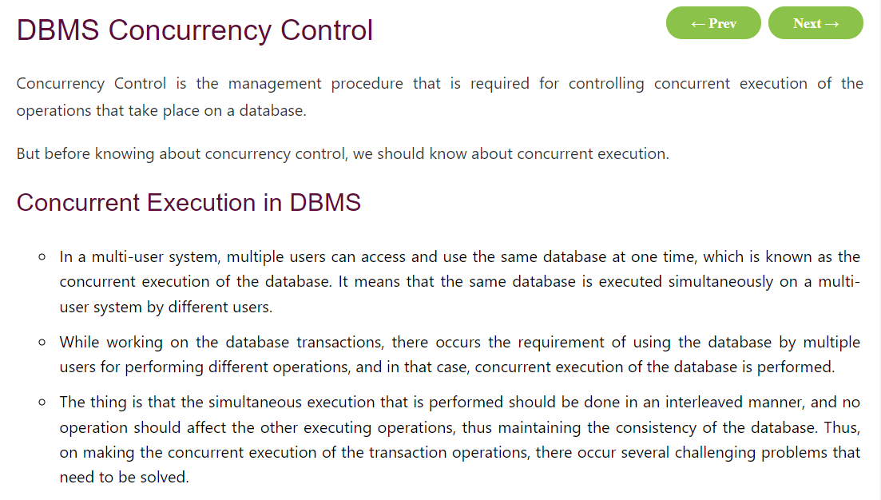

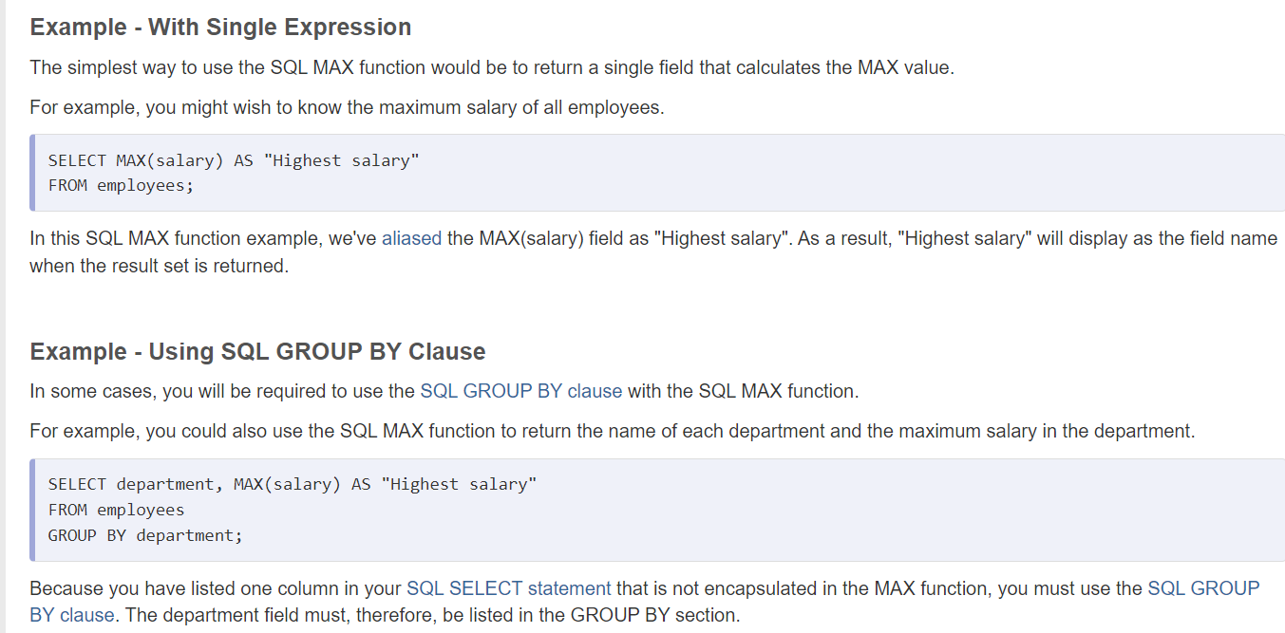



query to fetch 500 records and print only last 10 records

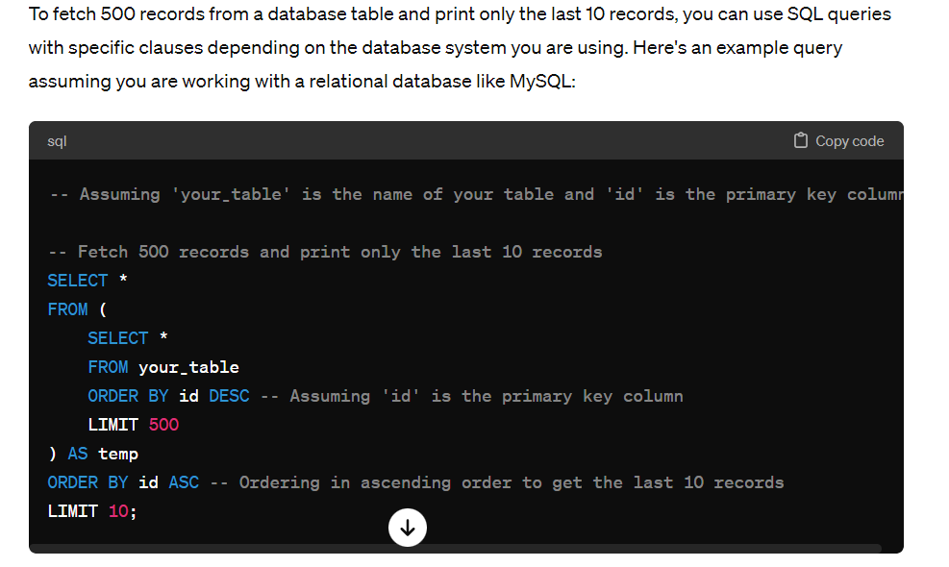

To lock certain records in a database, you typically use transactions and locks provided by the database management system (DBMS). Different databases might have different mechanisms for achieving record locking, but here's a general approach:

1. **Start a Transaction**: Begin a transaction to encapsulate the operations that involve the records you want to lock.
2. **Select the Records to Lock**: Execute a SELECT query with appropriate conditions to retrieve the records you want to lock.
3. **Apply Locks**: Use the appropriate locking mechanism provided by your DBMS. Common types of locks include:
   * **Row-level locks**: Lock individual rows to prevent other transactions from modifying them.
   * **Table-level locks**: Lock the entire table to prevent any operations (e.g., INSERT, UPDATE, DELETE) on it.
   * **Exclusive locks**: Locks that prevent other transactions from accessing the locked resource.
   * **Shared locks**: Locks that allow other transactions to read the locked resource but prevent them from modifying it.
4. **Perform Operations**: Perform any necessary operations (e.g., updates, deletions) on the locked records within the transaction.
5. **Commit the Transaction**: If the operations are successful and you no longer need the locks, commit the transaction to make the changes permanent and release the locks.

Here's a simplified example in pseudocode using SQL:

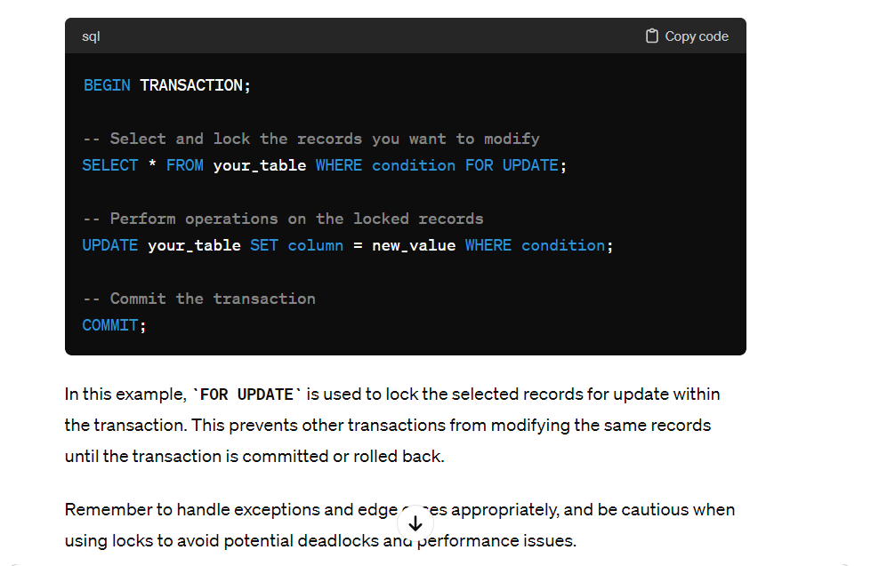

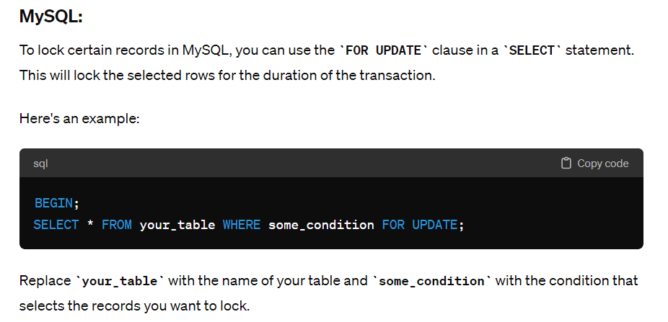

# REST VS SOAP

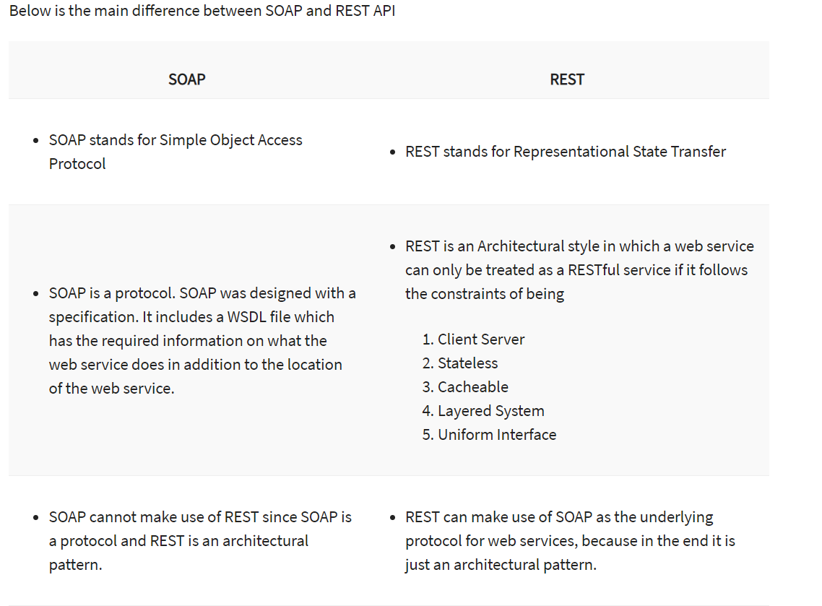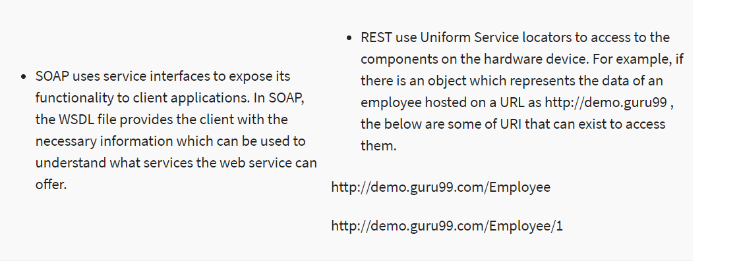

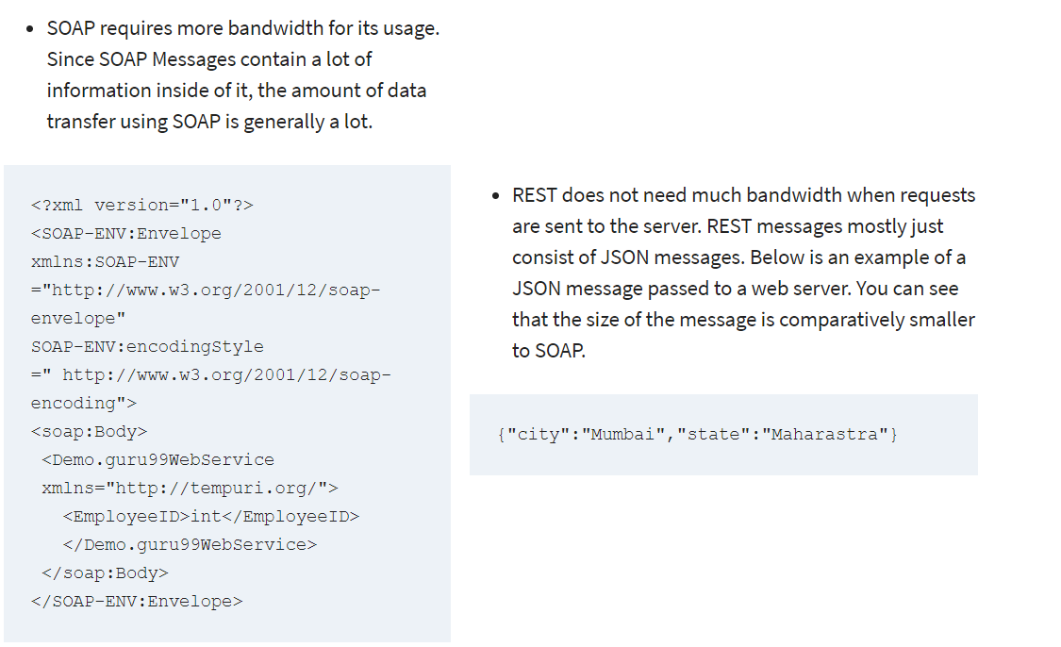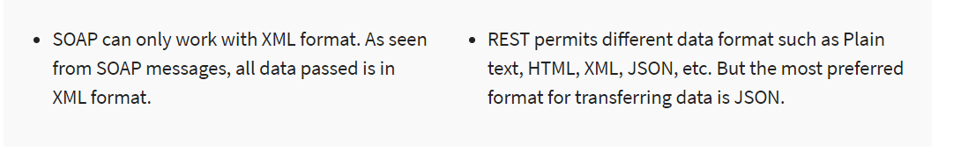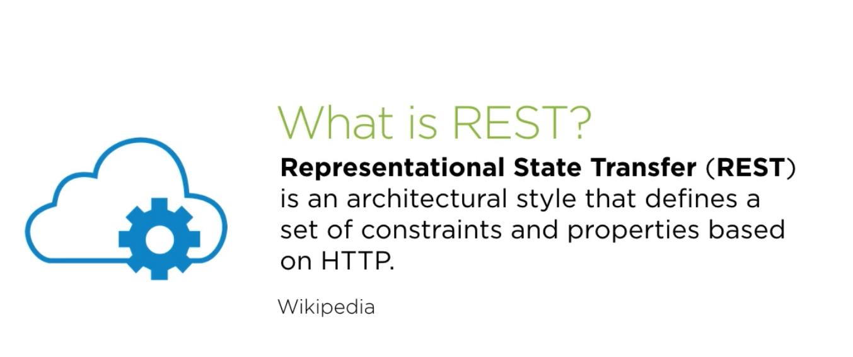

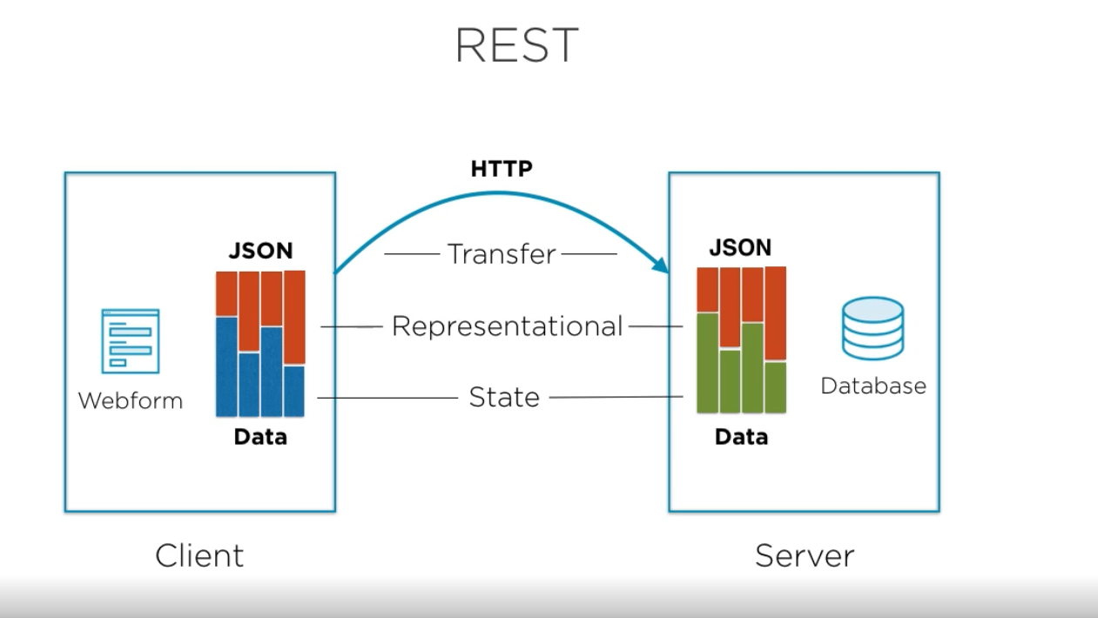

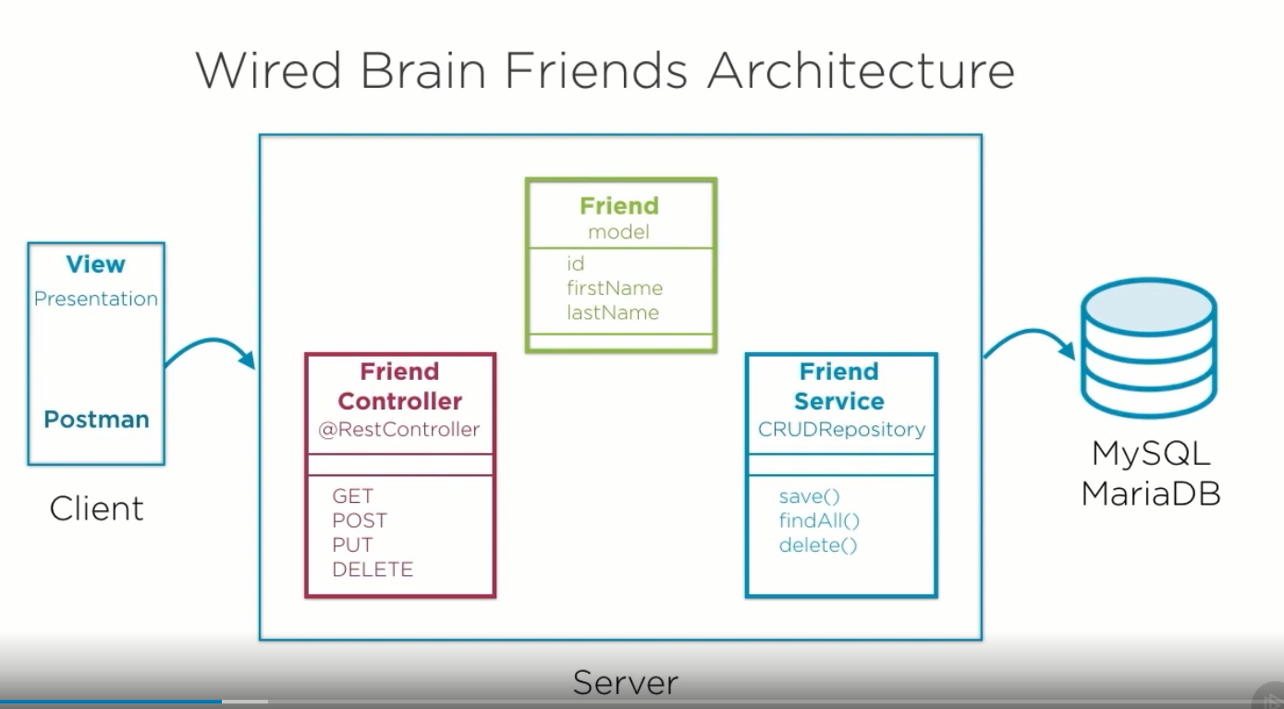

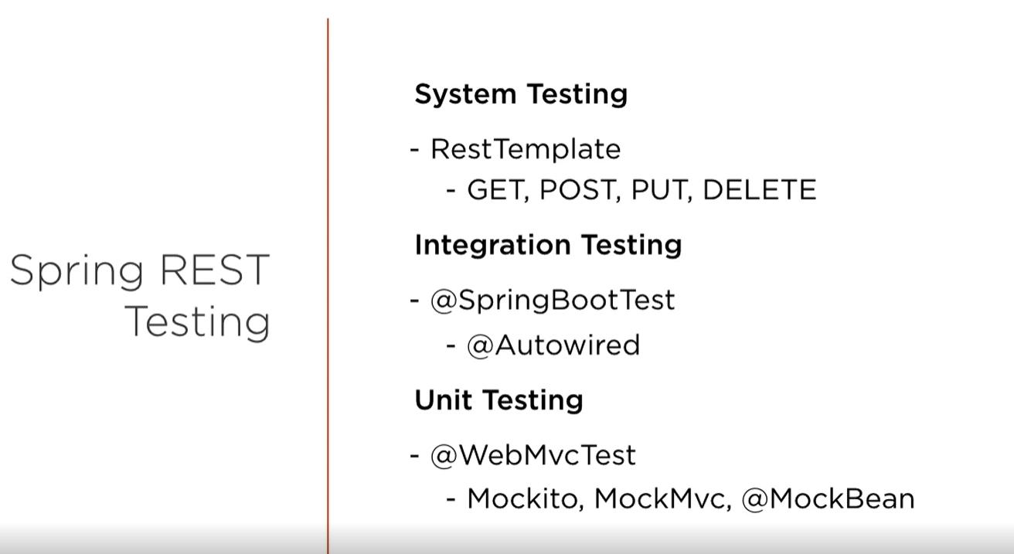

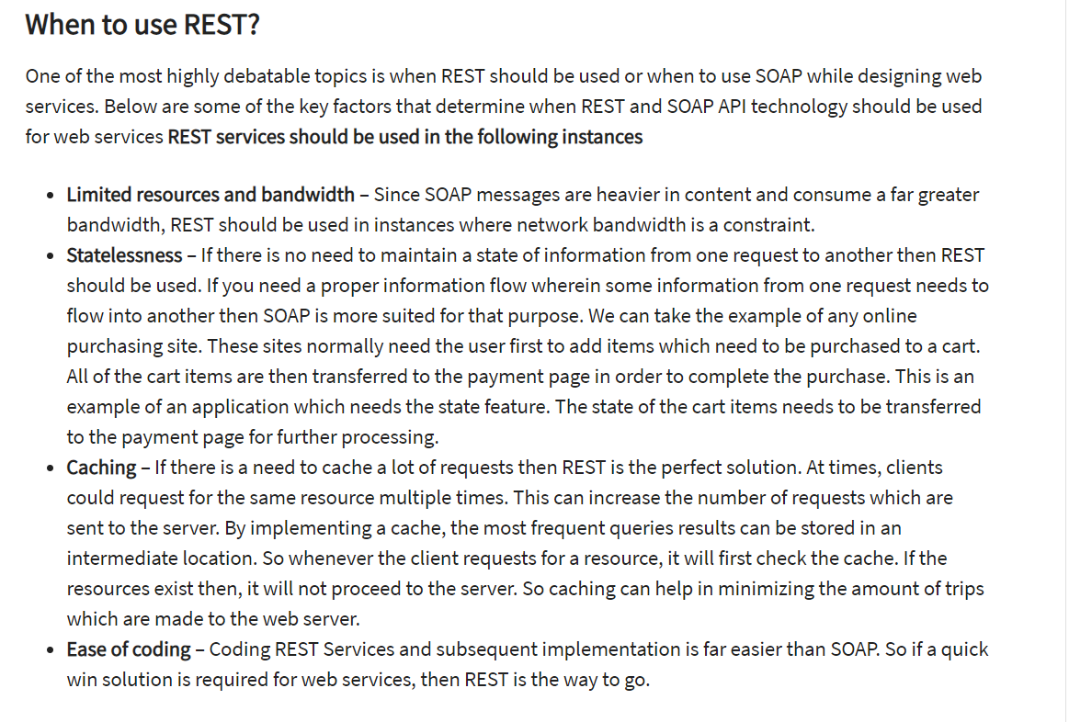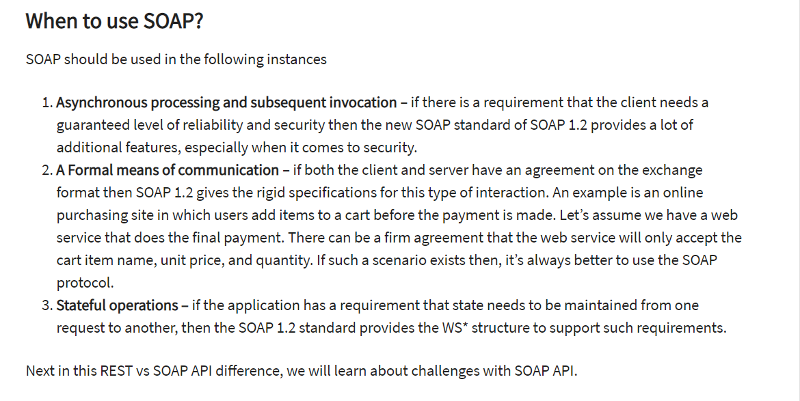

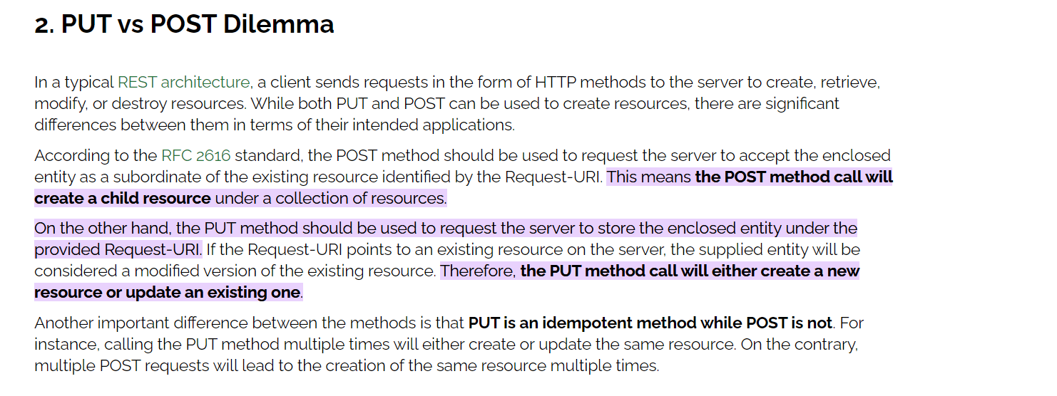

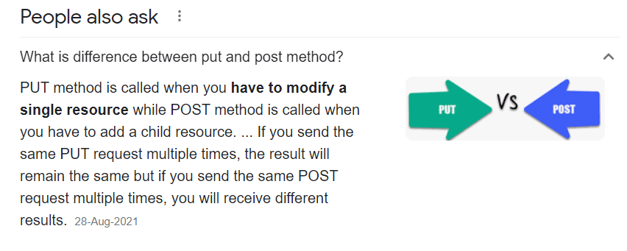

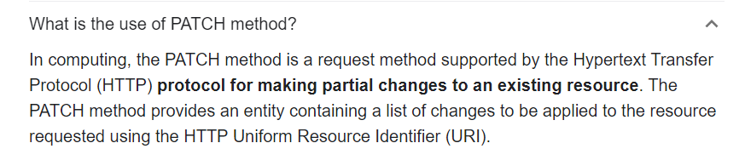

**Authorization for REST API:**

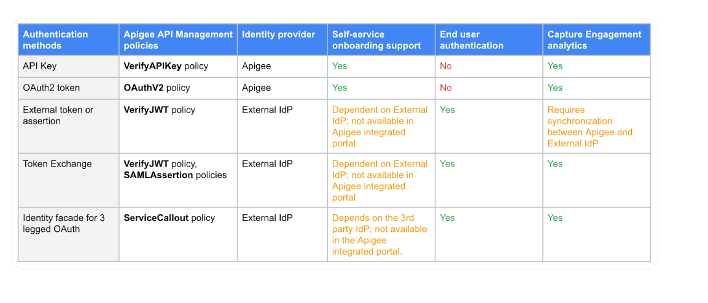

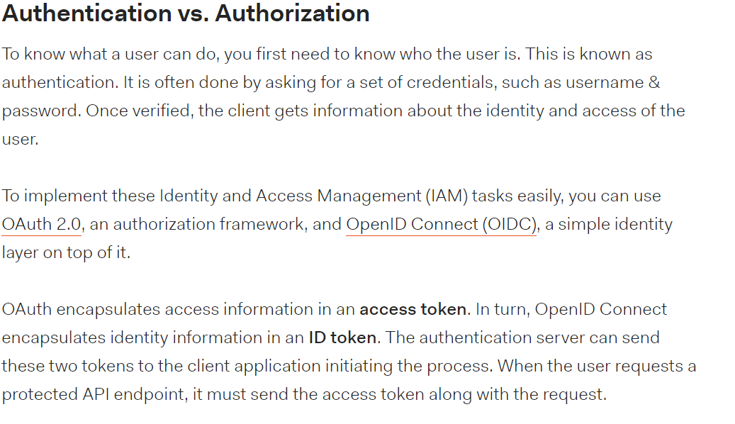

# HTTP Error codes :

HTTP (Hypertext Transfer Protocol) status codes are issued by a server in response to a client's request made to the server. These status codes indicate the outcome of the request, whether it was successful, encountered an error, or requires further action by the client. Here is a comprehensive list of HTTP status codes categorized by their ranges and meanings:

1. **1xx Informational Response**:
   * **100 Continue**: The server confirms that the client should continue with its request.
   * **101 Switching Protocols**: The server is changing protocols as requested by the client (e.g., switching from HTTP to HTTPS).
2. **2xx Success**:
   * **200 OK**: The request was successful, and the server has returned the requested content.
   * **201 Created**: The request has been fulfilled, and a new resource has been created.
   * **202 Accepted**: The request has been accepted but may not be processed immediately.
   * **204 No Content**: The server successfully processed the request but does not need to return any content.
3. **3xx Redirection**:
   * **300 Multiple Choices**: Indicates multiple options for the resource that the client may follow.
   * **301 Moved Permanently**: The requested resource has been permanently moved to a new URL.
   * **302 Found**: The requested resource temporarily resides at a different URL.
   * **304 Not Modified**: Indicates that the client's cached copy is up to date, and no new data is needed.
4. **4xx Client Error**:
   * **400 Bad Request**: The server cannot process the request due to a client error or malformed request.
   * **401 Unauthorized**: Authentication is required, and the client needs to provide valid credentials.
   * **403 Forbidden**: The client is authenticated but does not have permission to access the resource.
   * **404 Not Found**: The requested resource could not be found on the server.
   * **405 Method Not Allowed**: The HTTP method used in the request is not allowed for the specified resource.
5. **5xx Server Error**:
   * **500 Internal Server Error**: A generic error message indicating that the server encountered an unexpected condition.
   * **501 Not Implemented**: The server does not support the functionality required to fulfill the request.
   * **502 Bad Gateway**: The server received an invalid response from an upstream server.
   * **503 Service Unavailable**: The server is currently unable to handle the request due to temporary overload or maintenance.
   * **504 Gateway Timeout**: The server did not receive a timely response from an upstream server or gateway.

These HTTP status codes provide valuable information about the status of requests and help in diagnosing and resolving issues during web communication between clients and servers. Proper handling and interpretation of these status codes are essential for building robust and reliable web applications.

# Microservices:

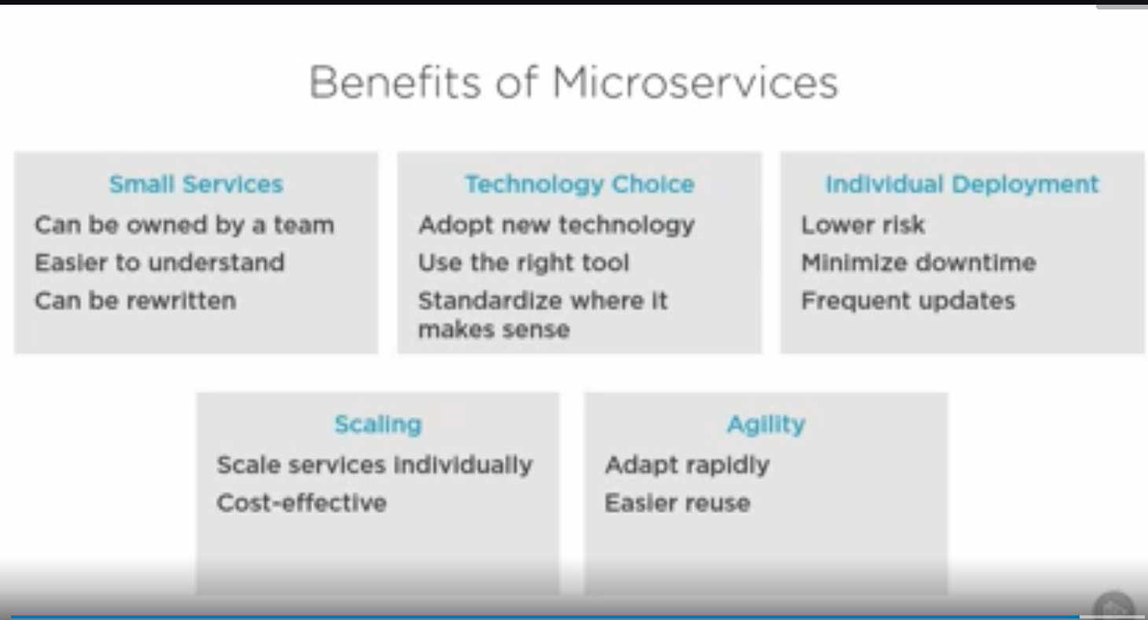

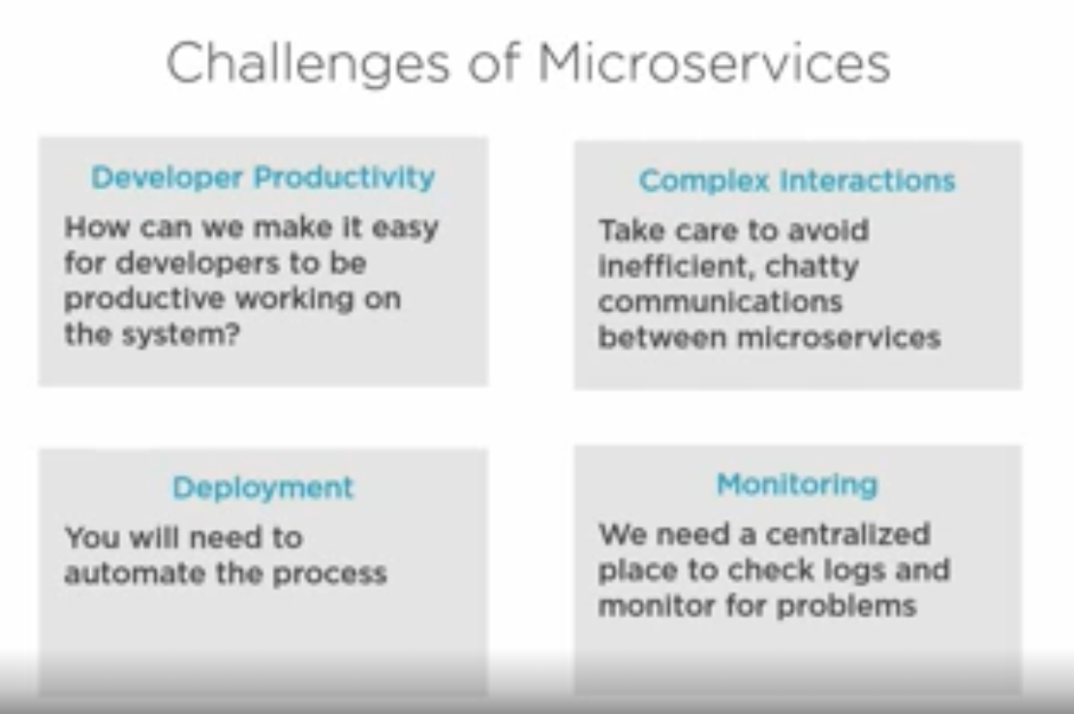

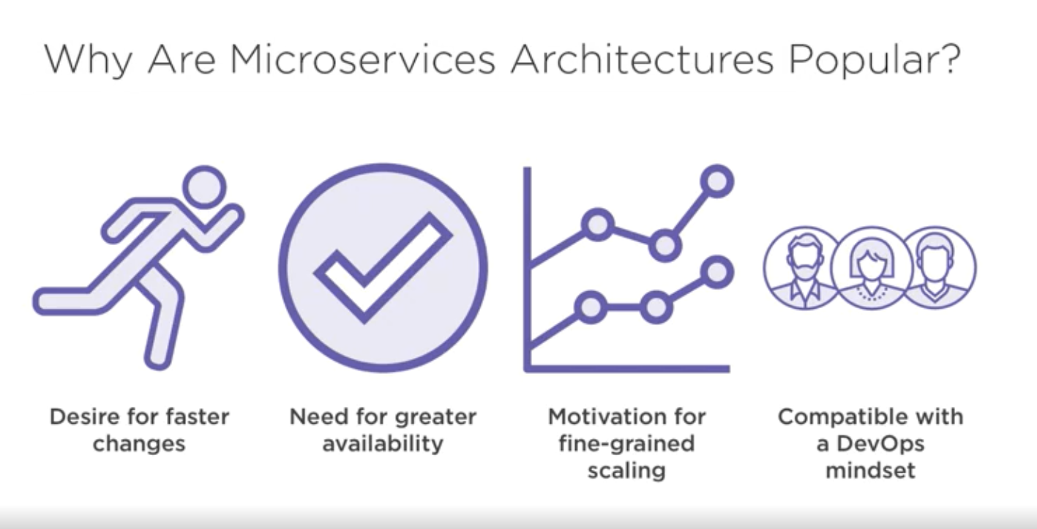

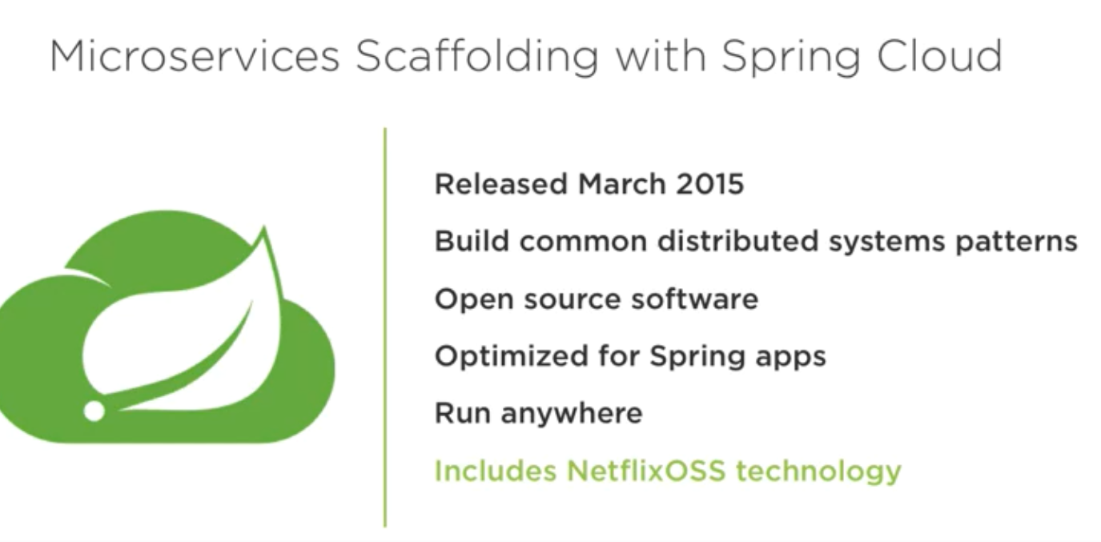

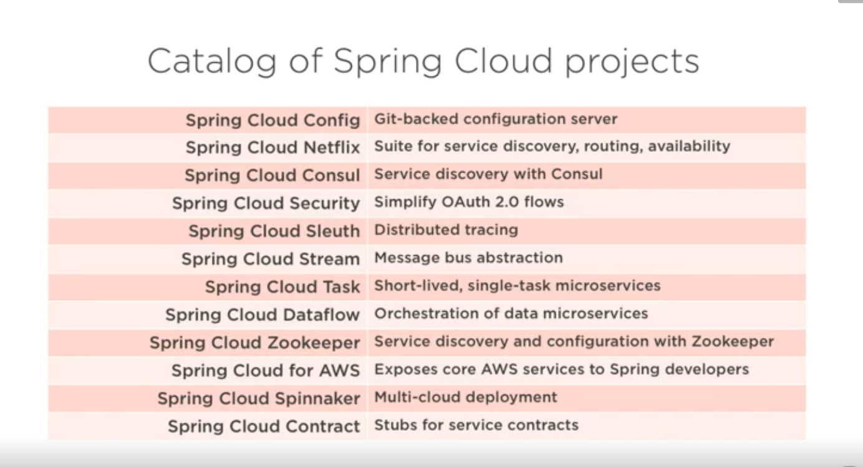

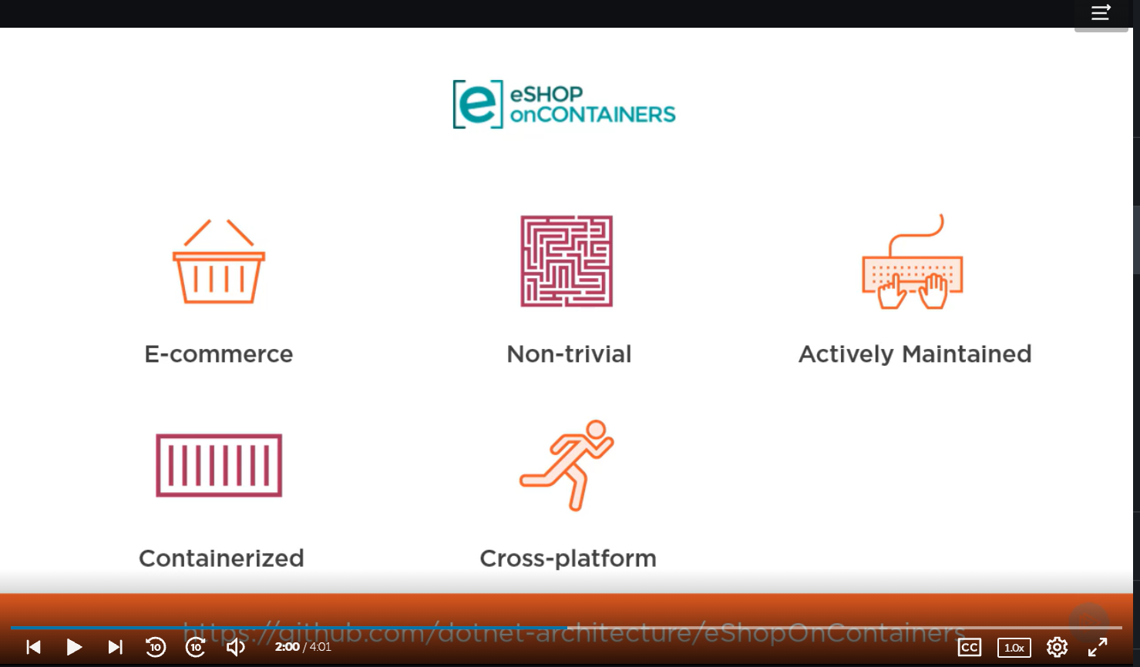

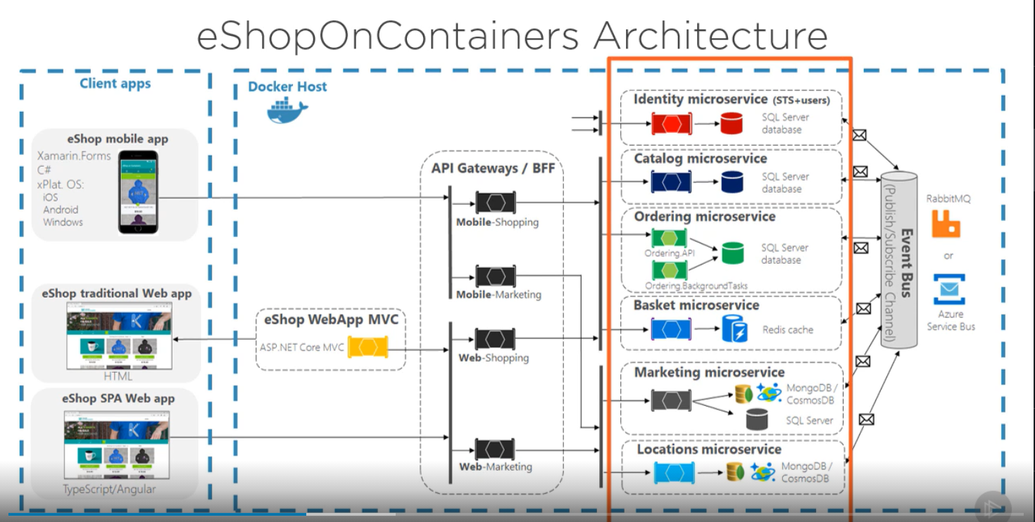

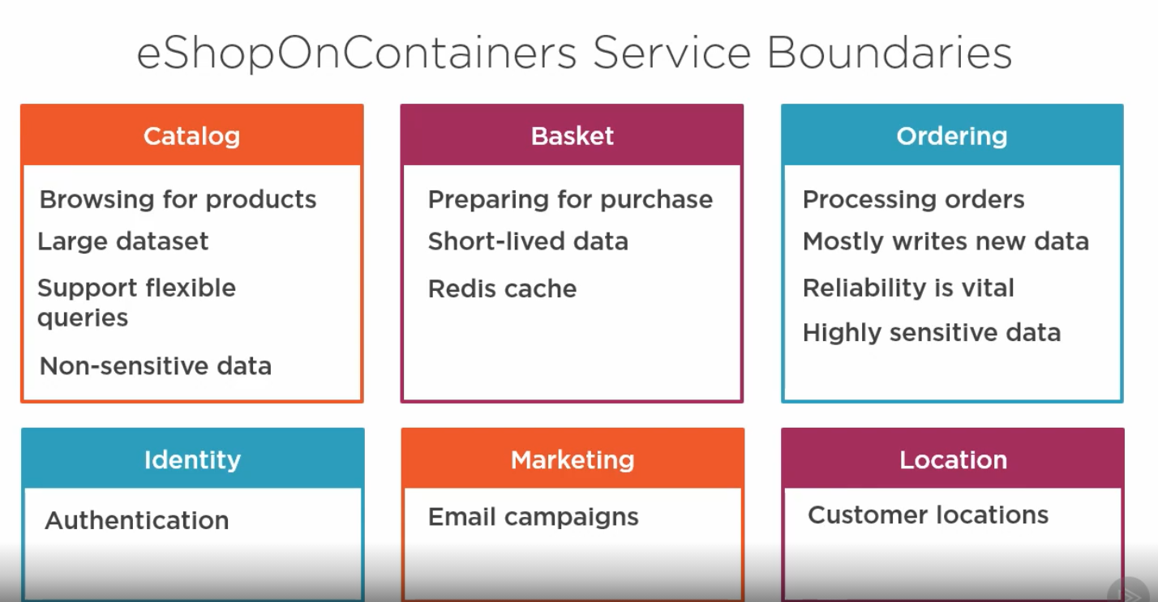

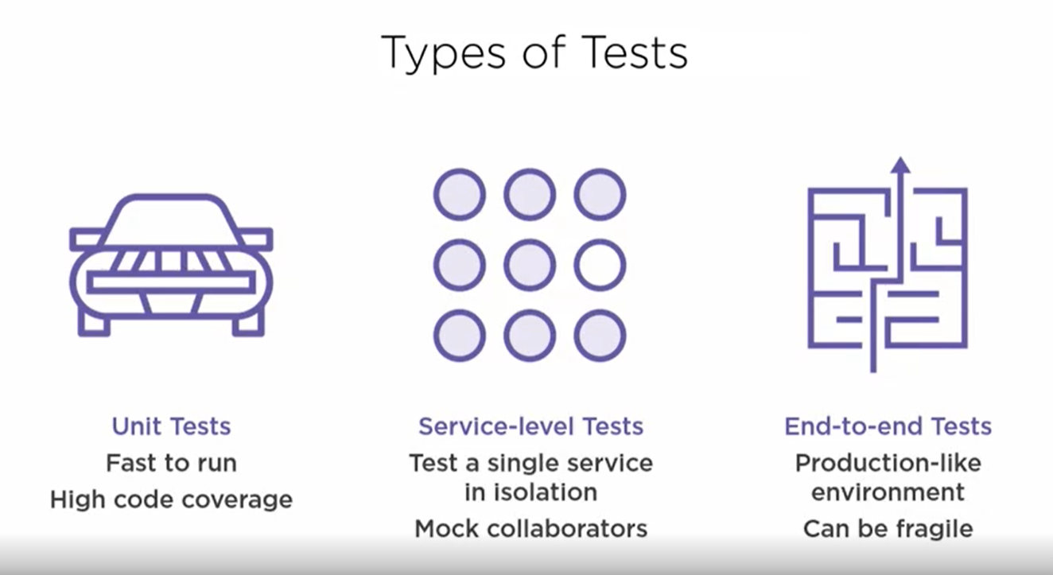

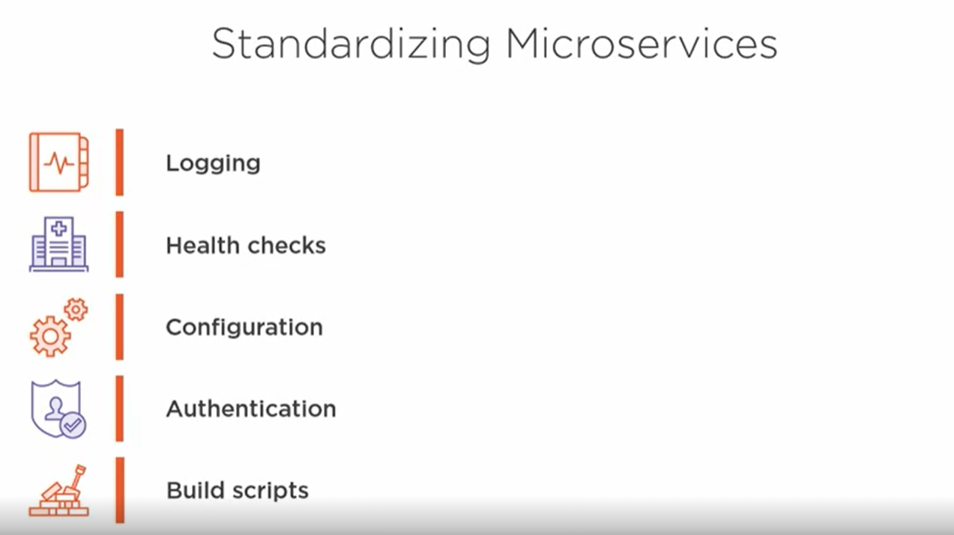

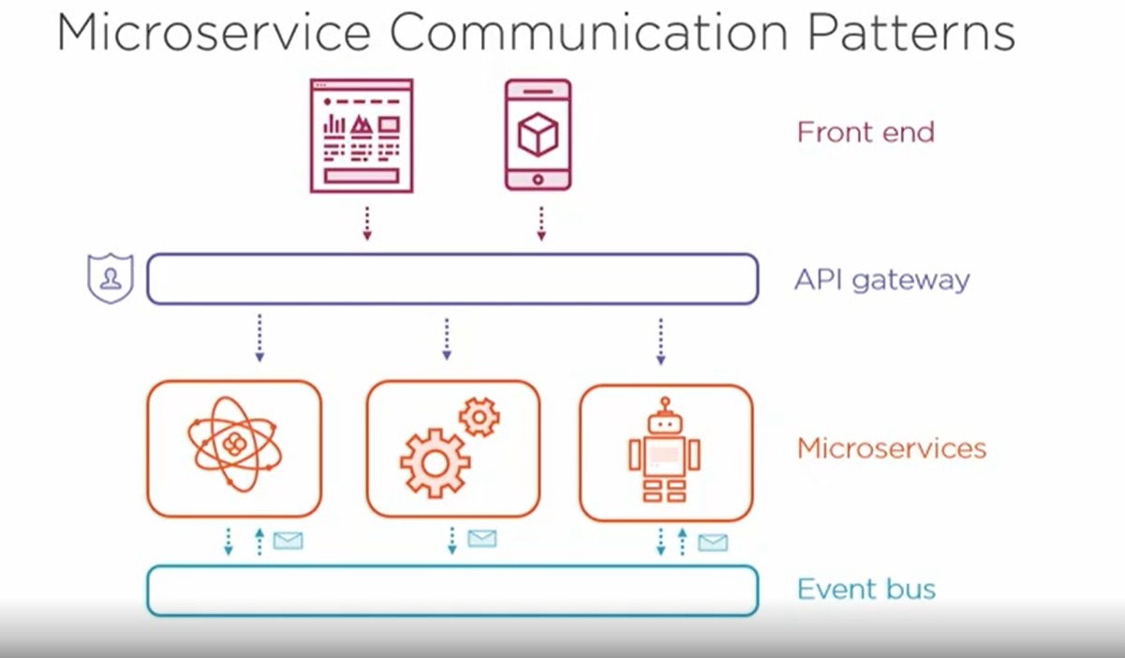

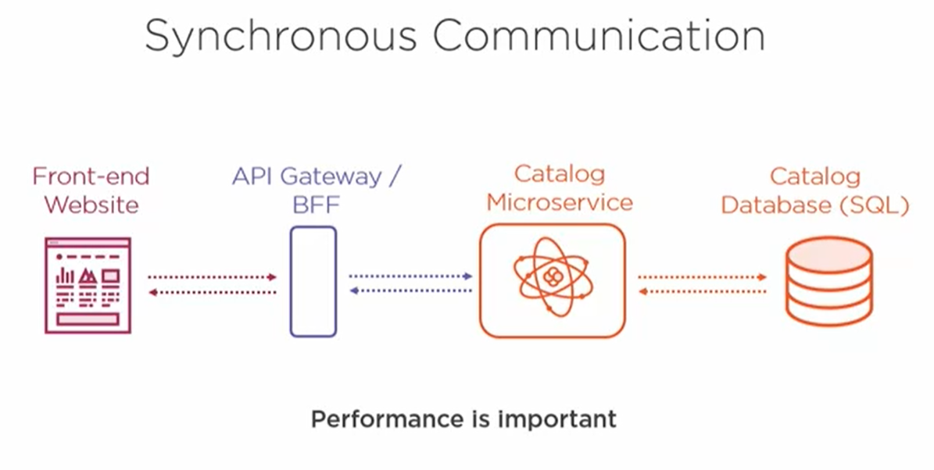

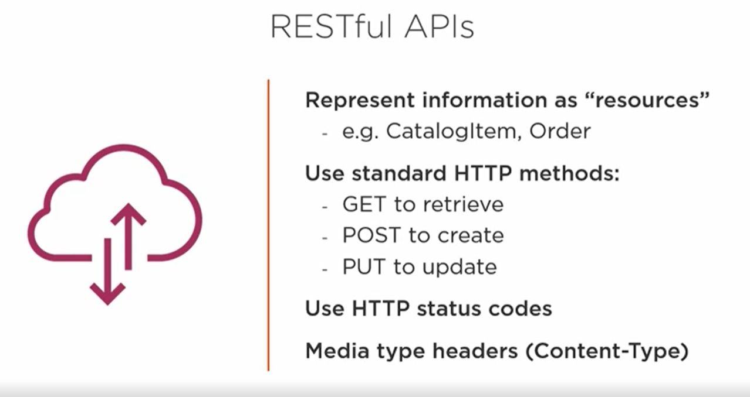

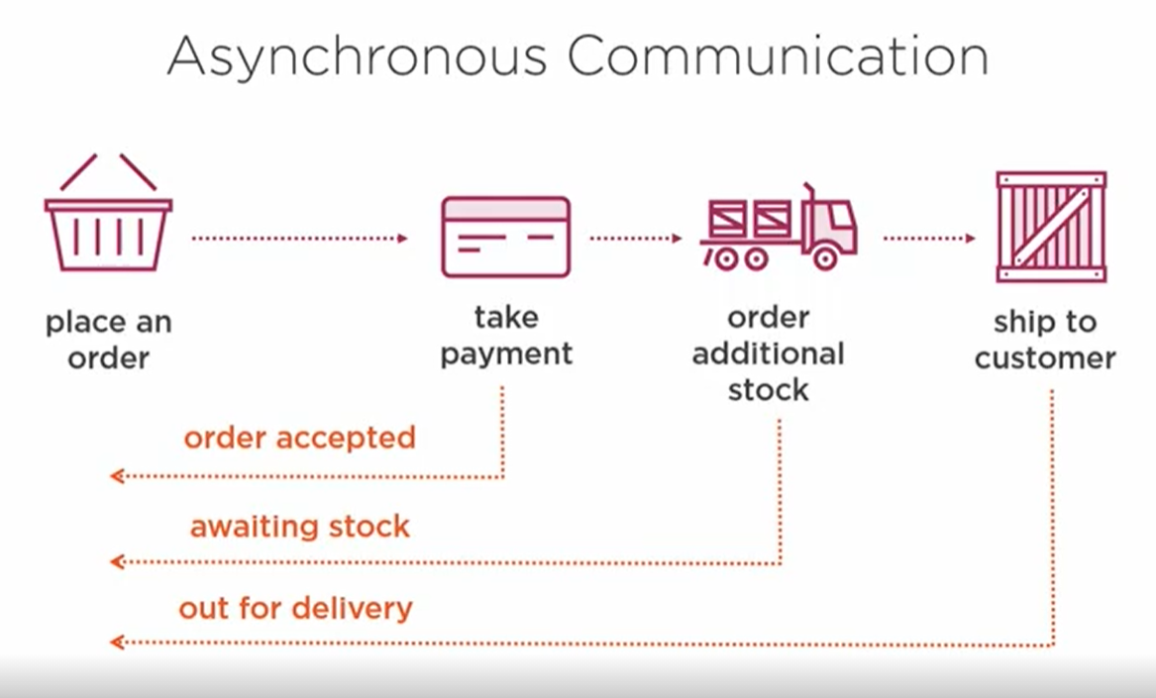

**How two microservices communicate with each other**

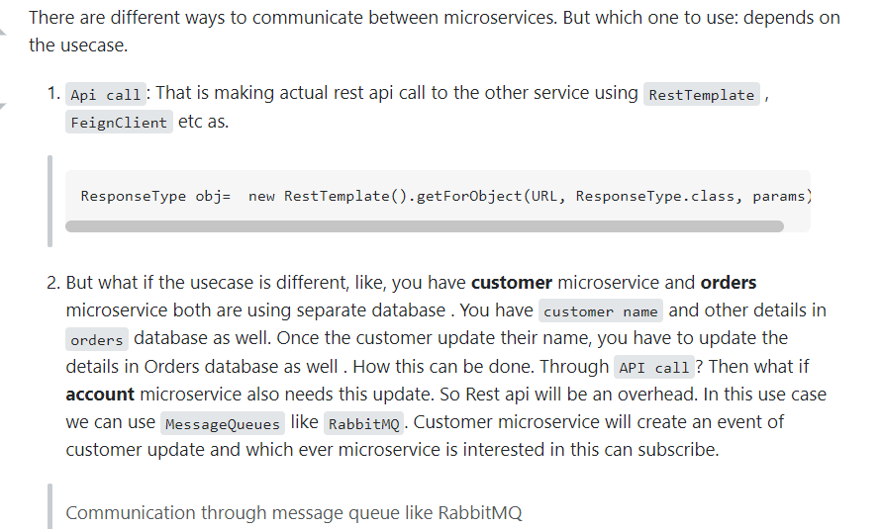

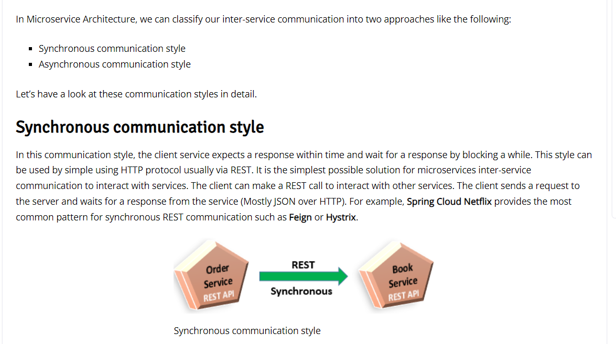

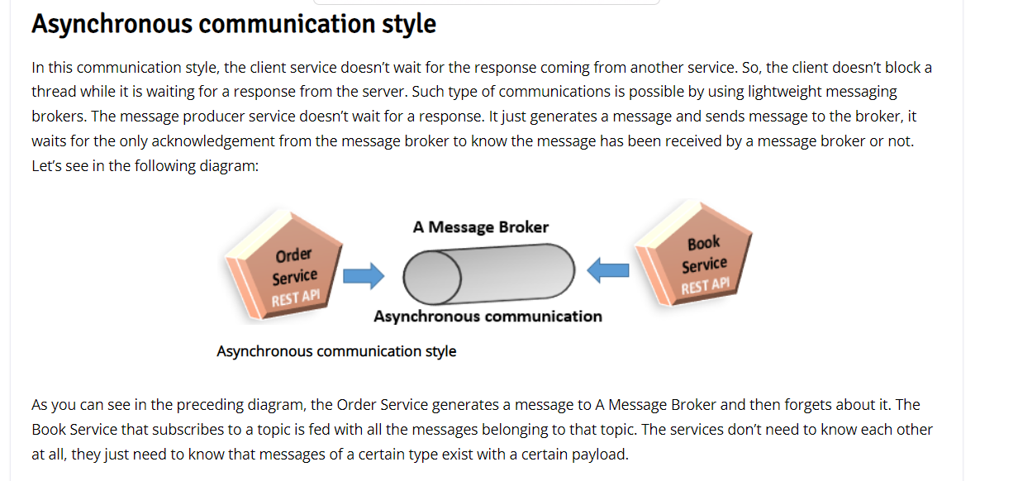

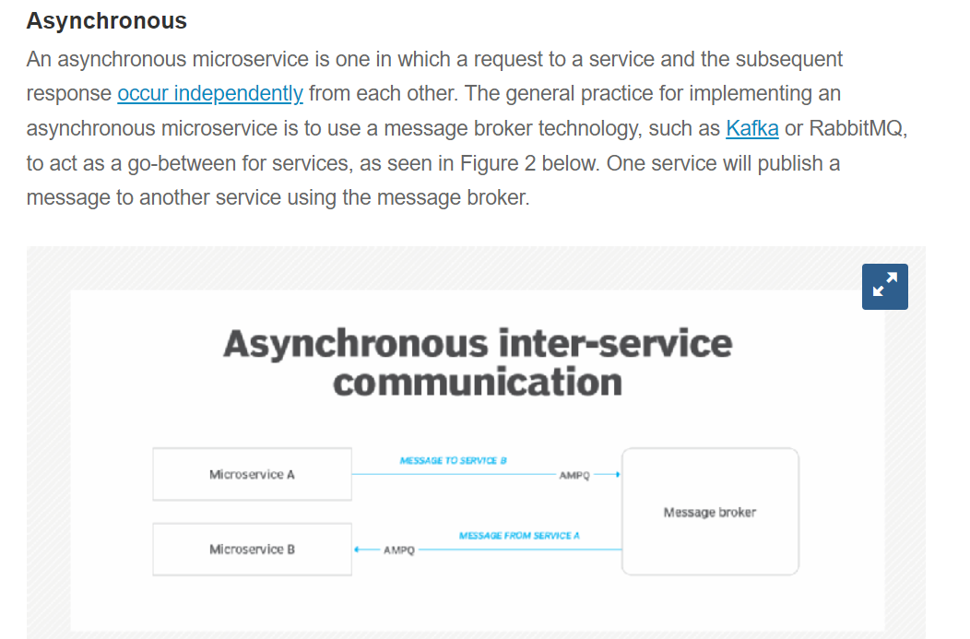

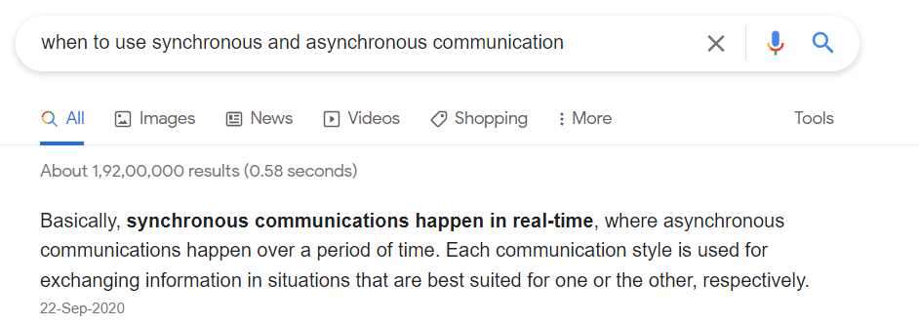

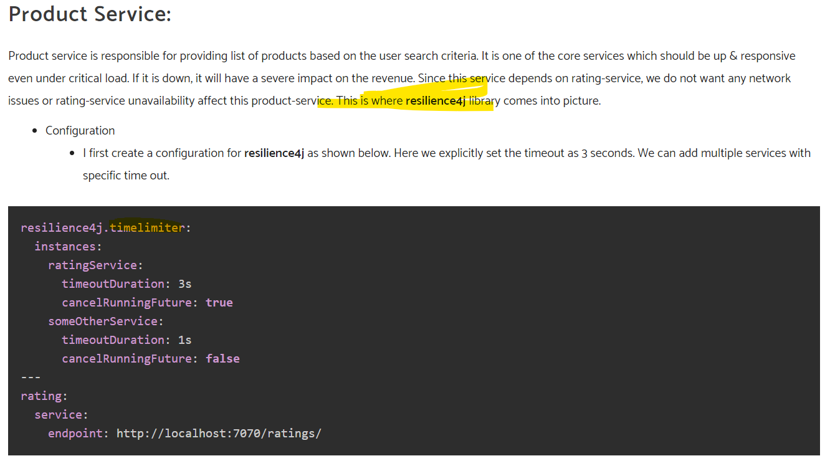

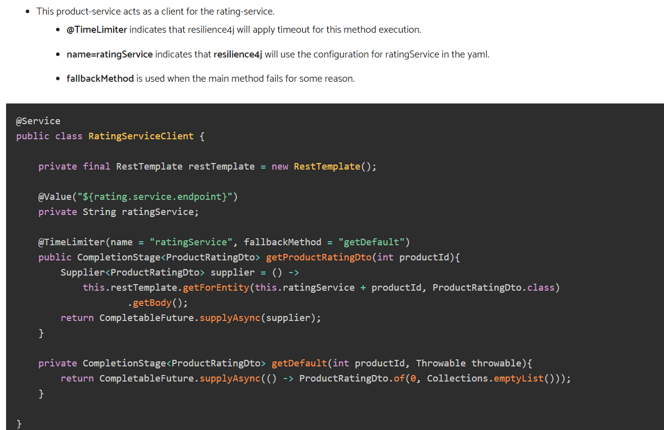

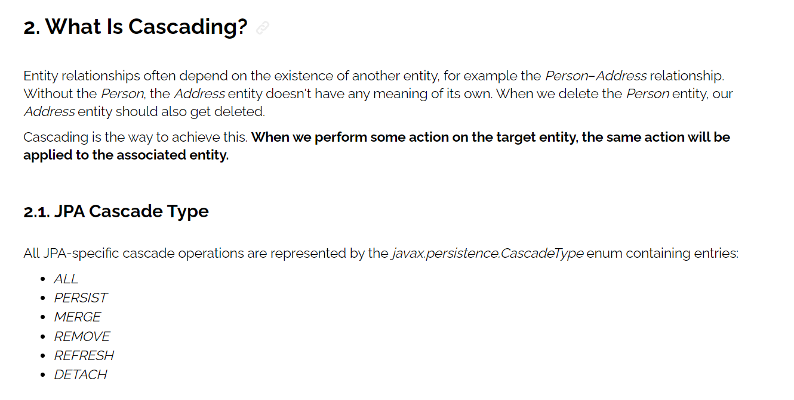



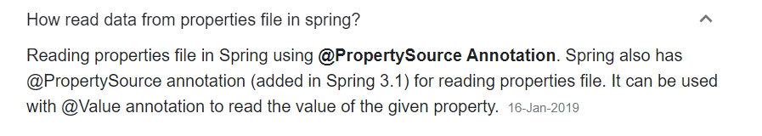

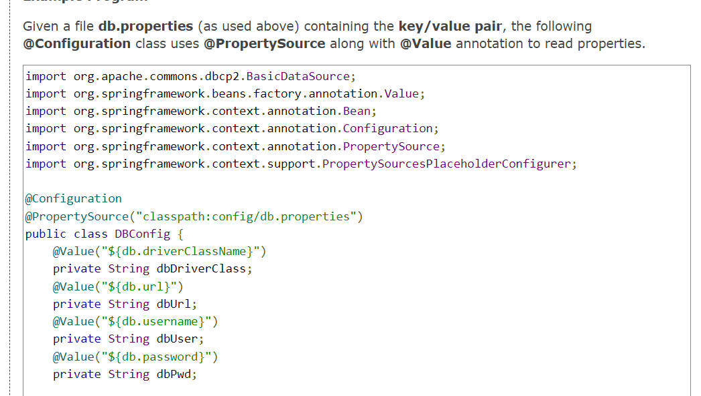

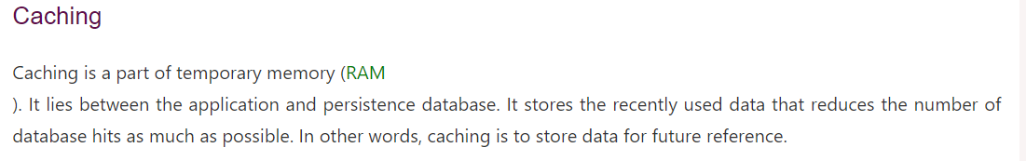

[**https://www.javatpoint.com/spring-boot-caching**](https://www.javatpoint.com/spring-boot-caching)

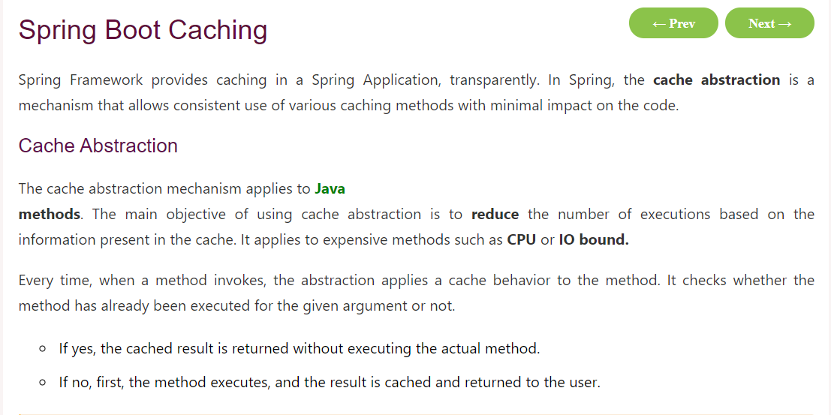

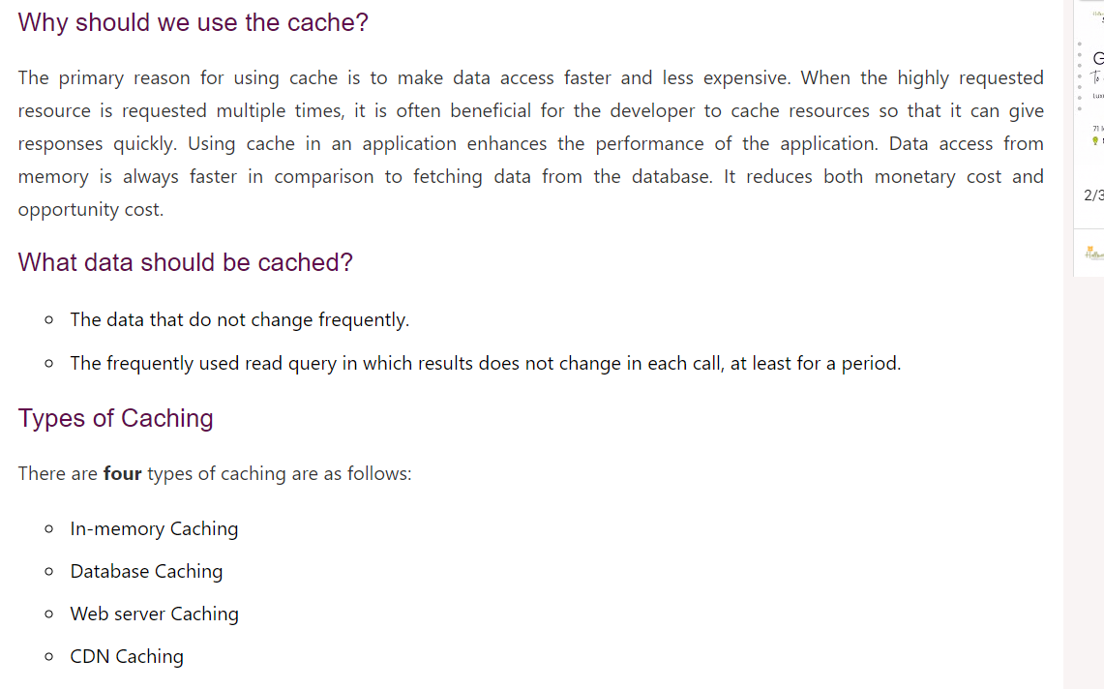

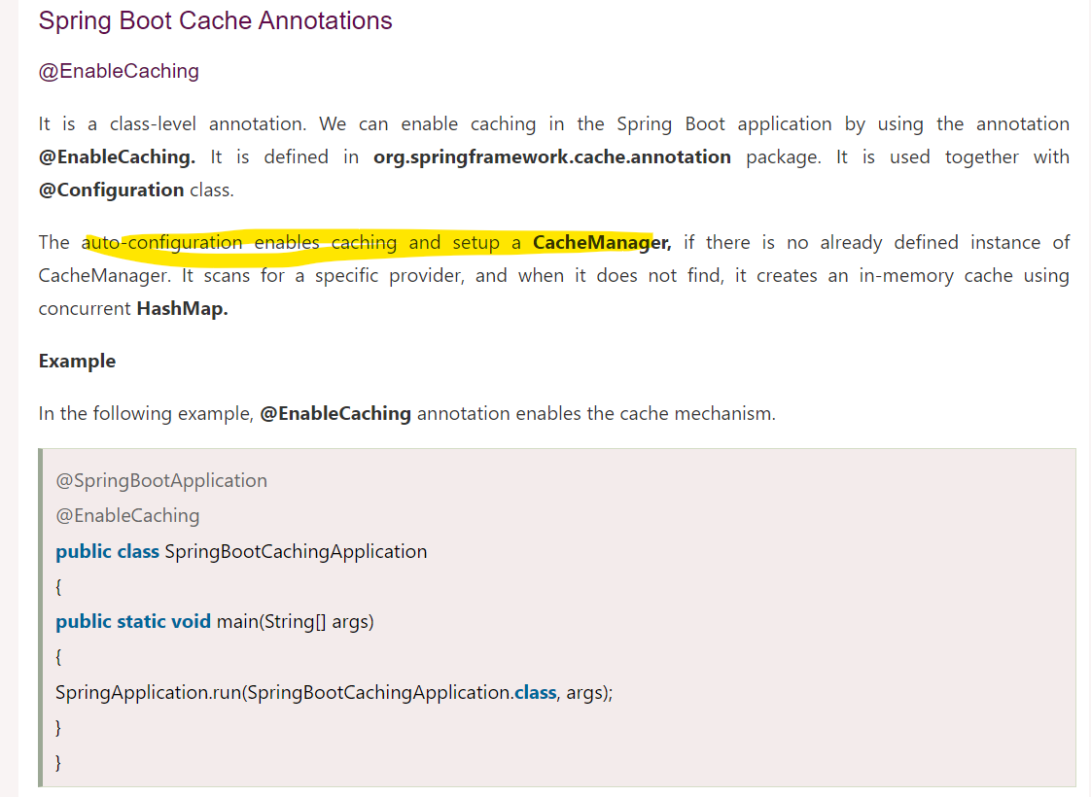

## Architecture

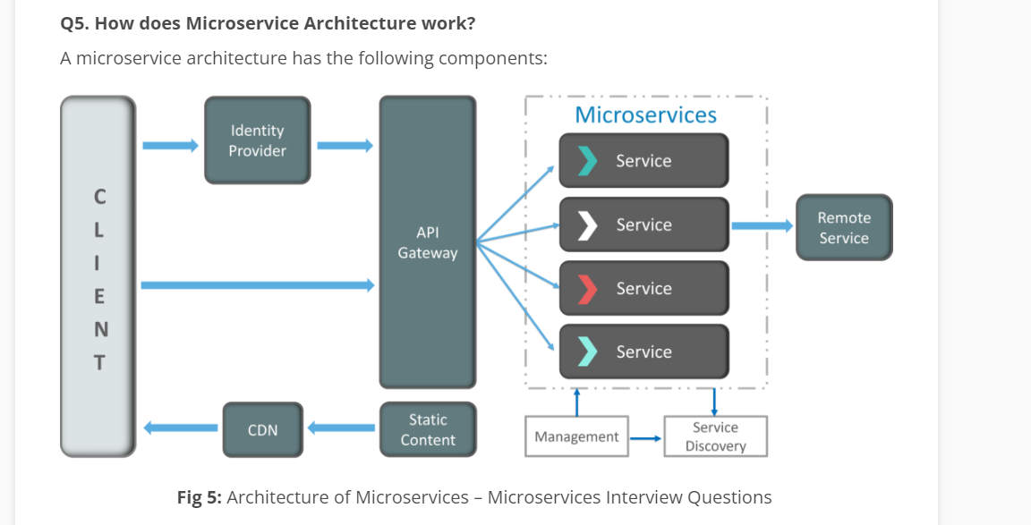 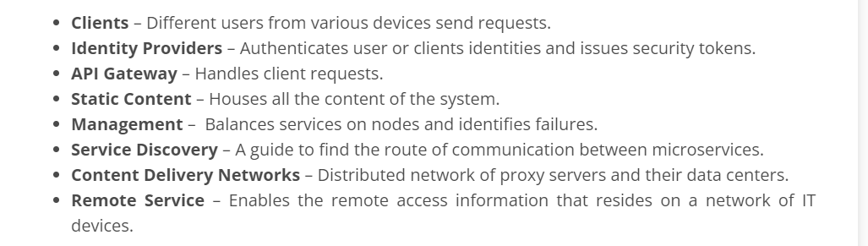

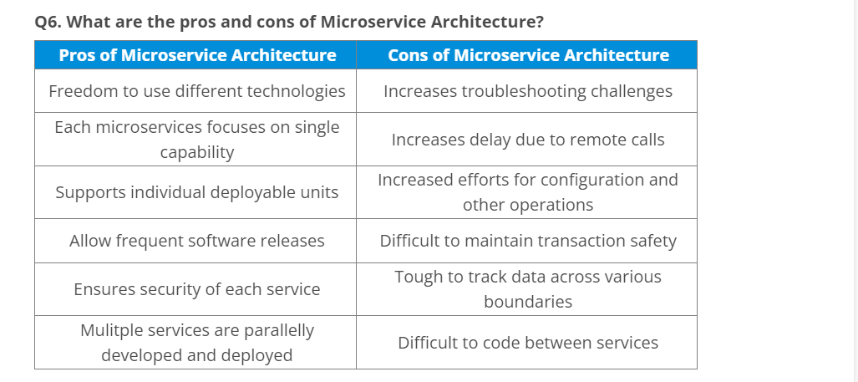

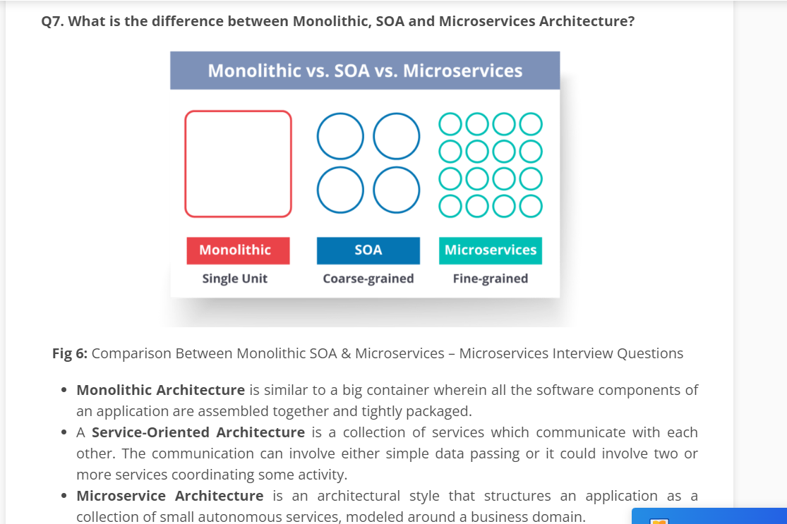

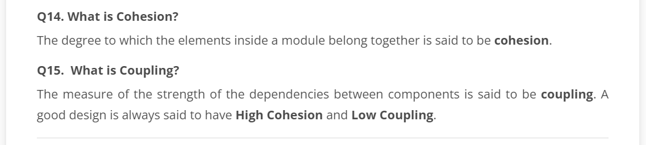

**Spring Boot** is the solution to this problem. Using spring boot you can avoid all the boilerplate code and configurations. So basically consider yourself as if you’re baking a cake spring is like the ingredients that are required to make the cake and spring boot is the complete cake in your hand.

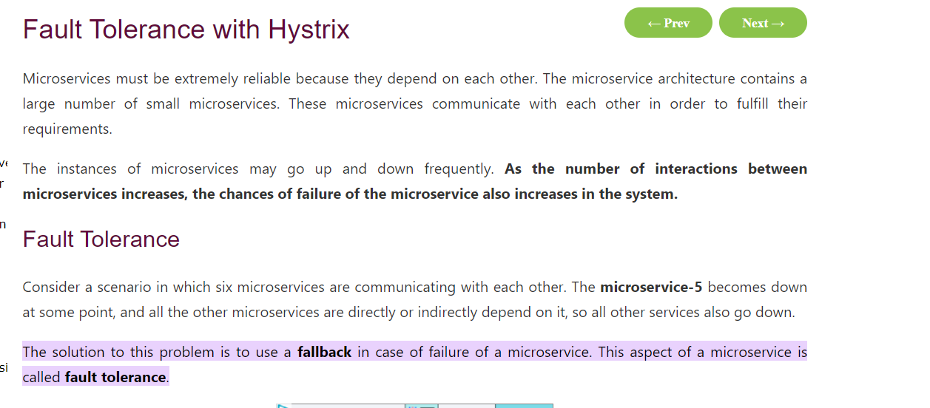

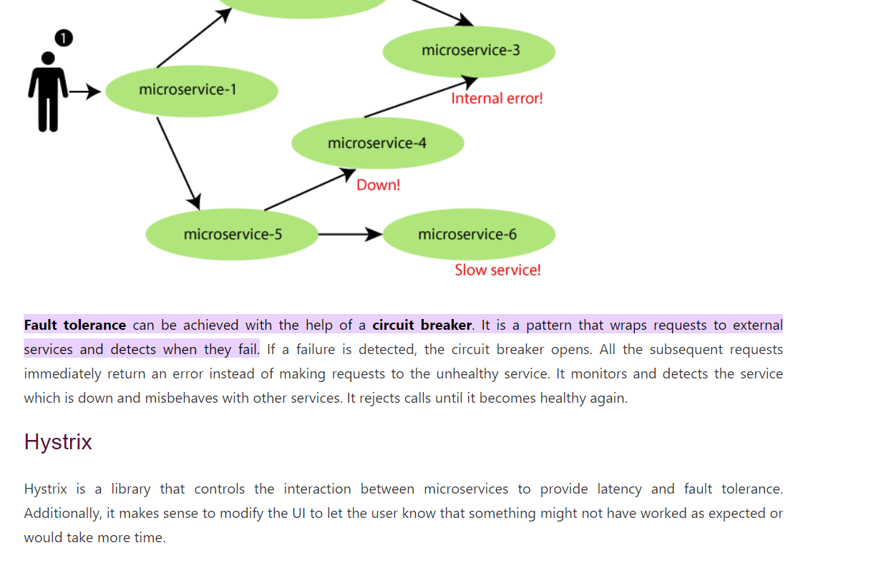

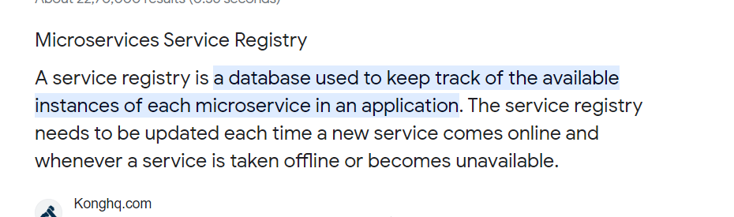

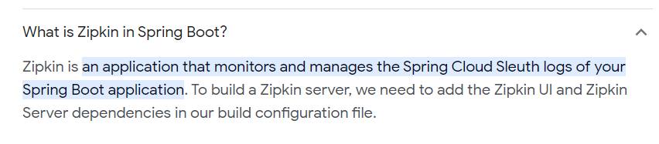

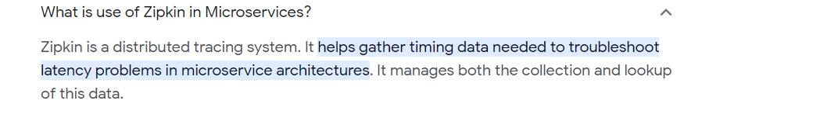

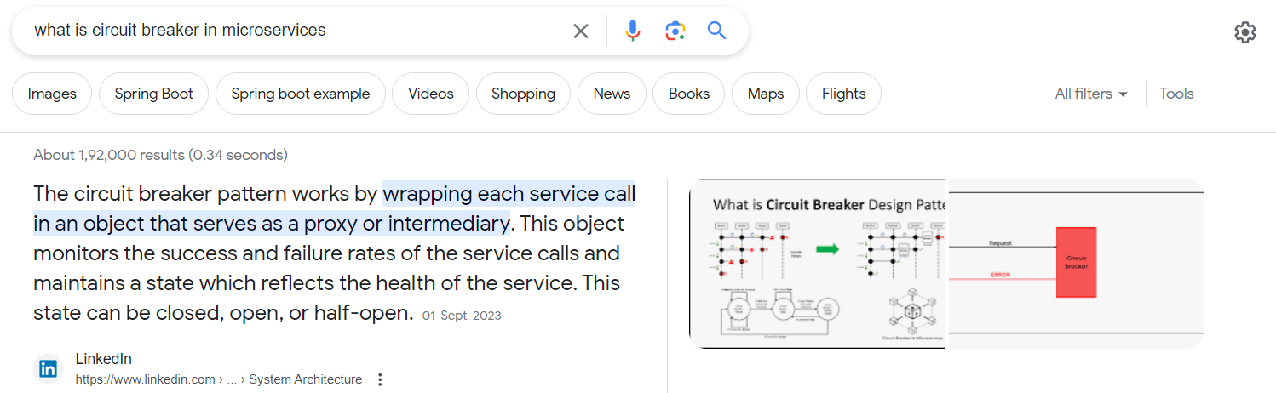

## Scaling Spring Boot Applications:

[**https://medium.com/javarevisited/scaling-spring-boot-applications-from-zero-to-hero-best-practices-and-techniques-to-29d950e15d3e**](https://medium.com/javarevisited/scaling-spring-boot-applications-from-zero-to-hero-best-practices-and-techniques-to-29d950e15d3e)

[**https://medium.com/javarevisited/difference-between-api-gateway-and-load-balancer-in-microservices-8c8b552a024**](https://medium.com/javarevisited/difference-between-api-gateway-and-load-balancer-in-microservices-8c8b552a024)

## Design patterns

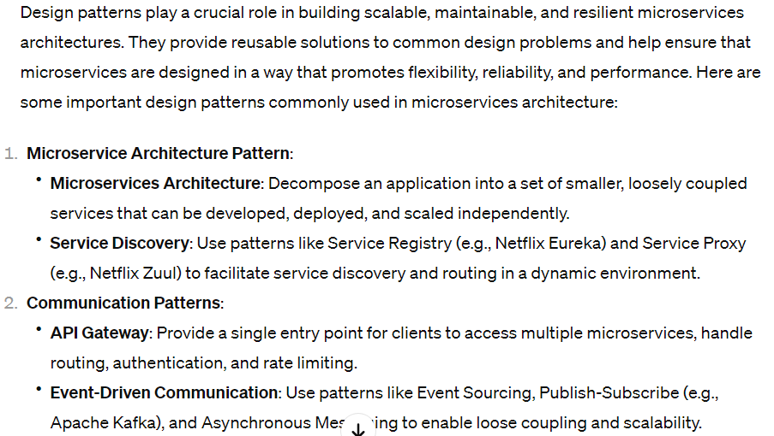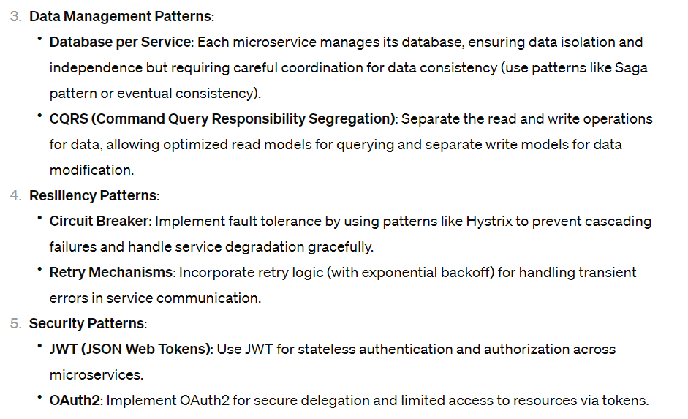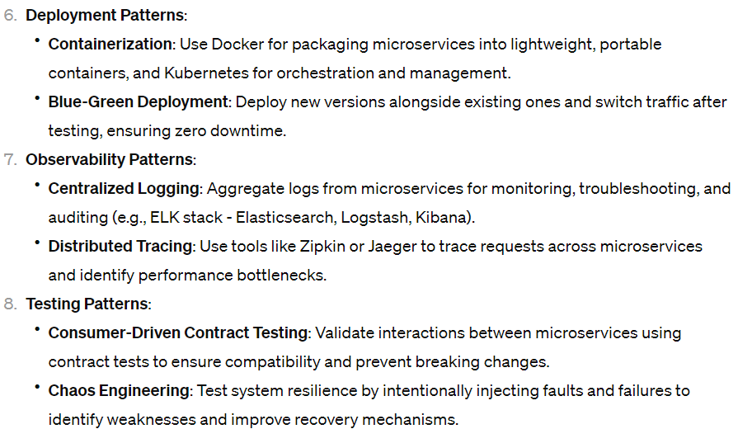These patterns are not exhaustive, but they cover essential aspects of designing and implementing microservices architectures effectively. It's important to adapt and combine patterns based on specific application requirements, scalability needs, and organizational constraints. Additionally, adopting best practices for DevOps, continuous integration/continuous delivery (CI/CD), and automation complements these patterns for successful microservices development and deployment.

**Saga**

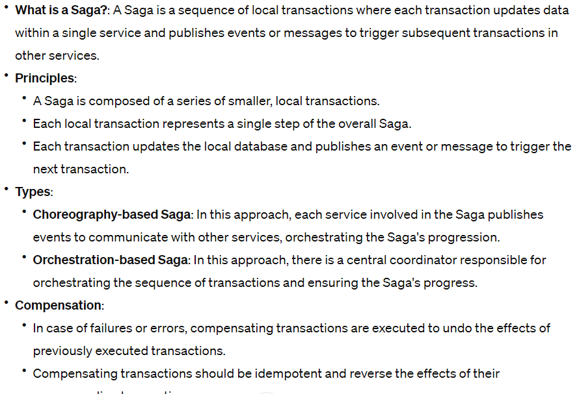

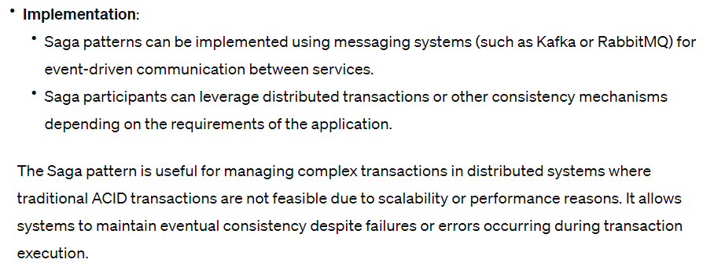

# Transaction management

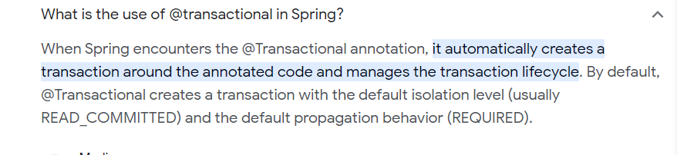

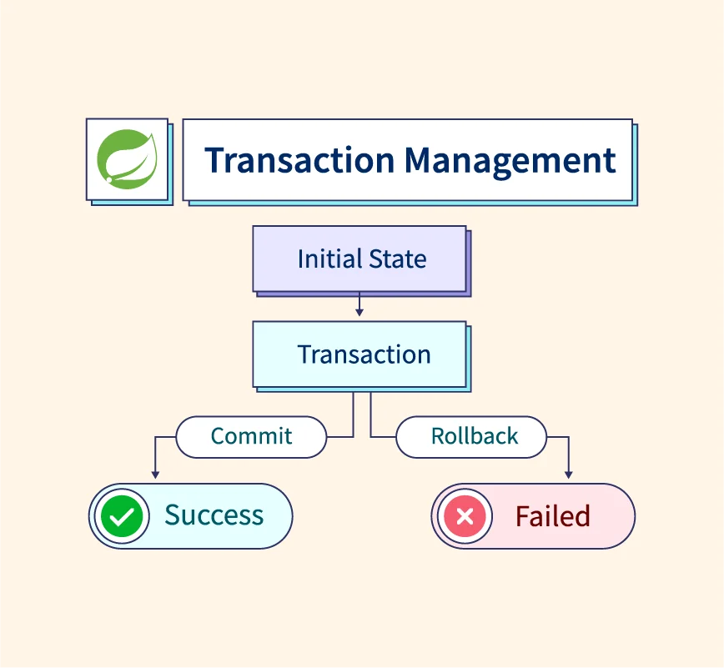

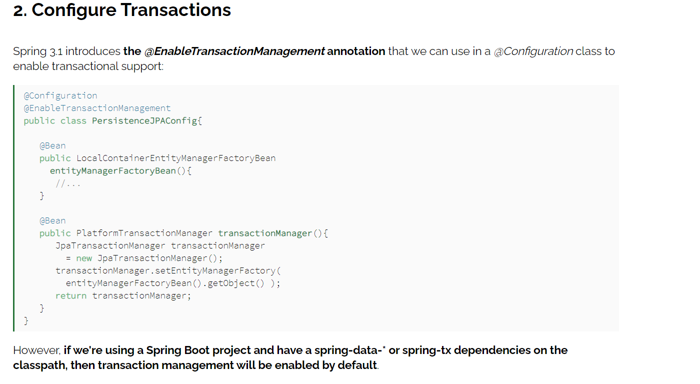

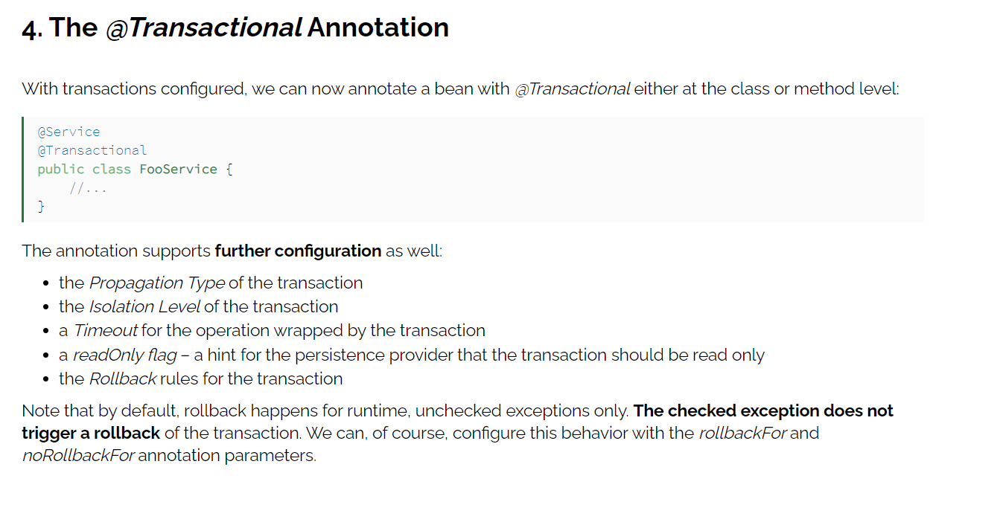

[**https://www.baeldung.com/transaction-configuration-with-jpa-and-spring**](https://www.baeldung.com/transaction-configuration-with-jpa-and-spring)

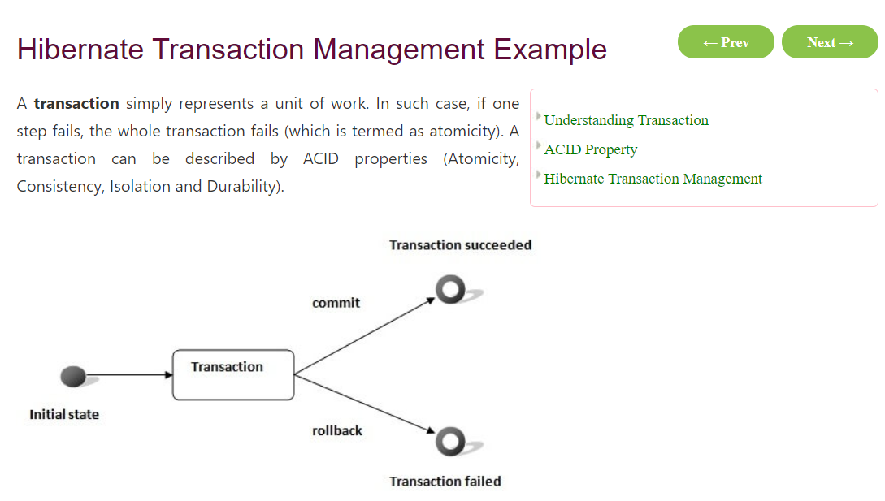

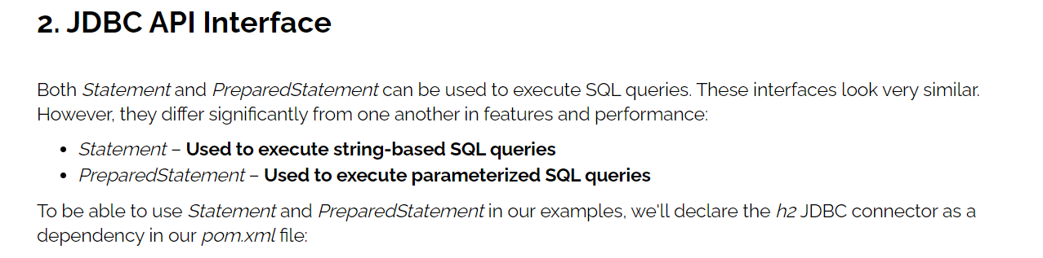

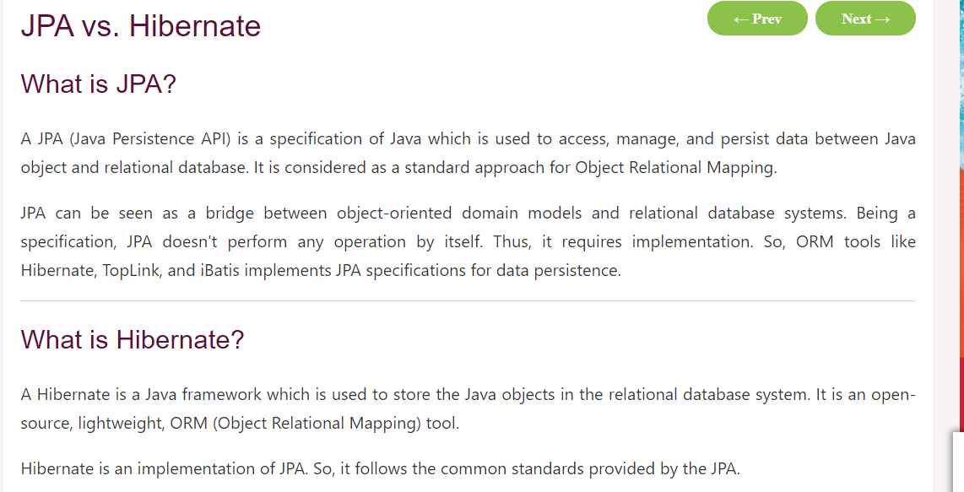

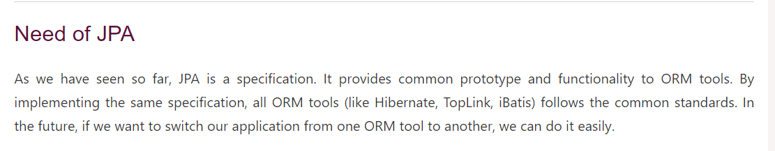

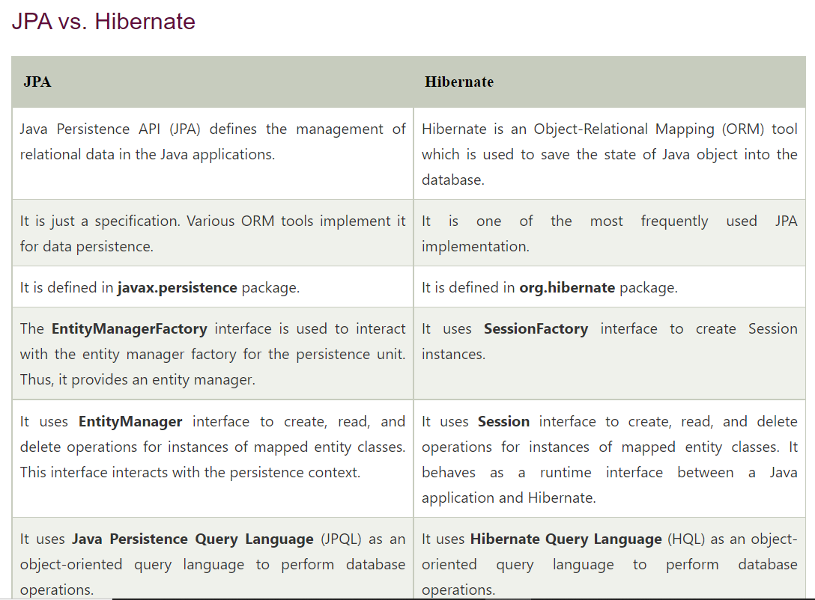

# Hibernate

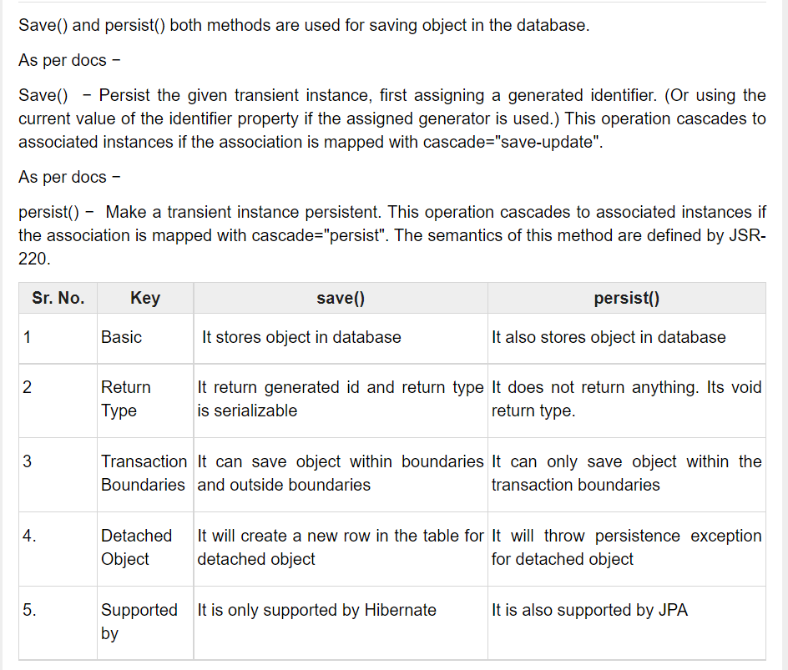

# GIT commands

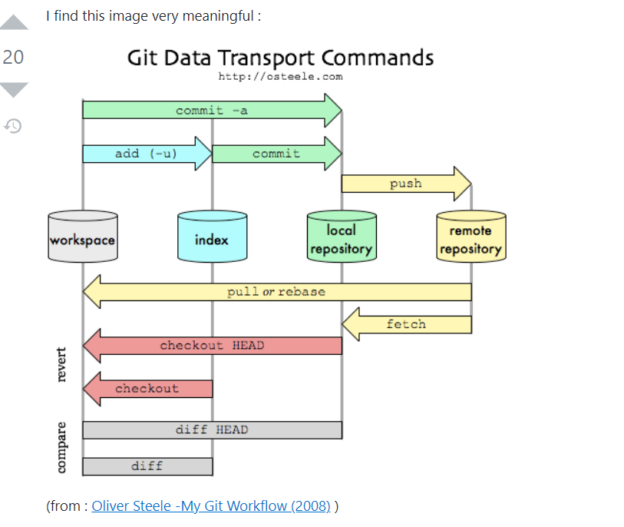

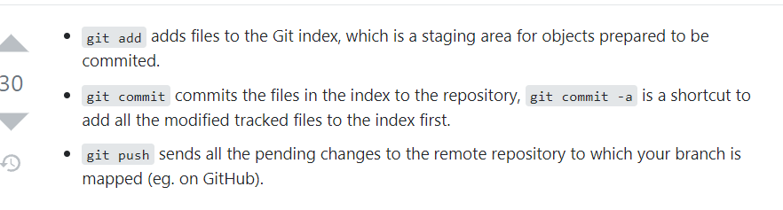

# Generics :

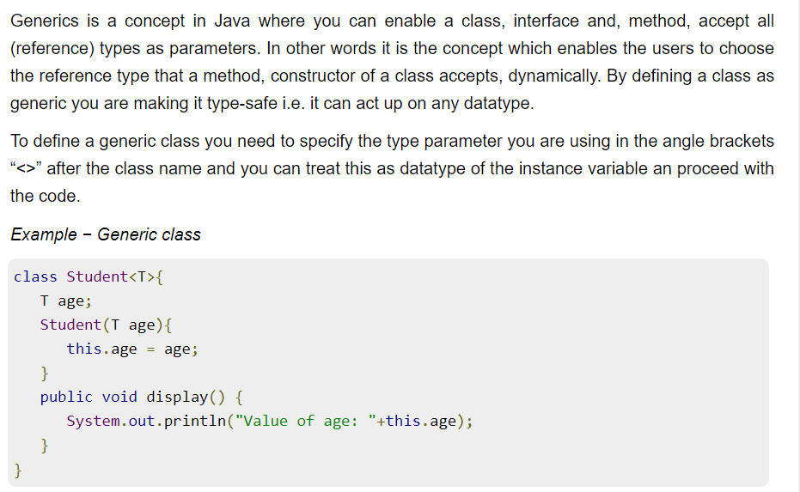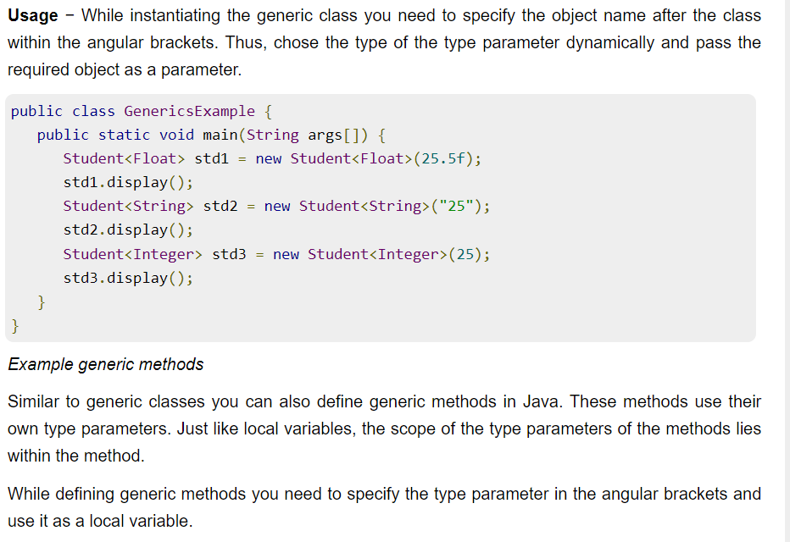

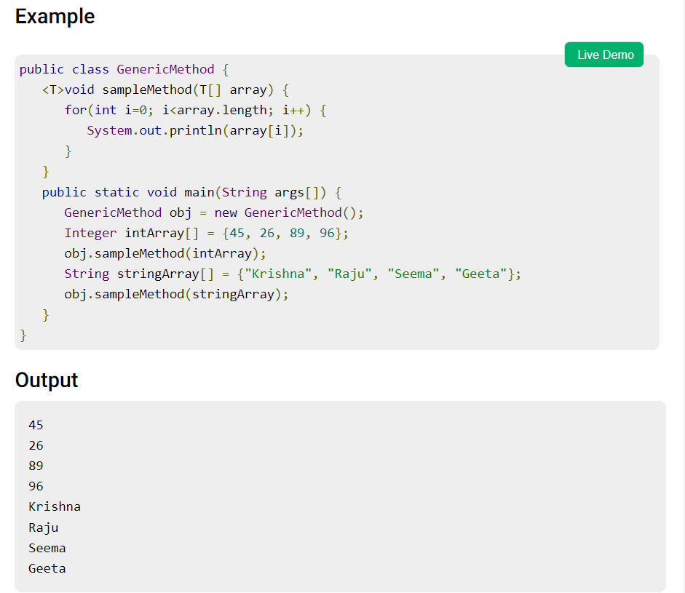

# Liferay

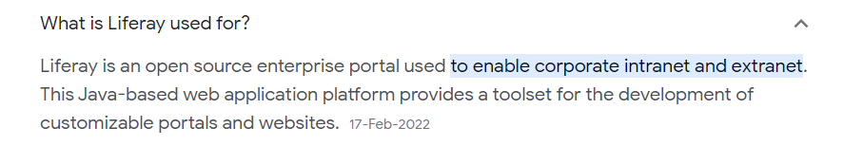

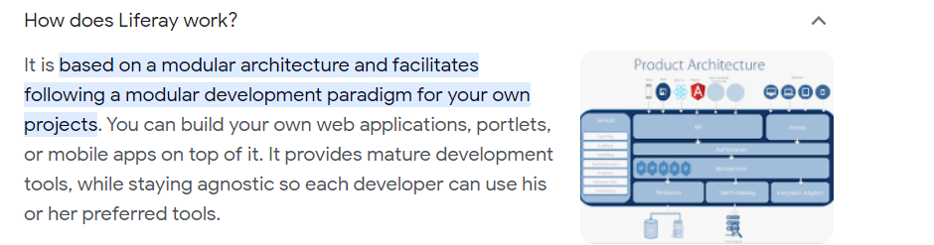

# JUNIT

# React JS

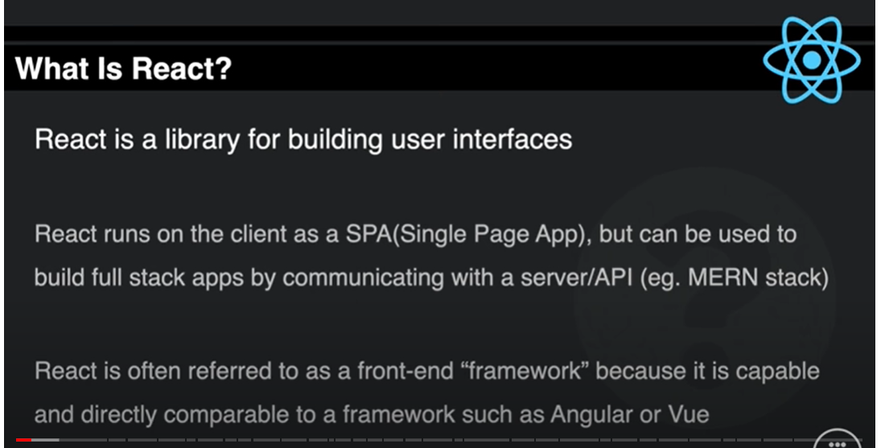

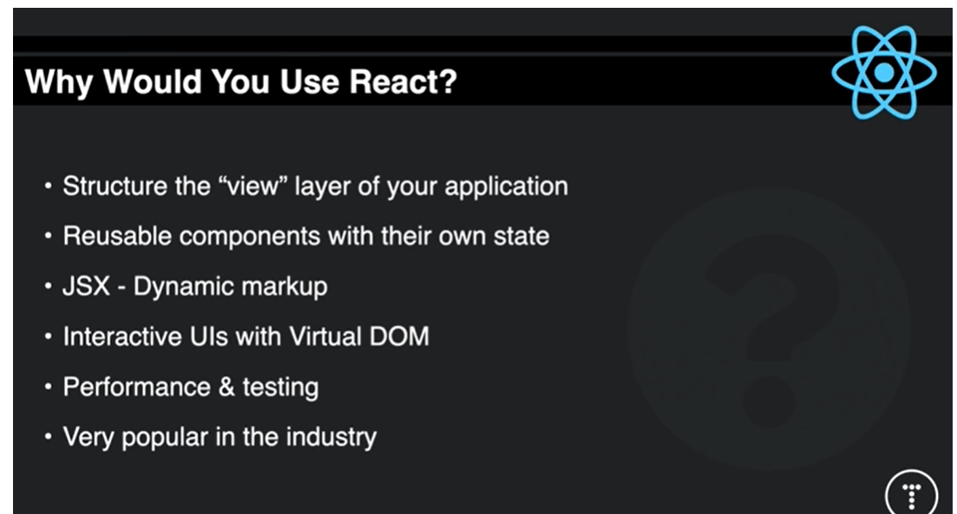

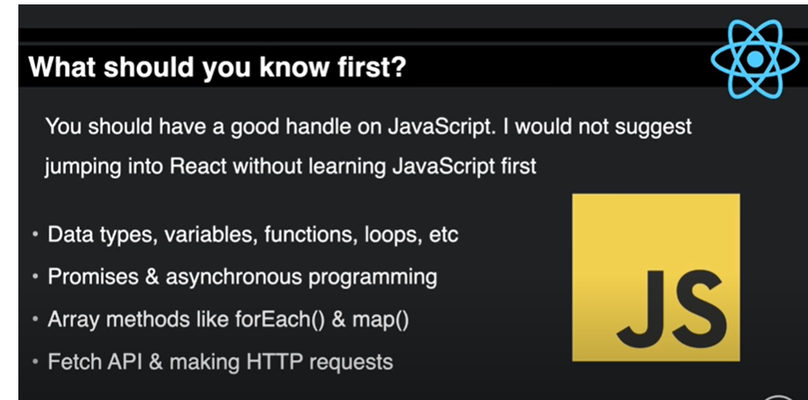

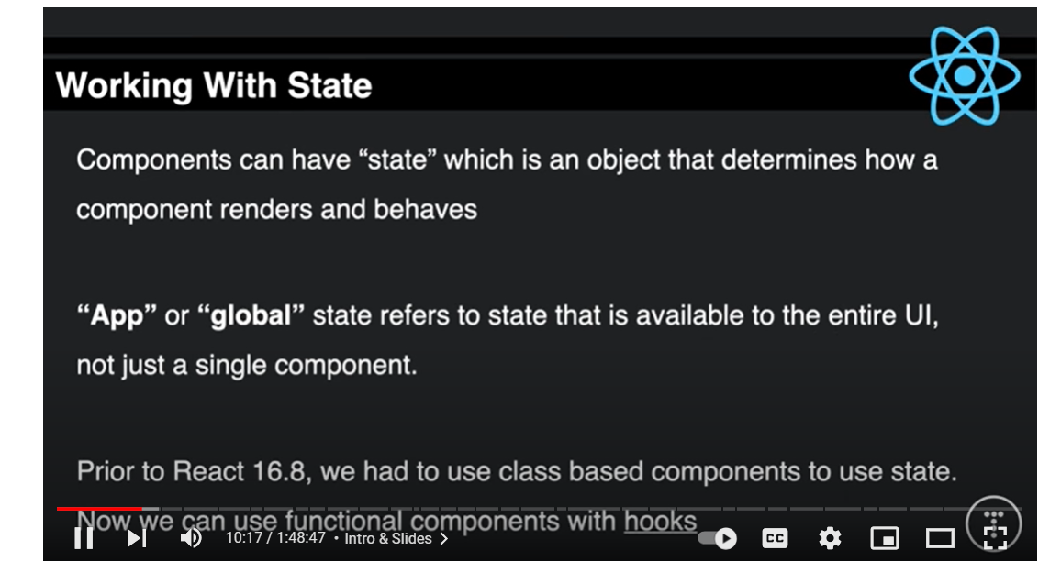

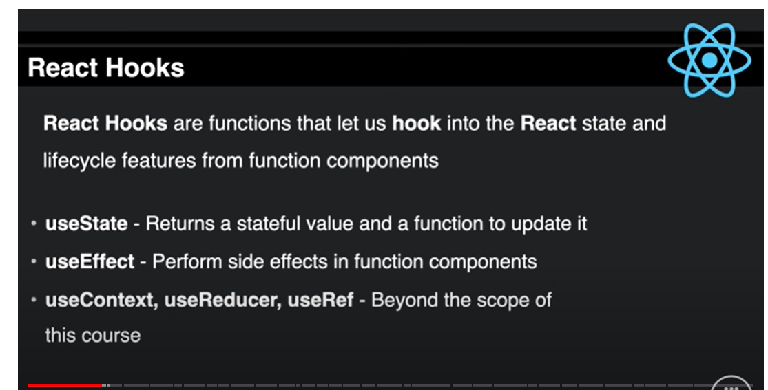

## React Query

```js

import { createBrowserRouter, RouterProvider } from 'react-router-dom';

import { QueryClient, QueryClientProvider } from '@tanstack/react-query';

import { ReactQueryDevtools } from '@tanstack/react-query-devtools';

const queryClient = new QueryClient({

  defaultOptions: {

    queries: {

      staleTime: 1000 * 60 * 5,

    },

  },

});

...

const App = () => {

  return (

    <QueryClientProvider client={queryClient}>

      <RouterProvider router={router} />

      <ReactQueryDevtools initialIsOpen={false} />

    </QueryClientProvider>

  );

};

export default App;

```

ES6 Features

https://divami.com/blogs/top-ecmascript-es6-features-every-javascript-developer-should-know/

<https://www.simplilearn.com/tutorials/reactjs-tutorial/reactjs-interview-questions>

Promises

<https://testbook.com/interview/javascript-promise-interview-questions>

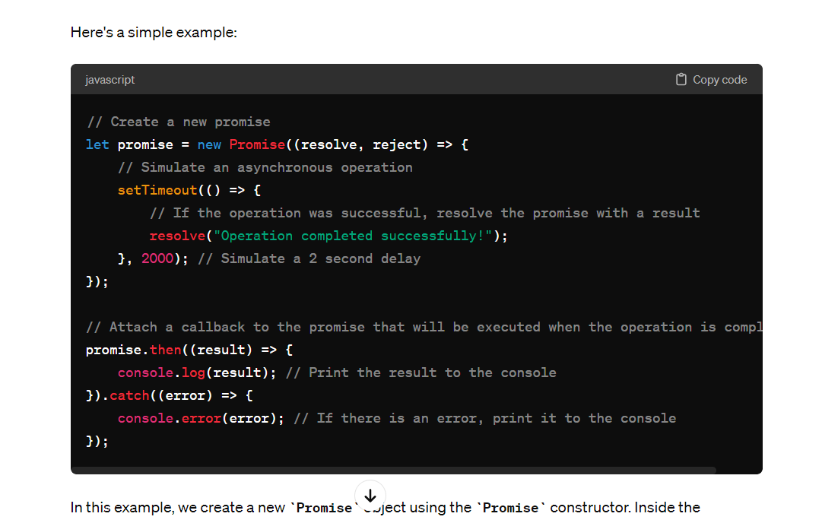

error handling : <https://www.freecodecamp.org/news/effective-error-handling-in-react-applications/#:~:text=Error%20Boundaries%3A,a%20fallback%20UI%20to%20users.&text=Wrap%20components%20that%20might%20throw,component%20to%20gracefully%20handle%20errors>.

.

## **Flatten array JavaScript recursion**

Simple example code when calling flatten recursively, you need to pass arr[i] to it and then concat the result with newArr.

Flatten nested arrays while preserving the order, e.g. [[1, 2], 3, [4, [[5]]]] should be converted to [1, 2, 3, 4, 5].

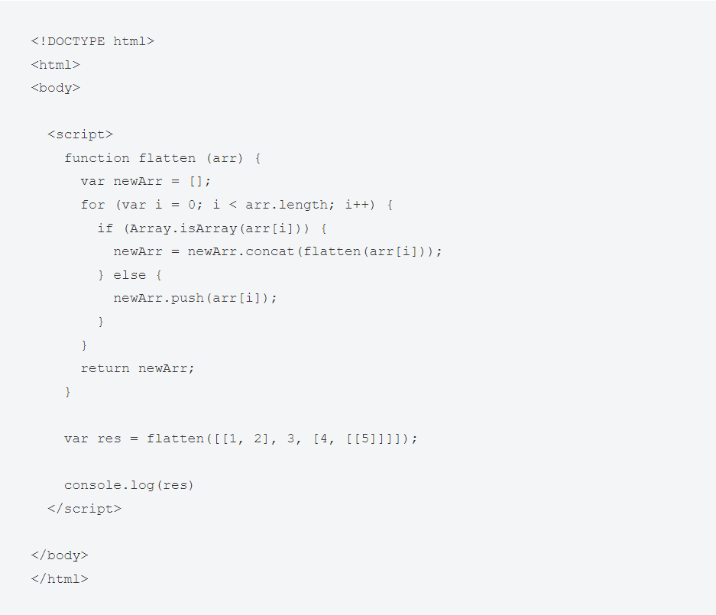

Remove duplicates from array

<https://builtin.com/software-engineering-perspectives/remove-duplicates-from-array-javascript>

**== vs === in javascripts**

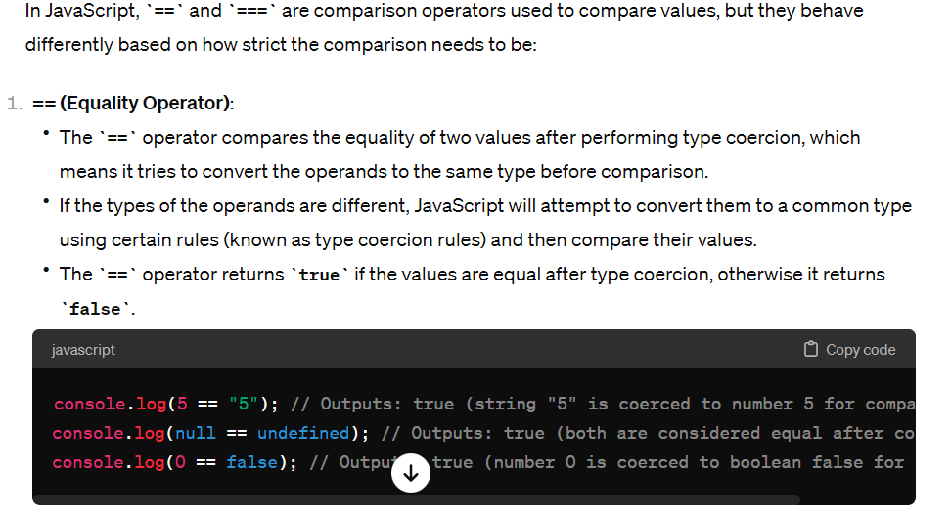

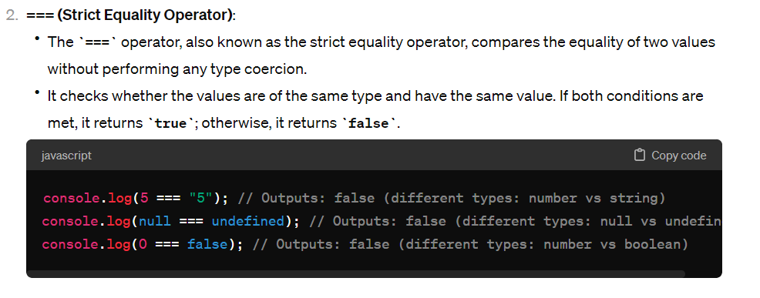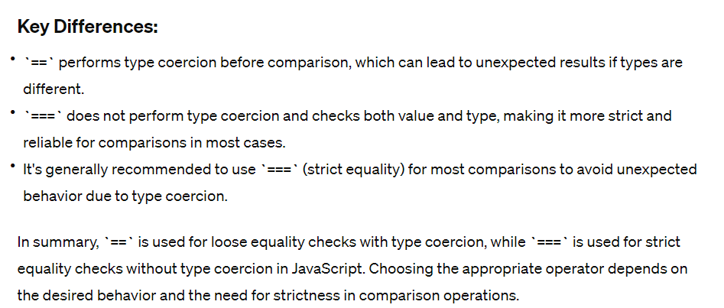

**controlled event and un controlled reactjs events**

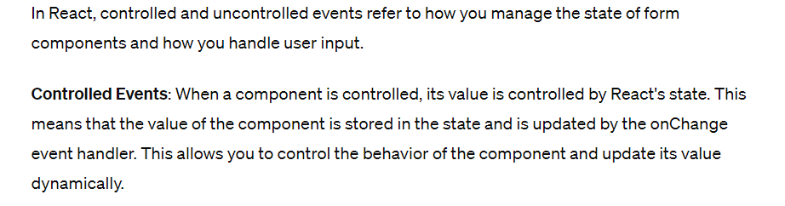

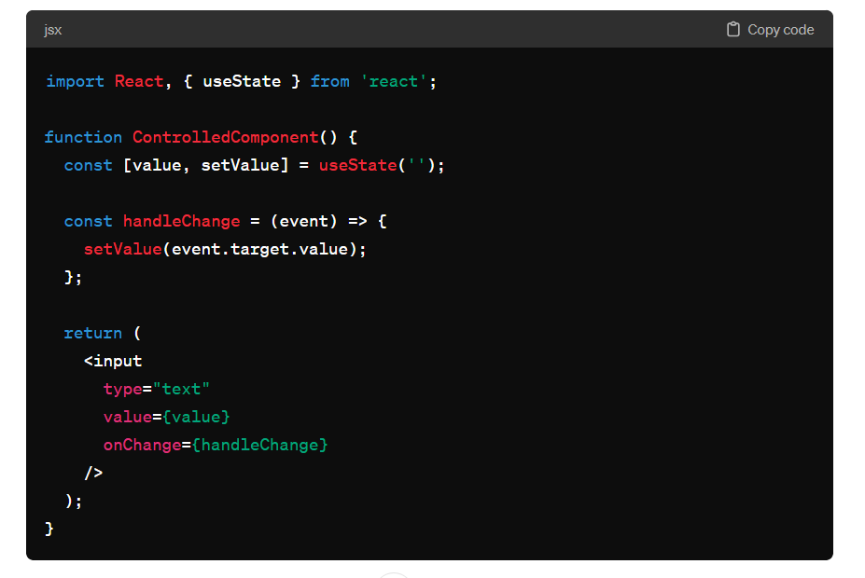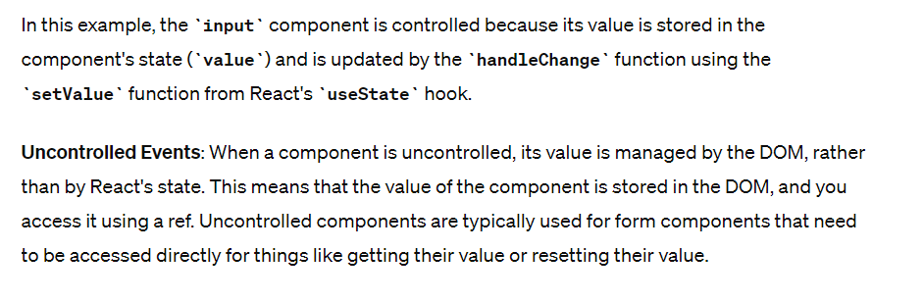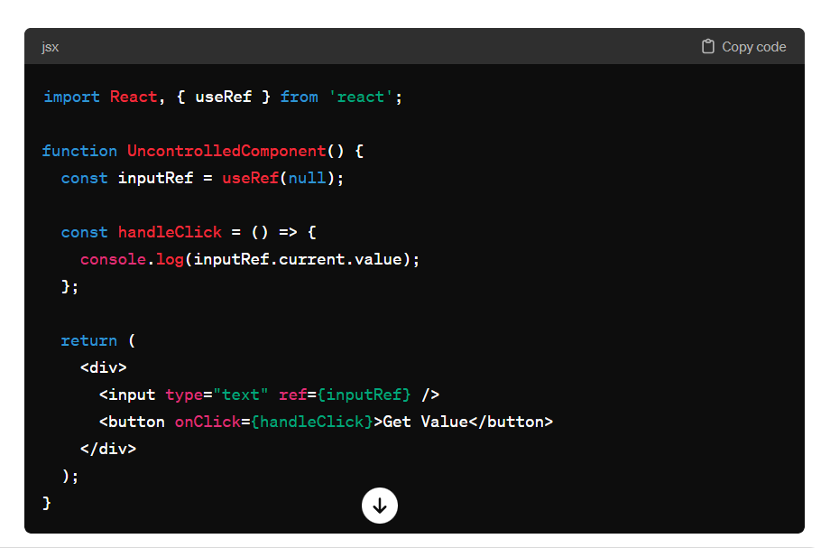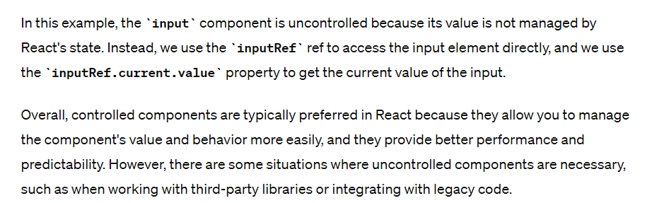

# Tricky Interview Questions

* Lifecyle of POM.xml

In a Java project using Maven, the **pom.xml** file plays a central role in defining project configuration, dependencies, and build settings. The lifecycle of the **pom.xml** file in a Maven project can be broken down into several stages, each representing a phase of the project's development and build process. Here's an overview of the lifecycle of the **pom.xml** file:

1. **Project Initialization**: When you create a new Maven project, you typically start by creating a **pom.xml** file. This file serves as the project's configuration file and contains information such as the project's group ID, artifact ID, version, and dependencies.
2. **Dependency Resolution**: Maven reads the **pom.xml** file to identify project dependencies. It then resolves these dependencies by downloading required libraries from remote repositories specified in the **pom.xml** file or configured in Maven settings.
3. **Project Build**: Maven uses the **pom.xml** file to execute the project build process. This includes compiling source code, running tests, packaging artifacts (e.g., JAR, WAR), and performing other build-related tasks specified in the **pom.xml** file.
4. **Plugin Execution**: Maven plugins defined in the **pom.xml** file are executed during various phases of the build lifecycle. Plugins can perform tasks such as code generation, resource processing, code quality checks, and deployment.
5. **Project Reporting**: Maven can generate project reports based on information collected during the build process. These reports, such as test reports, code coverage reports, and static analysis reports, provide insights into the project's health and quality.
6. **Project Deployment**: If configured, Maven can deploy project artifacts (e.g., JAR, WAR) to remote repositories or servers. Deployment settings are typically specified in the **distributionManagement** section of the **pom.xml** file.

Throughout these stages, the **pom.xml** file serves as the blueprint for Maven's behavior and dictates how the project is built, tested, and deployed. It's essential to maintain the **pom.xml** file accurately to ensure the project's dependencies and configuration remain consistent and up-to-

## webpacks

Webpack is a popular open-source module bundler for JavaScript applications. It is widely used in modern web development workflows, especially in projects using frameworks like React, Angular, and Vue.js. Webpack's primary purpose is to bundle JavaScript files and their dependencies into a single file or multiple files (bundles) for optimized loading in the browser. Here are the key aspects and features of Webpack:

1. **Module Bundling**:
   * Webpack treats every file in your application as a module, including JavaScript files, CSS files, images, fonts, etc.
   * It builds a dependency graph that maps out which modules depend on which others, and bundles them into one or more bundles that can be loaded by the browser.
2. **Code Splitting**:
   * Webpack allows you to split your code into multiple bundles, which can be loaded on demand. This is useful for optimizing initial loading times by only loading necessary code upfront.
   * Code splitting helps reduce the initial bundle size and improves the performance of your web application.
3. **Loaders**:
   * Webpack uses loaders to process different types of files beyond JavaScript. Loaders transform files from one format to another as they are added to the dependency graph.
   * Examples of loaders include **babel-loader** for transpiling ES6+ JavaScript using Babel, **css-loader** for processing CSS files, **file-loader** for handling file imports, and more.
4. **Plugins**:
   * Webpack plugins extend its functionality and allow for advanced optimizations and tasks during the bundling process.
   * Commonly used plugins include **HtmlWebpackPlugin** for generating HTML files, **MiniCssExtractPlugin** for extracting CSS into separate files, **UglifyJsPlugin** for JavaScript minification, and **CleanWebpackPlugin** for cleaning up output directories.
5. **Development Server**:
   * Webpack provides a built-in development server (**webpack-dev-server**) that serves your bundled files locally during development.
   * The development server supports features like hot module replacement (HMR) for instant module replacement without full page refreshes, which speeds up the development workflow.
6. **Code Optimization**:
   * Webpack performs code optimizations such as minification, tree shaking (removing unused code), and chunk splitting to generate optimized bundles for production deployment.
   * These optimizations help reduce bundle size, improve loading times, and enhance the overall performance of your web application.
7. **Configuration**:
   * Webpack is highly configurable through a **webpack.config.js** file where you define entry points, output settings, loaders, plugins, and other configurations specific to your project.

Overall, Webpack simplifies the management of JavaScript modules and assets in modern web development, providing a powerful toolset for bundling, optimizing, and serving web applications efficiently. It is an essential part of many front-end development workflows and build pipelines.

Top of Form

# JavaScript

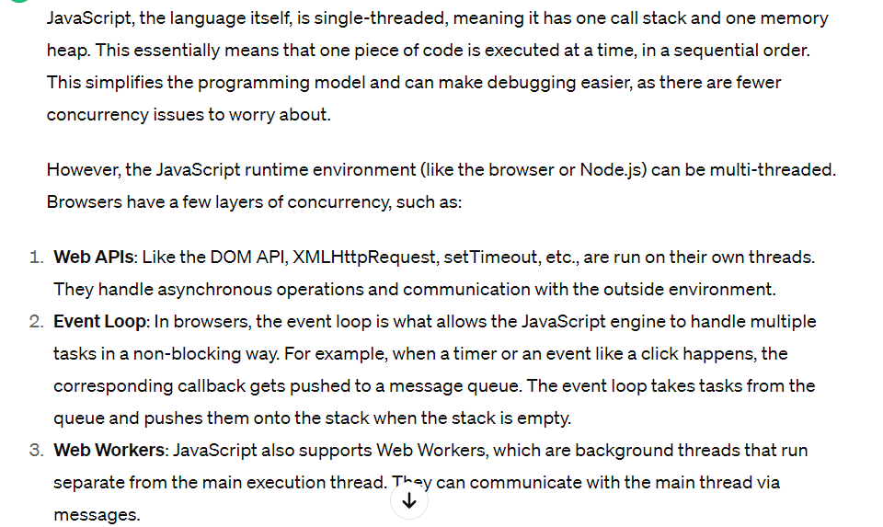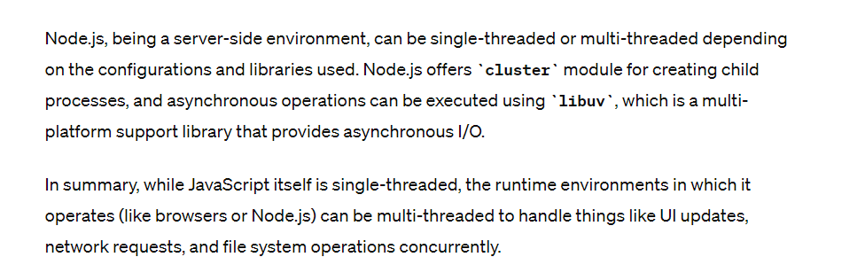

var a={},

b={key:'b'},

c={key:'c'};

a[b]=123;

a[c]=456;

console.log(a[b]);

**remove duplicate object based on name using javascript**

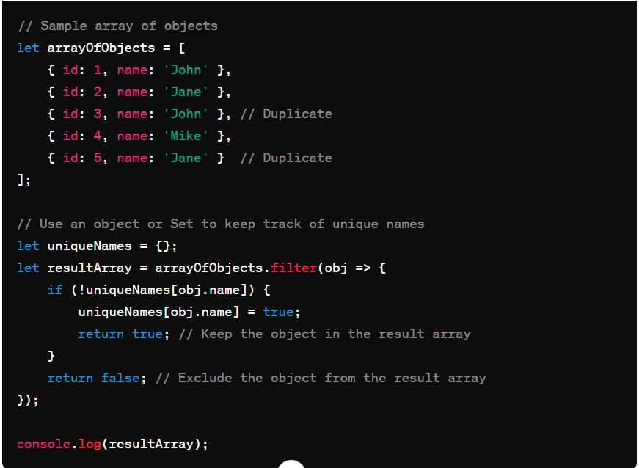

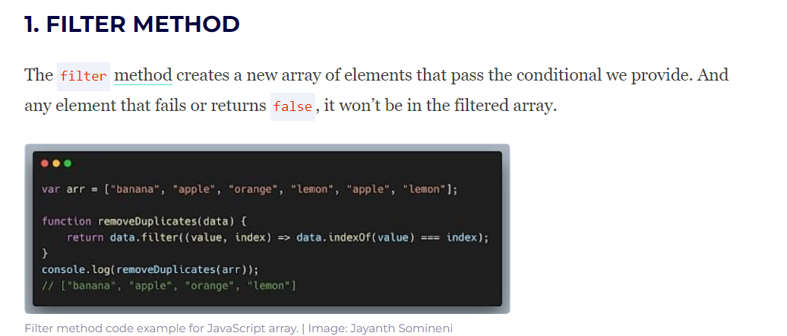

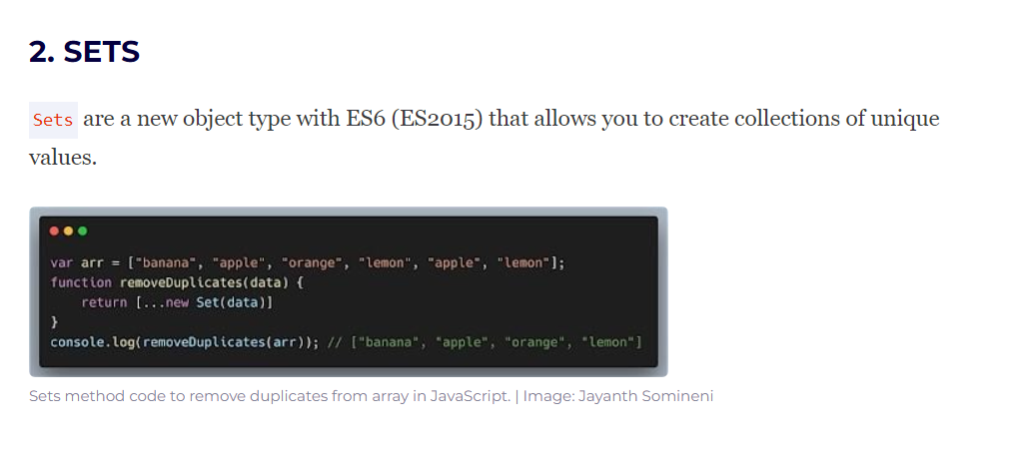

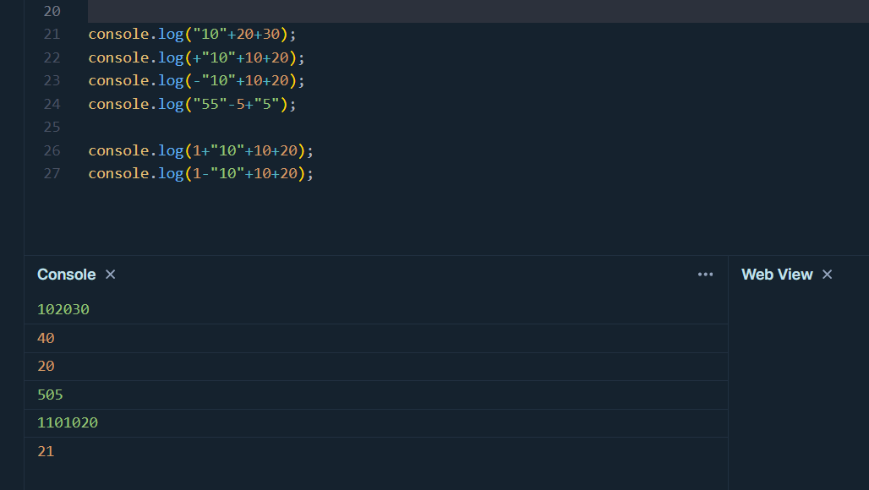

## Clousers

